Gorski Consulting Website

Archived News - 2012 - April
April 26, 2012
Large Platoon of OPP Vehicles Pass Through Thamesford, Ontario, Northbound on Highway 19
While I was busy this morning (April 26th, 2012) examining the results of a fatal collision that occurred in Thamesford yesterday evening I was alerted to sirens approaching the intersection of Dundas and Allen Streets (i.e. the site of the fatal collision). As I had been taking photographs of the site I turned my camera toward the approaching sirens and took the following photo just as an OPP truck turned the corner from eastbound on Dundas Street to northbound on Highway 19.
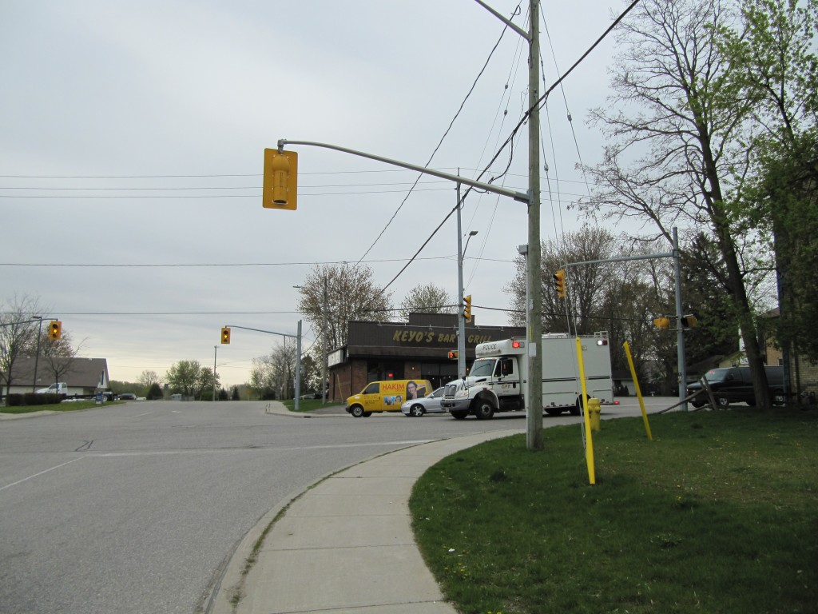
View from the north side of the Dundas/ Highway 19 intersection as the first of several OPP vehicles enters the view.
You will note that behind the OPP truck is a black van, which is also an OPP vehicle but is unmarked. As the first vehicle passed my location I took another photo as shown below.
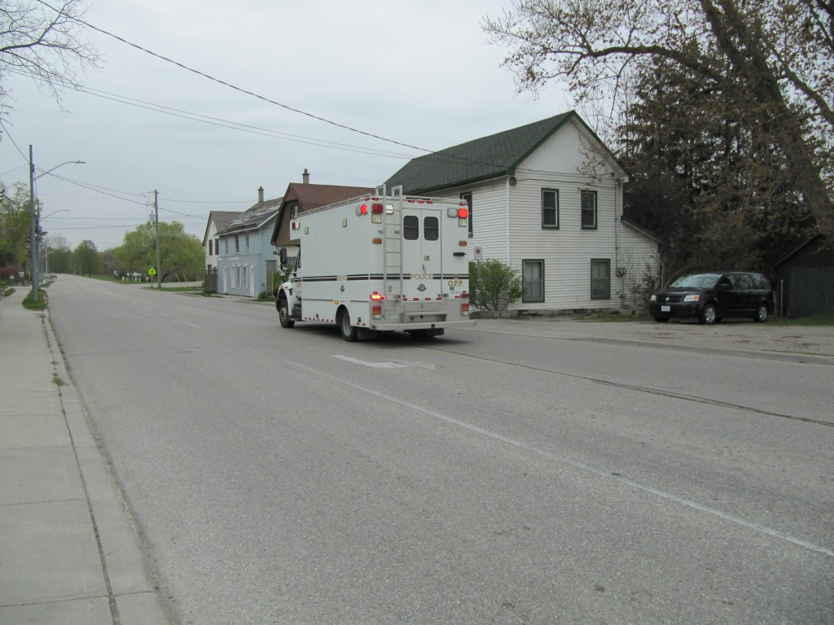
View of first OPP Truck travelling northbound on Highway 19 and leaving Thamesford, Ontario.
This is not a cruiser or anything that you would commonly see on the streets. It is larger than your average ambulance. After the black, unmarked van passed there was a second truck that passed me, identical to the leading truck, as shown below.
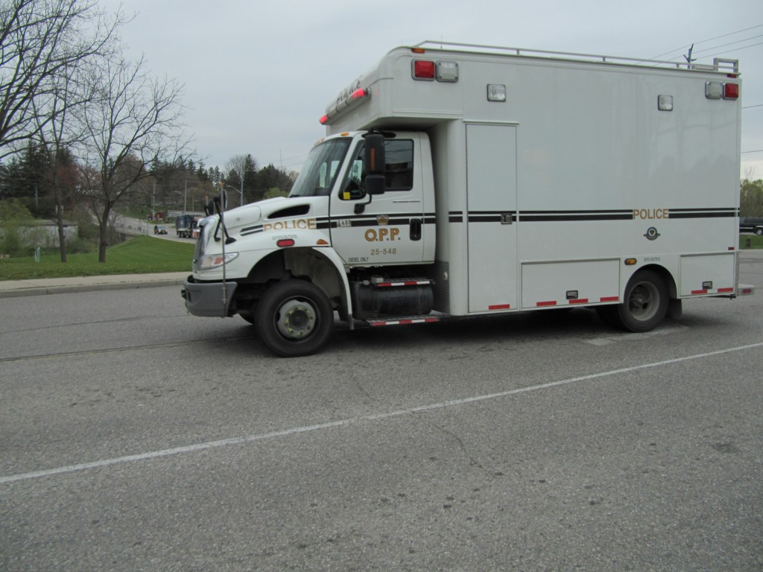
View of second OPP truck passing the Thamesford location
One would think that the story was complete, but not so. OPP vehicles kept passing. A third OPP truck, another unmarked, black van, and an actual marker cruiser, as shown in the photos below.
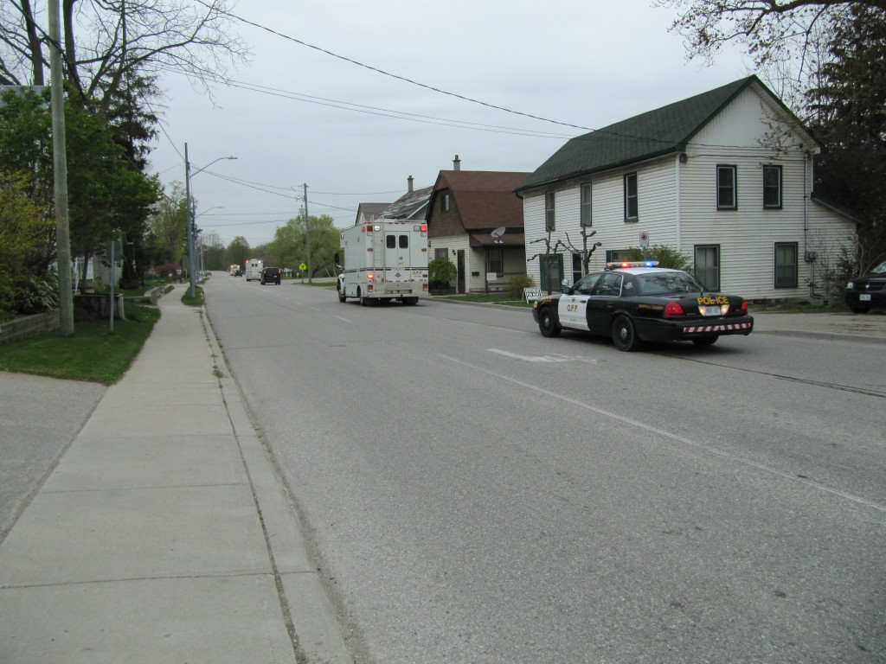
View of platoon of OPP vehicles travelling north on Highway 19 from Thamesford
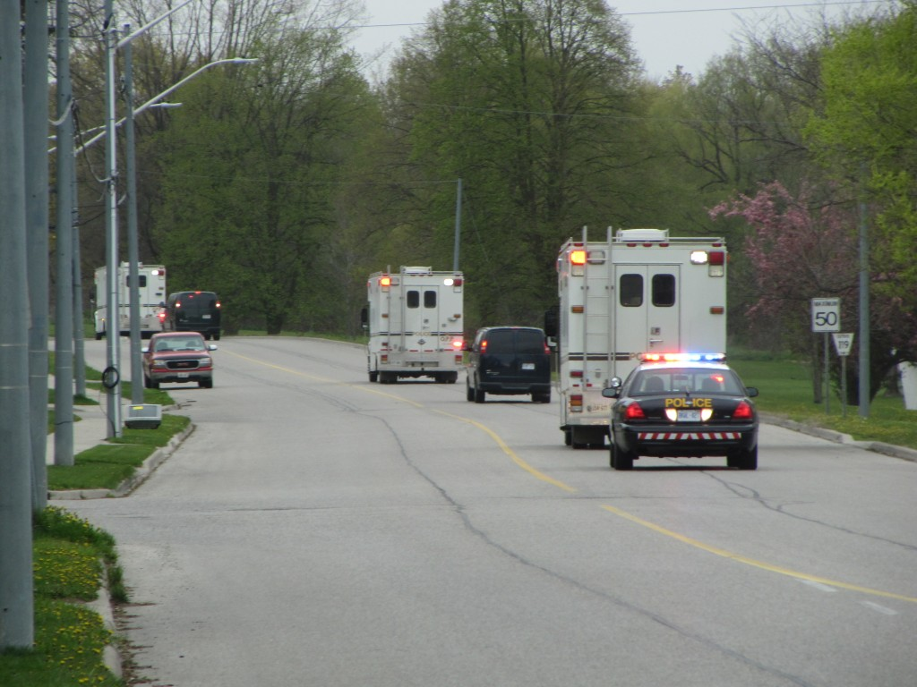
Line of six OPP vehicles heading northbound on Highway 19 out of Thamesford
If you count the vehicles in the background I am sure you will come up with six OPP vehicles in a line. Where are they going and why at this mid-morning hour? It is interesting to note how slow the official news media are in reporting these events. By 1930 hours the most reliable (quick) source of local information, the noble London Free Press, still had not reported a single word about the events that brought forth this entourage.
Little Notice Or News Of Fatality In Thamesford, Ontario
On Wednesday evening, April 25, 2012, the official news agencies reported that a fatal collision had occurred in Thamesford, Ontario. It was reported that a car had collided with a tractor-trailer and the male driver of the car was taken to Ingersoll hospital where he died. Neither of the drivers in the collision were identified. The travel directions were not identified. The manner in which the collision occurred was not identified.
The only firm fact was that the driver of the car was taken to Ingersoll hospital. That, in itself would appear curious. Ingersoll is a small town with a small hospital. Thamesford, where the collision occurred, is relatively close to Ingersoll but it is also not that far from London, where the facilities to take care of severely injured persons would be expected to be better.
Travel from Thamesford to a hospital such as Victoria at the intersection of Commissioners and Wellington could be done mostly through rural roads. For example, an ambulance could have travelled from the Thamesford site, west on Dundas to Shaw Road, north on Shaw Road to Hamilton Road which then becomes Commissioners. Essentially all that travel would be rural, at highway speed. The only possible congestion could be in the area on Commissioners Road travelling westbound from Highbury but this road would be four-lanes and there would be plenty of opportunity to pass slower traffic. So the travel time between the Ingersoll Hospital and Victoria in London would not be that large.
My point is that reaching a fully-equipped hospital is extremely important when attempting to save the life of a severely or critically injured person. Here is a situation where no one has asked any questions, the news media appears to have fallen asleep and the police have provided essentially nothing in terms of describing what occurred.
For your information, we have several photos of the site taken from this morning, or about less than 18 hours after the occurrence. The photo below was taken on Dundas Street looking west toward the intersection with Allen (Highway 19). You will note an extremely long skid mark in the westbound lane.
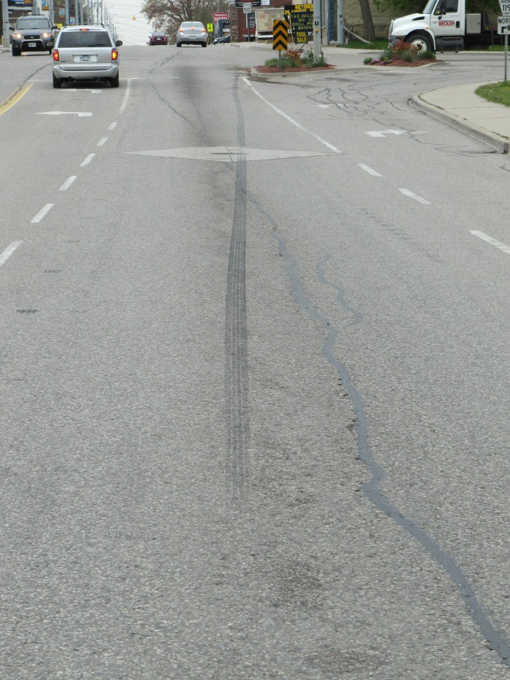
View, looking west, from east of the intersection of Dundas and Allen Streets in Thamesford
Ordinarily such extremely long skid marks are caused by towing personnel as they lift the front or rear end of a car while believing that the tires on the remaining axle that are in contact with the ground will rotate. Instead, one of the wheels is jammed and slides as the vehicle is towed away. This is what we suspect happened in this case but we cannot be absolutely sure. So we wanted to get more information such as the travel directions of the vehicles, where the damage existed on each vehicle and so on. That has not yet been provided.
We can indicate that at the intersection there is a variety of evidence that confirms that an impact occurred there. For example a hazard sign contains fresh damage, as noted in the photo below.
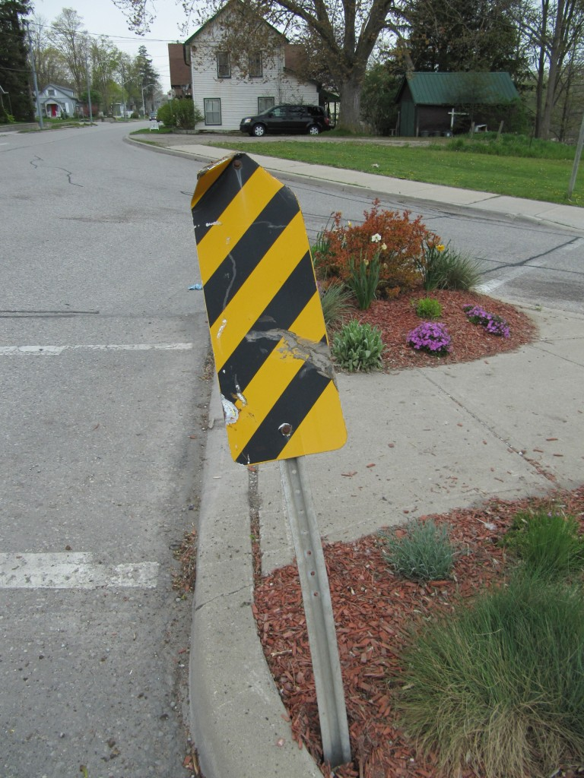
View of fresh impact damage to hazard sign on traffic island of intersection
There is also other evidence that I will not discuss in detail but can show through a general, westbound view of the intersection, as shown in the photo below.
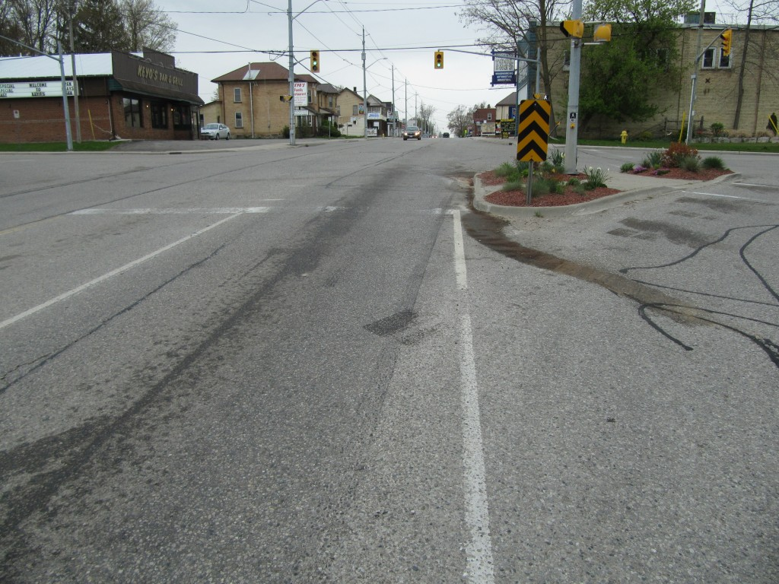
View, looking west along Dundas Street in Thamesford, from just east of the intersection with Highway 19.
We will wait for any official description from the investigating police before we decide whether we will comment further on this matter.
UPDATE: April 27, 2012; 1930 Hours
Police have now released the name of the deceased in the fatality that occurred in Thamesford, Ontario on Wednesday evening, April 25, 2012. Milan Djordjevic, 49, of Woodstock was the deceased driver.
The quality of the information is still poor however. There was no information provided about the the travel directions of the vehicles. The London Free Press only made this single sentence statement:
“Milan Djordjevic, 49, of Woodstock, was killed when he failed to stop at a red light
at an intersection, colliding with a turning transport truck.”
Could the information be any more scarce? I hope neither you nor I face this indifference when our lives come to a traumatic end.
As an expert with 31 years in accident reconstruction I would like to examine the reported facts and confirm that they are consistent with what I saw at the accident site. Being totally independent I can be objective enough to do that. But when police provide essentially no information how can that evaluation be done? Particularly when there is an issue of an intersection and a traffic signal, much of the information that police gather is based on what someone has said: “Yeah, I saw it all and the car went through the red light”.
But I have seen all this before. People say things, sometimes when they do not have a clear view, sometimes when they are mistaken, and sometimes purely because they are lying. It needs a further study of the physical evidence to confirm whether the witness information is believable.
It is often easier for the investigators to blame the person who is dead and cannot speak. On the other hand, it may be totally the deceased driver’s fault. The point is that when absolutely no information is provided to the general public then the possibility of improper behaviour being undetected is increased.
UPDATE: April 28, 2012; 1015 Hours
Congradulations go out to the local Woodstock newspaper which finally reported the travel directions of the two vehicles involved in the Thamesford fatal crash. Milan Djordjevic was reportedly travelling westbound on Road 68 (Dundas Street) when his vehicle collided with a tractor-trailer “turning left at the intersection onto Road 68.”. Even that wording does not provide a clear indication of which direction the the left turn was being made.
The possibility that the Djordjevic vehicle was westbound would raise some questions from anyone who looked at the physical evidence because of the very long, single skid mark that was present. So the more reason for police and official news media to provide a clear explanation so that the facts are not misunderstood.
Police are not the only investigators who go out to these sites. Investigators working on a civil litigation case are hired by insurance companies or lawyers working for plaintiffs and their assessment also needs to be accurate. Those investigators cannot examine the site until the police have cleared the road. In which case, when emergency vehicles or towing operators produce confusing evidence this makes it more difficult to resolve what happens. Certainly the investigators working for the civil litigation will eventually obtain a full copy of the police investigtion notes, photographs and measurements, but each year the request and receipt of that information is further delayed by a lack of funding to speed this process along. So by the time civil investigators obtain the police file there could be a year or two or even more of delay. During that delay communications between the civil investigators and their clients continue and may be affected by any false evidence that is created at an accident site or on the involved vehicles. Over the years interviews of police have become progressively more difficult and expensive to accomplish leading to further delays before the true facts of a case are revealed. The bottom line is that the public is not aware that this creates waste and injustice. The waste is paid for by insurers who ultimately pass the costs onto all of us. The injustice is paid for by the individuals whose difficulties are never discussed by any official news media. This is why a seemingly non-important matter such as clear communication of the facts surrounding a fatality or serious injury becomes important.
It is most probable that the long skid mark was created by towing operations after the fact. But that will not be obvious to persons who are not privy to the police investigation.
April 23, 2012
Glanworth Curve Crash – Public Deserves Better of Police Investigation
On February 11, 2012, an SUV rounded the north portion of the Glanworth Curve on the south edge of London, Ontario, Canada. The vehicle left the road to the outside of the curve and crashed into a tree. A young child and an adult were both killed. Police waited only until now to release a conclusion to their investigation. The death of two
persons, where the only driver involved will not be charged, has resulted in a cryptic,
single-sentence, police media statement:
Police have determined that the cause of the collision was a combination of a number of factors including driver experience, vehicle equipment issues, weather and weather related road conditions.
This is the result of closing the accident site for many hours and preventing any other investigator from evaluating the evidence.
The question: What did police believe they were achieving by releasing this one sentence of indecipherable verbiage? Were they informing the public of something? What is the public, or the family of the deceased for that matter, going to gain from this sentence?
I would like to know how they determined that driver experience was a factor in the cause of this collision. Because if that conclusion is only based on the fact that the driver was relatively young, such a conclusion is simply not worth the computer time used to create it – and that computer time was extremely minimal.
What does “vehicle equipment issues” mean? It could be anything. What use is such a
broad comment to anyone?
What about “weather and weather related road conditions”? Do they mean that the roadway was dangerous to travel? It was the police who had the responsibility to close the road if that was so. But was the roadway properly maintained? Did the persons responsible for maintaining the road do their job properly? We have no idea because none of this is mentioned in the police statement.
The public deserves better from its police in reporting its findings when persons are killed. When a single sentence like this is presented as the sole summary of the police actions and conclusions it should not be dressed up as somekind of accountablility to the public that it is supposed to serve because clearly it is not.
April 21, 2012
Fatalities & Injuries Surrounding Attempts By Police to Conduct Traffic Stops
Recent occurrences shine a spot light on the number of incidents where attempted police traffic stops have led to driving fleeing and killing themselves and others. While we have not attempted to conduct any meaningful study it is apparent that these events are not uncommon.
On April 18th, 2012, a driver reportedly failed to stop for police in Oxford County. A short time later the vehicle was involved in a rollover collision just outside Oxford County, in Perth County, south of Stratford Ontario. While injuries to the two occupants were reported to be minor this was more to do with luck as the collision, which included impacts to some trees, could easily have resulted in fatal injuries. We have uploaded an article about this incident in the Articles page of this website.
On April 6th, 2012, police in the Flamborough area, west of Hamilton, Ontario, had taken over control of an intersection at Middletown Road and Concession Road 5. A northbound vehicle on Concession Road 5 passed through the intersection at high speed and crashed into the west roadside. The lone female occupant was deceased.
At a similar time, Ontario Provincial Police were reportedly conducting a “routine traffic stop” on Highway 69 in the Parry Sound area when a female driver reportedly fled. Police used spike belts to attempt to stop her however her vehicle struck two police cruisers and the female was pronounced dead. Two police officers also sustained minor injuries.
We are not aware of any study that has examined the number of serious collisions that occur in the midst of police traffic stops but it would appear to be a worthwhile inquiry.
April 17, 2012
Today’s Collisions In City of London, Ontario
A relatively serious collision occurred near noon-time at the intersection of Florence Street and Rectory Street in central east London. Injuries were reported including a fractured leg to one driver but these injuries were not life-threatening.
Earlier, a similar collision occurred at the intersection of Dundas and Hale Streets, also in east London. As shown in the photo below, a westbound Sienna van attempted to make a left turn from Dundas onto southbound Hale when an eastbound Hyundai Accent attempted to pass through the intersection.
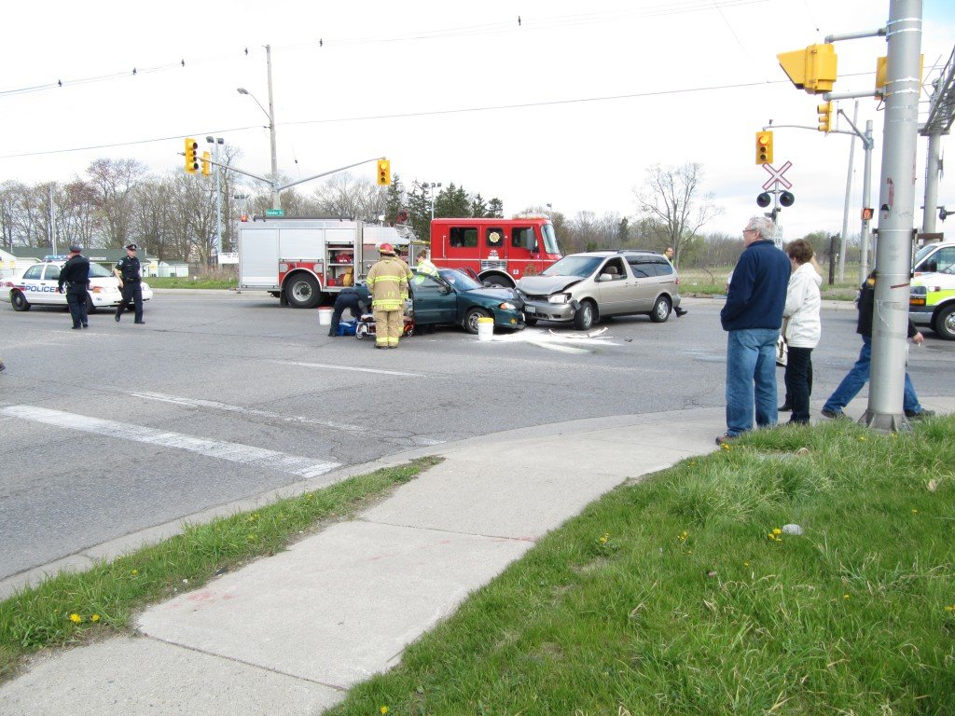
View, looking north-west from the south-east quadrant of the intersetion of Dundas Street at Hale Street where two vehicles collided at approximately 1000 hours today.
As noted in the photo below, damage was relatively light to both vehicles however the two occupants of the Accent were transported to hospital.
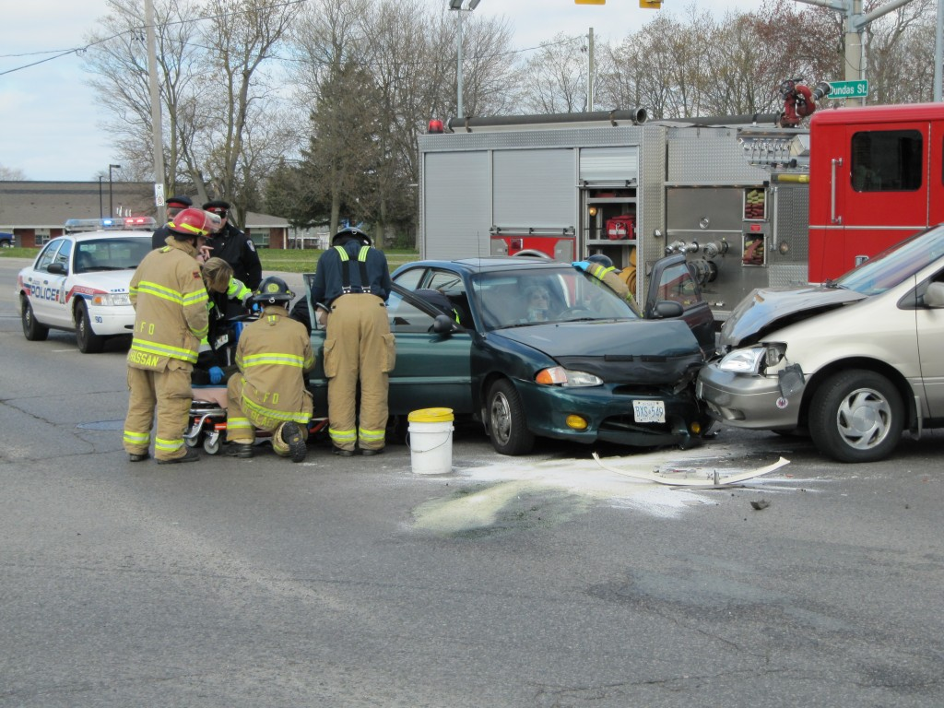
View, looking north-west at two vehicles that collided at the intersection of Dundas and Hale Streets in London on the morning of April 17, 2012.
As noted in the photo below, interactions of larger vehicles with smaller ones can increase the severity of the impact to those occupants of the smaller vehicle.
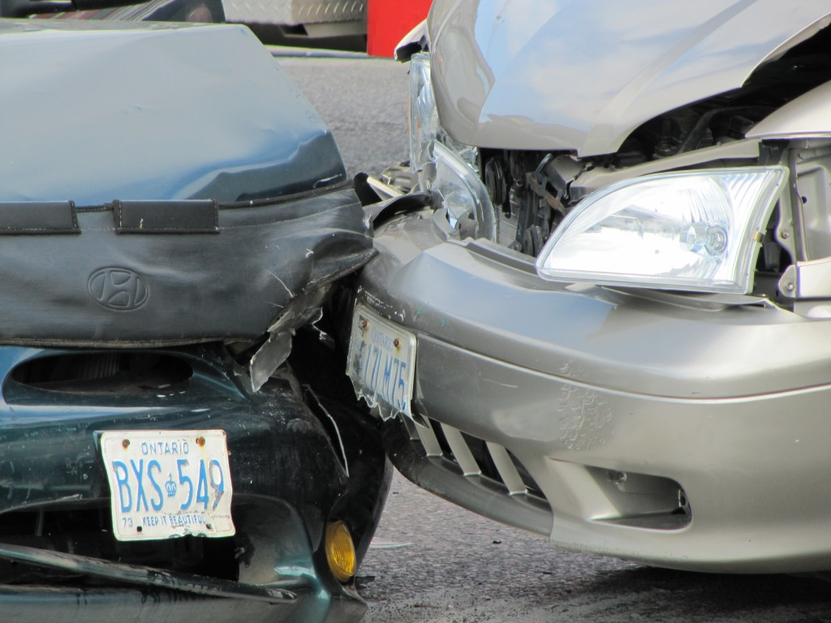
View of front bumper of Sienna Van riding over top of the bumper/fender of the smaller Hyundai Accent.
In this case the two occupants of the Accent were also elderly and therefore potentially more frail and more likely to sustain injury. It is therefore reasonable to examine these occupants in an emergency department to make sure that hidden injuries did not occur.
Generally, collisions within the limits of larger urban areas will be, on average, relatively minor in severity, although there are obvious exceptions.
April 11, 2012
Oxford At Gideon Fatal Crash – “Evidence Cannot Explain Why” - But We Disagree
Respectfully, we disagree with Sergeant Tom O’Brien of the London Police Service when he has told the news media that the physical evidence from the double fatal collision such as occurred on Oxford Street near Gideon yesterday cannot tell why the collision occurred. What can be done with the physical evidence, and how it can be interpreted, has much to do with the experience of the interpreter, rather than the ability of the evidence to reveal a cause.
If investigating police officers spend 10 years in the accident reconstrution unit and, just as they are becoming proficient, they are then sent to the Criminal Investigations unit, then a new body has to start almost from scratch. Interpreting physical evidence is not like a physics or calculus formula that only requires that you memorize the formula or pull it out of a book. There is hopelessly scant information discussing how to interpret physical evidence of motor vehicle collisions. And that is understandable because everyone simply wants to plug in a bunch of inputs to a magic formula without studying if those inputs are a correct application of the theory. Correct application of theory must require that you study and understand the physical evidence. You cannot know that physical evidence from spending a just few years at it, it’s a much longer learning curve.
The suggestion that the present collision was possibly caused by an attempt to avoid a wild animal is really stretching the facts. We have not seen any of the evidence, nor have we even examined the site yet, but this type of discussion is a reflection of the standard set of responses police have as to why a collision occurred – whether there is sufficient factual evidence or not.
If someone was alcohol impaired then obviously it was the alcohol impairment that caused the accident, never mind whether any facts were unearthed to support that allegation. If speed was high then again it was the speed that caused the accident, never mind whether a proper accident reconstruction was performed to support that allegation. If we are true scientists of fact then this type of biased analysis should not be acceptable. We should simply state that speed and alcohol are known to affect the safe driving of the general public and leave it at that. The notion that a wild animal caused the present collision is, in our opinion, a wild speculation.
UPDATE: April 12, 2012; 1515 Hours
The two drivers in this crash have now been identified. Dana Winterburn, 49, a London doctor and Associate Professor at Western University was the driver of a westbound Subaru and Bradley Haggith, 47, of London was driving an eastbound SUV. Both drivers were killed in the crash.
We have now had a chance to examine the evidence at the accident site.
The physical evidence at the site indicates that the impact occurred at the north edge of the westbound lane at the gouges noted in the centre of the photograph (below).
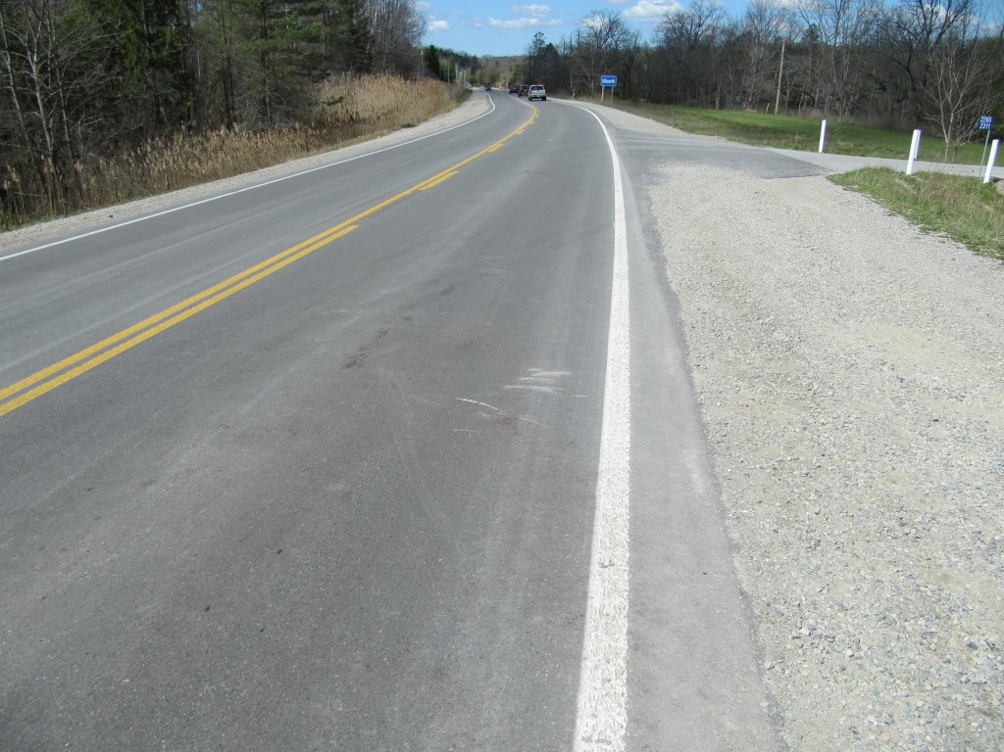
View looking westbound on Oxford Street with gouges visible on the north edge of the westbound lane.
The position of these gouges would indicate that the eastbound SUV driven by Bradley Haggith was very far into the opposing lane and that Dana Winterburn may have steered to the right just before impact in an attempt to avoid the collision. Given the approximate 50 percent overlap of the front ends of the vehicles at impact, the Winterburn Subaru would have been partly off the westbound travel lane at impact and the only reasonable explanation for this is if she made that evasive motion to steer to the right.
The final rest positions of both vehicles were east of the point of impact and, even though the SUV might have been heavier than the Subaru, this still indicates that the Haggith SUV was travelling much faster than the Subaru at impact.
April 10, 2012
Death of Bibi Shazeena Ally, 38, At Police-Controlled Intersection Draws Our Attention
While it may be unfair, our suspicion of the circumstances by which a driver sped through a stop sign at an intersection that was controlled by police will remain until we have grounds to conclude otherwise. Bibi Shazeena Ally was identified as the northbound driver who sped through the stop sign on Middletown Road, west of Hamilton, Ontario, Canada at approximately 1000 hours on the morning of Good Friday, April 6th, 2012. It was reported that the intersection at Middletown and Concession 5 West was being blocked by police in order to allow the Hamilton Cycling Club to run their race. Ally’s car reportedly travelled through the intersection at high speed and crashed into a ditch. Ontario’s Special Investigations Unit (SIU) was called in to examine if police wrong-doing might have played a role in the result.
The only time the SIU would publicize any wrong-doing is if there were grounds to lay a criminal charge against police. But there could be numerous issues of “non-criminal” wrong-doing that could be at play that would never be revealed, and that is just as important for the public to know. The SIU has walked a fine line between sustaining strong criticism from police agencies while also failing to properly disclose a meaningful amount of information about the results of their analyses to the public. While their duty is is a difficult one it is not insurmountable.
While in the past we would have allowed these events to proceed without comment, we have personally witnessed the wrong-doing of police in an investigation without any consequence to those responsible. And since our attention has been drawn to this issue we have observed numerous questionable actions that will remain questionable not only because no further information can be obtained but also because, in those cases where the SIU was involved, the secrecy with which the SIU operates and then fails to inform the public about how they came to their conclusions remains a continuing problem.
If actions of police at the intersection caused Ms. Ally to fail to detect the stop sign and then caused her to lose control of her vehicle, that may not be something with which police can be found criminally responsible. However a life has been lost and failure to disclose if police contributed to that loss is not only unfair to the victim’s family, it could fail to address a problem that could re-occur, and it is also unfair to the police who may have done nothing wrong but due to pervious prejudices and mis-understandings people develop a reason to build a wall of distrust. Having once seen uncorrected mis-deeds, and having been exposed to several questionable ones, we would no longer assume that the investigation of Ms. Ally’s death will be properly taken care of.
UPDATE: APRIL 15, 2012 0845 HOURS
We had an opportunity to examine this accident site on April 11th, 2012. We confirm, as reported, that the vehicle driven by Ms. Ally was northbound on Middletown Road and passed through the intersection of Concession Road 5, likely at highway speed – although our comment about the speed is only based on the physical evidence several seconds after the vehicle passed through the intersection.
The earliest visible evidence of her vehicle’s travel was in the form of yaw, tire marks that commenced about 90 metres past (north of) the interection. These tire marks showed that the vehicle rotated counter-clockwise and slid onto the west roadside. It struck two smaller trees. One of those trees became uprooted and fell over. Although the force to cause such damage can be variable, overall it suggests there was substantial speed on the part of the vehicle at the time of impact with those trees. The vehicle came to rest in a field about 10 t0 20 metres past the tree impacts.
The vehicle travelled about 65 metres from the the beginning of the visible yaw marks up to the tree impact. Applying a broad range of deceleration (.2 to .4 g) would result in a speed loss of about 57 to 81 km/h during this motion. Considering the tree impacts and post-impact travel we would have to conclude that the vehicle was likely travelling well above 80 km/h at the point where it commenced its rotation.
The photo below shows the view that Ms. Ally might have had as she approached the intersection, at least in terms of the visibility of the stop sign. It is not clear if the stop sign might have been obscured in any way or if police activities at the intersection caused her attention to be taken away from the presence of the stop sign.
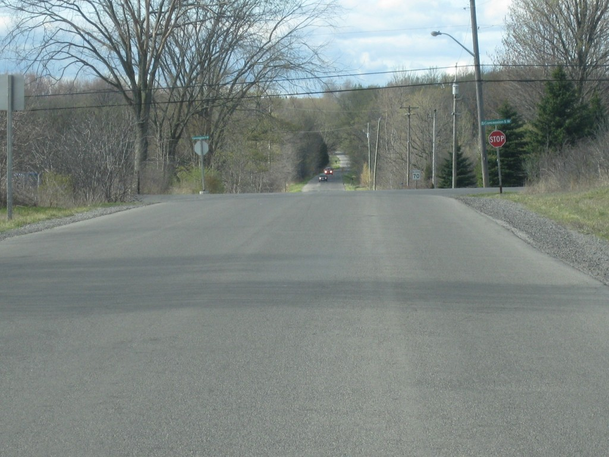
View, looking north along Middletown Road toward the stop sign at the intersection with Concession Road 5
The photo below shows a view just after the start of the yaw marks which begin on the right side of the road and then curve toward the left (west) roadside.
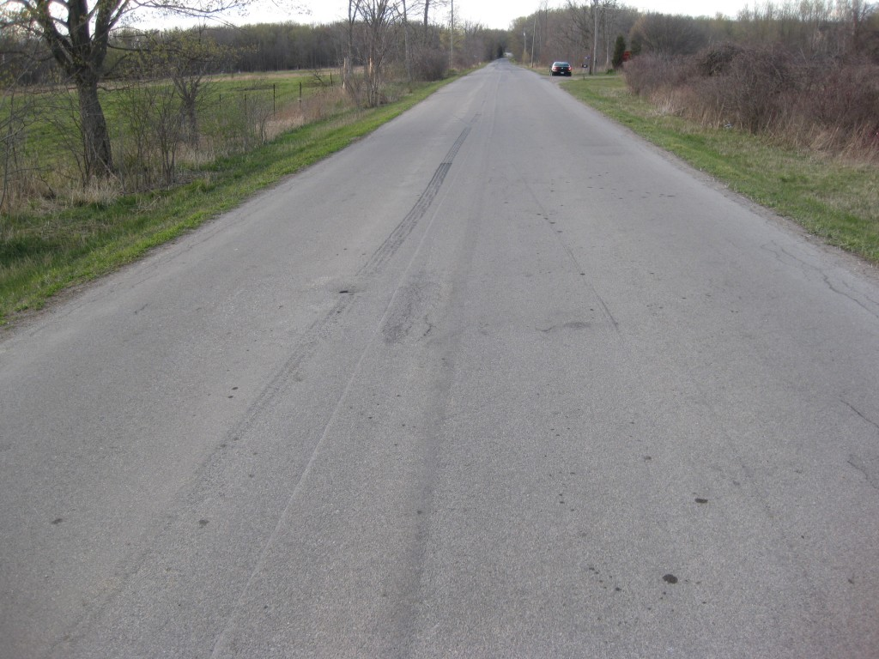
View, looking north neat the beginning of the yaw mark. The vehicle struck some trees on the left roadside just before the location of our parked vehicle which is shown on the right side of the road.
There is an unusual tire mark running along side of the yaw marks which was caused by another vehicle. This tire mark is located to the left of the centre of the road. It possesses lock-up and release characteristics similar to a wheel being braked with an anti-lock braking system. It is a relatively fresh tire mark but obviously we would be unable to determine if it is related to the collision events.
In the photo below you can see the yaw marks as they curve toward the west roadside. At the bottom right you can also see the character of the other tire mark which shows the pulsation characteristics of an anti-lock braking mark. The struck trees can also be seen in the background.
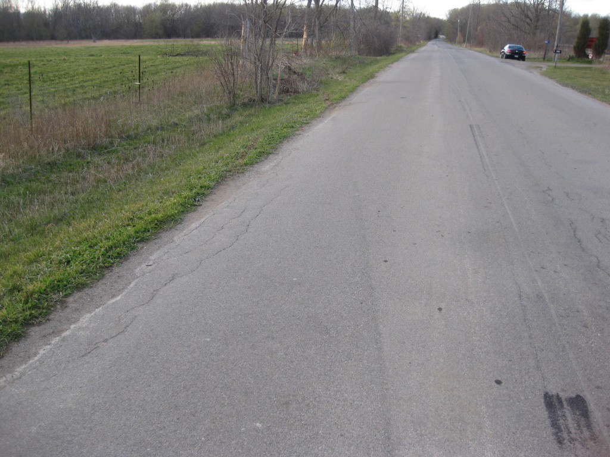
View, looking north, along the yaw marks as they curve toward the west roadside. The struck trees can be seen in the background.
Below is a view of the struck trees and you can also see part of large branch in the field where the vehicle came to rest. You can see that the tree in the foreground has been uprooted by the impact.
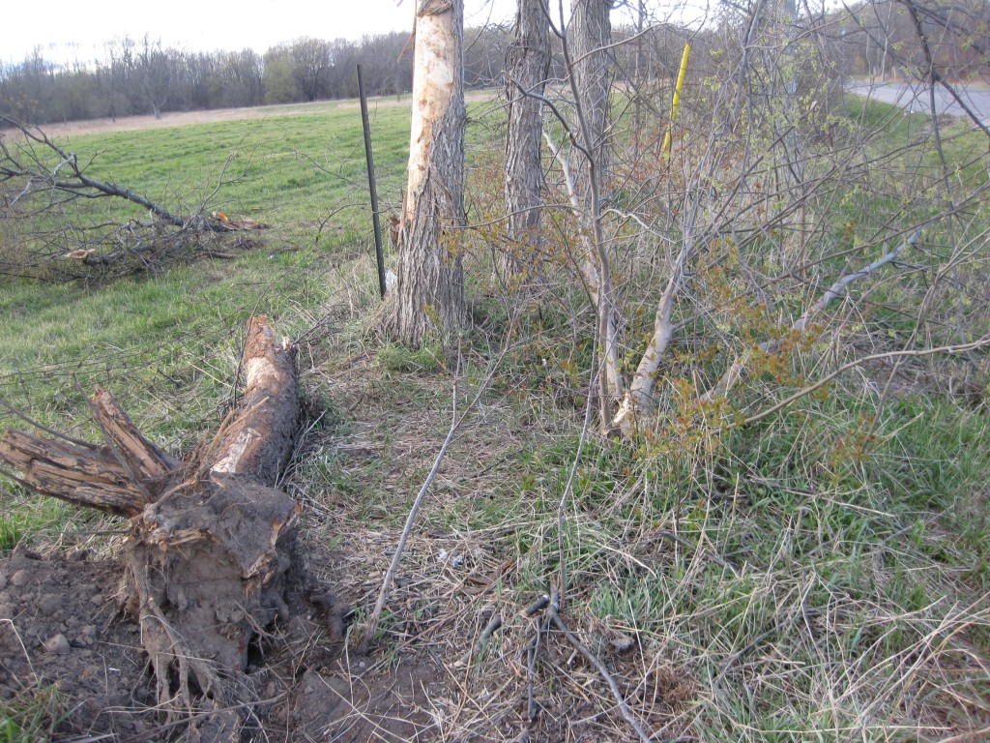
View, looking north, at the struck trees located on the west side of Middletown Road about 150 metres north of the intersection with Concession Road 5.
The approximate 150 metres of distance from the intersection to the tree impacts is a curious fact. At a speed of 110 km/h a vehicle might travel about 30 metres every second. Thus, if the vehicle was travelling at 110 km/h, it would have travelled this 150 metres in a least 5 seconds. When we consider that Ms. Ally should normally have had some warning that she was approaching the intersection, and that police were present, it is curious why the vehicle is still travelling at highway speed at such a long distance after passing the intersection.
This is a scenario where, regardless of the conclusions that are eventually drawn, the SIU needs to ensure that the public have been given sufficient information about how their conclusions were reached. The SIU was formed at least partly for the reason that the public needed to be assured that any actions of police wrong-doing would be evaluated independent of the police community. When the SIU provides insufficient information about how they reached their conclusions in an investigation, the required assurance of the public is not met. The circumstances of such an investigation are difficult for all parties involved and it is easy for persons who are not properly informed to develop a bias about the possess. It is unfair, if police have acted properly, to leave their activities in doubt. This is distructive to our society as as we need to be assured that police can be relied upon.
April 2, 2012
“Simple” Back-up Into Driveway Leads to Two Deaths on Walpole Island
One would think that two deaths could require a spectacular crash involving speed, alcohol and lack of seatbelts. Our modern vehicles would appear to protect us from almost any eventuality. But not so. An incident on March 31, 2012 on Walpole Island in South Western Ontario proved that slow speed motions can be deadly when we do not recognize the danger.
A simple exercise of backing a van into a private driveway led to the miscalculated travel of the vehicle over a steep embankment and into a small drainage ditch filled with a shallow level of water. But because the van came to be upside down the rear occupants of the van could not escape and likely drowned.
For those of us who are strong supporters of seatbelt use this consequence is bad publicity and many officials would like to have the cause and outcome held with as little publicity as possible. Thus the official news media fail to raise the question: Did the occupants die because they were trapped in their seats by their seat-belts? This is an important issue.
We are strong supporters of seat-belt use but we are also strong supporters of public knowledge and openness. When you wear your seat belt it does not come with a magical force field that protects you from every harm. That reality needs to be emphasized, not hidden. When we become aware of the things that kill us then we also raise our voice for change and ultimately this is what makes safety devices such as seat belts safer. But when we attempt to hide problems they do not get fixed.
The second problem is the drainage ditch itself. Why did we not recognize this potentially fatal trap for what it was and still is? Again, the news media did nothing to make the public aware of this common danger. Every spring ditches become water-filled and vehicles enter them resulting in rollovers at relatively low speed. Sometimes this is because the banks of the ditches are not designed to reduce the possibility of rollover. Sometimes guard rails and other devices need to be installed to keep vehicles away. Sometimes driveways are too narrow and make it more probable that a vehicle may wander off the edges and into a ditch. Sometimes back-up cameras can help to reduce these incidents. All these concerns should be raised and discussed.
UPDATE: April 2, 2012: 2015 Hours
Names of the persons involved in this tragedy have now been released. Jaclyn Shipan, 36, and Harold Kris Nahdee, 33, were the two back seat passengers of the van who perished.
However, it is also reported that the driver of the GMC SUV, Own Frances Myers, 27, has been charged with two counts of criminal neglience causing death. While details are not available this pronouncement appears to be rather harsh.
For example, this collision reportedly occurred at 0530 hours in the morning. It would have been totally dark at that hour. Also, whether this was a van or an SUV, the point is that backing such a vehicle into a driveway with such steep embankments could easily result in difficulty, regardless of what the police may have uncovered regarding the driver`s actions. While there may be sound reasoning for these charges, on the other hand, we have seen some investigations follow a path or surrealism as wisdom and logic sometimes take a back seat to politics and emotion.

