Gorski Consulting Website

Archived News - 2012 - August
August 31, 2012
15th Year Anniversary of Princess Diana’s Death Still Has Not Resulted In A Proper Revelation of the Causal Factors
Having attended the accident site in 2006 and followed the details of the Coroner’s inquest, leads to our observation that the discussions of driver speed, alcohol and paparazzi fail to illuminate the additional causal factors that led to Princess Diana’s death on August 31, 1997.
The Paris tunnel into which her Mercedes sped on that fateful night contained unprotected columns that were spread too far apart. When the Mercedes entered into the counter-clockwise yaw, if the columns had been spaced closer together there would have been little chance that the vehicle would have sustained the massive deceleration that it did. Equally, any protective guardrail would have also prevented that penetration.
Additionally, the primitive mechanical stability control system of the vehicle worked to point the nose of the Mercedes in the direction that it was travelling. Although over a large population of collisions this is thought to be a safer outcome, in Princess Diana’s case it only placed the impact force closer to the vehicle’s centre of gravity and therefore assured that the Mercedes would sustain the mentioned massive change-in-velocity. Had the Mercedes functioned in a primative fashion and continued to rotate counter-clockwise without the intervention of the stability control, the vehicle would have experienced an impact to the right front at a substantial angle and a substantial distance from its centre-of-gravity. This would have caused the Mercedes to continue spinning down the tunnel after the initial impact and the its velocity would have been more gradually reduced.
Even with the violence of that massive change-in-velocity, Princess Diana’s seated position was the most favourable of the four occupants toward probability of survival. The impact of her body with the right-front seatback would have further helped to lengthen the time of deceleration of her otherwise unrestrained body. Her internal bleeding required an immediate transportation, at the quickest speed possible, to an operating table of an advanced trauma unit. Instead, emergency personnel waited and waited, and finally transported her at the rate of a slow funeral procession which eventually led to the true funeral we later came to observe.
Princess Diana’s death was a tragedy shared by much of the world, but it is an even greater tragedy that the true issues of her death have not been addressed.
August 30, 2012
Police Propaganda Triumphs Over DeMerchant’s Justice
It apparently does not matter that Terry DeMerchant was acquitted of five charges in relation to a crash which killed Constable Margaret Eve in 2000 on Highway 401 near Chatham, Ontario. DeMerchant has reported that his life has been ruined, he has been divorced and he cannot find job.
To make matters worse police have reportedly used his collision as the “poster child” for promoting Ontario legislation that requires drivers to move over and away from emergency vehicles that are parked on the roadside. DeMerchant claims that the video makes it look like he was at fault in the accident. Yet Superior Court Justice John Kerr had criticised police at his trial for creating a situation “fraught with danger to the users of the highway”. Toronto police reportedly made the video.
OPP’s Sargeant Dave Rektor confirmed that he saw the video but defended it stating “…it doesn’t mention the truck driver or any charges. It’s appealing to every driver on that highway. It’s not singling out anybody”. Yet DeMerchant states that even though his name is not mentioned, other persons related to the collision are, and when those names are typed into an internet search engine his name comes up.
In our experience a truck driver such as DeMerchant is often in a difficult situation when confronted with emergency vehicles that are stopped within the travel lane of a controlled-access highway like the 401. The controlled access causes drivers to enter a state of expectation that traffic will continue to flow at high speed because, in a very high percentage of the time, traffic does exactly that. The few disturbances to traffic flow that occur in the lower traffic volumes near Chatham involve minor adjustments in speed. It would be extremely rare to encounter an actual stopped vehicle in the travel lane. Even though police may have their emergency lights activated, the visibility distance of those lights will not be infinite but will vary depending on factors such as the topography and roadsides that will block that view to varying degrees. Truck drivers not only require a longer distance to slow down but they also need more time to check their mirrors and evaluate what opportunities they have to change lanes.
Construction personnel take a long time to study a site before determining what signage and barriers are needed to safely close a lane. When police attempt to do so quickly and sometimes with very little more than cruiser over-head lights, bad consequences become a much higher probability.
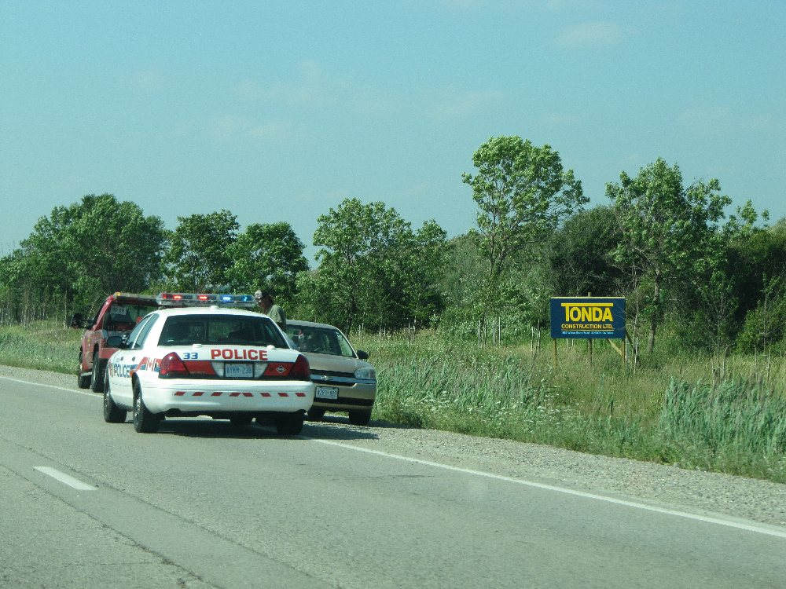
Police cruiser stopped in live lane of expressway in London, Ontario
Transport truck drivers typically require about 6 seconds to complete a lane change. However additional time is required to scan the highway and locate a gap in the traffic of the adjacent lane. The gap required to fit a typical transport truck and trailer much larger and therefore less available than for someone driving a typical passenger car.
Now consider that such a truck may be travelling at a speed of 30 metres per second (about 108 km/h). In 6 seconds the truck will travel about 180 metres – and that distance is required just to complete the lane change, not to determine where/when such a lane change is safe. At a viewing distance of 180 metres the size of a police cruiser in the truck driver’s field of view can be appreciated by sticking a rectangular piece of paper, with dimensions of about 2 to 3 centimetres, onto a wall and then looking at it from a distance of about 10 large steps. And if that view has to be made a number of seconds before starting that lane change then the size of that piece of paper becomes rapidly smaller, or you must adjust your viewing distance significantly further away from the wall.
The important fact is that, when an emergency vehicle is very small in the field of view it is difficult to detect if the vehicle is actually stopped and whether it is actually stopped in the truck’s lane. This makes if difficult for the truck driver to estimate how much time he has to effect the lane change and instances will occur where the driver fails to activate sufficient braking because he may erroneously believe that a rapid braking action is not required.
Braking down from a speed of 110 km/h to 80 km/h makes little difference in collision severity if the truck strikes the cruiser because that cruiser will likely be launched from impact at a speed close to the impact speed of the massive truck. Thus both the cruiser and the truck will be moving, out-of-control, toward any persons standing in the vicinity. Therefore it is very precarious for emergency personnel to believe that they are safe standing anywhere near 100 metres of a police cruiser that is stopped within the live lane of a controlled-access highway such as the 401. Yet this warning is rarely heeded or understood.
It was only a few days ago, on Friday morning, August 24th, 2012 that a police cruiser was rammed from behind by a truck while the cruiser was stopped in the live lane of Highway 402 near Sarnia, Ontario. In that collision police charged the truck driver with dangerous driving and then apparently changed the charge to one under the new “Move Over” legislation. But nothing seemed to be learned by police from previous incidents as the police spokesperson, Constable John Reurink remarked “I think the stars are aligned in a situation like this” with respect to the fact that no emergency personnel were killed or seriously injured. That cruiser had blocked the live lane with its emergency lights flashing.
As much as the public needs greater education about what they should do, police appear to be equally uninformed about the dangers they are placing themselves in and that a whole new approach is required in dealing with the problem. Although more expensive, properly designed trucks equipped with portable signs and impact attenuating devices must be made more available and other vehicles must not stop within a live lane unless absolutely unavoidable; for example only where a loss of life is highly possible if the lane is not blocked.
In those instances where a police cruiser must block the lane it must be placed a long distance in front of where emergency personnel are likely to be standing. While it many appear to emergency personnel that a distance of 50 to 100 metres is unusually long and that they might fear that traffic might return to the blocked lane after passing such a cruiser, this possibility is less probable. Emergency personnel must have an understanding that at highway speeds vehicles cannot change direction very quickly over a given distance. Thus, while shorter blocking distances might be more suitable on lower speed roads, on high speed multi-lane highways the procedure must be adjusted. The set up of the least dangerous positioning scenario must be understood when every alternative will inevitably create some level of heightened danger. For the present time, police do not seem to have a firm grasp of the safest alternative for themselves and conversely the general public.
Unfortunately, truck drivers such as Terry DeMerchant must live with the injustices brought on by this lack of understanding.

August 23, 2012
Head-On Collision of Police Cruiser and Civilian’s Car In Scarborough, Ontario
While it is still very early in the investigation, the reason why a police cruiser and car were involved in a head-on collision in Scarborough earlier today likely has more to do with a third vehicle that is not being discussed. That third vehicle was reported to have “light” damage but its final rest position appeared to be ahead of the area where the head-on impact occurred. While the debris field would indicate that the head-on impact occurred in the cruier’s lane, it is likely that there was an initial impact with that third vehicle and that will likely provide an important clue to how this collision occurred. It has already been confirmed that the collision-involved officer was “was responding to a call” when the collision occurred. Since the Ontario Special Investigation Unit (SIU) has been called in there will likely be further smothering of the facts which will likely not be revealed for several months, if at all.
August 21, 2012
Tree Impact on West Hill Line Near Beachville Claims Life of Male Driver
Minimal information is available at this time however it has been reported that a male driver of a 2000 Chrysler Intrepid was southbound on West Hill Line near Beachville, Ontario, this morning at approximately 0900 hours, when he failed to stop for the stop sign at the T-intersection with Clark Road. The front end of his vehicle struck a tree and he sustained fatal injuries.
Below is a view looking southbound on West Hill Line from north of the site.
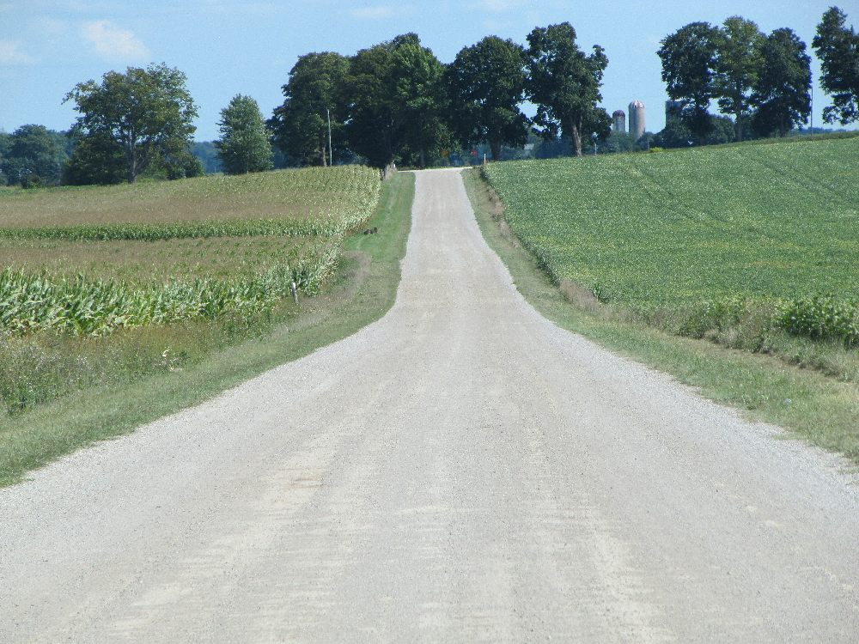
View, looking southbound on West Hill Line toward the intersection with Clark Road. This zoomed in view shows how the roadway dips and then rises just before reaching the intersection. The intersection is shaded by large trees therefore the shadows could pose a problem in seeing signage in the shade.
The view below shows a closer view as we approach the intersection.
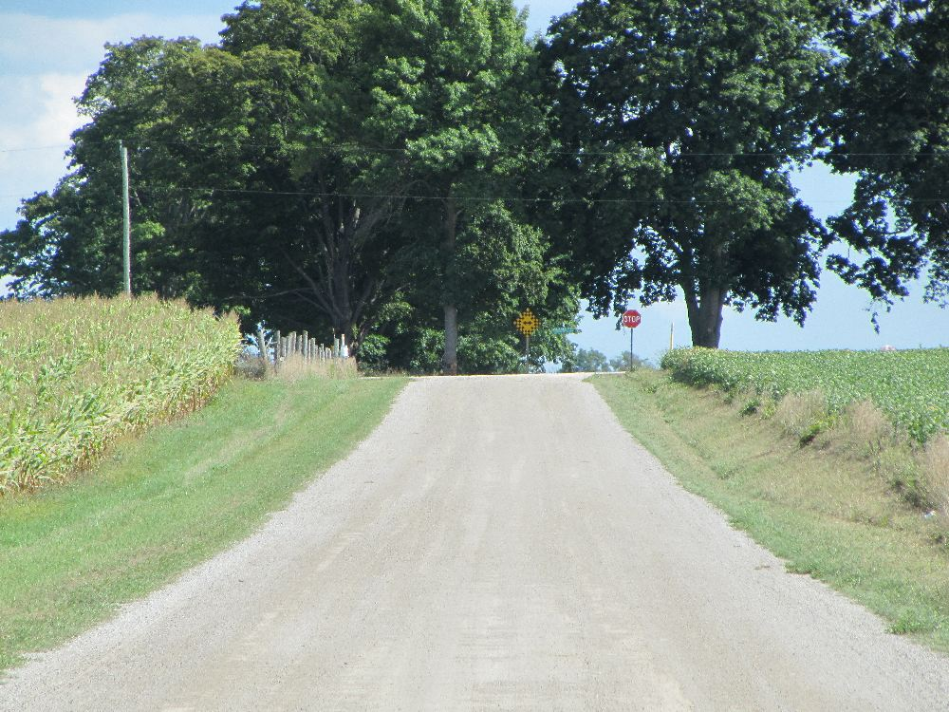
Looking southbound at a closer look at the intersection and the positioning of the signage.
In the view below it is possible to see the struck tree which was located just to the east of the checkerboard sign.
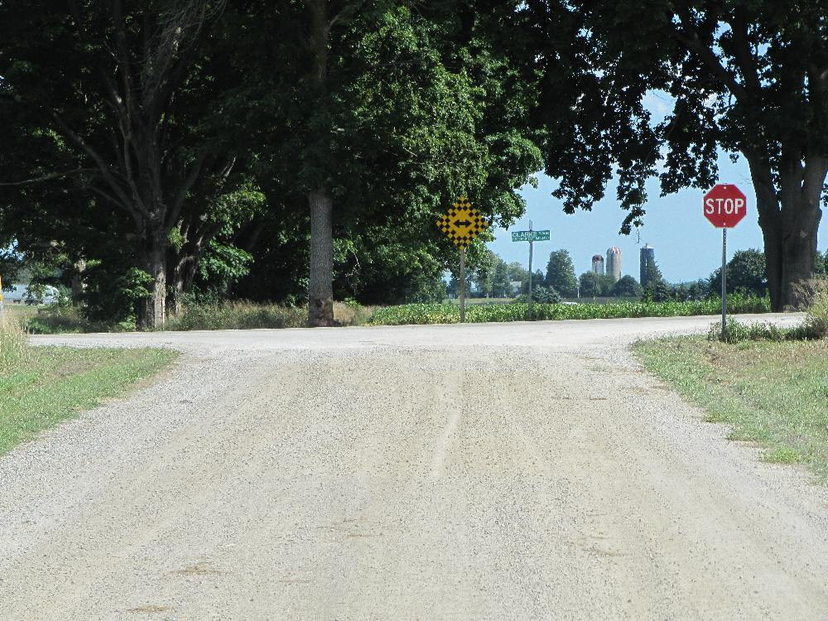
View looking southbound. The struck tree is located just to the left (east) of the checkerboard sign.
The view below shows the impact damage caused to the struck tree.
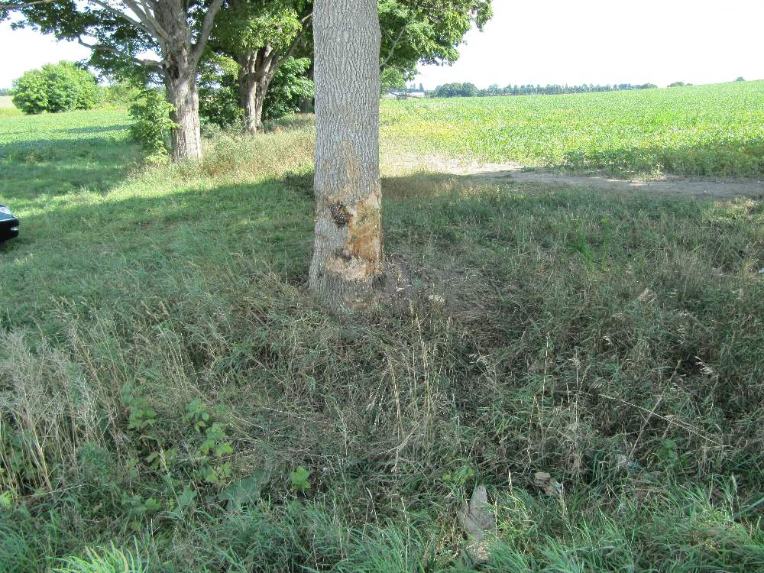
Southbound view of impact damage to the struck tree
Given that a checkerboard sign is required to be positioned in line with the centre-line of the roadway, the impact of the tree would suggest that the driver steered to the left before the impact.
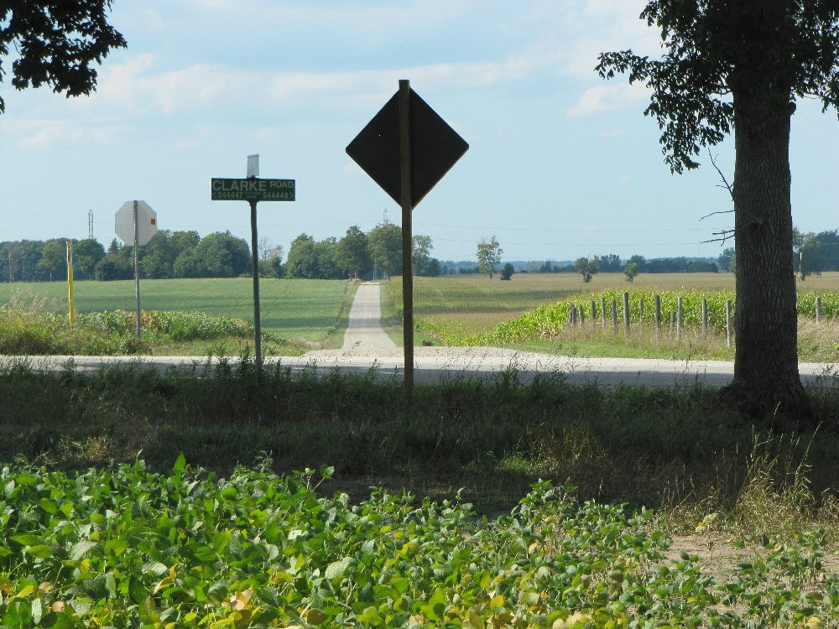
View, looking north from south of the area of impact. Since the checkerboard sign is normally lined up with the centre-line of West Hill Line, the impact to the tree would suggest that the driver steered to his left before impact.
No tire marks or other pre-crash evidence was present to indicate why the driver approached the tree at highway speed.
Vehicle Hits Bakery On Egerton at Florence in London, Ontario
Details are still sketchy however earlier today an eastbound vehicle on Florence travelled straight through the T-Intersection at Egerton and crashed into the store front of a bakery. The vehicle then reportedly backed out of the bakery and fled the scene. The vehicle was then found a short distance away on Francis Street.
Below is a view of the damage to the front of the bakery.
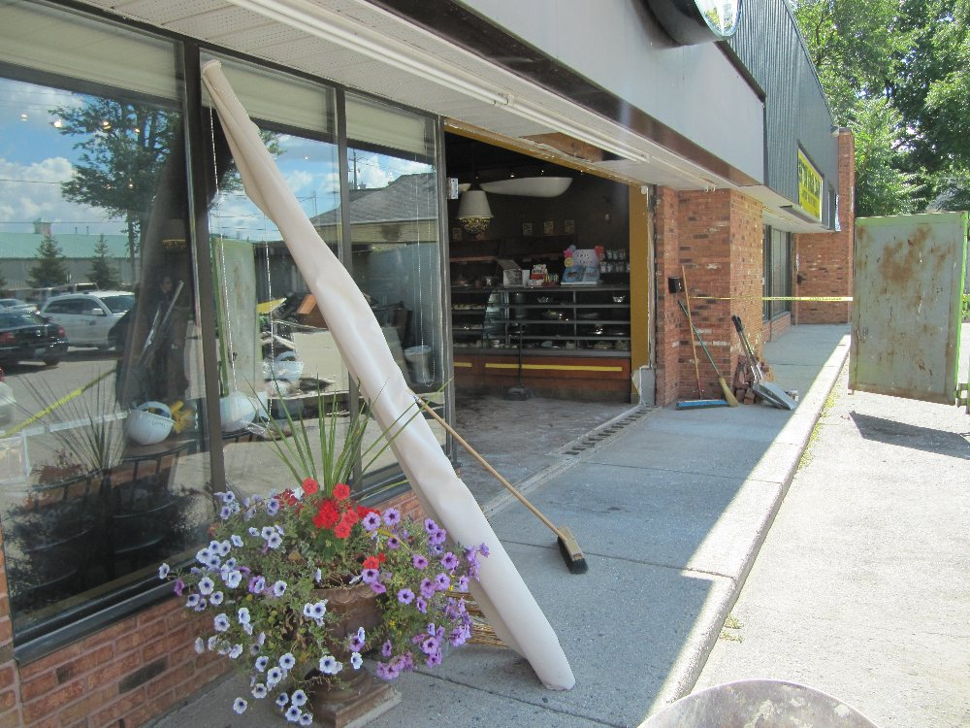
View of damage to store front of Nova Era Bakery on Egerton Street and Florence.
Examination of the roadway and parking lot leading up to the bakery showed no evidence of any tire marks or other markings that would explain who the crash occurred.
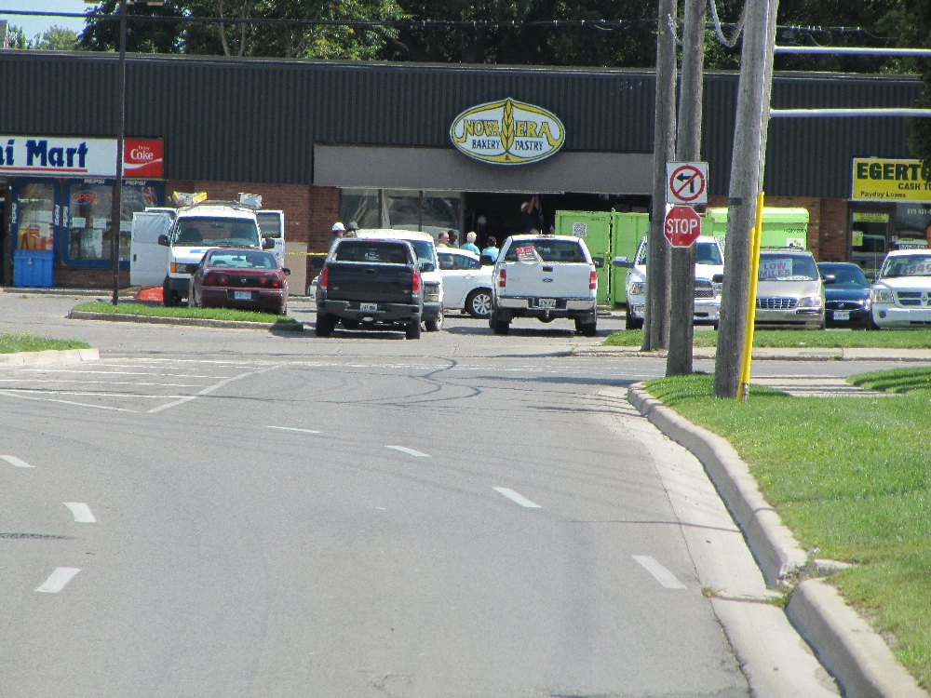
View, looking east along Florence Street toward the T-intersection at Egerton. The struck bakery building can be seen in the background.
August 17, 2012
Dorchester Man Killed In Collision With Rock Embankment of Driveway on Trafalgar Street, On Eastern Outskirts of London, Ontario, Canada
A 79-year-old man from Dorchester, Ontario was reportedly killed when his eastbound vehicle travelled off the south side of Trafalgar Street, west of Shaw Road, glanced off a tree, and collided with a rock foundation adjacent to a private driveway. The collision occurred at approximately 0630 hours this morning, August 17th, 2012.
Below is a view, looking east along Trafalgar Street from several hundred metres west of the accident site.
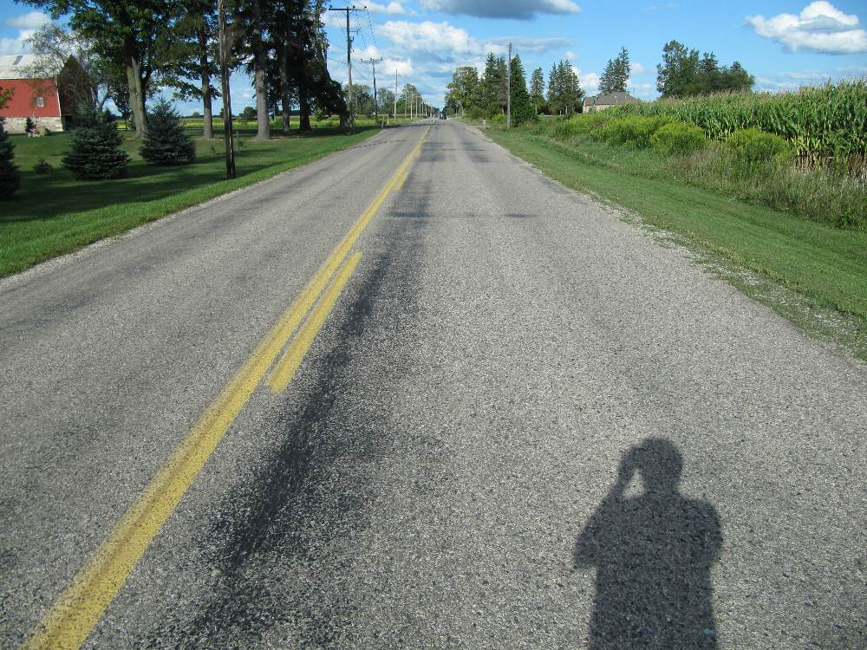
View, looking east along Trafalgar Street, toward the accident site which is several hundred metres away in the distant background.
As can be seen in the above photo, the roadway was straight and level in the distance leading up to the crash site.
The photo below shows the road in the area just before the vehicle exited onto the south roadside.
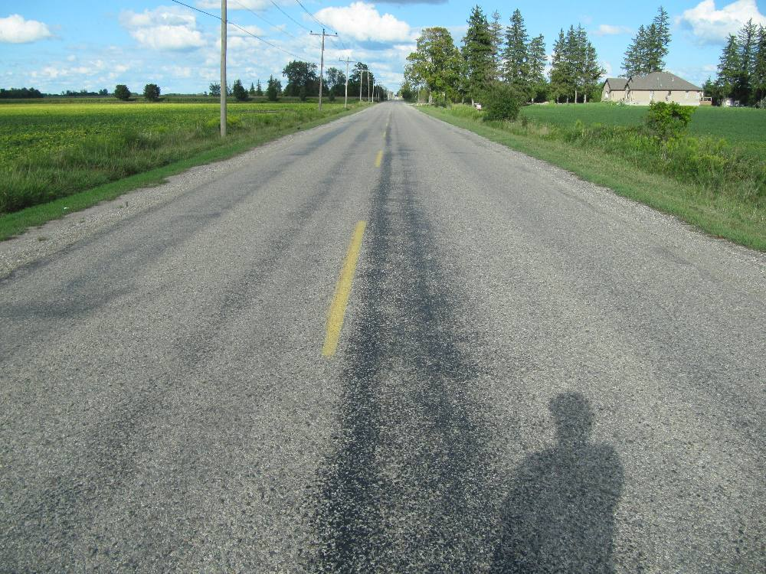
Looking east, showing the area of roadway just before the vehicle exited onto the south roadside.
The photo below shows the area of the road just as the vehicle exited toward the trees on the right (south) side.
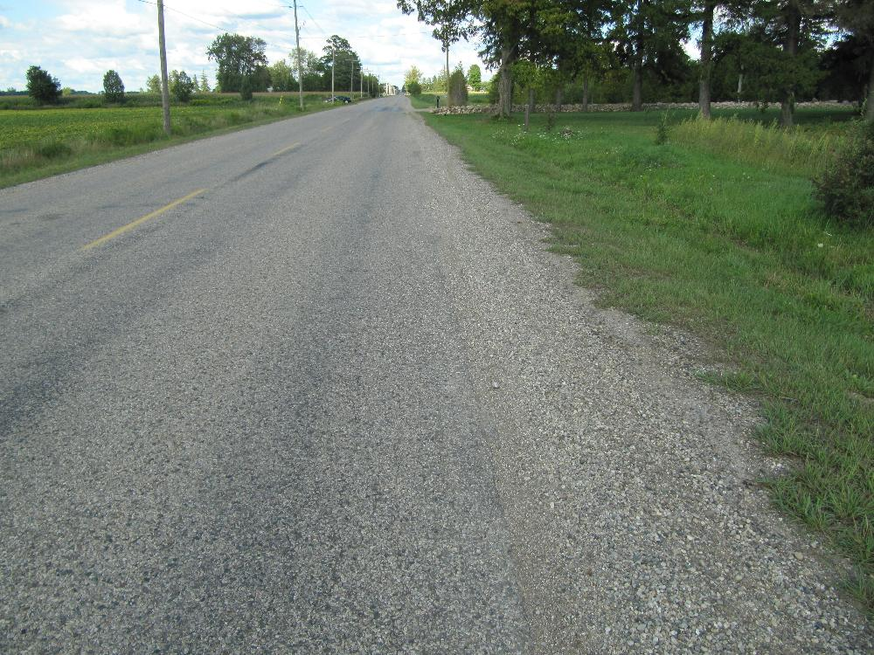
View, looking east at the area where the vehicle exited the road and travelled toward the trees on the right (south) side of the road.
The photo below shows a view looking westward and we can see the tire marks in the grass where the vehicle just grazed by the first tree on the south roadside.
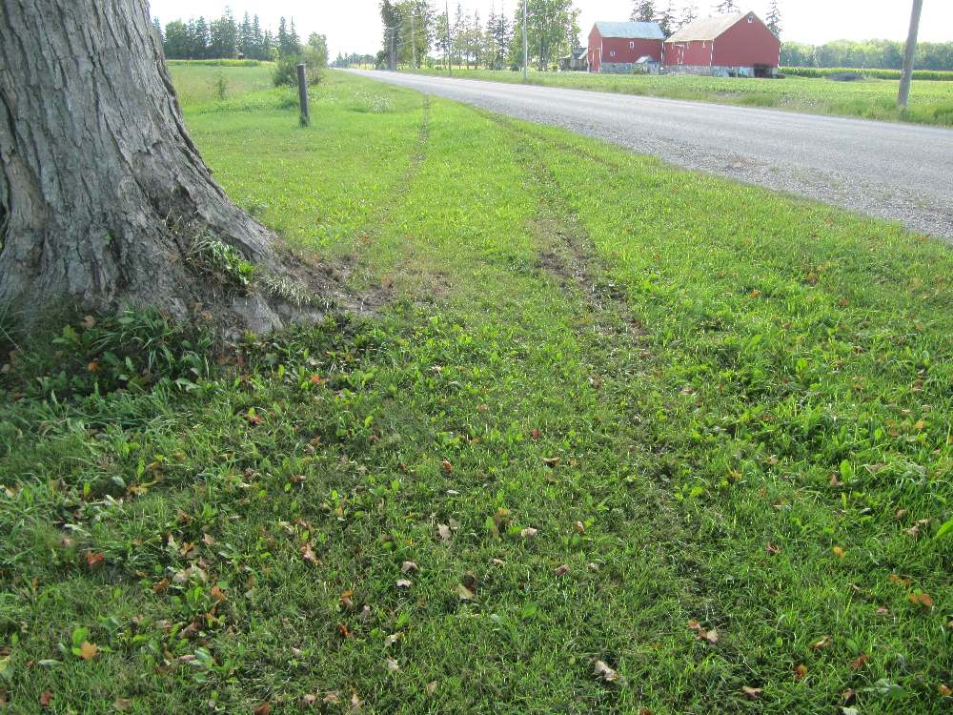
Looking west, from the south roadside showing the tiremarks where the vehicle grazed by the first tree.
After grazing by the first tree the vehicle then made a more substantial contact with a second tree before colliding with the rock foundation of a private driveway as shown in the photo below.
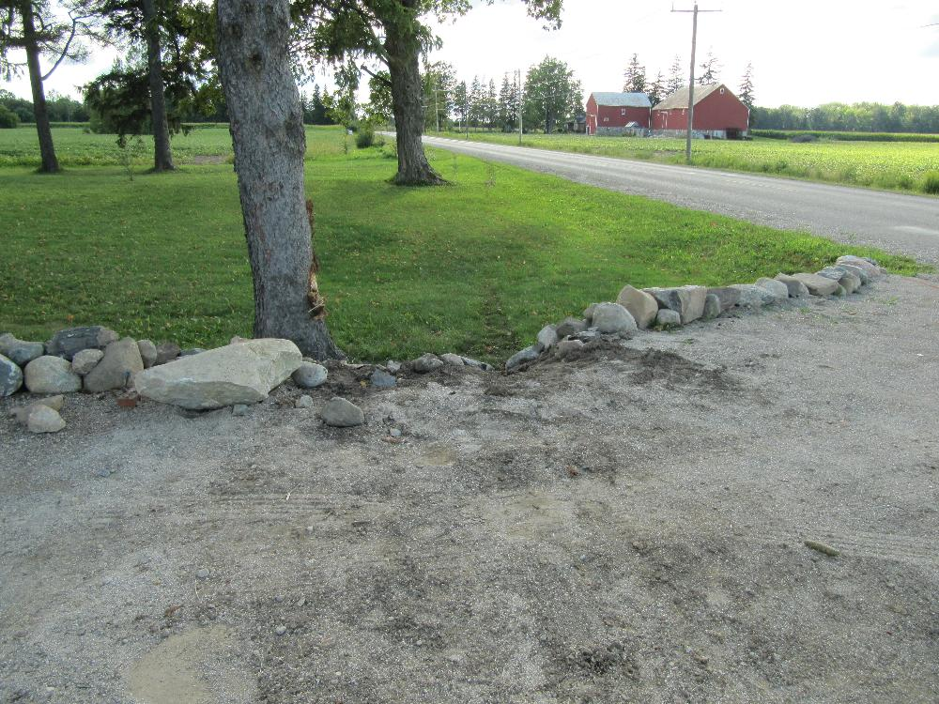
View, looking west showing the area of impact with a rock foundation of a private driveway.
As shown in the photo below, the vehicle vaulted over the driveway and came to rest on the other side.
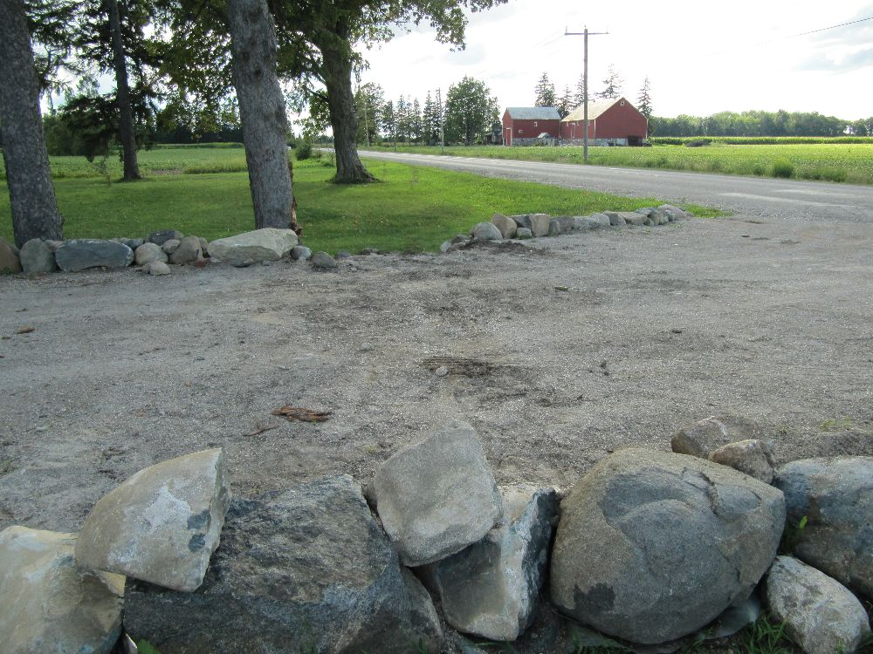
After striking the rock foundation the vehicle vaulted over the driveway and came to rest on the other side.
The impact caused large rocks to be thrown eastward along the south roadside as shown in the photo below.
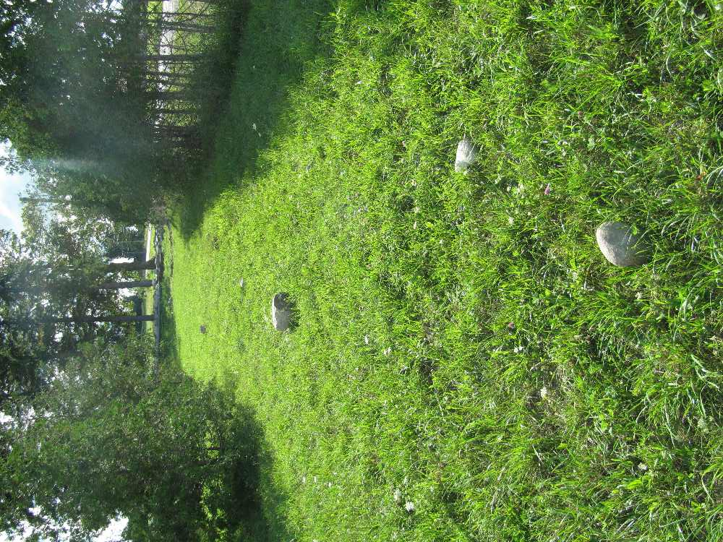
View, looking west, from several dozen metres east of the driveway showing the large rocks that were thrown eastward as a result of the impact.
The physical evidence did not provide any indication why the vehicle left this straight and level roadway. Although the edge of the asphalt was deteriorated and not ideal there was no significant drop off of the edge and the shoulder was compacted and hard. A utility pole that was adjacent to the driveway was replaced even though it did not appear to be in the direct line of the vehicle’s path and therefore it is questionable why the replacement occurred.
Further east of the driveway, perhaps within 100 metres, and located on the south road edge, there was an indication that a vehicle went off the pavement edge and produced a strong acceleration burn out in the grass. The curvature of the tire mark would suggest that the vehicle had been travelling very slow when it performed this motion and therefore it could be related to post-collision events. But we simply do not know. As in many instances the physical evidence at a site, even though it may be fresh, cannot always explain why events took place. The police have not yet released the identity of the driver nor any other information about the crash.
August 15, 2012
Sweaburg Collision Escapee Caught But Strange Circumstances Leave Unanswered Questions
Michael Heaton, 35, of Zorra Township, Ontario was reportedly caught by police in Alberta and brought back to face numerous charges revolving around a stolen pick-up truck that crashed with another on Trillium Road Near Woodstock, Ontario, Canada.
Rather than providing a clear explanation of the events, the reports from official news media only provide further unanswered questions. The reports have continued to stress how scientific and “methodical” the search process was, involving the canine unit and aerial support. Yet the process failed to catch Mr. Heaton. OPP Constable Michelle Murphy was quoted as saying “The canine unit and emergency response unit were called in to try to track them“. But it is unclear where this word “them” came from. Clearly, throughout this reporting it was stated that police were only looking for a single driver who was Mr. Heaton.
We reported earlier in this News page, shortly after the July 25th, 2012 crash, that the news media were indicating that Heaton was not injured. Yet, if Heaton was not found how could anyone know his injury status? The stolen truck in which Heaton was the driver showed evidence of a peculiar condition with the cab and box completely detached from a very deformed frame. The single news photograph of the damaged vehicle showed that the detached cab was essentially undeformed. It is possible that some damage may have existed to the portion of the cab that was not shown in the photo however any major deformation to the unseen surfaces would exhibit itself via deformation induced by the direct contact. A photo of the other pick-up truck that was reportedly involved in the crash showed fairly typical damage, predominantly to the right of its front and suggesting an impact for applied from the right to the left as might occur in an intersection collision of two vehicles approaching at 90 degrees to each other.
In totality the reporting of the events surrounding this crash can only be described as peculiar.
August 13, 2012
Evidence Needs Through Evaluation in Charges of Port Colborne Man’s Fatal Truck Collision In North Carolina
Guy James Keetch, 44, of Port Colborne, Ontario, was involved in a tragic collision on July 25, 2012 south of Charlotte, North Carolina which resulted in the death of his fiancee, Jennifer Fenwick. He was driving his tractor-trailer along the curve of an exit ramp from Interstate 485 to northbound Interstate 75 when the truck rolled over the outside guardrail and down the adjacent slope. His fiancee was in the sleeper portion of the cab when the incident occurred. He is now facing charges of “misdemeanour death by vehicle” and reckless driving. The charges appear to stem from the police finding that his speed was about 49 km/h faster than the posted advisory speed for the curve of 70 km/h.
When speed is alleged to be the primary “smoking gun” in this case we have to be cautious in all these matters even if police believe they have conducted a proper investigation. In a scenario like this the primary source of speed data would likely come from an engine control module on the truck which would have the capability of storing event data. Event data would be abnormal actions or forces on the truck that would be sensed and logged in somekind of memory which is then downloaded by specialized equipment. However there has been no mention of how the speed evidence was obtained and whether indeed it was via download from the mentioned module.
Even if there was a recording of the vehicle’s “speed” that does not necessarily mean that the recorded “speed” is the same as the ground speed of the vehicle. The parameter that is labelled as “speed” is usually based on some internal data from the operations of the truck such as the rotational speed of the wheels or what rpm existed in a specific gear. In normal circumstances the spin of the truck’s wheels should indicate the speed of the vehicle since the wheels should be rolling over the road surface. But in some instances where the wheels are not in direct contact with that road surface the wheels might spin at a high revolution without the vehicle actually moving at the indicated speed. In a similar scenario the truck’s engine could also rev up to some level without necessarily meaning that there is force applied to the wheels to move a truck at the speed suggested by the gear and engine speed.
The obvious caveat is that, regardless of the data that has been obtained from any “black box” on a vehicle, the analyst must be capable of examining the physical evidence to confirm that the downloaded speed matches that evidence. As information from event data recorders (“black boxes”) becomes more prevelant in the accident reconstruction community and in the courts the connection between the the physical evidence and the speed calculation becomes in jeopardy of being lost.
Similarly, factors such as speed, alcohol and inattention are frequently mentioned in these investigations and these become the blinding light that prevents all other issues from being seen and recorded. For example, in the present case, the fact that the truck rolled over top of a guardrail was not given any consideration in the news reports or in the commentary of the local citizens of North Carolina. In particular the citizens provided general comments about the ramp being unsafe but none connected the rolling of the truck over the guardrail as anything unsafe – as if this is exactly what trucks should do and it is the very purpose for the existence of guardrails so that vehicles can trip over them. No one made the connection that we spend a considerable amount of money on roadway design and maintenance not just to prevent collisions but to reduce the consequences of those collisions. That is why a guardrail is put in place, to redirect a vehicle from the greater danger that is supposed to lie on the other side of the rail. When a guardrail fails to cause that redirection the obvious question should be why it failed. But none of that discussion came forth.
If the guardrail failed to redirect the truck because the designers of the road threw up their arms and conceded that it would be too expensive to redirect the large mass of a truck around this curve then that important information should be available to the truck drivers who use it. This is particularly so if, similar to Ontario’s Highway 401, the percentage of vehicles using the Interstate could be as much as 50 percent, or greater. A roadway design that fails to protect about half the users of the roadway should at least carry with it a proper warning much like drug companies need to inform users of their drug of its side-effects.
It all cases of official reports of fatal collisions it is important to read behind the lines and be able to evaluate whether what is reported makes proper logical sense.
August 12, 2012
Fatality as Loss-of-Control Van Strikes Parked Cars on Pleasant Ridge Road South-West of Brantford Ontario
On Thursday morning, August 9, 2012, a southbound, 1999 Ford Van carrying eight occupants, rotated clock-wise, out-of-control on Pleasant Ridge Road just south of Wetmores Road, in Brant County. The vehicle slid sideways off the west roadside and struck some parked cars as well as some bushes. It was reported that a male occupant of the van was ejected from the vehicle and killed.
Below is a view, looking southbound, on Pleasant Ridge Road from about 200 metres north of the van’s rest position.
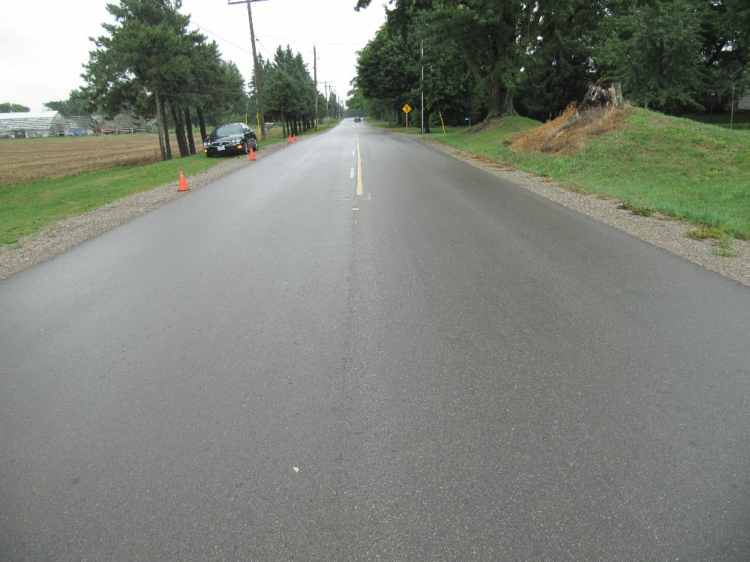
View, looking southbound on Pleasant Ridge Road from about 200 metres north of the Van's final rest position.
It may be significant that the southbound centre-line indicates that the passing zone was just ending as shown in the above photo. It is not uncommon that drivers lose control of their vehicles when they are hurried to return to their lane during a passing motion.
Below is another view, looking south, from about 75 metres north of the Van’s rest position. You can see on the right side of the road that there is a red car parked on the front lawn of the property. This is one of the parked vehicles that was struck by the Van.
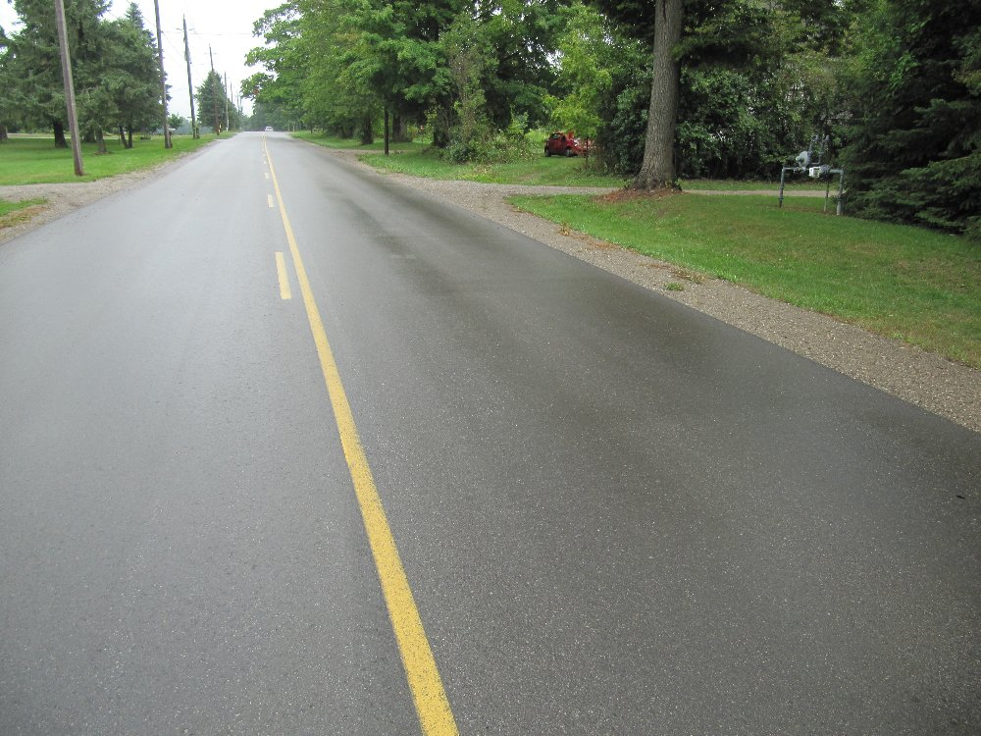
View, looking south, from about 75 metres north of the Van's final rest position.
The view below shows the tire marks of the Van as it rotated out of control toward the west roadside where it then struck the parked red car.
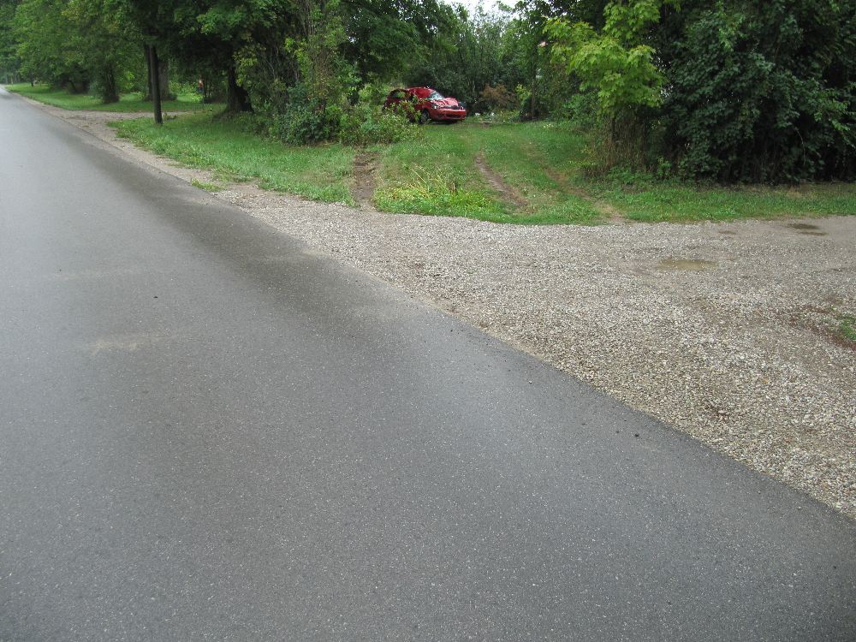
View, looking south-west showing the tire marks as the Van left the roadway and struck the parked red car in the background.
The view below shows some of the damage caused to the parked red car.
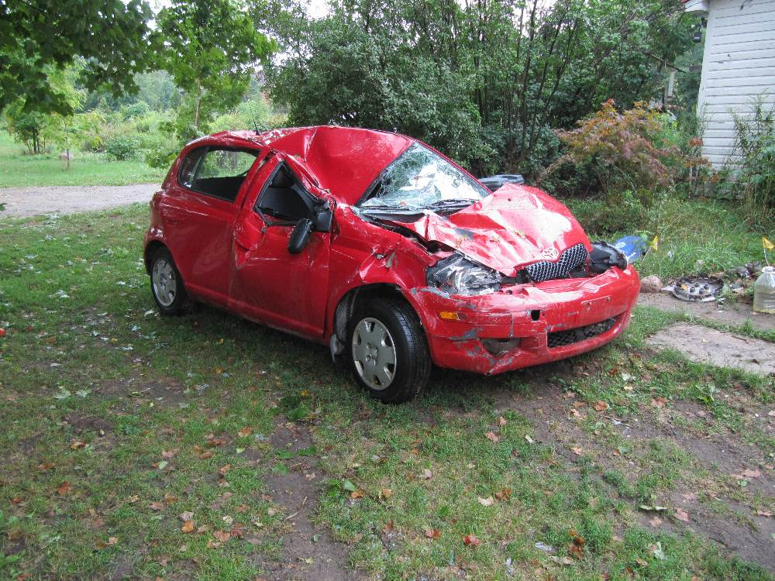
View of damage caused to parked red car.

UPDDATE: August 12, 2012; 1645 Hours
Updated news reports are indicating that there were nine occupants of the van. Horace Clarke , 42, in reported as the occupant who was fatally injured. Safton Bailey, 34, was reported as the driver of the van who is charged with carless driving, failing to remain at the accident site, and cirminal negligence causing death.
The scenario is reported to involve Jamaican farm workers who were in the van at the time of this crash. A number of these were sent to hospital with a variety of injuries. Considering the potential that all of these occupants could have been killed if the conditions were changed by a slight margin, it is comparable to the tragedy in Hampstead, Ontario in February 2012 where eleven farm workers lost their lives after their van was struck by a truck. Yet the contrast in news media reporting of the two events is drastic. Not even the local Brantford newspaper made mention of the present occurrence. Yet, at Hampstead there was a media circus where parking was almost impossible near the accident site as the various news networks sent numerous reporters and their crews to the site, as shown below.
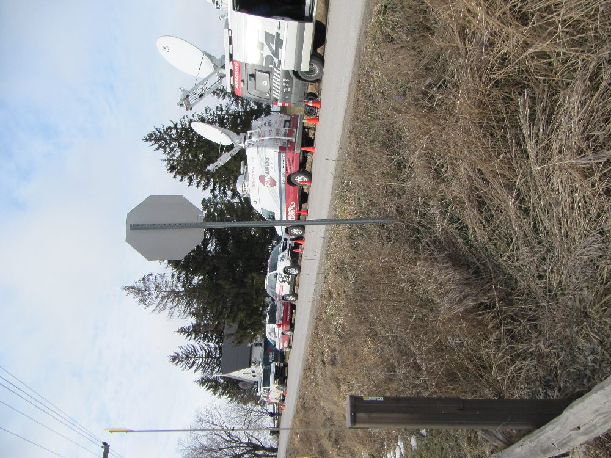
Example of News trucks parked along the edge of the highway at the Hampstead Ontario accident site in February, 2012.
The situation on Pleasant Ridge Road could have been just as devastating except that a few minor changes in the scenario caused the occupants and their van to tumble to rest instead of sustaining a single powerful impact as was the case in Hampstead. The occurrence of these two events should lead us to ask whether this is a statistical fluke or whether there are a large number of out-of-country farm workers being transported around the Ontario countryside with little safety provided to them.
August 8, 2012
Safe Transportation of Children Must Be A Community-Wide Concern
There is an understandable friction between privacy and freedom of information particularly in recent times when technology has enabled certain persons and agencies the ability to snoop into some things they should not. When children are involved our society is naturally protective of their privacy with good reason.
However, privacy about injuries caused to children is a double-edged sword. While we like to think that keeping information about how children became injured is best left to the few who investigate and submit official reports, our past experience indicates that this is not always true. Injury to children can be an explosive public issue and when there is a conflict of interest the cause of the injury fails to reach the public’s eyes and ears.
An example is the collision on Monday afternoon, August 6th, 2012, near the intersection of Oxford County Road 13 and Pleasant Valley Road south of Woodstock, Ontario, Canada. Official news agencies simply reported that a two-vehicle collision had taken place whereby a southbound red Ford pick-up truck on Oxford County Road 13, slowed to turn east onto Pleasant Valley Road and was struck in the rear by a second, black Ford pick-up truck that was also southbound.
Having conducted safety research for a number of years where we compared injuries to their sources, we recognize the tell-tail signs when something does not fully add up. It was reported that a male driver and female passenger of the red (lead) pick-up truck we transported to a local hospital with non-life-threatening injuries. The male driver of the rear-ending pick-up truck was also treated at the scene for minor injuries. Those facts provide a substantial amount of information about the severity of this crash and the protection that should normally be afforded to occupants of light trucks with their additional mass and larger dimensions – factors that are beneficial to occupant safety.
So it is a red flag when these official news agencies then report that two children, ages 4 and 6-years old “were initially transported to Tillsonburg Hospital but were then transferred to London Health Sciences Center with life-threatening injuries”. The possibility that one child could be seated in an area of the occupant compartment sustaining direct intrusion of the crushed structure into the seated space could explain why one child could sustain such injuries even though others were mildly injured. But this is supposed to be a rear end impact of a pick-up truck. Pick-up trucks have long rear ends and intrusion into the occupant compartment from a rear end impact of a pick-up truck approaches the realm of impossible. It would take a tremedously severe impact to cause this and all the occupants of both vehicles should have sustained compariably major injuries.
Why did these children sustain the injuries that they did? Were they properly fastened in a child seat or booster cushion? Was this really a rear end impact or more of an angle impact with some contact to the left side of the stuck truck? If so was there an air bag deployment at an inopportune time and did this have something to do with the injuries? Were the children seated in a non-designated seating position? For example many pick-up trucks are equipped with a “rear seat” that is a seat in name alone as it is too small to fit an adult and would comprimise the safety of a child but there is insufficient government testing of these seating positions due to the believed infrequency that these seats would be used in the rare possibility that a vehicle would be involved in a life-threatening collision.
Whatever the cause the public should have a right to know. It is not just the family’s interest or the interests of official agencies. Public knowledge in a democracy plays an extremely vital role in turning the wheels of the bueaucratic monster of government. But public knowledge is also an inconvenience as once something is public the official agencies are forced to take some action or be threatened with being turfed out of an important position.
A similar non-reported incident occurred July 5th, 2012 on Bloomfield Road south of Chatham, Ontario where, a four-year-old girl sustained critical injuries after the van she was in crashed through a guard rail and struck several trees. That collision also suggested that the girl’s injuries could have been preventable but nothing of detail was reported.
As experienced experts in this field of occupant injury and vehicular accident reconstruction we feel it is our duty to point out these issues and apply some heat to the toes of that dreaded bureaucratic monster. Change is sometimes a painful but important fact of life and cannot take place without a little friction.

