Gorski Consulting Website

Archived News - 2012 - February
February 28, 2012
Mis-Information In Official News Media Persists Regarding Double Fatal Collision On Oxford Road 6 North of Embro
It is revealing how the centralization of news media ownership jeopardizes our ability to get quality information that is independent of these large conglomerates.
News agencies have reported on the tragic death of Timothy Wood and his young son Ryan but they have provided wrong information about the travel direction of the Feed Tanker Truck which collided with the Wood vehicle. They continue to report that the truck was northbound when in fact it was southbound.
They are now reporting a further error by indicating that the collision occurred on Line 37 near Oxford County Road 6. Line 37 is the same road as Oxford County Road 6 (It is confusing since there is no explanation why the road has to have two different names). The news outlets should have stated that the collision occurred on Oxford Road 6 just north of Oxford Road 88.
One would expect the police to call one of the news agencies to correct the errors. Anyone associated with the family would realize that Mr. Wood and his son were at a hockey game in Embro and were returning home northbound to the Stratford area on Oxford County Road 6. Yet we do not read of anyone questioning the erroneous news.
It demonstrates how all the newspapers get their stories from the same limited sources so that, when there is an error in the source story, there is no independent source available to correct the problem. We need to be vigilant of this fact because in other matters it could have more serious consequences.
February 26, 2012
Double Fatal Collision North of Embro, Ontario on February 25th, 2012
The death of two persons in a collision on Oxford Cty Road 6 north of Embro has prompted a curious response from police investigating the incident. OPP Constable Stacey Culbert was quoted (Woodstock Sentinel-Review Newspaper) as saying:
“We want to do our due diligence to make sure a complete and thorough investigation is completed. The road conditions were poor at the time but we can’t jump to conclusions as to what happened.”
If we turned the tables and replaced “poor road conditions” with “driver impaired by alcohol” would we get the same “due diligence” comment from the OPP?
Our point is that historically police investigations have failed to document the conditions of a roadway as a possible cause in collisions. It is high time that this bias be changed.
We were performing our braking testing again on snow-covered roads yesterday in the late morning and early afternoon and we passed by the road closure on Oxford County Road 6. So our video cameras fully documented the road conditions in the area. We may have further comment once we have evaluated what further developments may be communicated of the police investigation.
UPDATE: February 26, 2012; 1300 Hrs.
We have now had a chance to examine the collision site on Oxford Road 6 just south of Brooksdale and north of Embro, Ontario. The London Free Press is reporting that a tanker truck was heading northbound on Highway 6 and this information is incorrect. The tanker truck was actually travelling southbound. We expect this error will eventually be corrected.
It is likely that a 2004 Chevrolet Avalanche was northbound on Oxford Cty Rd 6 and the driver lost control of the vehicle such that it crossed the roadway centre-line. Gouges near the west edge of the southbound lane indicate that the tanker truck driver likely tried to steer to the right and away from the oncoming Avalanche. Damage to the tanker truck’s deisel fuel tank would suggest that the impact was to the left of the front end of the truck however there is conflicting evidence in that that Avalanche was likely pushed backwards and across to the east side of the road. This is conflicting because pushing the Avalanche backwards would tend to imply a fairly central impact to that Avalanche rather than the rather glancing impact that would be involved with direct contact to the deisel fuel tank which would normally be located on the side of the truck. Again, these facts are difficult to resolve from just examining the site evidence and one must have an opportunity to examine both vehicles to properly assess the specifics of how the vehicles made contact. The Avalanche should be equipped with an event data recorder (“Black Box”) which will provide pre-crash data about its speed, brake applications and so on. The tanker truck may also be equipped with such a device but no details of its make, model or year are known.
We expect to upload a short article with photographs of the site evidence in the Articles page of this website in the next day or so.
UPDATE: February 27, 2012; 131o Hours
Since official news agencies still continue to report that the Tanker truck was northbound when it struck the Avalanche we have now uploaded an article on the Articles page of this website which reviews the evidence at the collision site. This evidence indicates that the official news agencies are wrong and that the Tanker Truck was southbound, not northbound.
UPDATE: February 27, 2012; 1320 Hours
The London Free Press now reports that police have released the names of the two persons killed in this accident. Timothy Wood, 38, and his son Ryan, 6, were both killed.
February 20, 2012
Results of Braking Testing on Snow-Covered Asphalt Road Surfaces
We have up-loaded an article on the Articles page that summarizes our recent experiments with braking on snow-covered asphalt roadways. This research in timely in that many collisions have occurred in Southern Ontario recently where the issues of roadway maintenance and driver behaviour have been in the forefront. Driver loss of control or inability to avoid a collision due to the quality of the road surface has seen little attention in the news media in the past as it has been explained that the reason why collisions occur is primarily due to driver error. Our test results demonstrate that driver error is not always the correct explanation for some collisions.
Review of Evidence at Site of Fatal Head-On Collision on Plank Line (Hwy 19) North of Tillsonburg Ontario
We examined the site of the fatal collision that occurred on February 15th, 2012 on Plank Line (formerly Highway 19) just north of Tillsonburg, Ontario. Unfortunately we were tied up with other matters and were unable to present the results of our examination until now. An article on that site examination has been uploaded to the Articles page of the is website.
February 17, 2012
Glanworth Curve – Further Analysis of Debris Field at Accident Site
Unfavourable environmental conditions made it difficult for us to examine all the evidence with respect to the double fatal collision that occurred on the Glanworth Curve on the south edge of London, Ontario, Canada on February 17, 2012. We have prepared an article (uploaded to the Articles web page) that discusses this issue.
Frequently, investigators attend an accident site on only one occasion and their ability to detect and document evidence is affected by what is possible to be seen under that set of environmental conditions. We have recognized on many occusions that an investigation could have been better performed if investigators considered the role that environmental conditions might have on their perceptions and to return to the site on a different occasion to examine it under different conditions.
February 15, 2012
Two Fatal Collisions in Area in Just Over 24 Hours
A fatal collision on Wetmores Road south of Brantford has claimed the life a driver, Leslie John Dinsmore. The Brantford newspaper reported the collision site location incorrected as the actual location was further east than reported. Also, the vehicle struck a tree on the north side of the road, not the south side. While eastbound the SUV encountered a straight and flat surface that was in good condition. Tire marks leading up to the tree impact were at a sharp angle with respect to the road thus suggesting the vehicle was not travelling at high speed at that time. It is questionable why the vehicle struck the tree. A heavy deposit of salt still remained on the road surface making it questionable exactly when the salt was laid and for what purpose.
A second fatal collision occurred on Plank Line (Formerly known as the Provincial Highway 19) this morning, just north of the intersection with Airport Road. This location is just north of Tillsonburg. It is apparent that a northbound cube van may have strayed into the southbound lane and collided with the left front and side of a Coleman tractor-trailer. Gouges in the southbound lane provide clear evidence of the impact location. Both vehicles travelled off to the east shoulder following the impact. The driver of the Cube van suffered fatal injuries.
Further details on both these incidents may be provided shortly if time permits.
February 14, 2012
Glanworth Curve – Further Analysis Shortly
We are working on a further article on the Glanworth Curve double fatality that will be posted likely later today.
UPDATE: FEBRUARY 14TH, 2012; 2230 HOURS
We have now included another review of the fatal collision on the Glanworth Curve that occurred on February 11th, 2012, on the south edge of London, Ontario. This review has been uploaded to the Articles page of this website. The review is a critique of recent comments and conclusions made in the news media about the crash that killed a 15-month-old girl and a 38-year-old male passenger of an SUV which struck a tree. The issue of the road surface conditions at the time of the crash still needs to be evaluated but police have not made any comment in that regard up to this time. As indicated earlier, just in the few days and hours prior to this crash we were involved in road surface testing through the streets of London and to the north of London so we have relevant data regarding road surface conditons at various parts of the City as well as locations north of London. Because we were interested in studying the effects of snow-cover and ice on the safety of roads we were purposely looking for roads that might contain more problems and that is why we chose to conduct our tests north of the City where we expected that the snow squalls would be of greater intensity. We would not expect the snow squalls to be of the same or greater intensity at the Glanworth Curve. Therefore we await the official comments from the police investigation before providing a further critique, if necessary.
February 13, 2012
Further Evaluation of Double Fatal Tree Impact on Glanworth Curve in London, Ontario
As indicated yesterday, we attended the accident site on the Glanworth curve at which two persons lost their lives in a collision with a tree. Given that the police closed the site throughout the day on Saturday, February 11th, we were unable to examine it before darkness.
On Sunday morning, February 12th, we were engaged in some testing which was a continuation of testing we have been performing for several days now involving documentation of road surface conditions in London and the highways north of London. Part of that testing involved multiple video cameras that documented the road surface conditions. Another part of our testing involving hard braking on the snow covered surface to document the slipperiness of the surface. So, we were busy with our testing and could not get to the noted accident site on the Glanworth curve on Sunday morning.
However it was also unclear on Sunday morning that an actual collision had occurred on the Glanworth curve since no official news agency reported it except CTV News (TV). The CTV news report at 2300 hours simply reported the event as an injury collision. This did not jive with the inquiries we were received on our website with respect to a fatal collision involving children. But since it has been our experience that the official news agencies are fairly quick in reporting fatal collisions we had to come to the belief that perhaps the inquiries to our website were perhaps just rumours. It was not until Sunday morning that the London Free Press finally published an article that confirmed that a fatal collision occurred. We then attended the site on Sunday afternoon.
CTV News later reported (yesterday) that police did not inform them that the collision from the previous day was a fatal collision. That fact is rather peculiar. It has been our experience that when a fatal collision occurs the police do not withhold that fact. They may not release details but they would not withhold the fact that there was a fatality. Yet it is now obvious that a 38-year-old occupant of the noted SUV had died at the scene. So police should be been aware of that fatality shortly after 1300 hours on Saturday when it was reported that the actual collision occurred. But we are told that this information was not provided until the morning of the next day. We are puzzled why there was this delay.
We have also reviewed the latest comments made from the official news media that we feel are mis-information. For example the London Free Press news article authored by Dale Carruthers makes it appear that the weather conditions on Saturday were extreme and that these extreme conditions were the cause of the snow-covered and icy road conditions on the Glanworth curve. We disagree. We conducted our videotaped testing in the late hours of Friday, February 10th and past midnight so that testing was done into the early morning of Saturday, February 11th. We also conducted a further testing session on Saturday morning commencing about at about 0845 hours and this lasted to about 1030 hours, or just 2 1/2 hours before the crash on the Glanworth Curve. Our testing took us to both the east and west ends of London. We also conducted testing on major highways on the northern outskirts of London. At no time did we come to the conclusion that the roads in London (and north of London) were icy or particularly slippery. Yes, there was snow on the roads but it was loose and packed in some locations. The important factor of ice on the pavement was simply absent. We conducted numerous braking tests throughout the city that confirms this. Those tests are fully documented by video. So why was Glanworth curve both snow-coverd and icy when our testing demonstrated that no other road in our areas of travel in the City of London exhibited those conditions? Where did Mr. Carruthers of the London Free Press obtain his information that it was the extreme weather conditions that were the cause of this tragic collision on the Glanworth curve?
The LFP article also stated “The stretch of road (Glanworth curve) in the community at the south end of London is dangerous because vehicles travel at high speed on a wide curve”. Where did Mr. Carruthers obtain the facts that led him to conclude why the location was dangerous? We suggest that Mr. Carruthers does not have the data at hand to state that drivers speed through this curve any more than drivers speed through any other part of the City. We further suggest that the reason why the present fatal collision occurred and why another very serious collision occurred there just three weeks previous remain to be uncovered and that the suggestion that the speed of vehicles and the width of the curve are the cause is providing mis-information about what might have caused these collisions.
The LFP article also refers to a snow squall as if that was the factor that caused this collision: ” London was under a snow squall watch from Environment Canada for most of the weekend, with squalls finally moving through the city on Sunday morning and into the afternoon”. There are some small but important details in this quote. London was under a snow “watch” , not a “warning”. And the squalls “finally” moved in on Sunday morning – not on Saturday afternoon when the fatal collision occurred. So the road conditions cannot be blamed on a snow-squall that was not there.
We believe it is important to get the facts straight about what caused this fatal collision. The weather conditions were not extreme in the London area a short time before the collision on the Glanworth curve. A unique situation could have existed on the Glanworth curve but we should not assume so. That fact should be documented in a police investigation. But it should not be left to a broad statement made by police investigators who provide no specific evidence. Police have a duty to document the roadway conditions at a fatal accident site as much as they have a duty to take a breath sample from a driver whose breath smells of alcohol. When they find evidence of a factor that might have led to a fatal collision they must document that fact whether that relates to someone’s speed, inattention, drug use or if it relates to an unreasonably, unsafe road surface condition.
February 12, 2012
Unusual Interest In Wellington Road Closure At Glanworth Curve
We experienced an unusal amount of interest on our website regarding the closure of Wellington Road at the Glanworth curve yesterday. London’s CTV News reported that a collision had occurred there but nothing that would explain the road closure. Road closures often occur in accident investigations where there has been a fatality or there are life-threatening injuries. Neither of those conditions were reported by CTV.
The London Free Press, which is often quick to report any news relating to serious motor vehicle accidents has not published any account nor have they even acknowledged that a road closure occurred.
The St. Thomas Times newspaper reported that the closure was due to weather conditions and not due to an specific accident. The road remained closed until after sunset yesterday therefore it would have been in-efficient for us to examine the site at that time to obtain an objective assessment. This morning a heavy snow squall likely passed through the area likely covering any evidence that might have been there.
In totality, we have not obtained any evidence to substantiate rumours that something unusual occurred yesterday at the Glanworth curve and unless we learn otherwise we will not comment further on this issue.
UPDATE: FEBRUARY 12, 2012; 1415 HOURS
It would appear that the rumours regarding a fatal collision on Glanworth Road were correct. The London Free Press has finally published a news article confirming that a 15-month-old girl and a man were both killed when their SUV hit a tree. We find it unusual that CTV News in London did not report these facts yesterday, only that injuries occurred, the St Thomas Times reported the road was closed due to poor road conditions, and it has taken this long for the London Free Press to mention anything at all.
The issue is that “roads were snow-covered and icy at the time of crash” as reported in the London Free Press. Well, how snow-covered and icy were they? Throughout Friday and Saturday we were driving our test vehicle through the streets of London and north of London and videotaping the road conditions and performing braking tests based on the instrumentation we discussed in our Articles page of this website. So we are very aware of what the road conditions were like in the area because we have detailed video and testing data. So how did the site on Glanworth compare? Will there be a release of that information?
This has been my point through many of my discussions on this website. The public has a right to know what the road conditions were like and, if they were icy and snow-covered why were they so?
We will now examine the site but given the snowfall in the area that portion of the evidence will not be useful. The location of the impact and other details will likely be revealing however. Note that it was not too long ago that we documented a loss of control collision with a tree at that curve and likely not far from where this fatal collision occurred.
Standby for more details.
UPDATE: FEBRUARY 12, 2012; 1635 HOURS
We have now examined the collision site of the noted double fatality on Glanworth curve, south of London, Ontario. The vehicle in question slipped off the right portion of the curve and into a tree. This circumstance is very similar to another serious collision that occurred on January 22, 2012 only about 200 metres further into the curve. At that time we commented on the freezing of the lane as a likely contributor to the crash. The current collision leads us to believe the accident may have occurred from a similar cause. For reference you can examine our original posting of January 22nd, 2012 as we have re-created it as a separate article in the Articles section of this website. We will post some photos of the present collision, likely in a separate article shortly, however as we indicated, it appears to us that the same icy road condition may have been involved as the collision of January 22, 2012.
We reiterate however that it must be required that police conduct a proper investigation of this matter and provide a full explanation of the road surface conditions with an explanation of what investigations they conducted to determine whether the conditions were unavoidable.
February 10, 2012
When, Where and Why Slippery Roads Occur – Some Objective Testing at Gorski Consulting
We have uploaded an article summarizing some of the exploratory testing we are conducting with multiple video cameras to document the surface conditions of roads in our area. Testing in ongoing and we will be discussing the results in upcoming articles.
Developing Story: SIU Investigating Collision on Highway 4 on the Northern Outskirts of Lucan, Ontario
We appreciate the public’s interest however we have no information about the status of the SIU involvement in the incident on Highway 4 just north of Lucan. A crash has been reported from this morning but police have closed down the area. Unfortunately, with the appoach of snowfall, evidence could be lost, but that is reality. We all hope to hear further details through the regular media channels and once the roadway opens, likely tomorrow, we may examine the site.
UPDATE: FEBRUARY 11, 2011; 1840 HOURS
Due to the amount of snow that has fallen in the area we do not believe it would be efficient to examine this site as any evidence would likely be destroyed or altered by that snowfall and the maintenance activity related to the snow fall.
Although the collision is reported as a rollover a photograph of the vehicle suggests that the left front wheel has been pushed rearwards into wheelwell, there is direct contact damage to the rear and there is almost no damage to the roof area. The sum of these observations suggests that the event is not a typical rollover. That is all that can be said at this time.
February 9, 2012
Coatsworth Road Fatal Collision
We apologize for our further delay in uploading our article on the double fatal collision on Coatsworth road but it is longer than we had expected. The first part of the article will be uploaded in the next few minutes (approximately 1245 hours).
February 8, 2012
Further Details About Double Fatal Collision On Coatsworth Road
It is apparent from examining visitors to our website that there is interest in further details about the double fatal collision that occurred on Coatsworth Road, south of Tilbury Ontario a few days ago. Unfortunately we are temporarily tied up with other cases and have not had a chance to prepare an article (with photos) on our website. We can only ask for the visitors’ patience and we will attempt to upload such an article in the Articles page of our website later this evening.
February 6, 2012
Eleven Fatalities At Hampstead Ontario Crash
In 1976 Ontario enacted manditory seat-belt use laws. Shortly there-after on Governors Road west of Woodstock Ontario, 6 seat-belted persons were fatally injured in an Oldsmobile while 3 unrestrained persons in a Chevrolet Impala survived. This became the beginning of a difficult sell for seat-belt use. Persons began saying that seat-belts kill.
Well, Hampstead may come back to haunt us again. Seat-belts can and do kill when they are not worn properly. That message has never been spelt out properly. In winter-time, when you wear heavy clothing the seat-belt that you wear across your pelvic, iliac crests slips upward onto the soft abdomen where there is no protection from the impact force. The seat-belt can basicly cut through you until it meets the spine on your back. Slack in a seat-belt is a very dangerous thing. Wearing heavy winter clothing causes the belt to be placed a long distance from your body and it should never be there. We have not heard the term “submarine” in quite a long time, but that is what happens to your body in relation to a lap belt with slack, it submarines or goes underneath the belt, or in other words, the belt slips onto your soft abdomen where it should not reside.
Whether this is part of the mechanism that has killed some of the 1o occupants of the westbound van or not is not the issue. Slack in seat-belts is something that needs to be discussed. But as we have said a lot in the last few years on this website, much of the discussion is not held and we continue to talk about the mistakes without correcting them.
Today’s incident will truly be remembered as a great tragedy as the news slowly develops…
UPDATE: FEBRUARY 7, 2012, 1650 HOURS
Having now had a chance to examine the site evidence and further views of the van it would appear that the van was struck in the right side and the extent of the side intrusion is not fully indicated by the available photos. We can indicate that there were no pre-impact tire marks from either vehicle. There is also the possibility of a sight obstruction by trees located at the north-east quadrant of the intersection. Even though a driver has a stop sign a “visibility triangle” is required of open view between drivers so that, if a driver fails to stop for a stop sign the driver on the main road will still have about 3 seconds to avoid the collision. Although we have not taken any specific measurements at this time the existence of the trees could be an issue.
The van may have been equipped with an event data recorder and if so there could be some useful data that could provide objective evidence about how this accident occurred. We will await further news before providing you with our photos taken from the site. Stay tuned…
UPDATE: FEBRUARY 7, 2012: 1830 HOURS
We are not impressed with the early turn of events that surrounds this crash. News media are interviewing various police and emergency responders where the indications are that the damage to the van is very severe and that the three survivors are lucky to be alive. No such thing. Although this is a collision where fatalities could be expected it is questionable why 10 of the 13 persons occupying the van perished.
Persons on officical news outlets are blaming 15-passenger vans. That is just not so. Survival in a 15-passenger van could be improved if this meant that certain occupants were a fair distance away from the point of intrusion. We must remember that rapid change-in-velocity is what causes injury and persons seated in various portions of the van can experience significantly different change-in-velocity than that experienced at the centre-of-gravity of a vehicle.
The objective evidence that should be revealed regarding the collision is the extent of crush and where it was located on the van, who was wearing seat-belts and specifially how the injuries came about and caused the deaths. It is questionable why this many persons should perish in one vehicle when there should have been areas of the vehicle where intrusion was not a major factor. So we suggest that you do not believe everything you hear if you do not understand what is being told to you.
UPDATE: FEBRUARY 8, 2012; 0815 HOURS
It s being reported that the GMC Savana van transporting the migrant workers was supposed to be travelling back home to Kitchener where the workers lived. This is peculiar since the westbound van should have attempted a left turn to travel southbound on Perth Road 107. Instead, the gouges at the area of impact were located in the southbound lane of Perth Road 107 and their north/south orientation with respect to the cross road would indicate that the van was in a position consistent with travelling westbound through the intersection. Maybe it is time to view some images…
Below is a view of the accident site looking north along Perth Road 107. The Fulton truck would have been coming down the hill toward the camera. In the foreground you should recognize the typical evidence of an intersection collision by way of the gouges, tire marks and fluid spills. Note that this evidence is lined up, generally, the southbound lane. So there is little evidence that Mr. Fulton was able to change the direction of his truck upon impact.
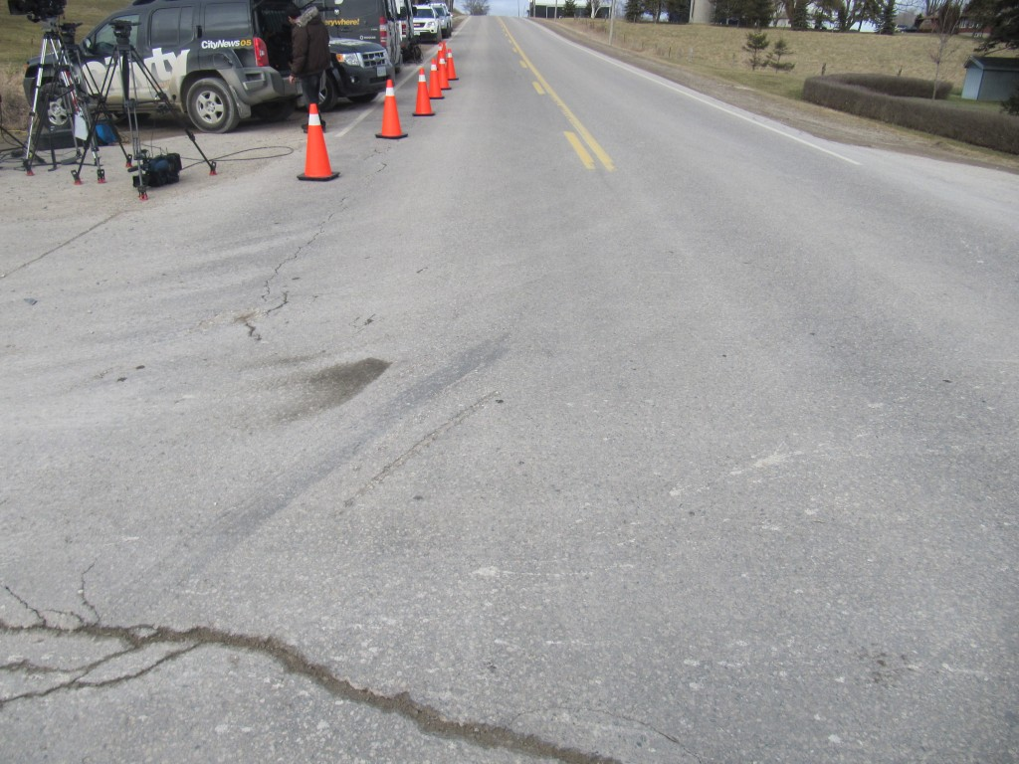
View, looking north, at gouges in the southbound lane of Perth Road 107 indicating the point of impact
Next, we can look at those same gouges, etc. but from the west looking east as seen in the photo below.
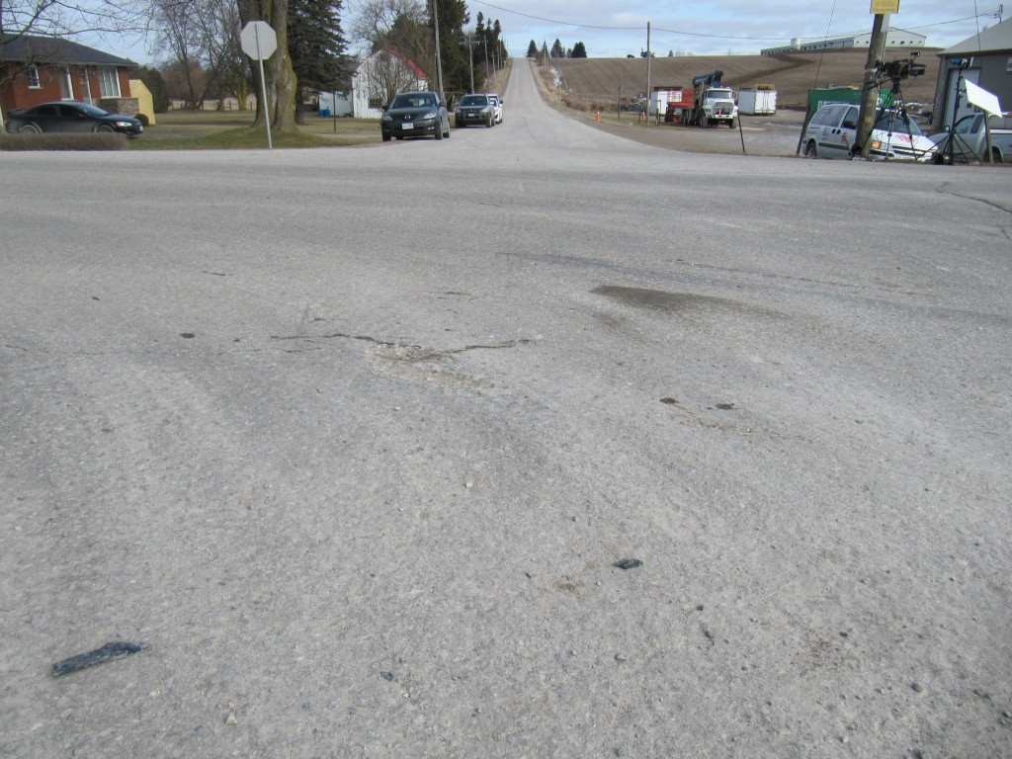
View, looking east, fromt the west side of the intersection at the position of the gouges which indicate the point of impact
Again, the gouges and other evidenced lines up with the crossroad. If the Van was intending to make a left turn then it would have been in a substantially further position toward the south by the time in reached the southbound lane of Perth Road 107. But that is not the case. This positioning is consistent with the van travelling straight toward the camera or straight through the intersection westward.
So why is the van westbound when it does not make sense if it is supposed to be travelling to Kitchener?
As I indicated earlier, both of the above photos show that there is no evidence of pre-crash braking by either driver.
Some have speculated that, due to the sunny sky and the time of day, the driver of the van may have been blinded by that sun and this is why he passed through the stop sign (By the way it has not been established yet whether the van passsed through the stop sign without stopping). While the sun might have been a factor certainly it is unlikely that the sun was anywhere behind the stop sign as shown in the photo below.
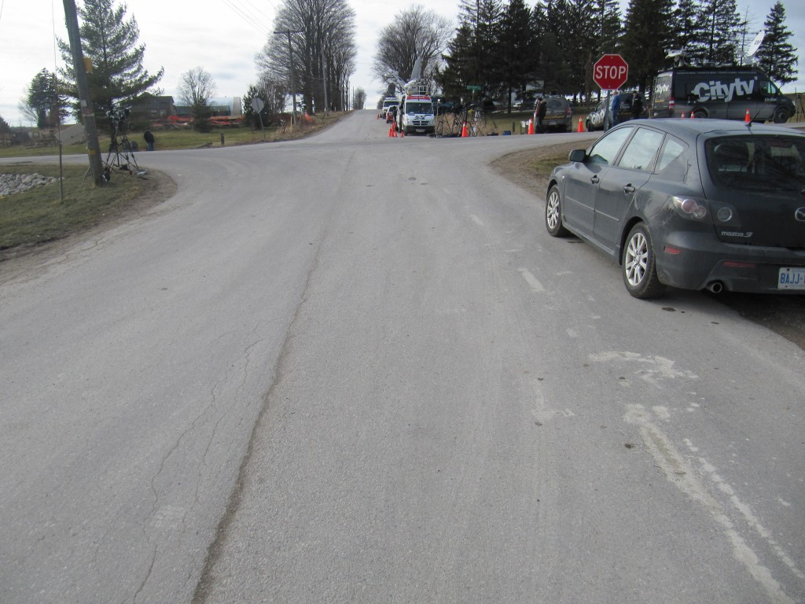
View, looking westbound, at the background of the stop sign that could have been viewed by the van driver before entering the intersection
As can be seen in the above photo, the background behind the stop sign is made up of a group of trees. So, certainly the sun would not have been directly behind the stop sign. There is a possibility that the driver travelling through a sun-lit road and the stop sign was in shadow thus making it more difficult to detect but there is no information or analysis to determine if something like that existed. For the moment we would have to conclude that the sun was likely not a major issue here.
We reiterate that a GMC Savana van would have been equipped with an event data recorder (“black box”) and this would likely contain pre-crash data for at least five seconds before impact. Data from the EDR would indicate the speed of the vehicle, engine RPMs, percent throttle and brake application. These specific parameters would shed great light on what occurred.
We must also stress the importance of vehicle crashworthiness and the question of how this van stood up to the impact forces. Certainly there has been concern expressed by us in the past that larger commerical carriers of passengers are not crash tested and there has been obvious evidence in previous crashes where outside objects have penetrated into the interior of such vehicles. So this crashworthiness issue also needs to be evaluated.
February 5, 2012
Site of Crash & Fire on Coatsworth Road South of Tilbury Ontario
Two persons are reported dead in a fiery crash that occurred on Coatsworth Road, south of Tilbury, Ontario on just after midnight on February 5, 2012. A three person who managed to exit the vehicle was transported to Hospital in London, Ontario.
The crash involved a single vehicle at an “S” curve at the junction with Herman Line. Photos of the site appear to show a significant drop off between the paved asphalt and gravel shoulder.
Incidents of fire occurring during a collision should receive more detailed investigation since there are safety standards in existence to prevent such fires. The occurrence of a fire could indicate a safety-related problem with a vehicle and could lead to a safety recall. In a very large number of incidents however police are not focused on motor vehicle safety standards and in many cases will not have heard of a fire prevention standard. Details of what transpired are still unknown as police are reportedly still investigating.
UPDATE: FEBRUARY 7, 2012: 2240 HOURS
We would have updated this story earlier but we have been tied up with trial appearances and our own file work. Of course another very severe collision occurred in Hampstead which we felt important to attend the site.
In the meantime, we can indicate that we examined the site on Coatsworth Road. We appreciate that there might have been fog in the area at the time of the crash. The intriguing fact is that the vehicle seemed to begin rotating before it reached the curve. Let Us explain.
Loss of control rotation usually occurs because someone is travelling too quickly around a curve. The force demanded by the tires at that high speed becomes too large for the interface available between the tire and road surface. So the tires begin to “slide out” and rotation occurs. This is explainable when the vehicle has entered into a reasonably sharp curve (small radius curve) but it is difficult to explain why a vehicle would begin such rotation before it reaches such a curve.
We prepared some video which might shed some light on the issue and this could possible put on You-Tube. But time is at a premium and we have file work to attend to.
To put this simply: things are complicated in a loss of control situation. What you think should happen does not always occur or the cause is somewhere else. In this case there is actually a deep edge drop off on the other side of the road from where this vehicle began a loss of control. Sure, many things could happen. But if a vehicle went off that deep drop off and then interferred with the subject vehicle we may have a loss of control evasive action before the curve due to the interference of another vehicle that simply vanishes and is never revealed. This is one of many possibilities but we notice that police are still “investigating” and holding their cards to their chest. We wonder if they too found it unusual that the driver lost directional control before reaching the curve. Perhaps a statement will be made by police… and perhaps not.
February 3, 2012
Research of ABS Braking Tire Mark Characteristics on Snow-Covered Asphalt Roads
In continuation of our research into evidence that may be used in scientific analysis of motor vehicle crashes we have up-loaded an article on our Articles page regarding our recent brake testing on snow-covered asphalt roads. The tests have found decleration rates of about 0.2 g for most tests where there was about 1 to 2 inches of snow covers the pavement. That deceleration rate dropped to about 0.16 g when we tested a road where initial plowing packed the snow and then a subsequent fresh layer of 1 to 2 inches of snow covered the harder snow surface. This could suggest that, maintenance activities that only pack down the snow on a road could cause more problems when a fresh layer of snow falls on top of that packed snow. Although the reason for the results is not known it could be that the loose snow acts similar to ball bearings on the harder surface. We will be continuing to conduct further research and discuss it here as well as in our Articles pages of this website.

