Gorski Consulting Website

Archived News - 2012 - January
January 27, 2012
Reports of Extremely Icy Road Surfaces Up To 0900 Hours This Morning In London, Ontario
Rush hour was reportedly extremely hazardous in London, Ontario this morning, January 27th, as most roads contained a covering that looked like slush but underneath there was an extremely icy condition. Reports of numerous collisions have been noted throughout the City. As typical there is no information, nor is there likely be to any information, about what actions were taken by roadway maintenance personnel to anticepate this condition. Whether these actions were proper or not, they should be made available to the general public as this is a very important issue affecting the safety of all drivers.
UPDATE: January 28, 2012; 0900 Hours
A City of London roads maintenance spokesperson was interviewed by news media yesterday and he indicated that 25 vehicles (either plows or salters/sanders) left their yard at 0500 hours. Yet, information from drivers travelling on Oxford Street indicated that the most of the length of this major arterial roadway was extremely icy.
It is this kind of seemingly contradictory information that needs to be cleared up. Oxford Street should be one of the first roadways in London to receive treatment because of its high volume of traffic. Yet, 3 to 4 hours after 25 vehicles leave the maintenance yard the road is observed not to have received any form of treatment for the ice that developed. If there is a reasonable explanation for this occurrence it is not being provided through news media who do not seem to be asking the appropriate questions. Why was Oxford Street so icy if it had been treated to prevent ice build up? If the roads department performed the treatment yet the roads still developed this extremely icy condition then this is important news that the public should be made aware of because there is an understanding by the public that treatment should be sufficient to take care of such a hazardous condition.
Cyclist Fatality South of Brantford, Ontario
It is reported that a 60-year-old man sustained fatal injuries as a result of a collision on on Cockshutt Road (Brant County Road 4) between River Raod and Brant County Road 18 at approximately 1830 hours on January 26th, 2012. The collision involved a northbound 1999 Volkswagen. The police investigation is still on-going.
Such events are more common due to the unusually warm January weather which has left normally snow-covered roadsides bare thus making bicycle travel possible. It was raining last evening through most of Southern Ontario and this mix of darkness and precipitation is a dangerous scenario for bicycle travel.
On rural roadways where speed limits of 80 to 90 km/h are exceeded, on average, by over 10 km/h, that average speed results in a vehicle motion of over 25 metres per second. Normal low-beam illumination is not good enough to illuminate objects that are beyond 50 metres ahead of a vehicle. Given that a driver’s detection, identification and reaction can easily take 2 seconds an impact could occur before a driver is able to effectively steer or brake to avoid a collision. Also a rider’s clothing can often by of similar reflectance (luminance) to the dark background of an asphalt roadway making detection more difficult. Although high beam use is preferable that is not always possible or remembered by a driver. Thus low illumination makes it difficult for drivers to see cyclists on rural roads in time to avoid a serious accident.
A cyclist can help the situation by wearing florescent materials and using some form of head/rear lamp. Unfortunately, the type of cyclist who is out on a rainy January evening is unlikely to be there through their wealthy pleasure but likely through low-income necessity. Thus the opportunity to purchase proper clothing and illumination becomes less. As our society’s middle class shrinks and more and more persons are forced to use economical cycling as a necessity instances of travel in poor weather conditions are not likely to lessen.
UPDATE: January 28, 2012; 0900 Hours
The deceased cyclist has been identified as Alan Derasp, 60. He was known to ride the roadsides and collect cans and bottles. Commenters and witnesses said he often carried bags with him, sometimes dropped his bike on the shoulder, sometimes wore dark clothing and did not have a light on his bike. He had been struck approximately a year earlier at the Cockshutt Bridge.
January 25, 2012
Release of Most Collision-Prone Intersections Continues To Mis-Lead London Drivers
Every year we continue to criticize the City of London, City Police and local news outlets that continue to release a list of the ten “Most Dangerous” intersections in the City. Granted, the most recent release has changed the tone to “most collision prone” intersections but the meaning left in the eyes of London drivers is still the same. It informs the public that they must be more careful at these intersections than others and that is simply wrong.
It is reminisent of the publicity surrounding Highway 401 in the 198os when there was a rash of median-cross-over fatalities before a permanent concrete barrier was installed. News media hype of each collision caused many drivers to avoid driving on Highway 401 simply because they believed it was less save than driving on a two-lane rural highway such as Highway 2 which ran parallel to the 401. These decisions were deadly. Despite the median crossovers if anyone in the know had been contacted they would have informed the public that Highway 401 was much safer than a two-lane rural highway such as Highway 2.
The latest release indicates the following (with number of collisions in 2011 in brackets).
1. Wonderland Rd & Oxford St. (47)
2. Highbury Ave & Oxford St. (44)
3. Wellington Rd and Commissioners Rd (40)
4. Exeter Rd & Wellington Rd (38)
5. Adelaide St. & Oxford St. (36)
6. Commissioners Rd. and Wharncliffe Rd. (35)
7. Hamilton Rd. & Highbury Ave. (34)
8. Sarnia Rd. & Wonderland Rd. (34)
9. Fanshawe Rd. and Richmond St. (32)
10. Oxford St. and Wharncliffe Rd (31)
Since Oxford Street has been named in four of the ten intersections maybe drivers will stop driving on Oxford and head into the low volume streets where they will race through and collide with children, parked cars and themselves. But would it not make sense that, because Oxford Street is a main arterial road travelling through London that the higher traffic volumes might have something to do with it? And there could be so many other factors.
It is not that we are against providing information to the public about where collisions occur. It is the direct opposite. We encourage more and more information. But that is exactly the problem here. Numbers of collisions are reported but there is a lack of information about why they occurred, or how they occurred, or what severity of impact was involved, and so on. The public has no idea what is important and what to look out for.
And for this reason we continue to criticize those who should know better than to mis-lead the public.
January 23, 2012
Lack of Attention to Road Paint Removal Leads to Double Stop Bar for Westbound Traffic on Sunningdale Road in London, Ontario
We noted this week that London’s road crews have left behind an interesting ( and confusing to drivers) set of road paint markings on westbound Sunningdale Road at Adelaide Street in North London, Ontario. Note the photo below showing the existence of a double stop bar, one of which exists within the pedestrian crossing lines.
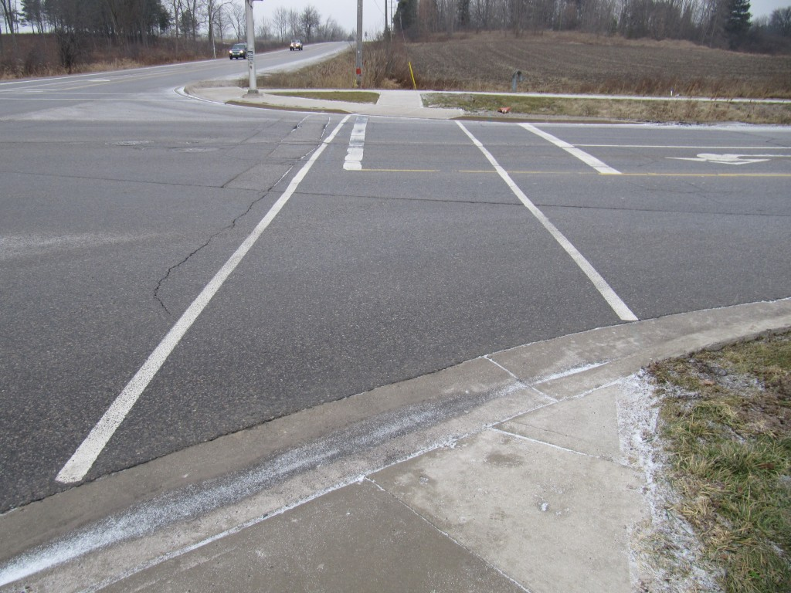
View, Looking North, at Painted Double Stop Bar on Westbound Sunningdale Road in North London, Ontario
Judging by the results of the photo below perhaps the driver has taken a conservative approach by stopping half the distance between the two stop bars and thus reasoning that he has “half complied” with both required stops?
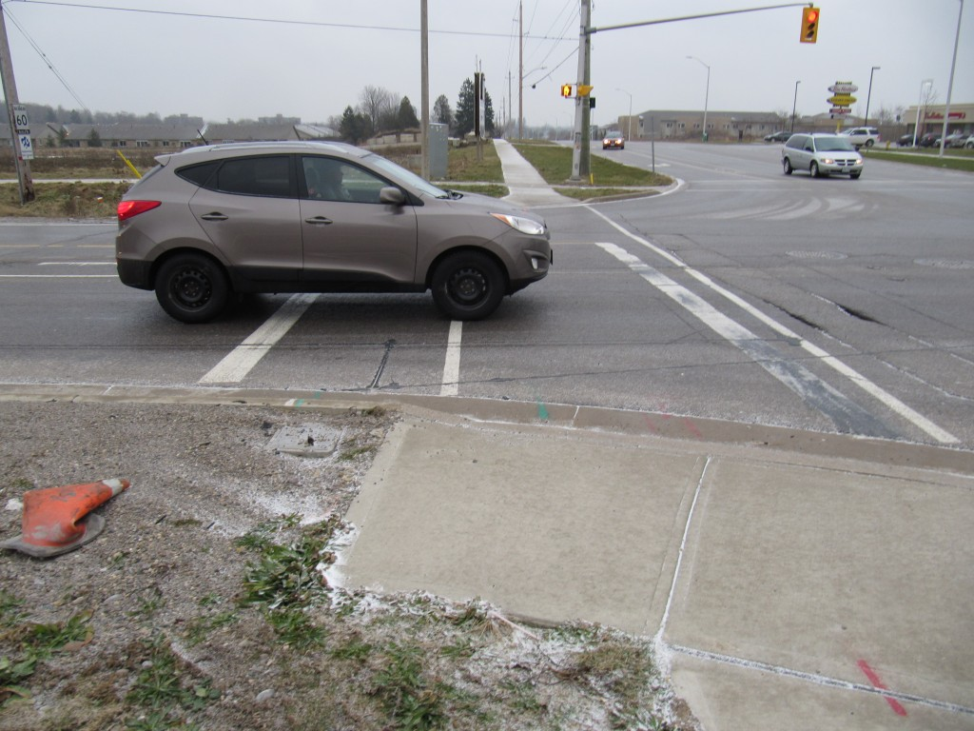
View, Looking South, Of WB Vehicle Stopped Between the Two Stop Bars
Well, no. There is little pedestrian traffic in this area and most drivers will apply common sense and not enter the pedestrian crossing zone. But courtroom lawyers have been known to argue that their client was confused and therefore stuck the pedestrian resulting in catastrophic injuries resulting in partial fault and a large claim against a City. These are the kinds of minor problems that a City must pay attention to if it wants to reduce its exposure to civil suits.
Can A Municipality Legally Reject Its Duty To Repair Roads?
When road repair was a provincial responsibility individual municipalities could not simply stop supplying their road works departments with sufficient money to maintain roads. But has that now changed?
It is reported that the City of Waterloo has decided not to increase taxes despite a $250 million backlog in repairs to roads and buildings. With respect to roads, a backlog of $170 million in repairs is awaiting municipal funding but that funding has been voted down. According the the Kitchener Record newspaper counselors such as Scott Witmer have stated “I don’t feel my car going to fall into an abyss. To have beautiful black asphalt on every road in the city, its not attainable”.
This should be freightening to anyone who understands roadway safety. Standards have been developed not to make roads look “pretty” but to protect the public from injury and death. These standards have not been developed out of the blue but have evolved over decades of scientific research and testing. Yet a city council that may not understand the reasoning for maintaining roads to proper standards can simply eliminate the problem with a simple wisk of the magic wand.
What ends up happening is that collisions fall into the hands of plaintiff lawyers who are more than happy to take everything the city wants to give up. And a road that is not in compliance to standards that are universally acknowledged is a simple decision for a judge to make – if that judge can be relied upon to do his/her job in an ethical manner. The result is that the city is sued for a large amount and then that City joins other muncipalities to try to curb the swell of ever-increasing judgments against them. And the vicious circle spins like a dog chasing its tail.
We understood many years ago that roadway maintenance and improvement was a provincial responsibility and there was a very important reason for that. All one needs to do is look at the City of Waterloo decision to understand that, when money becomes tight, elected officials will succumb to the pressures of local groups and fail to do what is right. Under provincial jurisdiction it did not matter what local pressures were involved – there was a standard level of roadway maintenance that had to be upheld whether the roadway was in Thunder Bay, Prescott or Windsor. And there was a scientifically established reason for maintaining our roads to common standards throughout North America. We will painfully discover that reality as time carries on and more roads are left in disrepair.
January 22, 2012
Fleeing Police On Glanworth Curve Likely Involved Ice and Loss of Control Impact Into Tree
While the driver of a GM car struck a tree while fleeing police yesterday evening, the reason for the loss of control of the vehicle was not only speed, but also some melt down that froze in the northbound lane.
The view below shows the north end of the Glanworth curve of Wellington Road at the south edge of London, Ontario.
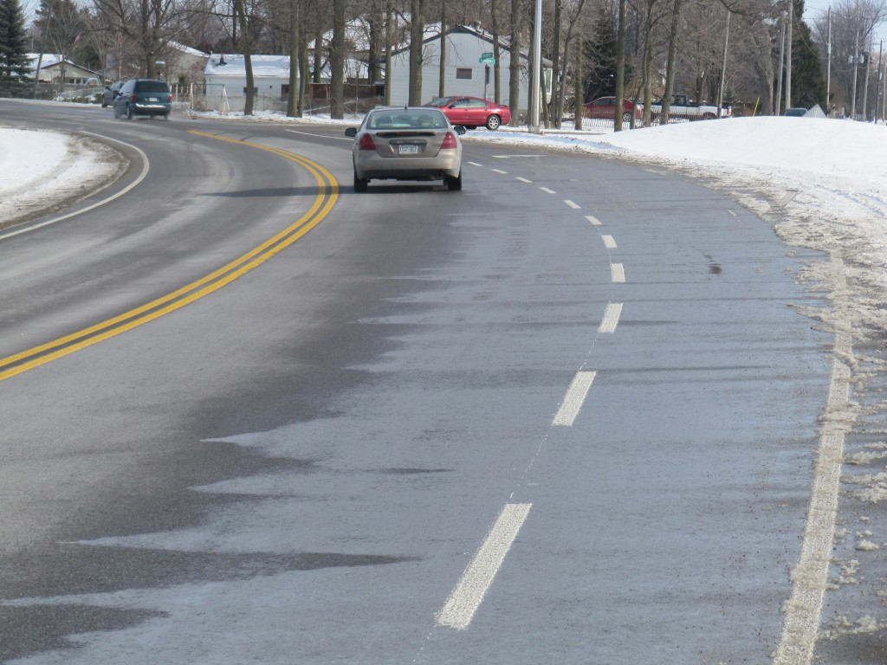
View of Melting Snow/Ice that flows onto the northbound lane of Wellington Road at the Glanworth Curve. The crash occurred several hundred metres in the background.
The left curve contains a significant superelevation to help drivers travel around the bend. But in creating the superelevation there is always a concern that melting snow and ice will slide onto the travel lane and then freeze in colder conditions. Looking at the present conditions in this photo that was taken just before noon on January 22nd, 2012, we can see how the ice and snow on the south (right) side of the curve is melting and then the water is flowing onto the northbound lane. These are similar conditions to what occurred yesterday when the sun was out and providing ideal melting conditions.
The actual collision occurred around 2120 hours. But previous to that, the sun had gone down and the moisture that was present likely began to freeze. When you add a little speed to the mix bad things happen.
Below is a closer view, looking north, showing the curve just before the location where the vehicle travelled off the roadway and struck a tree on the right roadside.
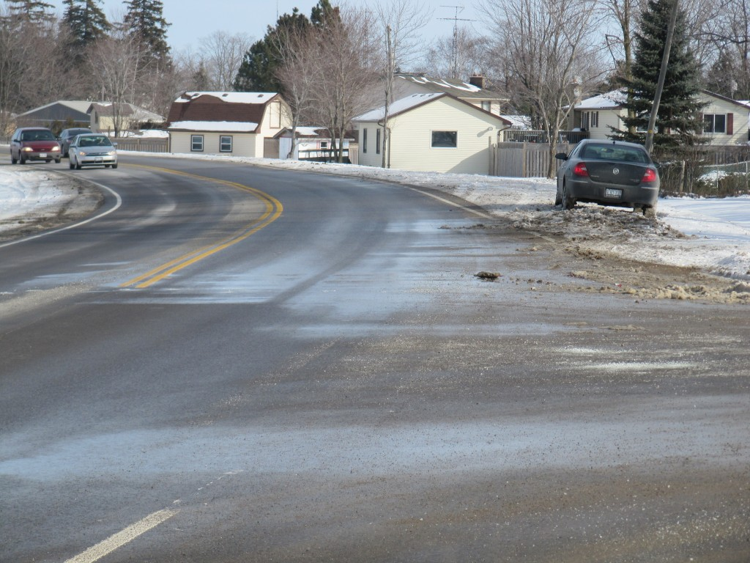
View looking north on Glanworth Curve Showing Moisture on Northbound Lane at Location Where Fleeing Vehicle Left the Roadway
We would be less inclined to focus on this issue if the vehicle had performed a typical, yawing motion before leaving the roadway. Instead the tire marks suggest that the vehicle may have left the roadway while sliding almost rearwards and that is not a common scenario.
The photo below shows the location just south of where the fleeing vehicle left the roadway. The impacted tree is located just to the left of the evergreen tree in the background.
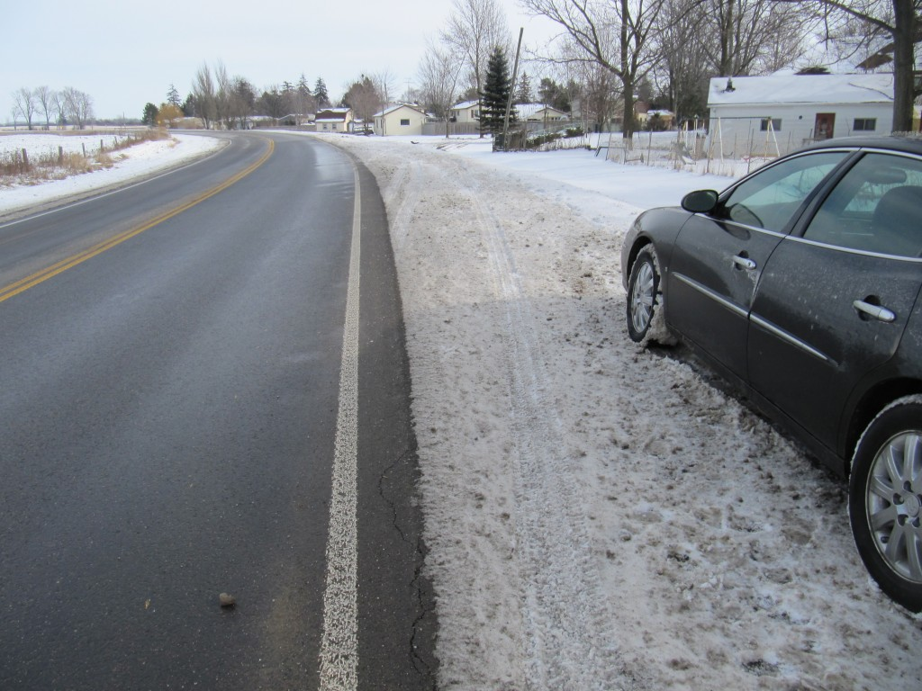
View, Looking North, Along the Right Side of the Northbound Lane of Wellington Road Just South of the Location Where the Fleeing Vehicle Left the Roadway.
Below is a view at the commencement of the tire marks of the fleeing vehicle as it left the roadway and struck a tree in the background (just to the left of the evergreen).
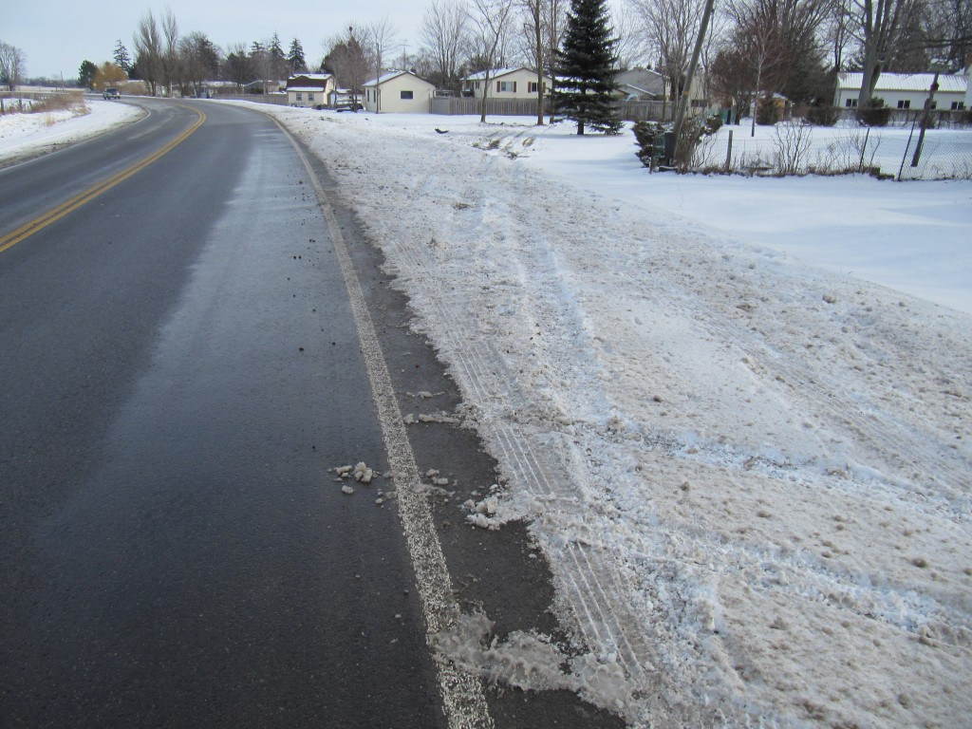
View, Looking North, at the Beginning of the Tire Marks in the Snow, Caused by the Fleeing Vehilce That Struck a Tree in the Background.
What you should recognize from these tire marks is that there is little evidence of rotation of the vehicle about its vertical axis, or there is minimal evidence of yaw. Sometimes such little evidence of yaw may signify a very high speed. But regardless, the other important point is that the vehicle was likely sliding almost backwards as it left the road and produced these tire marks.
Below is a further view of the tire marks and you should now be able to recognize the tree where the impact occurred. Note how the tire marks are not crossing each other or diverging or converging. So the vehicle is essentially sliding rearwards into the tree with little rotation. The reason for the short discontinuity in the tire marks is because the vehicle has travelledd over short down-slope so it was momentarily airborne.
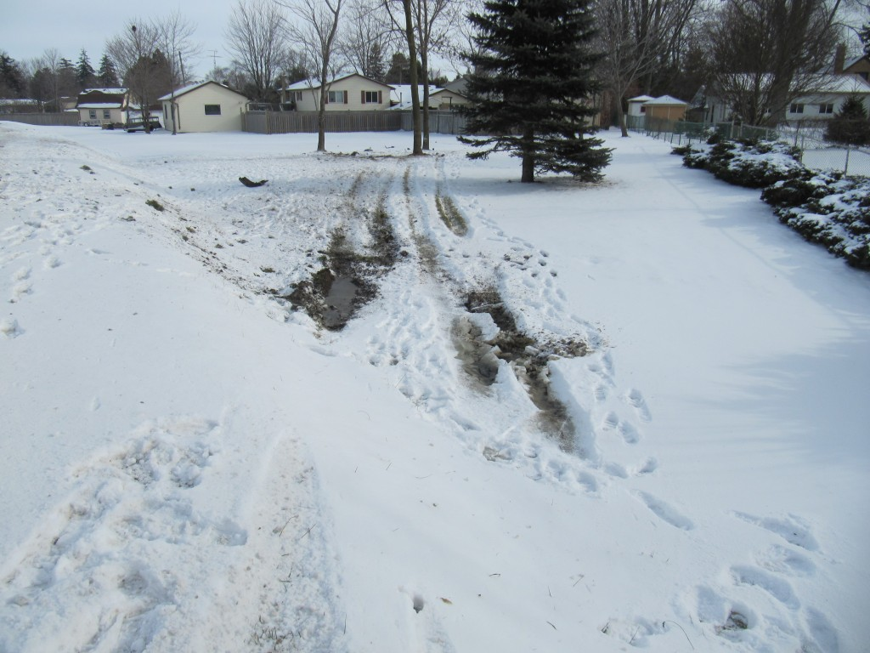
View of Tire Marks as They Approach the Tree Impact.
The photo below shows how the tire marks continue to be straight as they approach the tree impact.
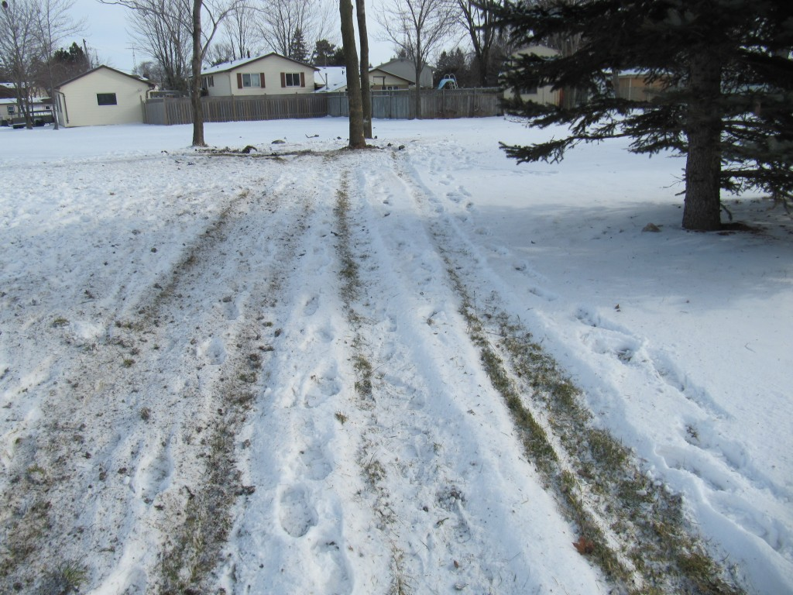
View of Straight Tire Marks as They Approach the Tree Impact.
Below is a view of the damage caused to the struck tree. By examining the damage, as well as the particles that are imbedded in it, it is possible to obtain further information about how the impact occcurred. This why we state that the vehicle probably struck the tree at least partially with its rear surface. There is also evidence that there was penetration into the occupant compartment and thus intrusion, possibly into the area where the driver was seated.
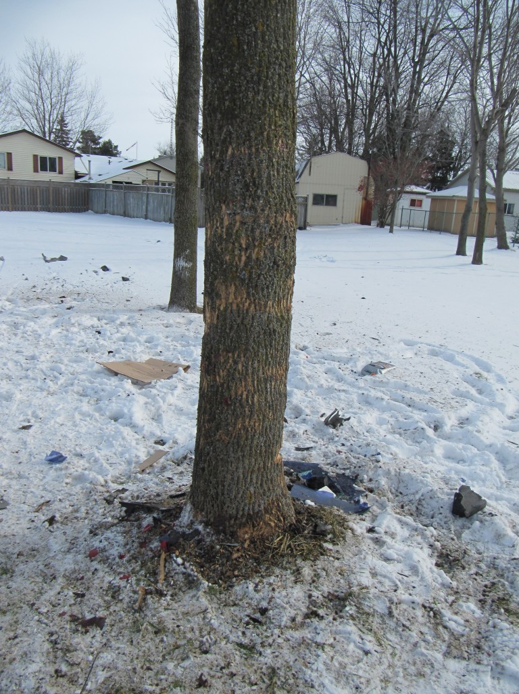
View of Damage to Struck Tree
The unusual circumstance in this case is that the vehicle exited the roadway while leading partially with its rear end. This is not typical and suggests excessive rotation of the vehicle while it was still on the road. Noting its path with respect to the curve and combining the fact that it did not appear to go around the curve, along with the evidence of moisture and likely freezing in darkness, there is a strong likelihood that icing on the road suface was a factor in this crash. It is still unknown what roll the police played in this happening and whether police were present in this location when the fleeing vehicle approached. Thus there is a limit to what we can say about how this collision unfolded without having examined the vehicle and without knowledge of what other vehicles (including police vehicles) were in the area when the vehicle left the roadway.
We have uncovered further information but have decided to stop at this time to evaluate what further facts may be revealed through the police or the SIU. One must understand that interpretation of site evidence like this has its difficulties without a full knowledge of the investigation details.
UPDATE: JANUARY 24, 2012
Having had a chance to review our photos of the damaged parts and material imbedded in the struck tree, the conclusion regarding how the vehicle was oriented at the tree impact may be suspect. Our evaluation can only be based on the physical evidence at the site and that physical evidence shows a set of tire marks with essentially no evidence of pre-impact Yaw. The vehicle is simply sliding, albeit while off-tracking slightly. In the general condition we would expect the vehicle to come into impact leading with its front end. What has led us to believe it came into contact with its rear end is the evidence of damaged parts lying around the tree and beyond. Let us look at another photo below.
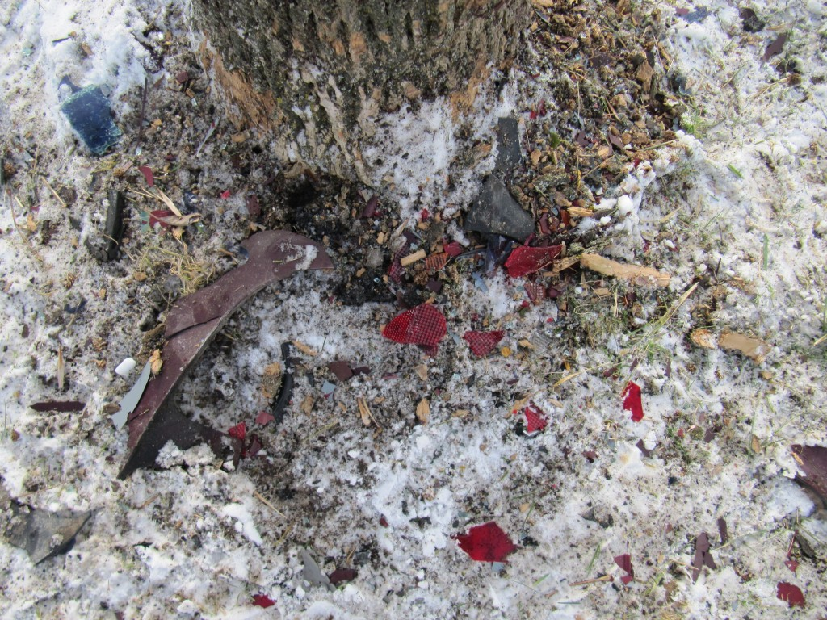
Close-up View of Red Lens Material Lying at the Base of the Struck Tree
When we see red lens material, such as shown in the above photo, and it is concentrated in small particles like it is, then it commonly suggests that the rear tail-light was in contact with the tree. Other debris from the rear of the vehicle also suggests to us that there was damage to the rear of the vehicle, hence our reasoning for the vehicle orientation.
However this is a peculiar and uncommon happening. Granted there is reason for us to believe that this uncommon happening would occur if there was ice in the northbound lane of Wellington Road and this caused the vehicle to rotate backwards while still on the road. But there can be many influences involved that we cannot be aware of and it requires a full examination of all the evidence that may be on the vehicle as well as any witness or driver statements.
We want to add further that, an impact of a tree by the rear end of a vehicle makes it difficult for penetration and intrusion to occur into the occupant compartment simply because there is so much structure to get through before reaching that occupant compartment. Yet we see that there is evidence of glass imbedded in the tree which is very commonly associated with penetration into the occupant compartment. Note the imbedded glass in the photo below.
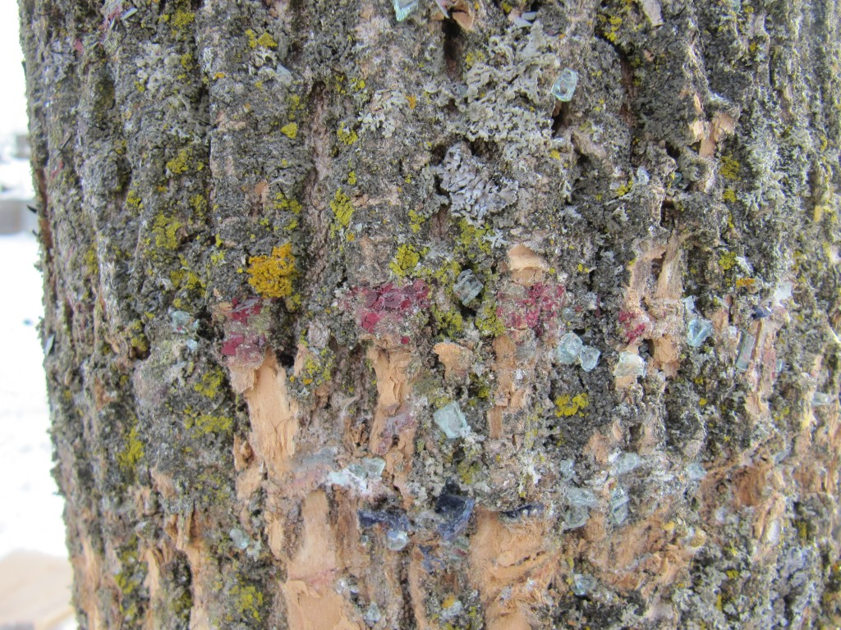
View of Glass Particles Imbedded in Struck Tree Indicative of Occupant Compartment Involvement
Additionally, there is also orange lens material clinging to the bark and that is more associated with impact of the front end of the vehicle. In the photo below is a close-up view of that orange lens material.
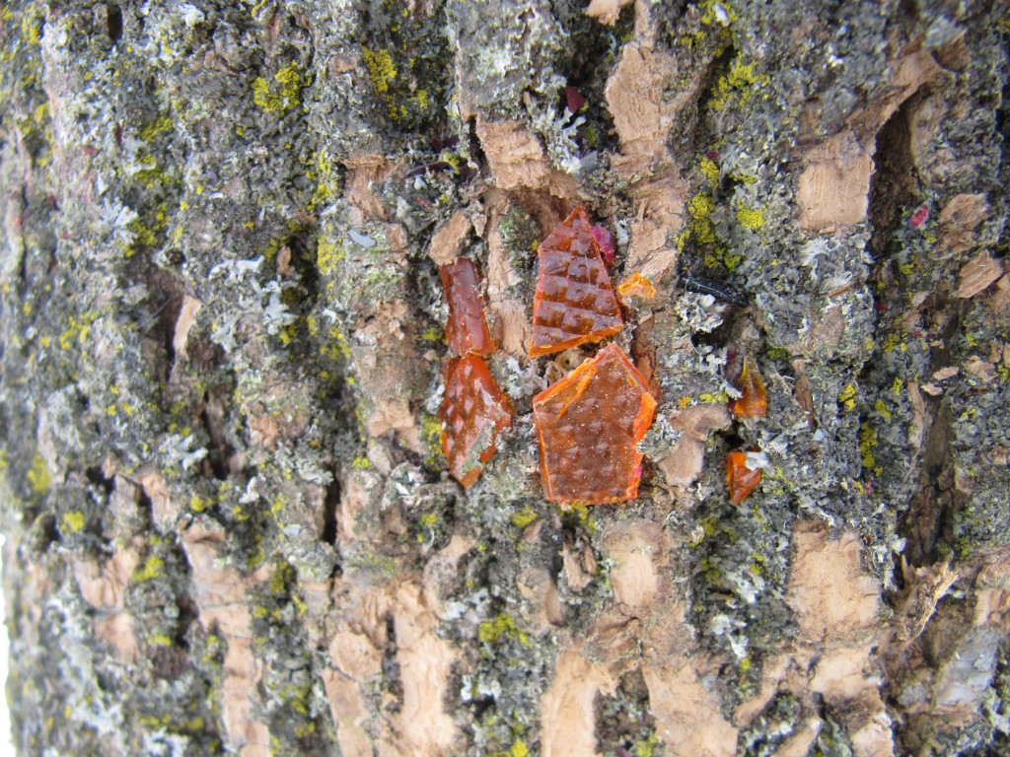
View of Orange Lens Material Clinging to the Bark of the Struck Tree.
So this contradictory evidence exists. The problem would be easily solved by someone who saw the damaged vehicle but when you are working solely from site evidence the process is a little more challenging. But regardless of the vehicle’s orientation, the issue of an icy road surface would still exist and either vehicle orientation could be caused by as an icy road.
January 20, 2012
Deadly Highways 401 and 402 Are Not All Drivers’ Fault When Road Surface Becomes Icy
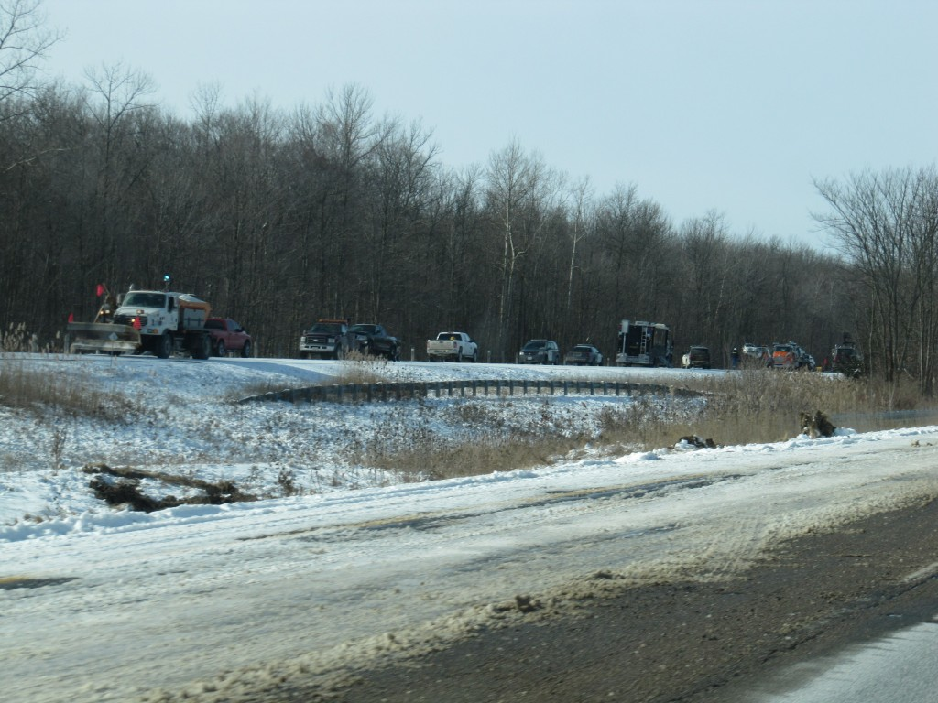
View of Clean-up Proceeding in Eastbound Lanes of Highway 402 East of Forest Road Following the Fatal Collisions that Occurred there January 19, 2012
With the lastest multiple collisions and fatalities causing closures of two of the major controlled-access highways in southern Ontario the events have spawned the standard reactions of emergency personnel and the public about “stupid” drivers and similar vulgarities. While driver error is a major factor that must be addressed, these ignorant comments are just that, ignorant; because these persons truly mis-understand the issue.
On a snow-covered road, or partially snow-covered road, the co-efficient of friction that provides the force to change the motion of your vehicle could be as high as 0.5 to 0.7 g depending on whether traffic has moved some of the snow out of the way and created paths of bare pavement. In such environments it would not be unreasonable to travel 80 km/h when we have video-taped proof that the average speed on Highway 401 in good road conditions is in the range of 115 to 117 km/h. The stopping distance, never mind the distance needed to detect and recognize, would mean that you could stop a passenger car in a distance of about 40 to 50 metres on such a road surface.
But when a road surface becomes icy that co-efficient of friction can drop to 0.1 g or lower. If drivers cannot detect that a roadway ahead has become icy then that speed of 80 km/h becomes deadly. Suddenly, that stopping distance of 40 to 50 metres cataputs to a distance of over 250 metres. While many of these supposed experts state that the driver should drive according to roadway conditions, leaving a gap of 250 metres (820 feet) between every vehicle on busy super-highways like the 401 and 402 is simply never going to happen.
The point is that, while driver speed and behavior are a problem, they are not the only problems and making derogatory comments about the stupidity of the driving population will never lead to a solution, it will only lead to the demonstration of the stupidity of the so-called experts. When a road surface suddenly becomes icy no one can react acceptably to the condition, regardless of one’s experience. Expertise can only minimize the consequences of a crash, but a crash will happen. Those who proclaim their superiority by avoiding a crash are simply lucky participants in a game of russian roulet. The expert who claims he or she can steer their vehicle away from trouble on an icy road surface is simply a snake oil salesperson who is enjoying their moment in front of a camera while providing no useful help to the public. Sooner or later that expert will be caught in an unexpected situation and their panic reaction will be very little different than anyone of us.
The question that no one asks in these circumstances is what actions were taken by roadway maintenance personnel to foresee that an icy road condition might develop. We never see the TV or newspaper reporter’s interview at the local road maintenance department where the supervisor pulls out a detailed listing of all the actions that were taken and at what times. That kind of detail is kept secret. But it is a vitally important issue that the public must be made aware whether certain roadways have not been taken care of, long before it is too late. If roadway maintenance personnel have not had a chance to thoroughly deal with the potential development of an icy road surface then that information should flashed, at interent speed, to every member of the public. Because this does not occur there could be 20 to 40,000 vehicles a day that may be affected at every section of highways such as the 401 and 402 and the price is what was witnessed yesterday.
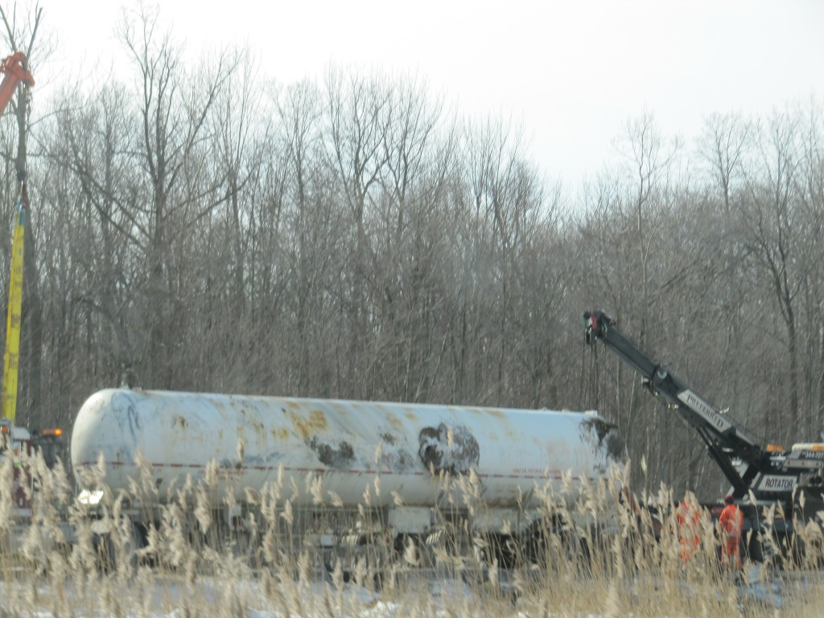
View of Tanker Truck Being Righted After it Fell Onto its Side at the Site of the Fatal Collisions on Hwy 402 East of Forest Road
The availability of detailed information about roadway maintenance should be an absolute requirement.
January 18, 2012
Tow Truck Driver Fatality In Windsor Ontario Raises Complaints Over Towing Safety and Identity of Accused
Paul Rocheleau, 49, of LaSalle, Ontario was the tow truck driver who was killed January 17, 2012 while attempting to change a tire of Dave Matteis’ car on Highway 3 in Windsor, Ontario. The incident has prompted several tow truck operators to complain that their lives appear to be less important that police and fire personnel who work in similarly dangerous conditions but who are protected by a law requiring drivers to pull into another lane away from a stopped emergency vehicle.
The identity of the London man who drove his Mercedes into Rocheleau has not been released which prompted a commentor to reveal that it was the husband of a London city councelor who is also an instructor at the University of Western Ontario’s Ivey Business School. The commentator opined that the identity of the driver was not released due to his, and his wife’s, prominent positions.
These comments raise legitmate concerns, but too often that is not the case. The true nature of our society is revealed during these times when commentors, who do not have to leave any identifiable name with their comments, vent their anger and hostility, warranted or not, upon individuals, organizations, laws or whatever, irrespective of whether their comments are rude, inconsiderate or worse. This is not a judgment on society but simply an acknowledgment that, we are not always as pretty as we pretend to be.
Solar Panels In Unsafe Location of Sebringville OPP Property Demonstrate How Police Are Focused on a Narrow Range of Road Safety Issues
We have often commented on this website about the lack of recognition and focus that unsafe roadway infrastructure and maintenance is a significant causal factor in many collisions. Official news agencies continually report on the issues of speeding, alcohol use and inattention of drivers, like they should because these are very important. However when unsafe roadway design, maintenance, signage, lighting or similar issues exist these factors are essentially ignored. We have attempted to focus the public’s attention on the fact that police do not appear to act as the independent evaluators of causal factors like they should and that they frequently ignore, or do not reveal roadway safety factors in the proper way that they should.
The problem is exemplified in a news story of today from Sebringville, Ontario where the local OPP Detachment had a number of large solar panels placed on their property adjacent to Highway 8 which is the main highway that passes through the town. These solar panels were placed too close to the highway and it is revealing that no one from the OPP Detachment made any notice of the fact.
How the error was found and by whom is somewhat mirky. It is reported that Ontario Ministry of Transportation staff noticed the problem about “two months” after either the project was started or completed; that fact is not clear. According to a London Free Press article the Municipality of Perth East “contacted the ministry to advise of the solar panel installation” but whether the Muncipality accomplained or simply commented about the beauty of the structures in not clear. The error caused the panels to be positioned as little as 1.5 metres set back “from the road” and that this set back was in compliance with “municipal road standards, not to those for a provincial highway”.
Having some experience in evaluating roadway safety issues it is with concern that we read that the set back of such large, immovable barriers to motion would be allowed under municipal road standards and why that would be so. Municipalities in Ontario have recently been given the authority to manage their own affairs in preparing their own stardards for roadway safety without the general public’s awareness. As police forces are often paid by these municipalities, conflicts of interest should be a large red flag waving in the public’s face, but it is not.
It is noted that the OPP at Sebringville appeared to watch passively as these as large structures became planned and then were erected. But there is no word that any OPP officer or official made the observation that this installation was unsafe. Now this is a single incident but it reflects what exists throughout the Province of Ontario. What guarantee does the public have, that when an unsafe roadway problem exists and that problem has influenced whether collision occur that the OPP, or any police force, will understand and identify the problem? Apparently there are laws that prevent persons from driving unsafe vehicles. There are are laws against driving drunk or being distracted. But what laws exist that would fine an agency for knowingly causing an unsafe roadway design or maintenance to exist? The answer is simple, there is no such law. Police are not trained to understand what constitutes an unsafe roadway condition. It is also our belief that police are even discouraged from reported roadway safety problems.
We know this from first hand experience. Recently we attempted to document a local roadway problem. Instead we were visited by local police and threatened with a charge that our videotaping on the road could be interpreted as stalking drivers. The local police officer acknowledged that the roadway problem existed but stated to us that if he complained that no one would listen. The local police then refused to report the unsafe roadway problem. Yet, several months later the roadway problem was suddenly repaired. Is this the proper functioning of a police force?
While the story about these solar panels would appear to be a small and innocous affair, beneath it there lies a greater problem.
January 17, 2012
Trailer Illegally Parked in Heavy Traffic A Very Bad Idea
Yes, there are always some surprizes when it comes to any individual’s logic. However this morning there was a demonstration of particularly bad logic on Clarke Road, near Culver Drive in north-east London, Ontario.
Clarke Road is a major arterial roadway in north-east London. On this dark and rainy day someone decided to park their unlit, non-relectorized and black trailer in the curb lane of the road as shown in the photo below.
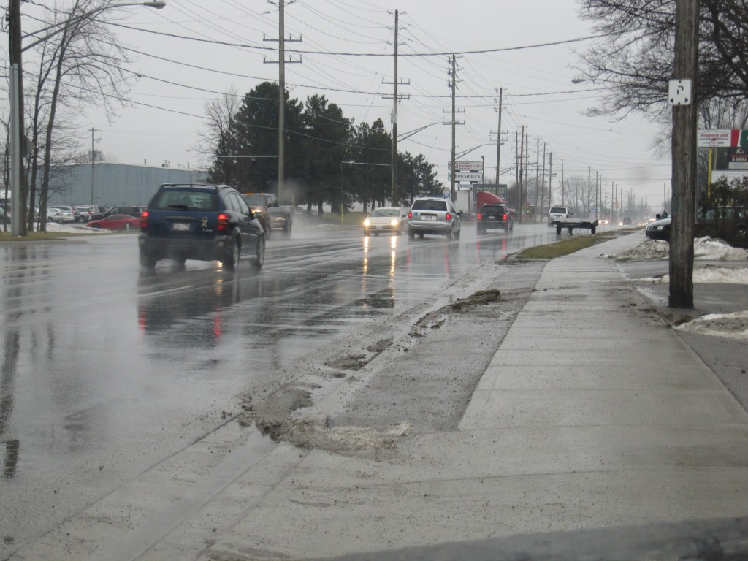
View of Low, Black Trailer Parked in Traffic of Clarke Road
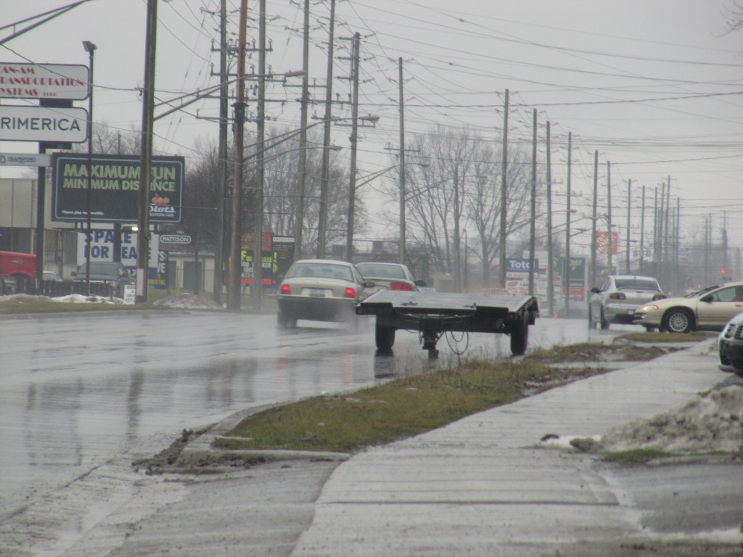
Closer view of trailer parked in the curb lane of Clarke Road
Note that the trailer is so low that it cannot be seen above the height of a typical passenger car. No reflective materials are on the trailer. It is black in colour. This is a rainy day with low contrast. Everything about this scenario spells a disaster just waiting to happen.
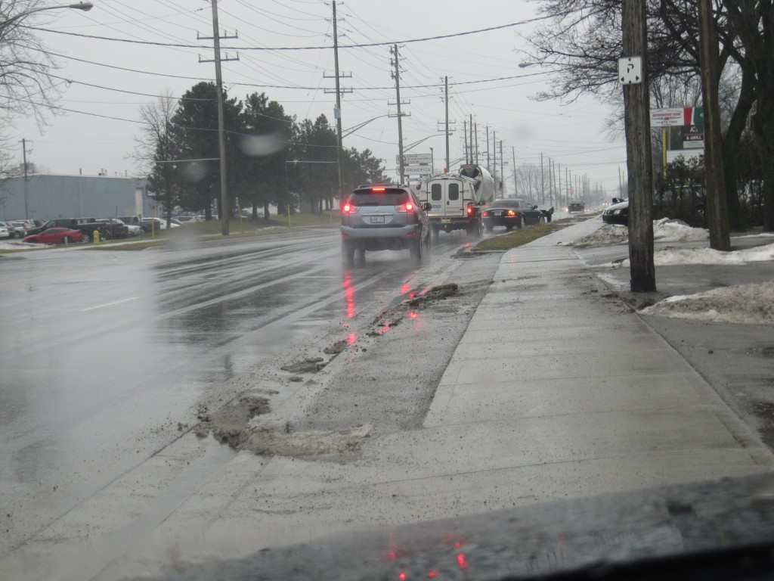
Drivers would likely be unable to depect the trailer in time if traffic was ahead and suddenly changed lanes exposing the trailer to view at the last instant
As can be seen in the photo above, drivers often travel in the blocked lane while they wait for an opportunity to change lanes to pass the trailer. When a vehicle changes lanes while too close to the trailer it means that drivers travelling behind that leading vehicle will not have a view of the parked trailer until the very last instant. This is a common occurrence in many collisions. But placement of such a trailer on this roadway in these weather conditions is simply dumber than dumb.
January 16, 2012
Driver of Single Vehicle Loss-of-Control Collision On Norwich Road Air Lifted to Hospital
A single vehicle collision involving an eastbound 1993 Mercury Marquis occurred on Norwich Road, west of Pick Line on Sunday, January 15, 2012 at approximately 112o hours. The driver was air lifted to hospital however his identify and status of his injuries are not yet known.
The evidence at the site was spread out over a very long distance of almost 300 metres. Much of that evidence was in the form of tire marks indicating that the eastbound Marquis appeared to drift, at a shallow angle, onto the north shoulder where it remained for a distance of about 22o metres, or well over the length of two football fields. During this travel the right side of the vehicle glanced off a telephone junction box near the north edge of the shoulder. The Marquis then commenced a sharper angled motion towards the ditch where its right front end stuck a culvert which crossed underneath a driveway. This impact sent the vehicle into the air and commenced a lateral tumble into a corn field. The vehicle travelled a distance about 130 metres during this tumbling and then came to rest on its roof. Evidence at the site would suggest that the male driver was partially ejected from the vehicle and may have been partially pinned beneath it.
It is not known what caused the events but the poor condition of the vehicle’s rusted suspension should be one of many possibilities. The condition of the road itself does not appear to be a factor although it is not yet known whether road surface conditions such as snow or ice may have played a role. Evidence of markings from a snowmobile and a possible motorized bicycle that crossed the road are also possibilities however it is not known whether these vehicles crossed the roadway at around the same time as the approach of the Marquis. The hoof prints of a horse that existed both on the north and south shoulders of the road also cannot be discounted as being unrelated at this time.
Unusual acceleration marks in the snow along the north shoulder were also present and these crossed over the tire marks caused by the Marquis. Although these acceleration marks were created after the tire marks of the Marquis the timing between the creation of the markings is unknown. Certainly many emergency vehicles travel in the area of a shoulder so the existance of tire marks is not particularly unusual. What is unusual is that the tire marks suggested that a vehicle was accelerating and changing direction back and forth on the shoulder for a long distance along the same path as the tire marks caused by the Marquis. It would be unusual for a police cruiser to cause such markings as this might destroy potentially valuable evidence. Fire and ambulance vehicles also would not engage in such actions so far away from where the vehicle came to rest.
The photo below shows the evidence at the beginning of the tire marks of the Marquis as it left the roadway and drifted onto the north shoulder. The black car in the distant background is where the vehicle struck a culvert and was projected into the air, which began its rollover.
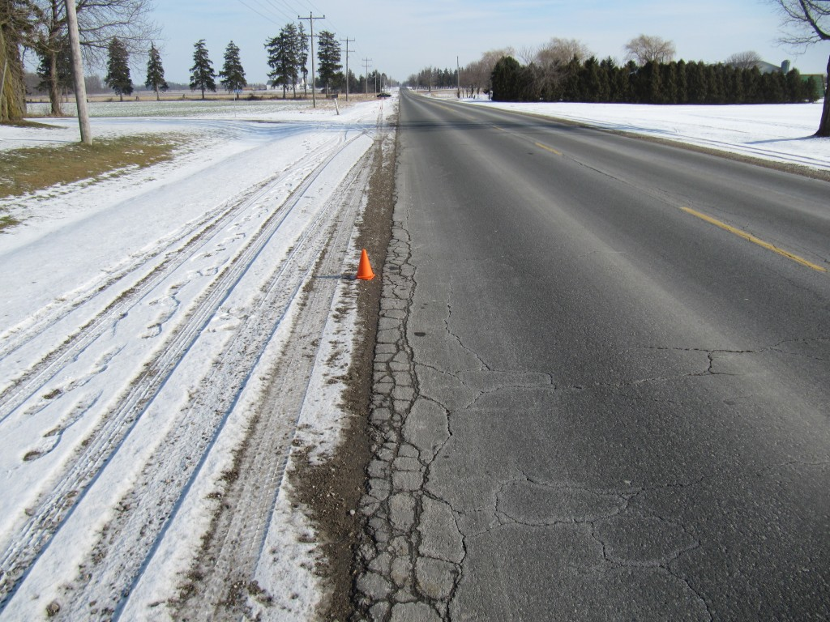
View, looking east along Norwich Road along the beginning of the tire mark (at red cone) caused by the Mercury Marquis as it drifted onto the north shoulder and subsequently rolled over
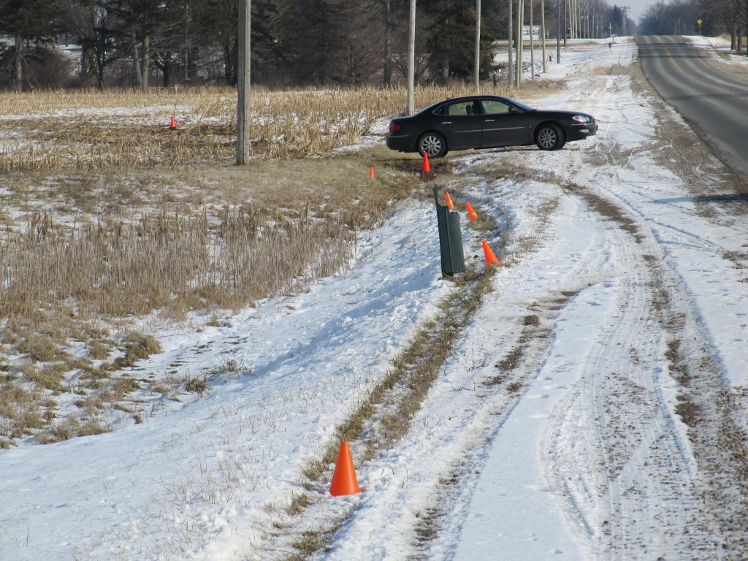
Looking east, showing tire marks of Marquis as they glance off a telephone box and then the vehicle strikes a culvert at the approximate location of the rear tire of the parked vehicle in the background.
The photo above shows the tiremarks of the Marquis at the point where the vehicle strikes the telephone junction box and then veers into the ditch where it strikes a culvert. A single red cone in the distant background indicates the final rest position of the vehicle. The distances displayed in the above photo appear rather close but the photo was taken with a zoom lens. In fact the distance from the telephone junction box to the final rest position of the vehicle was about 130 metres or well the length of a football field.
Note that a tumbling distance of about 130 metres could result in a speed loss of about 128 km/h. Therefore, if we were to consider that some speed was also lost during the travel along the north shoulder, over an additional distance of 160 metres, it suggests an extreme speed was involved as the vehicle left the roadway. There could be other explanations for this evidence that would need closer scrutiny but the preliminary evidence would suggest that this very high speed existed.
UPDATE: JANUARY 17, 2012
The identity of the driver of the Marquis has now been revealed. Terence Gardhouse, 87, reportedly of Southwest Oxford Township, was air-lifted to London’s Victoria Hospital but has since succumbed to his injuries.
It would appear out of character for an elderly man such as this to be travelling at an apparently very high speed.
Much of this mystery could be evaluated by examining the character of the tire marks in the snow when those marks were still fresh. Below is one of our photos of the mysterious acceleration/swerving tire mark along side the straight tire mark caused by the Marquis. Note that, in this area where the unknown vehicle is simply tracking along the snow the tread of its tire is clearly visible. Yet, when acceleration or braking occurs then the tread is not visible.
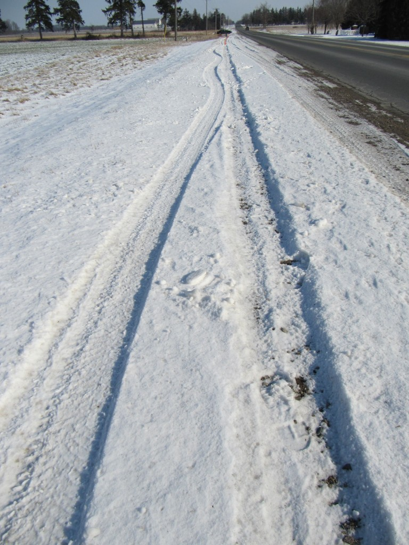
Comparison of Tire Mark Produced by Unknown Vehicle (left) With Tire Mark Caused by Marquis (right)
It can be noted in the above photo that the tread of the tire in the Marquis mark is not visible so it leads to questions about how the mark was created. Certainly aging of the tire mark could affect our evaluation of its character. The above photo was taken about 24 hours after the occurrence and the bright sun would have the effect of melting away some of the mark’s features. Thus examination of the tire mark just after it was created would be the best method of approach to this problem. Unfortunately this is beyond our control.
January 15, 2012
Shirley Foster of Guelph Reportedly Killed in Crash Near Elora
Shirley A. Foster, 57, of Guelph, was pronounced dead at the scene of a two-vehicle collision that occurred on Wellington Road 18, at approximately 1430 hours on Saturday, January 14th, 2012. It is reported the 1994 Pontiac Grand Am in which Foster was a passenger was travelling westbound when it struck a 2000 Dodge Pick-up that was northbound on the Wellington County Eighth Line. James Allen Richards, 71, was driving the Pontiac and sustained serious injuries.
Two men in the pick-up truck, Christopher Michael Waito, 24, and Matthew Andrew Artus, 21, were reportedly ejected from the vehicle and sustained serious injuries.
The scenario depicted by these facts makes it unusual that Foster would sustain fatal injuries. If the front end of the Pontiac Grand Am struck the passenger’s side of the Pick-up then the Grand Am would rotate clockwise and the maximum crush should be located at the left-front of the Grand Am. It is rare that there would be structural intrusion into the passenger’s seat area where Foster would be seated. As such, a seat-belt, properly worn, should have protected her from serious injury. This can be said by examining the injury result to the driver of the Grand Am.
At an age of 71 Mr. Richards’ survival would be affected by his age. He would also be located in the area of the vehicle where the crush would have been the greatest and, if the collision was of sufficient severity, intrusion of the vehicle’s frontal structure (left dash, lower cowl, Left A-pillar, etc.) would be likely. The fact that his injuries were reported as “serious” and not “severe” or “critical” could be a loose laymen’s terminology. However there are specific injuries that determine whether a person’s condition is reported as serious, severe or critical and that terminology is based on the likelihood that the person might succumb to his/her injuries. Serious injuries would involve something like a fractured femur, or multiple rib fractures without complications, etc.
Thus for a 71-year-old male to sustain only serious injuries has a relationship with the severity of impact and that relationship would suggest that the right front occupant should sustain less injury. Therefore this is an issue that should be explored further: Why did Shirley Foster sustain fatal injuries when the reported collision facts would suggest otherwise?
Also, it was reported that the force of impact caused the occupants of the Pick-up, Christopher Michael Waito, 24, and Matthew Andrew Artus, 21, to be thrown from the vehicle. Again, this is likely loose terminology used by news media who do not understand the implications of what they are saying. It would be extremely rare that a properly seat-belted occupant would be ejected from their vehicle because the collision was so severe. Alternatively it is most likely that, if they were ejected as reported, then they were not wearing their seat-belts or they were wearing them improperly. In the case of intersection collisions where there are very high rates of rotation occupants have been known to collapse their seat backs and be projected rearwards while using the angle of the seat back as a ramp. This condition is rare with Pick-ups because of the typical, limited room behind the front seats. Also a very high rate of rotation would require a large force that is far away from the vehicle’s centre of gravity and the reported impact to the side of the Pick-up, as well as the smaller mass of the Grand Am, would make such a high rotational force quite unlikely.
UPDATE: September 27, 2012
While we attempt to report factual and helpful information, there are instances when our comments are based on nothing beyond what has been reported in official news media. This case is an example of that.
Further information has been reported to us which provides some clarification and therefore we provide this further up-date.
It has been reported that the pick-up truck may have travelled through a stop sign and the driver attempted to avoid the collision by steering to the left. The driver of the Grand Am also attempted to avoid the collision by steering to his right. Thus the direct contact to the vehicles was more like a right side impact of the Pick-up and a left side impact of the Grand Am, rather than what was originally reported. There is nothing unusual about this difference in information as it is not uncommon for collision events to be reported by news media in imprecise terms. But as persons who reconstruct the details of collisions we cannot know whether the information being reported is due to loose terminology or whether a significant or unusual event has occurred that needs to be brought forward.
It was also confirmed that the two occupants of the Pick-up truck were ejected from their vehicle. As stated earlier, this would most likely be due to the fact that they were not wearing seat-belts.
Unfortunately it has been reported that the driver of the Grand Am, Mr. James Allen Richards, passed away about two weeks after this collision.
We also want to clarify our comments regarding the right front occupant of the Grand Am, Shirley A. Foster. The original reason for our posting of this news article was because we wanted to provide some information about how persons are injured and killed as a way to educate the public. It is important to discuss these matters because it may help to prevent a future fatality. There are also instances where there is something wrong about an investigation or the facts about a collision and the general public does not have the experience and background to detect the problem.
Many times the consequences of collisions fall into predictable patterns, but it is also important to recognize that each collision is unique. We are faced with the design problem that, although seat-belts have been unquestionably successful in saving the lives of thousands upon thousands of people, the shoulder portion of a seat-belt system rides over only one shoulder and this can become a problem to occupants in certain types of collisions.
If the collision had occurred as originally reported (i.e. the Grand Am was travelling forward and struck the right side of the Pick-up with its front end, then the impact force exerted upon the Grand Am would have been primarily from the front rearwards. In effect, this would cause the Grand Am to slow down rapidly in the forward direction and the right front occupant would tend to travel forward with respect to the vehicle interior. Therefore a seat-belt would restrain that forward motion and would be very beneficial in reducing the occupant's injuries.
However, it is reported that both drivers steered away from each other and the impact force to the Grand Am was much more from the left than from that front. Such a scenario becomes more problematic because the Grand Am is now shoved to the right with respect to the right front occupant's position and the right front occupant's body is directed more to the left of the vehicle interior. In these instances a lap belt restrains the lower body and in many instances the shoulder (torso) belt also provides some restraint to the upper body. But the design of typical seat belts causes the shoulder belt to rest over the right shoulder and is less effective in preventing the upper body from slipping to the left when there is an impact force applied from the left toward the right. Unfortunately, when the upper body becomes unrestrained like this the head is the most distant body part from the fulcrum at the lap belt and therefore the head can attain a higher velocity toward a possible impact with the vehicle interior. Thus it is not uncommon for a passenger to sustain a head or neck injury that could be life-threatening in this circumstance.
We have come to recognize that various persons read our articles and some will take our original comments about seat belt use and report that an accident reconstruction expert's opinion was that Mrs. Foster may have been wearing a seat-belt improperly which led to her injuries. Nothing could be further from the truth. Under the additionally reported facts, there could be a good explanation why the injuries occurred and it could have nothing to do with improper seat-belt usage. It could be that the design of the shoulder belt could not protect Mrs. Foster from sustaining her injuries in this type of collision - or there could be other unknown issues. We must understand that vehicle designs and safety systems are improving and the focus of improvements is on the most common problems. Slippage out of a shoulder belt is a known problem, it does not occur frequently and it does not have a quick solution.
We want to add that, although we attempt to provide our educational comments from time to time, they are often based on our experience from examining previous similar collisions. But individual collisions are just that - they are unique and can result in unique consequences. This is why it is necessary to conduct proper examinations of a collision site as quickly as possible before any significant changes are made to the evidence. It is also vitally important to conduct properly detailed examinations of the involved vehicles. It is also important to conduct a properly detailed analysis based on all the available evidence.
Technology exists in the present day that could be utilized to obtain better information and in a quicker time. If police are to be the first and only responders to serious and fatal collisions then they should be equipped with video cameras and still digital cameras to document the evidence that is present. Laser scanners are now available that can take many thousands of measurements in a very short time and these could provide very detailed information at a collision site while clearing the roadway for traffic in a much shorter time. Such efforts can result in the increased quality of evidence that is available to the analyst such that conclusions about how an injury occurred, or other matters such as vehicle speed can be based on better scientific fact.
January 13, 2012
Multiple Vehicles Lose Control On Highway 401 in Oxford County
At approximately 0340 hours this morning emergency vehicles were called to Highway 401 east of Woodstock to respond to two vehicles that had entered a ditch. In the process a fire truck was also present. While these actions were in progress drivers from two tractor trailer lost directional control of their vehicles and one struck the fire truck. Several persons are reported to have been transported to hospital in Woodstock, Ontario though the status of their injuries is unknown.
Given that the potential for icy conditions was known for a considerable time, it would appear that road maintenance personnel should have taken steps to place de-icing material on the road particularly given that Highway 401 should be the top priority. The loss of control of four vehicles at the same location would suggest that the road surface was likely icy. However nothing has been indicated whether maintenance road crews performed their work like they should have.
January 12, 2012
It is being reported that OPP Constable James Morrow has been charged with dangerous driving causing bodily harm in relation to a motor vehicle collision that occurred on October 1, 2011 at the intersection of Colonel Talbot Road and Glanworth Drive near the Highway 401 interchange southwest of London, Ontario. That collision reportedly caused serious injuries to another officer, presumably sitting in the passenger seat of Constable Morrow’s cruiser. It was reported that Ontario’s SIU was called in to investigate the collision.
The lack of any information regarding the incident has resulted in the public’s criticism. For example, comments attached to the London Free Press article resulted in the following:
“Don’t I love when I onlyl get half the story?
and,
“Classic LFP reporting: absolutely brutal.”
While the story does supply little information this is often done with the belief that a focus on police mistakes would make the public think less of them. There is the opposite possibility that hiding information will lead to speculation and distrust and cause even greater damage to police reputations. Also revealing the details assures the public that an individual officer was not mistreated or unfairly singled out by his/her superiors or the SIU.
UPDATE; January 12, 2012, 2230 Hours
Subsequently London, Ontario’s local TV news (CTV London) aired a story accompanied with some video taken on the day of the collision and it provides further details about the vehicle rest positions. We have also prepared a further article on this accident on our Articles page of this website.
January 11, 2012
Will Your Last Words Be: “Maybe I Should Have Thought About This”?
Everyone gets those days.
You have been working late hours and you just want to get home. Or maybe you have to get somewhere and you’re late. Sure enough, when the usual trip takes 15 minutes you get stuck behind something large and it is going very slow.
You’re patient. There is a solid centre-line and you can’t see far enough ahead. So you wait, and wait, and wait. Finally, at some stage there is a thought cloud that bubbles above your head and you hear Clint Eastwood’s challenge: “Well, do you feel lucky Punk?”, “Go ahead, make my day”. You’re good enough for a challenge: I can’t see but should I take a chance anyway?
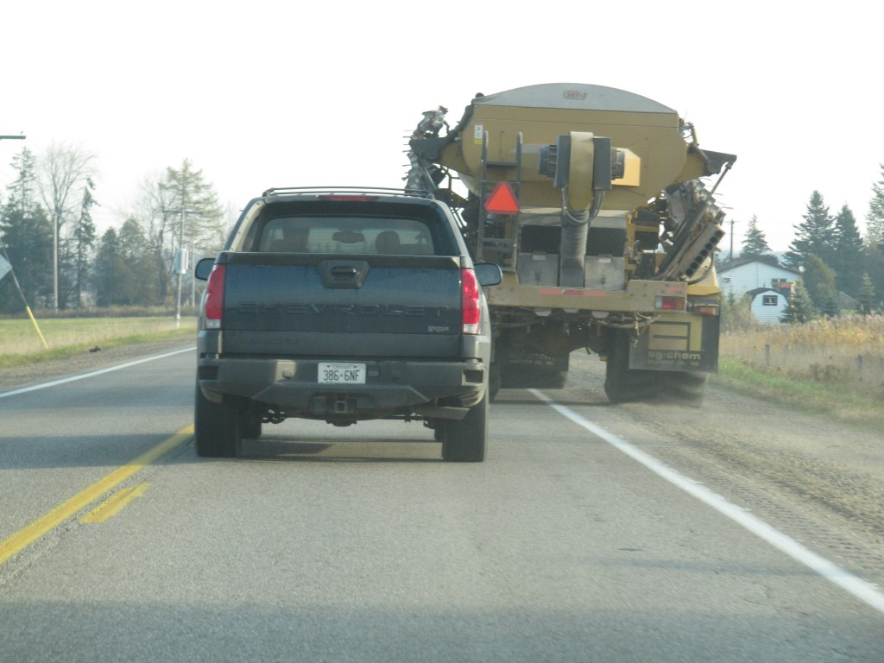
I Can't See - But Should I Take A Chance Anyway?
Well, no. You should never take that chance. Because losing your life is not worth it. Take a closer look. Did you see everything you’re supposed to. Go ahead take another look.
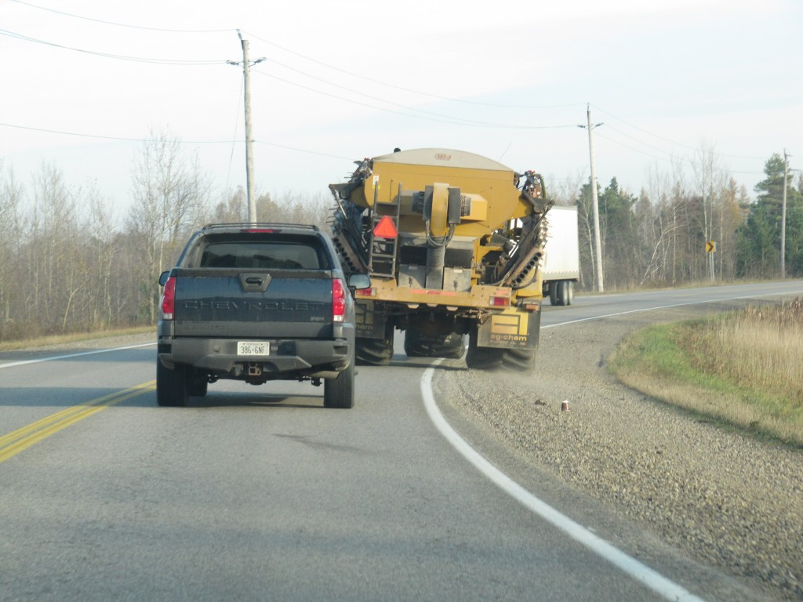
This Could Be the Last Time You See the Word "Freightliner"! - Think Again
Some Vehicle Manufacturers’ Refusal To Co-operate In Legal Proceedings Is Just Wrong and Should be Illegal
General Motors, and then Ford, should be commended for their cooperation and inputs toward vehicle safety and legal justice in the manner that they have developed, and made available to the public, the recordings from event data recorders (“black boxes”). General Motors was the first manufacturer to make this data available, not only to special interest groups such as police or for themselves, but to private individuals by working with companies such as Vetronix Corportation and now Bosch to develop a decoding product that can be used by anyone to conduct a download from a collision-involved vehicle.
It is an afront to justice and the democratic principles upon which many national constitutions are based, that some manufacturers set a policy of refusing a vehicle owner’s access to crash data even in the event of family deaths and catestrophic injuries. Many of these manufacturers claim that they do not possess the resources to download the data themselves or to arrange a relationship similar to General Motors or Ford, to have a third party developer arrange so that the crash data can be downloaded by specialized decoding hardware. In many instances of civil litigation where there may be death or catestrophic injury, lawyers or families who retain those lawyers are willing to pay thousands of dollars to obtain such downloads. Yet still some manufacturers continue to refuse that service.
It indicates how cheap the rights of average citizens have become. Many drivers and owners are likely not capable of raising the thousands of dollars necessary to obtain a download from a manufacturer or even from a third party company that owns the decoding equipment. In the case of a person wanting to clear their name from some alleged wrong-doing it has become as case of the rich get justice, the poor only get poorer.
It has been too many years now that the U.S. National Highway Traffic Safety Administration (NHTSA) requested that, if manufacturers insist on storing data about individuals’ crash experience by way of these event data recorders then that data must be made available to the public through decoding hardware that can be readily obtained by the public. A law was to take effect in 2012 and was then postponed to 2013 but the teeth of that law are still waiting to seen.
Resumption of Shafia Honour Killings Trial - A Resumption of “He Said She Said” But Little Scientific Fact
Much publicity has revolved around an event that occurred in June of 2009 where a family of four persons was found deceased in a submerged canal lock on June 30th, 2009 in Kingston, Ontario. Police charged three other members of the family with murder in what has been described as a staged car accident. Those three accused allegedly conspired to kill the others due to a family dispute.
As the trial proceeds much of the news media reporting has been centred on the testimony of one person or another, describing how one person lied or another said something that appeared unusual or perhaps indicative of guilt or innocence. This focus on what someone said or did not say is at the expense of revelation of the objective facts and scientific evidence.
As has become painfully obvious in many trials involving motor vehicle accidents, the focus of lawyers, judges, juries and the news media on what someone said is the reason why many innocent persons are found guilty or guilty persons are set free. Far too often these interested parties come to the erroneous belief that their superior intellect allows them to decipher when someone is lying or genuine. This is often at the expense of understanding the scientific evidence and analysis upon which guilt and innocense should be properly based.
As an example, a primary issue in this case is that police have stated that another family car was used to push the Nissan Sentra, occupied by the deceased persons, into the water. That is an important fact. But the reasoning for this allegation has not been properly revealed. Rather than focusing on who said what, the focus should be on objective evidence such as this and whether the evidence of that action presented by the prosecution is based on solid proof.
The difficulty is that few persons, even in the legal system, truly appreciate that reliance on what persons say, or have said, or whether they were consistent in what they say is fraught with failure. Yet we continue to rely on these outdated methods. It is the Wizard of Oz, shaking and rattling and exhausting smoke, that leads us to believe that the ordinary assessor behind the curtain is somehow god-like in being able resolve the motivation for human behavior where numerous psychologists and psychiatrists over the decades have not.
January 10, 2012
Double Fatal Rollover & Tree Impact In Mississauga
On Friday, January 6, 2012 Babar Akram and his friend Ali Habib were both killed when their Mazda RX-8 rolled and reportedly struck a tree on Erin Centre Boulevard in Erin Mills, Ontario. The vehicle was generally intact except for a sizeable imprint of a narrow object into the centre of the driver’s door area. Although a Mississauga newspaper article indicated that the vehicle rolled, struck a tree and a fence the shape of the imprint on the driver’s door does not match these reported facts.
The imprint is not what would be created during a simple rollover or from striking a tree. The very sharp vertical lines existing on the edges of the imprint suggest that the vehicle struck something man-made such as the rectangular shape of a lamp standard. This itself may not be of major significance except that we should always be concerned about the manner in which man-made objects deform or separate from their anchors. Objects, whether lamp standards, fences or various barriers must be of a character that would provide reasonable protection to vehicle occupants when struck. So a struck lamp stanadard that did not separate from its base but caused substantial crush and intrusion into the occupant space of a vehicle could be viewed as unsafe and improper, depending on the specifics of the circumstances. As is typical, newspaper articles rarely provide the type of detailed reporting that would inform the general public if such a problem actually occurred.
January 5, 2012
Seven Teenage Fatalities But No Questions About Road Conditions
Seven teenagers have been killed in two separate crashes near Parry Sound and Sudbury in recent days. Small mention was made that road conditions were poor, yet little or no mention is made of the actions of road maintenance personnel in the area to prevent these poor road conditions from occurring.
In the Parry Sound collision four persons were killed: Jessica Chamberland, 18; Alyssa McKeown, 17; Torry McIntrye-Courville, 18; and Cole Howard, 19. In that collision police were quoted as saying “…the roads were very slippery at the time..” but no further inquiry appeared to have been made by any news media whether this slippery road condition was due to the inactions of roadway personnel in preventing the road from becoming slippery. Police were quoted as saying a Camaro “…hit a patch of black ice…” causing it to cross the centre line into opposing traffic.
OPP Inspector Mark Andrews was quoted as saying there was no indication of alcohol involvement however, incredibly, he was then quoted as saying that “a lack of driving experience played a role” in the crash. He elaborated “If you’re an experienced driver, you’re watching for (black ice), some of our novice drivers aren’t watching. They don’t have the skill set to modify for that”. It is remarkable that Inspector Andrews, travelling at highway speed, at say 25 metres per second, could believe that he would be able to recognize black ice on the road, which should be similar in colour to the black pavement, and be able to “adjust” so that the tires of his vehicle could attain a proper grip to that ice, while say nothing about the danger posed by the black ice and whether anything was done to prevent its occurrence.
Alternatively, a surviving driver involved in the crash, Josie McKechnie, gave a different interpretation in a CBC radio interview. She was quoted as saying:
“I think maybe what had happened was the snow had melted with the sunshine and then the southbound lane of that section of the highway was in shade with the trees and, I think, with the temperature, likely froze. Idon’t think anybody could have anticipated it. The northbound car in front of me had no opportunity to even brake, it was so quick.”
Jennifer Savard, an aunt of the deceased girls was quoted as saying:
“They waited the extra day, they waited out the storm. They just had snow tires put on the car and all the levels checked. They waited until the next day and obviously it was still icy. Speed was not a factor. They were wearing their seatbelts. But they dont know winter driving. We learn it over time, by trial and error, what to do when the car starts slipping. You go into a ditch, you figure it out. They just never got the chance”.
Similarly, near Hagar (near Sudbury), three teenagers were killed: Keegan Melville, 18; Zabrina Rekowski, 19; and Hillary Afelski, 19. In this crash a minivan carrying four persons “crossed the centre line” of Highway 17 into the path of a Jeep. All three fatalities came from the van. No information was provided regarding weather or road conditions at the time of the crash or why the Ford minivan crossed the roadway centre-line. No information was given whether any news personnel these basic questions or if police made any inquiries of local road maintenance personnel regarding their snow clearance activities prior to the crash.
In an third, relatively unreported incident, Colin Rimkey, 18, of Orillia, was involved in a four vehicle collision on December 28th near the intersection of Highway 69 and Old Trout Lake Road. Again, Sgt. Bob Furchner was quoted as saying “The condition of the roads was very icy”, but no further response was given whether the icy conditions were preventable or whether the local maintenance personnel performed their duties as required.
In all these instances there is an immediate drawing of conclusions that somehow the collisions were the responsibility and result of poor or inexperienced driving. Dispite the fact that, at this early stage, none of these opinions could be based on the objective facts. Those opinions would require knowledge of basic facts such as the initial speeds of the vehicles involved and such information might not be known for many days or weeks after event and is often not shared by the investigating police. So to make these accusations, while not performing the investigation of what actions were taken by road maintenance personnel demonstrates the bias around which these investigations are carried out and the improper reporting of these facts by official news agencies.
January 3, 2012
Snow Squalls Present Exceptional Dangers To Drivers Unfamiliar With Southern Ontario Winter Conditions
Winter has finally arrived in Southern Ontario as evidenced by the annual snow squals that sweep off the Great Lakes and onto our rural highways. Particularly in the first part of the season the surfaces of the Great Lakes are not frozen and, as strong westerly or northerly winds pass over those large wet areas they take up a lot of cold moisture which turns into snow. All this white stuff is then dropped on the highways in very localized blizzards where the visibility could only be a few metres ahead and the snow accumulation could be be 6 inches (15 centimetres) per hour. If one of these streamers stays stationary over particular part of roadway there could be extremely hazardous conditions in the local area, while just a fews kilometers away the road conditions could be excellent.
At this time of year we have a lot of visitors to the Great Lakes region from visitors to the south wanting the experience a true white Christmas. This is OK, but we must remind them that snow and ice are slippery and the conditions need to be recognized ahead of time to prevent a disaster. The following photos high-light some typical dangers in our region during winter snow.
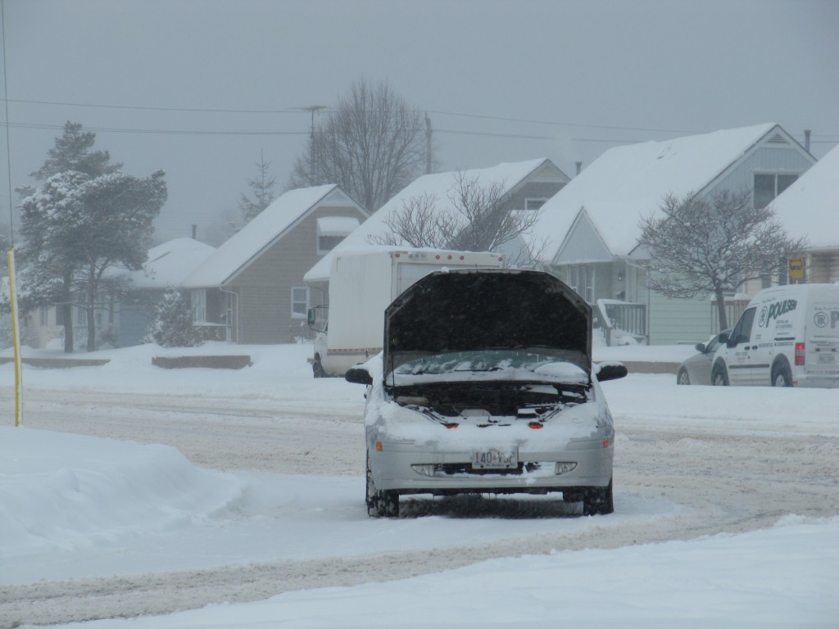
Vehicles in Poor Mechanical Condition Inevitably Come to an Emergency Stop in Inconvenient and Dangerous Locations
There is not reason to preach about the necessity of driving a well maintained vehicle. In recent years many families in North America have felt the economic pinch through no fault of their own and are left to drive vehicles that are of less than desirable condition. The reality is simple: Such vehicles will come to a halt in blizzard conditions at locations that are not only inconvenient but dangerous. The decision what to do when your vehicle stalls in traffic is never an easy one and your actions must depend largely on the unique circumstances. You need to evaluate the danger of your vehicle being struck by high speed traffic. If so, there is no point in remaining in your vehicle as the consequences are simply deadly. But if your vehicle has slid off the road in poor weather there is some reason to stay in the vehicle until help arrives. An emergency kit with blankets, a candle and other essentials are strongly recommended. This is a complicated issue that needs so thought.
Winter driving involves understanding that snow falls over top of many dangers that would normally be visible. In rural, two-lane, roadways the edge of the asphalt should be treated with respect. But when the edge of that asphalt is covered over by snow a driver does not know what lies beneath.
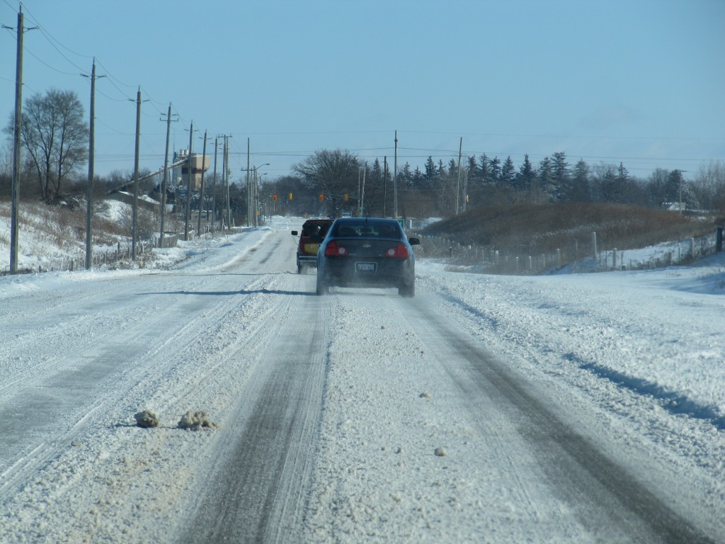
Snow Covers the Asphalt Edge Which Holds Unknown Dangers
Too often a dangerous drop-off exists between the edge of the asphalt and the gravel shoulder but that is covered over by an innocuous layer of snow. A slight mis-alignment, where the driver allows the right side wheels to travel too far to the right, can lead the right tires to travel onto a dangerous edge drop off and cause a sudden loss of control.
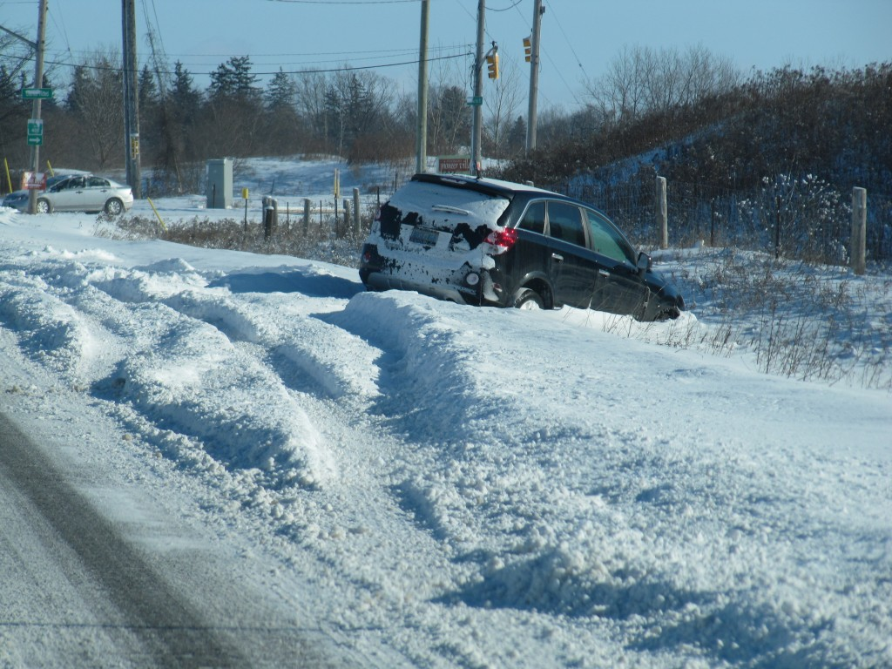
Loss of Control Can Lead to Unpredictable Results
Once a vehicle enters a state of loss-of-control the results are generally unpredictable. It may be favourable to have the vehicle travel onto the right roadside instead of into opposing traffic. But even this can cause an unpredictable rollover or perhaps an impact with a utility pole or a tree.
We often mis-understand visibility and the role that winter sunlight can play in masking many dangers. While bright sun can be helpful in illuminating objects it can also mask dangers. The photo below illustrates the danger when blowing snow clings to a warning sign to mask it message while the sun helps to blind the driver toward not realizing that the sign exists. Fortunately in immovable and large object such as a house tells the driver that the roadway does not continue.
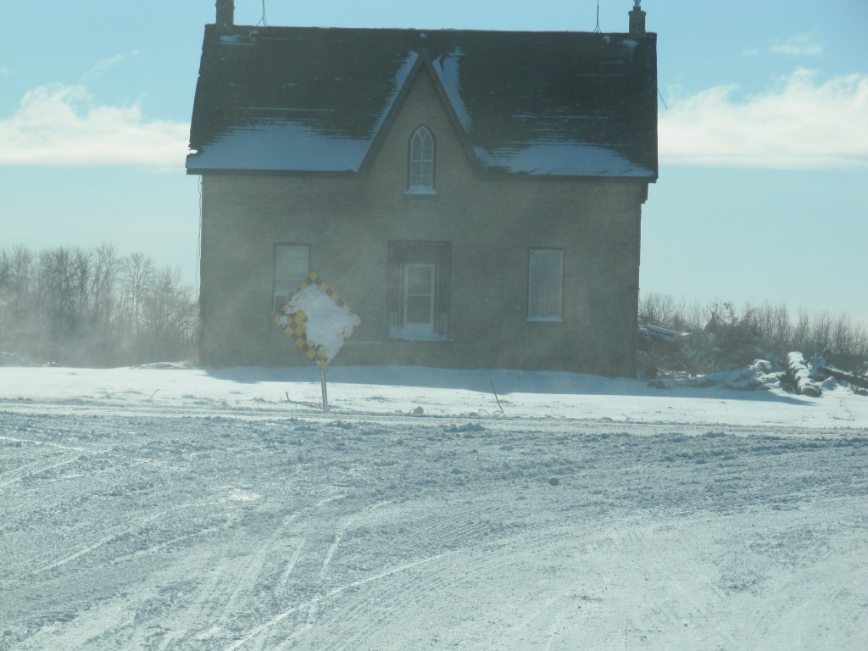
Warning Signs Can be masked by Bright Sunsight in Winter Conditions
Overall, there are many dangers that exist in our area during winter conditions that are often unique or uncommon to someone visiting us from a more southern climate. Even seasoned drivers who have experienced many winters in Ontario can be caught by surprize.
January 2, 2012
Pre-Cautions During Snow Plow Season
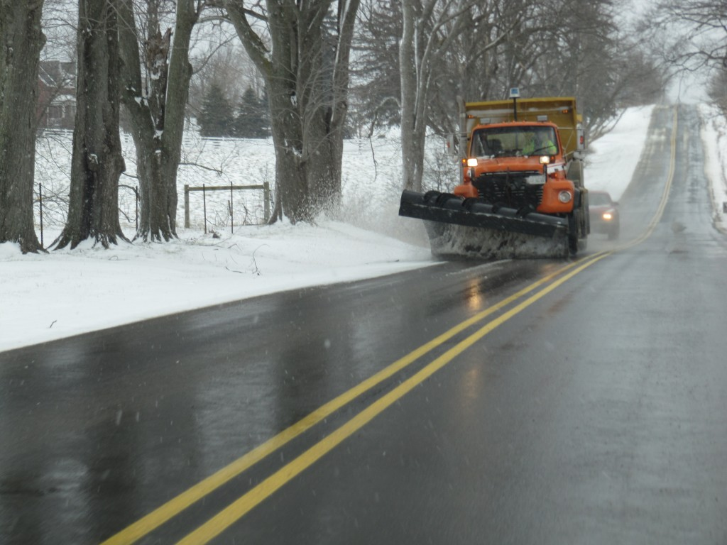
Caution: Snow Plows Are Slow And Block Your View Ahead
Every season brings its unique challenge to the driver. In wintertime snow plows are a common sight in Canada and that is no different in Southern Ontario. We often encounter snow plows during poor weather conditions when we may already be late for some particular engagement or work. The slow-moving plow sometimes entices us to make a bad decision to pass when the roadway terrain indicates there is not enough visibility ahead to complete a safe passing motion. This can lead to a very serious head-on collision at highway speed. Not a good choice.
So, take a moment to think this out. Major injury is not a happy consequence. Para or quadraplegia are consequences you may experience, or death may leave your family and circle of friends in a horrifying nightmare. None of that really needs to happen. Let the professional at the plow do his/her work and wait your turn.
January 1, 2012
PTCruiser and Chev Collide on Clarke & Dundas In East London
Injuries could have been significant had a Chevrolet Aveo been occupied by a right front occupant during an angle collision on Clarke Road just north of Dundas Street on Saturday afternoon, December 31st, 2011. The Aveo was southbound on Clarke Road and attempted a left turn into a parking lot at the north-east quadrant of Clarke and Dundas. A northbound PTCruiser stuck the right side of the PTCruiser during its turn resulting in substantial crush at the right front door of the Aveo. Below are a couple of photos, looking north and south, of the final rest positions of the two vehicles.
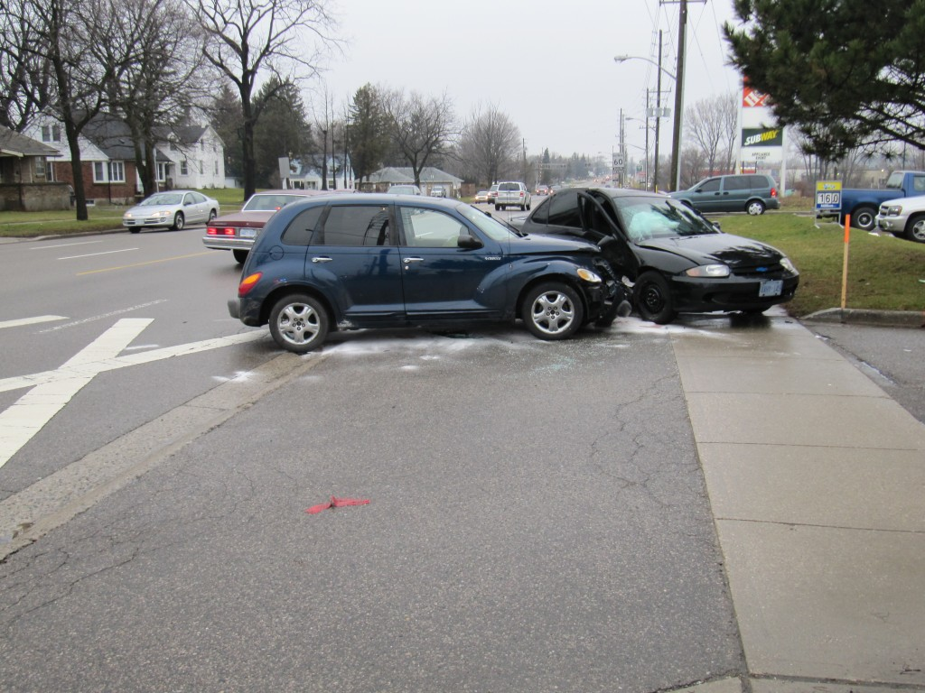
View, looking north along the east side of Clarke Road showing the PTCruiser and Aveo at their final rest positions following the crash.
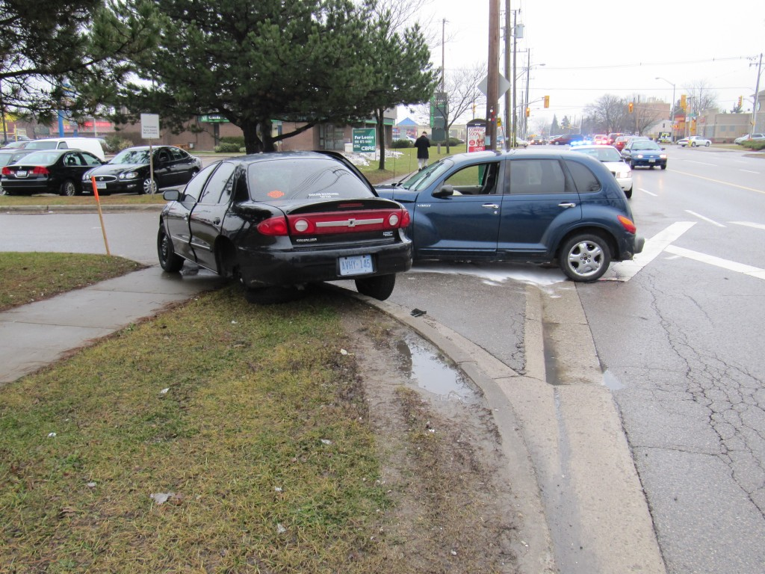
View, looking north along Clarke Road, showing the final rest positions of the vehicles.
Interestingly, as the the Aveo was driven sideways against the curb, its left rear wheel became separated due to a fracture at the axle. The brittle nature of the the metal of the axle makes this a common occurrence. The view below shows the left rear wheel tucked under the vehicle at final rest.
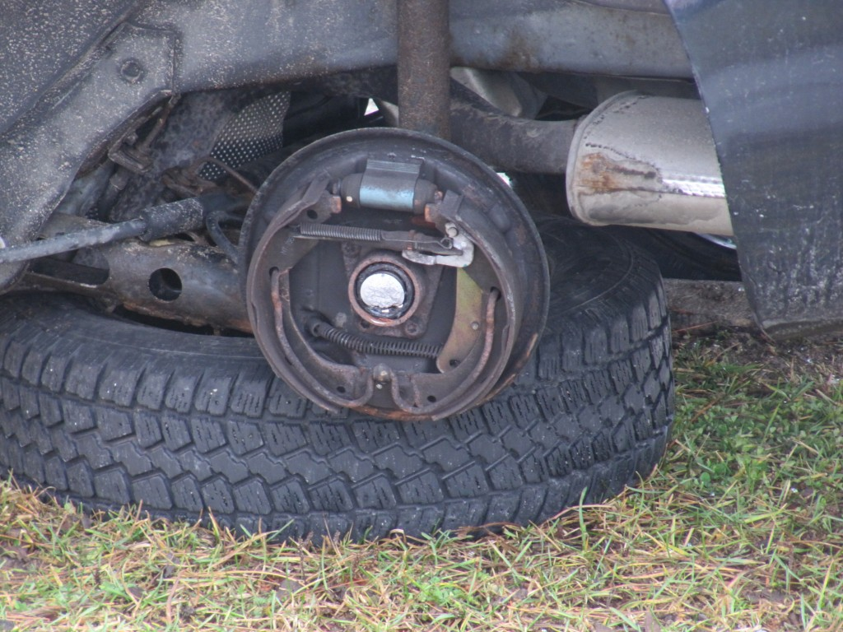
View of separated left rear wheel of
Second Tragedy Befalls Huber Family During Christmas Season
Eleven-year-old Jeremy Huber sustained fatal injuries as a result of a collision on December 22, 2011 at the intersection of Nafziger Road and Gerber Road near Wellesley, Ontario. It was reported that the Huber family was southbound in their van on Nafziger Road when they were struck by an alleged drunk driver travelling westbound on Gerber. The impact to the left side of the van was next to Jeremy’s seating position and he suffered major head and chest injuries.
This circumstance is more tragic due to the fact that the Huber family lost another son, Lyndall, due to a collision in March, 2011 near Palmerston, Ontario. The circumstances of Lyndall’s death involved a loss-of-control of his vehicle which subsequently collided with a utility pole. The cause of that collision was initially reported as driver error however in an article posted on this website we indicated that the physical evidence suggested the possibility that the driver was attempting to avoid something on the road. Subsequently police indicated that the female driver of a second vehicle was charged with careless driving but no further details were revealed.
It would appear that in both crashes the Huber family suffered due to inappropriate actions of other drivers. It is particularly noteworthy that prohibitions against drinking and driving have been advertised well in advance of the Christmas season. If indeed alcohol impairment was a factor in claiming Jeremy Huber’s life then the impaired driver should have been aware of the consequences of his actions.
Through many years of similar occurrences it is apparent that the hard-core repeat, drunk-driving offender is difficult to control and correct. Focused attention needs to be placed not only on indiviuals but also on how we can prevent chronic alcoholism, drug dependence and other parasitic problems of our society from claiming innocent victims. A genuine shift in our society’s focus to help those who might fall into such a parasitic lifestyle is not only good for the individual but also good, and a cost-saving, to our society as a whole.
New Child Seat Laws Will Not Be Easy For Parent Compliance
Although not publicly advertised, there has been a long history of problems in properly securing children to seat belts and other harnesses that were initially developed with the adult population in mind.
Even adults have continually worn their seat belts in a manner that subjects them to additional injury and death. As an often-ignored tragedy, we can recall the very unpopular crash in the late 1970′s on Governer’s Road west of Woodstock, Ontario where six, seat-belt restrained occupants of an Oldmobile were fatally injured in a head-on collision while the three unrestrained occupants of the opposing Chevrolet survived. The official investigation determined that several of those fatalities were caused by lap belts that rode up, or were positioned onto the soft abdominal area and not below the pelvic “illiac crests”. While the blame was placed on the occupants themselves, the seat belt legislation, without advertisement of proper seat-belt use, was perhaps the primary cause of those fatalities.
And many incidents throughout the decades have demonstrated that seat belts have never properly restained children that are substantially smaller than the average adult. Numerous child fatalities occurred before official advertising of the use of booster cushions and child seats. In the intervening time the general public simply complied with the law because it was the law and the cause of many injuries and deaths from seat belts were not made known.
There has always been the recognition amongst crash safety researchers that the proper restraint of children in child seats and infant carriers was mainly dependent on proper attachment of the restraints to the seats as well as the harnesses to the children themselves. The superior crash performance of the seats themselves was rarely an issue provided that the anchorages were installed properly. But the “properly” thing is the crucial point. How easy is it to anchor the child seat “properly” and how easy is it to attach the harness “properly” to the child or infant?
The vast majority of issues related to slack in the system. That is, parents cannot grasp the importance of making sure that the child seat is tightly secured to the vehicle structure by way of a tight seat belt. And similarly, it becomes difficult to tightly attach the harness to a squirming and dynamic child or infant that may also be wearing several layers of loose winter clothing. This slack in the system is what caused the child or infant to move into an inappropriate position with respect to the harness and seat/carrier. And while the seat/carrier may perform exceptionally in controlled tests with a “properly” secured child/infant that becomes more complicated in the real world when the “properly” cannot be practically achieved. Very much like the lap-belted adults who died of seat belt injuries, the parents are put to blame rather than recognizing the practical difficulties that exist in achieving that theoretical “properly” goal.
So, as of today, January 1st, 2012, our federal transport agency, Transport Canada, is changing their definitions so that children are placed in a rear-facing position of a child seat until they are of an older age or larger size. But many parents wonder how these older children will tolerate being placed in this position without wanting to squirm out or around to face the front. While placed in a rear-facing position the problem of being harnessed “properly” is reduced and the possibility of head injury is reduced. But again, how do you achieve this, practically, in the vast majority of the population?
It is an age-old problem that official agencies try to brush under the carpet.

