Gorski Consulting Website

Archived News - 2012 - June
June 29, 2012
Courts State That Ontario Municipalities And Ministry Of Transportation Law Does Not Protect Them From Liability – So They Just Reload
The Supreme Court of Canada has decided not to review the case of the Region of Halton and Town of Milton where they were found partly at fault for a collision on an icy Derry Road involving Patricia Giuliani on April 1, 2003. By that refusal the courts have confirmed that the Minimum Maintenance Standards regulation that the Municipalities, Ontario Ministry of Transportation and other defendants themselves created to protect themselves from liability will not fully protect them.
What is their response? They will simply re-write the law.
Now for our own editorializing…
To us this is no different than the actions of a third world dictatorship which makes up its own laws to protect itself at the expense of the general public. The pretense that these defendants are only protecting the general public from high taxes through preventing the courts from finding them at fault, when they truly are at fault, is a shell game that is a detriment to our Province’s collective best interest.
The fact is simple, a segment of our government, the Provincial Ministry of Transportation, has the responsibility to maintain our roads in a safe condition. In the recent past certain politicians in the Mike Harris government attempted to wiggle that Ministry out of that responsibility by preventing private citizens from suing the Ministry in those instances when the Ministry was negligent.
One way was by giving the responsiblity for road maintenance to lower tiers of government who could make up their own laws and who would no longer be subject to the “global” safety standards that were forced onto the entire province equally and fairly to all jurisdications. While this part of the “Common Sense Revolution” made sense to some, it is no different that the happiness of many gun-slingers of the old west when the Marshall left town and the citizens were left to fend for themselves. The law was left to whoever could draw his gun the fastest and not on the basis of logical justice.
Another way to circumvent its responsibilty was to create regulations such as the Minimum Maintenance Standards. Such regulations are unabashedly referred to by the very defendants who created them as the purposeful attempt to stop the judical process from finding them at fault, when all judical logical would conclude that, indeed, they were at fault. While we have not been happy with the functioning of our courts and have expressed that criticism when necessary, there is some comfort in seeing the ruling of Justice John Murray in his original ruling on the Giuliani matter, by preventing the province from falling into a lawless bordertown of gunslingers with no accountability for their own actions.
The primary issue remains as it always will: some entity in our society must be responsible for our collective safety when we travel our roads. When that entity has a monopoly it must also have a responsibility to the society and to be made accountable for its inactions or wrong-doings. This is particularly so in the field of roadway maintenance where information about what Municpalities and the Ontario Ministry of Transportation do during their maintenace activities is held in secrecy from the general public. If this secrecy persists then the only way a wronged citizen has of changing the actions of these monopolies is through the courts, and we agree that this is an expensive and unproductive way of making these monopolies accountable for their actions.
The more obvious solution is to make the actions of the Municipalities and the Ministry of Transportation more transparent and available for all Ontario residents to see. Presently that has been difficult as much of the reason for the secrecy appears to be the desire of these defendants to shield their actions from plantiff lawyers. Plaintiff lawyers would be more than happy to dig deeply into the specific actions of the defendants so they can have the arguments they need to suceed in their claims. But surely no one wins in this money-wasting enterprise except the lawyers from both sides of the battlegrounds.
From the outside all of this looks like a mad race of a dog chasing its tail with much energy lost and nothing gained. For the good of Ontario persons with a higher understanding of what is right for all of us must step forward and do the right thing above their own personal gain or bias.
June 27, 2012
Double Fatal Head-On Collision on Glencolin Road
We examined the site this morning of a double fatal head-on collision that occurred on Glencolin Road, north-east of Aylmer, Ontario, Canada, that occurred at approximately 1345 hours yesterday, June 26th, 2012. It was reported that a westbound Oldsmobile, driven by Richard McEown, 69, travelled into the path of an eastbound pick-up truck. McEown and the right-front passenger of his vehicle, James Hilliker, 58, were both killed in the crash. It was apparent that the front end of the pick-up truck struck the right side of the Oldsmobile and therefore the Oldsmobile must have rotated counter-clockwise before the crash. It was not immediately known what might have caused the Oldsmobile to go out of control in that manner as the roadway was generally straight and level.
We have uploaded an article that discusses the evidence found on the site of this accident from our examination on the morning of June 27th, 2012.
June 25, 2012
Major Motorcycle Crashes Over The Weekend Are A Sign of the Season
A fatal motorcycle collision has occurred on Highbury Avenue at the intersection with Brydges Street in London, Ontario over the weekend. Similarly, a female passenger of a motorcycle is clinging to life as a result of a collision at the intersection of Ron McNeil Line and Dalewood Road north-east of St. Thomas, Ontario.
Unfortunately these consequences are a sign of the summer times as more motorcycles are on the road and they are used more frequently for recreational purposes.
June 23, 2012
Site of Fatal Collision On Perth County Road 32 Near Stratford
A crash that killed 40-year-old Steven Bohms on Perth Road 32 near Stratford should normally have been survivable given the general circumstances. It was reported that Bohms was driving a Jeep on Perth Road 32 towards Stratford on Wednesday night, June 21, 2012, when the vehicle began to “drift” over the roadway centre-line. The driver of a Chevrolet Impala was travelling in the opposite direction and moved the Impala toward the right shoulder but a glancing impact occurred between the vehicles. The Jeep carried on through the opposing lane and into a corn field where the vehicle made a wide curving path through the corn coming to rest deep within the field. The Impala rotated counter-clockwise onto the right shoulder, then clockwise back into its own lane and then veered back into the right ditch where it came to a halt.
Given the rather glancing impact with the Impala and given the fact that the height of Bohms’ Jeep should have allowed him to sit higher than the driver of a typical passenger car leads us to believe that such an interaction should have provided him with sufficient protection from the impact to prevent fatal injuries. This is also based on the fact that the Jeep did not roll over but simply plowed through the field of corn as if it was driving through it. Therefore we believe that something uncommon must have led to his fatal consequence.
We examined the site on June 22, 2012, a little more than 12 hours after the occurrence. The sunny weather conditions make it more difficult to produce photographs that clearly show that evidence because of the glaring effect of the sun. However below is a general view of the accident site on Perth Road 32 looking toward Perth Road 130 which is only a few hundred metres away in the background.
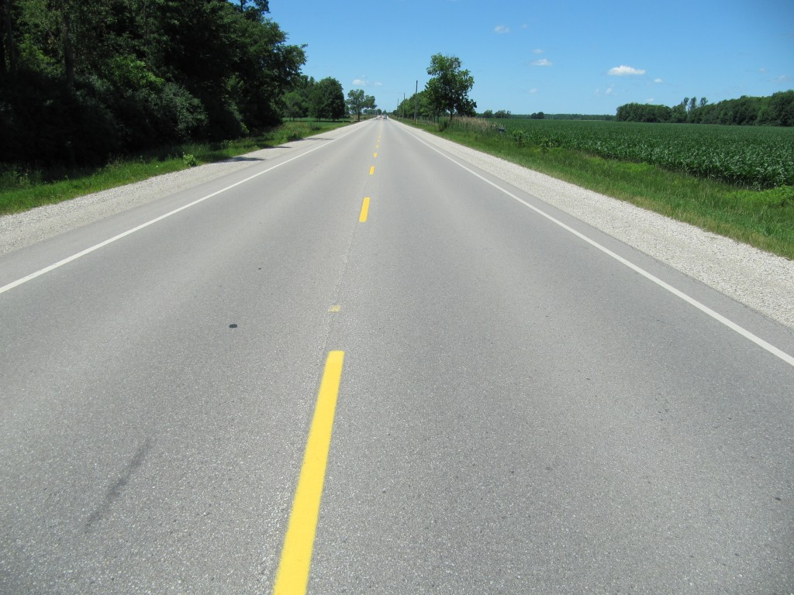
View, looking along Perth Road 32 toward Perth Road 130. The colliison site is near the closest tree located on the right roadside. This is the view that the Impala driver would have had on approaching the Bohms Jeep.
The corn field on the right side of the photo is where the Jeep travelled after impact.
In many situations a vehicle crosses a roadway centre line because it has previously travelled onto the right shoulder. Therefore, below is a view looking along the right shoulder of the Jeep (the Jeep would be travelling toward the camera). We did not observe any disturbance on this shoulder that would suggest that the Jeep was yawing (or rotating) on the gravel. It is also noteworthy that the pavement is a substantial distance from the white edge line of the lane and this is a beneficial characteristic.
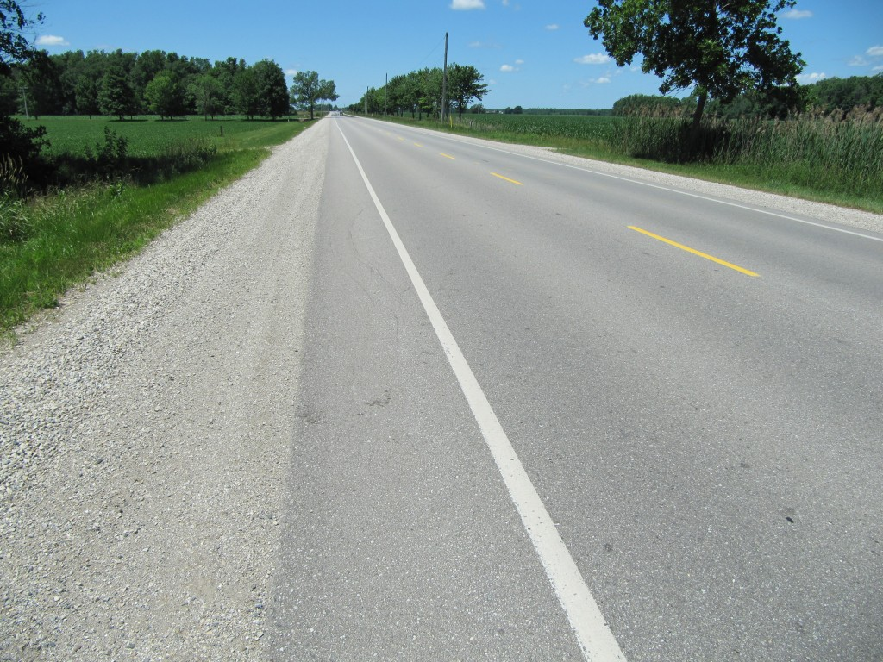
View, looking toward Road 130 along Road 32 along the shoulder where the Jeep might have travelled upon apporach to impact. The area of impact was approximately at the single tree shown at the far right corner of the view.
Although it might be difficult to see in these photographs, there was evidence on the opposite shoulder (i.e. the right shoulder of the Impala) that indicated that the Impala rode onto that shoulder as as the impact was occurring, likely in an attempt to avoid the impact. The photo below attempts to show you the evidence of that motion. For example it shows a black tire mark on the white edge line which would have been caused by one of the left side tires of the Impala while the right tires were in the gravel shoulder.
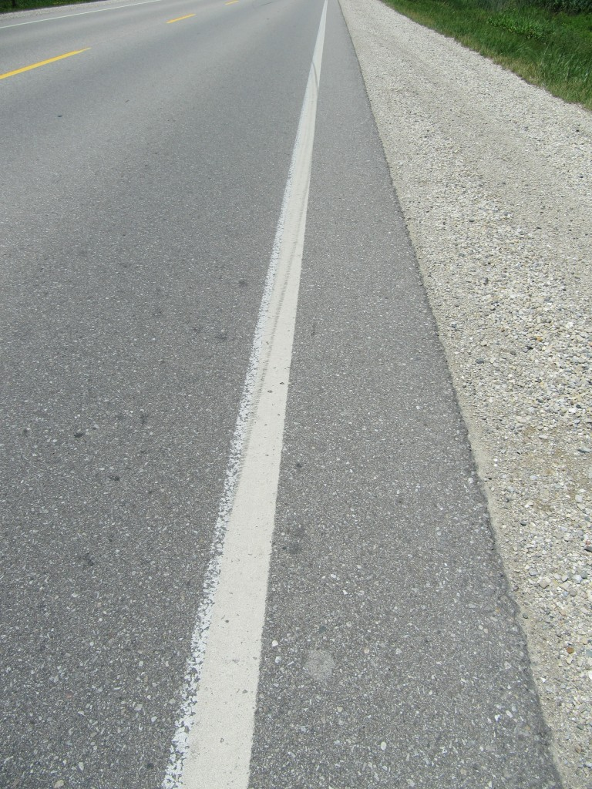
View of tire mark on white edge line caused by the Impala as it attempted to travel toward its right shoulder in an attempt to avoid the impact.
The curvature of the tire marks indicates that the Impala began to rotate counter-clockwise while on this shoulder. The Impala then re-entered its lane and then began to rotate clockwise as evidenced by the yaw marks in the photo below.
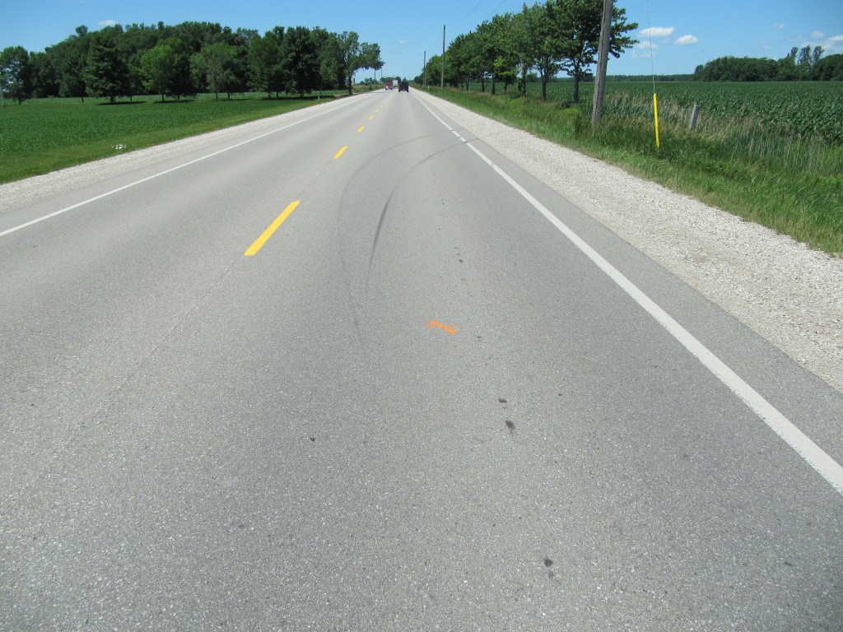
View, looking along the travel path of the Impala as it produced some yaw marks in its lane as it travelled toward its final rest position in the right ditch.
Turning around, we can look at the Jeep’s path toward its final rest position as shown in the photo below.
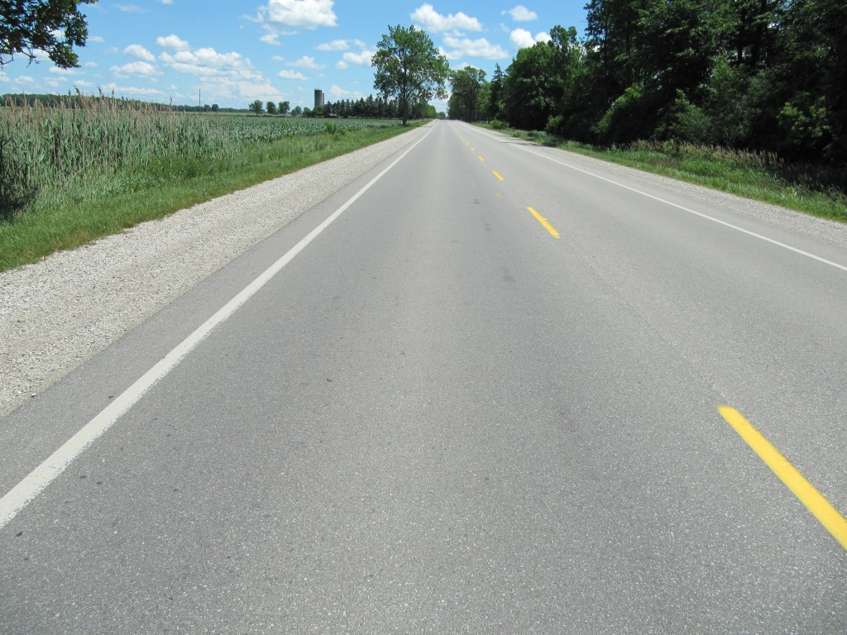
View, looking from the approximate area of impact toward the Jeep's path into the corn field. The Jeep's path was into the corn on the left side of this view.
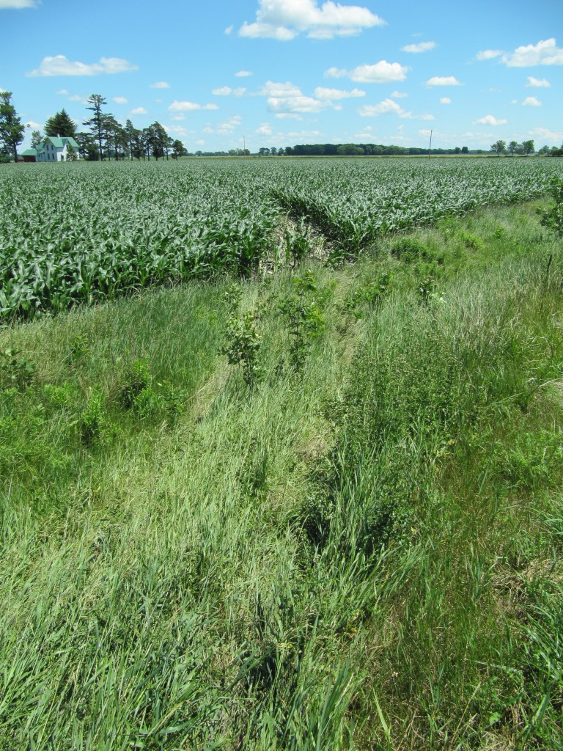
View of Jeep's entrance path into corn field.
The above photo shows a closer view of the point where the Jeep entered the corn field.
The fact that the Impala driver was able to drive toward the shoulder before impact suggests that the Jeep was exhibiting signs of loss-of-control was a longer than usual time. In most such cases a driver is rarely able to make any significant change in direction when an opposing vehicle encrouches over a centre-line. This fact illustrates the point that, as a driver you must look well ahead of your vehicle when driving on rural highways. Generally, if the opposing vehicle is within 50 metres (or about 1 second before impact) when you detect that it will come into your lane then it will be too late for you to do anything. Remember that two vehicles travelling at 90 km/h (25 metres per second) will close a distance of 50 metres between them in one second. At a distnace of about 100 metres (or the length of a football view you will have about 2 seconds to detect, recognize and react and in that scernario you may have a chance to affect the consequence.
June 22, 2012
Three Area Crashes In Last Couple of Days Suggest Similar Causes
Two fatal collisions along with a injury-causing crash that could have been fatal, all point to a similar cause that is difficult to evaluate in a scientific manner. All three crashes involved a vehicle crossing a roadway centre-line. In many of these instances there is a prior loss of control of the vehicle but it is difficult to be certain.
In Caledonia, James Merrilees died when his SUV collided with a fuel tanker truck on Highway 6 just outside of Caledonia, south of Hamilton, Ontario. This was a head-on collision where at least one of the vehicles had to be positioned on the wrong side of the centre-line at impact.
In a crash near Mitchell, Ontario a 66-year-old female driver crossed the roadway centre-line in her Toyota Vensa the front and left side of her vehicle struck the cab of transport turck. The truck driver was able to pull onto the shoulder before the crash and this suggests that The Toyota must have given the truck driver several seconds of warning that she was out of control since it is quite difficult to change the travel direction of such a large truck in a short time.
Last evening, June 21, 2012, a 40-year-old driver of a Jeep was involved in a collision with an Impala on Perth Road 32 , north of Stratford, Ontario. Again the Jeep reportedly crossed the roadway centre-line. Jeeps are known for their instability but the actual cause is unknown.
All three events have a similar result, a vehicle crossing a roadway centre-line. We need to study these events in more detail but unfortunately most investigations are tied up in either laying charges (police) or trying to sue someone (civil litigation) with little effort toward trying to understand the underlying cause of these events.
June 20, 2012
Cambridge Residents All-In-Circles Over Proposed Roundabout Near St. Benedict High School
Considerable opposition is growing against plans to construct a new roundabout on Franklin Boulevard near St. Benedict High School in Cambridge, Ontario, Canada. Many complainants point to recent collision problems at another roundabout (Homer Watson and Block) in Kitchener-Waterloo where a school bus struck a student pedestrian. Complainants believe similar collisions with students will occur if a similar roundabout is placed near the St. Benedict high school.
We conducted our own traffic safety study at the Homer Watson and Block roundabout and we reported on that study in an article in the Articles page of this website several months ago.
One of the major difficulties faced by both planners and politicians is that they are dealing with a public that has minimal information about the issue. It is a common problem in Ontario that accident statistics are well-guarded secrets yet this information is needed by the public when it places pressure on its civic leaders through uninformed comment. Whether/if roundabouts are unsafe or if certain types of roundabouts are bettter than others requires that someone conduct a proper study and that the methodology and results be made public. The problem in the Kitchener-Waterloo and Cambridge areas is that the public is not properly educated and informed.
Instead a survey has been made available asking the residents in the area to comment on various transportation issues. Again, uninformed persons will only provide uninformed opinions. It would appear that politicians simply want to gauge the public’s thoughts so that they can make a decision that will not endanger their political future rather than truly trying to get good and fresh ideas from an independent public that is capable of offering those good and fresh ideas.
June 19, 2012
Bicycling Helmets – Required or Not ? Ontario Chief Coroner Says Yes
A study by Ontario’s Chief Coroner’s Office recommends that bicycling helmets be mandatory in Ontario. This study was based on a review of 129 cycling deaths from 2006 to 2010 in Ontario. This has raised some contravery and debate amongst pro and con supporters for various reasons.
In our opinion, based on over 30 years of collision analysis, the effectiveness of properly fitted and properly worn helmets in reducing potential for injury and death is unquestionable. We should do all we can to increase the use of bicycle helmets by persons of all ages. Unfortunately, the situation in North America is a more complicated in that our transportation systems were not developed with cyclists in mind. Consequently cycling in Canada is very dangerous activity. There are numerous examples of this. Some issues are relatively unknown or unreported.
We want to highlight just one small and rather unique example. Below is a view of a dump truck hauling a pup trailer. The wheels/suspension of this vehicle was likely out of alignment such that it can be seen sidetracking within its lane.
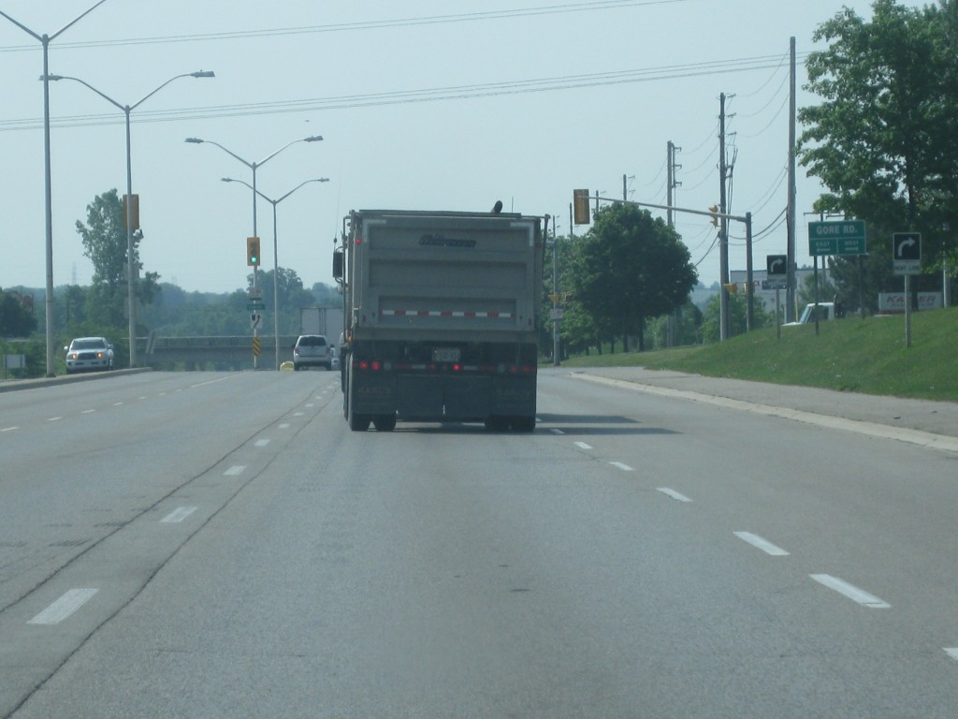
View of dump truck and pup trailer side-tracking while travelling along a highway.
It might not be terribly clear in the photo but the rear of the pup trailer was travelling substantially far toward the right edge of the travel lane even through the left front of the truck was well to the left of the lane.
Now imagine this scenario when the truck is travelling on a two-lane, two-way, highway and attempts to pass a cyclist. Certainly the front of the truck passes the cyclist but the rear portion of the pup trailer likely strikes the cyclist who is killed. Who would be at fault? Would anyone consider looking at the suspension or wheel alignment of the truck and then consider that its sidetracking could have been a factor? In my experience, likely not. This is a minor issue in the many factors that come into play when cyclists are in close proximity with fast-moving, large vehicles. And with respect to cycles, any motorized vehicle is a “large” vehicle because the consequences of large differences in mass are unforgiving.
One other point, when a fast moving vehicle is next to a bicycle we rarely consider that the end of a handlebar of a cycle is the furthest protrusion and therefore that part will be the first thing to come in contact with the passing vehicle. What happens when we violently pull the left end of a cycle’s handlebar forward while the rider has both hands on the handlebars? You will find that the upper body of the cyclist (and head) is rotated and is eventually pulled into the path of the passing vehicle. We suspect this has happened in several of our cases where major head injuries and death occurred. While a helmet may not prevent injury in such a scenario what other protection would a cyclist have to reduce the consequences of this occurrence? A helmet is the only way that a cyclist can reduce the chances of such a major head injury. It is too late to know that after it has occurred. But how many cyclists are aware of this mechanism?
We say again, a helmet is like a seat-belt in that it provides automatic protection when all else fails to prevent an impact. There is no panacea and no miracles, but helmets help.
June 18, 2012
Fatal Tree Impact On Centre Road Near Parkhill, Ontario
We are aware of the reported fatal collision on Centre Road that occurred on Saturday, June 16th, 2012. Unfortunately, due to our committments related to our normal business activities it is unlikely that we will attend the site to evaluate the circumstances of the crash. We apoligize to those who might have expected our input however we hope it is understood that, like any business, we have bills to pay and must focus our activities on our client’s needs when a conflict arises.
Overall, we have been surprisingly successful in examining a vast majority of the collision sites involving fatalities that have occurred within our vicinity in the last several years. This is not an easy task when we have our own business commitments to attend to. We hope that, if nothing more, we provide a different and educational perspective on these very difficult and tragic events with the possibility that some of this education results in a preventative action that saves a life.
June 7, 2012
Mini Cooper Fire After Striking Tree West of Strathroy Ontario Resulting in Fatality
It has been reported that a fatality occurred this morning at approximately 0320 hours on Naperton Drive, just west of Strathroy, Ontario, Canada, after an eastbound Mini Cooper collided with a tree and burst into flames. While the relevence of the fire is still to be determined, it is important to remember that Canadian Motor Vehicle Safety Standards (CMVSS) require a certain amount of protection to occupants of vehicles through standards that require fuel retainment and prevention of ignition of that fuel should a crash occur. Unfortunately, investigating police officers sometimes fail to consider whether the development of a fire is reasonable under the circumstances or whether the performance of the vehicle should be questioned and a defect complaint should be filed with Transport Canada. The Canadian Defect Complaint system, much like in the U.S. suffers from lack of publicity of its existence and thus many persons, including police, are unware of its existence and function.
As the roadway is presently closed we are unable to examine the evidence to evaluate what might have occurred. We will be monitoring this story and may provide further investigation of our own shortly.
UPDATE: June 12, 2012; 1655 Hours
Athough this collision occurred almost a week ago official news media have not provided any further information and there has never been any identification of the deceased. We need to keep in mind and accept that these are difficult results to family and friends. At the same time public safety requires that the public be made aware how and why a fatality occurred.
There are special concerns with the safety of ultra-small vehicles because they may not protect occupants as well as larger vehicles. Although federal departments of transport perform a limited number of crash tests to confirm that new vehicles comply with various safety standards none of these tests can take the place of real-life collisions which provide the most relevant data on a vehicle’s performance. The characteristics of Ultra-small vehicles make it challenging to provide a similar level of protection to their occupants as vehicles with greater mass and larger dimensions. Even relatively moderate crush to an Ultra-small vehicle has the potential of producing structural intrusion into where the occupant is seated. Higher stiffnesses of these structures also introduces the theoretical potential that impact forces and accelerations will be higher and it is difficult to isolate an occupant from these factors.
Any significant deformation of such a small vehicle introduces the possibility that failures and ruptures will create the potential for a vehicle fire. We need to pay attention to this possibility. When we do not reveal when such an event occurs we are in jeopardy of contributing to the death of another driver in the future because we failed to take steps to modify a potentially dangerous condition.
As to the actual collision site we confirm that we examined it within about 12 hours of the occurrence. Below is a view looking east from several hundred metres west of the point where the Mini Cooper struck the tree.
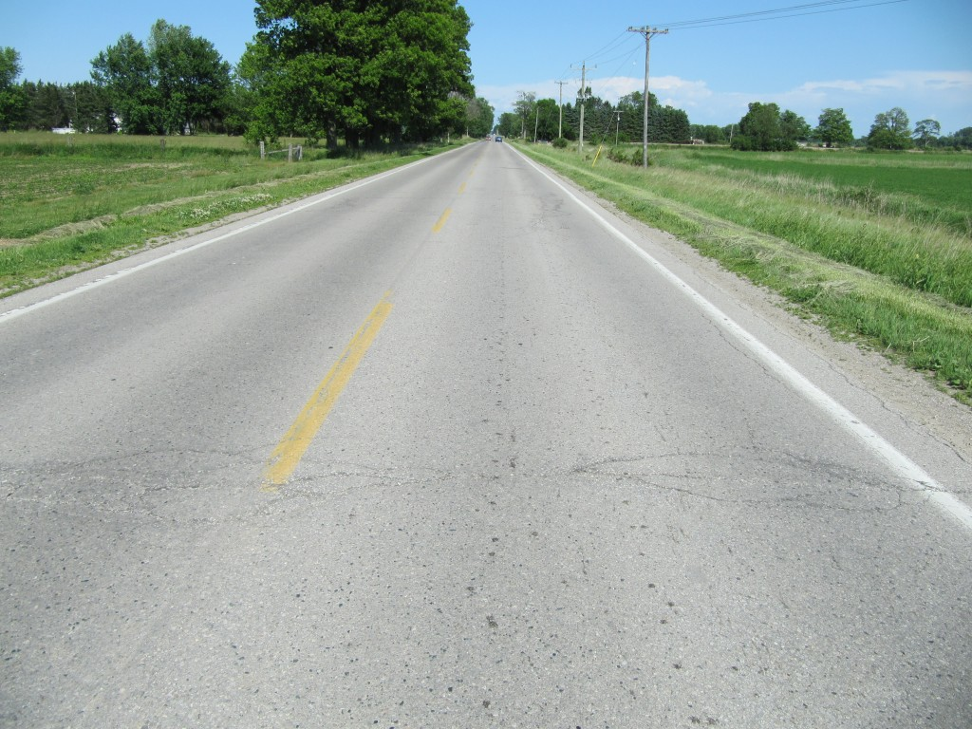
View, looking east along Napperton Drive, from several hundred metres west of the location where the Mini Cooper struck a tree.
There is nothing unusual or unsafe about the characteristics of the roadway. Note that there is substantial width between the white-painte edge line and the edge of the asphalt. We saw no indications of a significant edge drop off or any unusual cross-slopes. Although the pavement is not knew we did not observe any unusual deformation that could have contributed to this vehicle’s loss of control. It can also be noted that the roadway is generally straight and level. All these facts would suggest that the potential for a loss-of-control collision on this road segment should have been quite low.
The view below is taken from several hundred metres west of the impact location but this time we are looking toward the west or away from where the impact occurred.
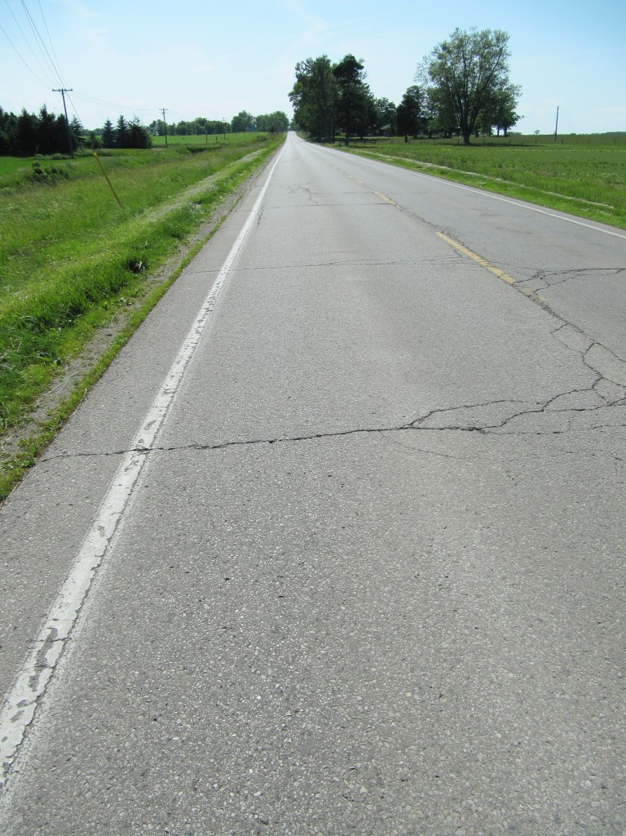
View looking west along Napperton Drive, from several hundred metres west of the area of impact
There is a slight knoll near the west horizon. While we watched traffic we oberved how eastbound vehicles were sometimes bunche together as they came over the rise and that several passing motions occurred in this straight section of road where passing was allowed. When roadway problems are not apparent then sometimes something like a passing motion might be involved and something goes wrong leading to a loss of control. Unfortunately we do not have any further information to confirm what could have caused this vehicle to leave the roadway and strike the tree.
June 2, 2012
Justices of the Peace Required To Be Lawyers – A Misguided Requirement From an Accident Reconstruction Viewpoint
Debate has been stirred in the last few days regarding proposed provincial legislation that would require Justices of the Peace in Ontario to hold a law degree. The legislation was introduced by Liberal backbencher, David Orazietti, and may not necessarily come into law.
Although the duties of a Justice of the Peace may be many, the portion of those involving motor vehicle accidents, the Criminal Code and Highway Traffic Act, lead us to believe that the legislation is misguided.
We agree that the qualifications of Justices of the Peace need to be improved, but causing them to possess a background in law will not improve those qualifications and, in certain instances, could actually degrade the quality of the Justices’ decisions within the narrower scope of motor vehicle accident issues. What we have observed from our limited exposure to JP decisions is that they lack understanding about basic and important issues surrounding how collisions occur and the evidence surrounding these issues. A law degree will not improve that understanding. In fact, a JP whose primary focus has been the “administration” of justice, increases the probability that the JP will not have sufficient training and understanding outside of that administrative focus.
Some of the worst decisions we have encountered were made by supposedly highly- qualified Justices and Judges, with substantial and advanced training in law, who developed an egotistical belief that they were all-knowing and their reasoning did not need to be tested by fully listening to the evidence. The possession of a law degree may only re-enforce this attitude while failing to focus the trier’s attention on the problems that we believe truly matter: Being a good listener, being prepared to adjust one’s reasoning based on new information, developing a good workmanship in the field of accident analysis and causation.
The greatest problem that we encounter is that the appointment of Justices of the Peace appear to be politically motivated resulting in individuals being placed in that position who, not only have no legal training, but who also have a poor ability and attitude for that role. It is as if those who make these appointments have little concern for the ramifications of these political appointments in terms of how the judicial system is harmed when inappropriate appointments are made. Also, when poor performance is expressed in a poor judgment there is little to be done to file a complaint to correct the Justice’s action or remove them from that position, if necessary. This is not a broad criticism of all persons in this position and it is unfortunate that the criticism should be made in those cases where very competent and skilled Justices do an excellent job, regardless of whether or not they hold a law degree. But requiring Justices of the Peace to hold law degrees will not solve the deficiencies in the system that we have observed.

