Gorski Consulting Website

Archived News - 2011 - 2nd Half
December 17, 2011
Ontario Ombudsman Marin Releases Second “Over-Sight” Report With New Criticsims of Attorney General’s Office In Undermining Province’s SIU
As if Andre Marin’s original report of 2008 was not enough of a wake-up call, Ontario’s Ombudsman Office has released a second report this week that would appear to be even more critical of the Attorney General’s Office handling of its own Special Investigations Unit (SIU). The new report specifically alleges that the Attorney General’s Office purposely “undermined ” the efforts of its SIU in dealing with investigations of alleged police criminal actions.
The new report, entitled “Oversight Undermined” continues to express great concern over inaction by the Attorney General’s Office in dealing with the ineffectiveness of the SIU in obtaining police cooperation during allegations of police wrong-doing. It describes incidents where police continue to refuse submittal of written notes of their actions surrounding investigations where officers are alleged to have committed crimes during the course of their duties. The notes are a required daily activity of every police officer. Instead the notes are apparently being withheld until a lawyer representing the police reviews the notes and changes are made. The problem is that the same lawyer also has access to the notes of other police and the notes of those others can potentially be changed to protect all officers involved.
It would seem incredible that the Attorney General’s office and police would act in such a manner. These persons are the ones who our society depends on to defend us from the dangerous people who would steal, assault and murder us. We expect that persons in these positions would act in an ethical manner. Yet, it would seem they do not understand that hiding information about a police officer’s potential criminal activity is simply wrong. The reprecussions of this are enormous in terms of the public’s respect and belief in the police being what they are advertised to be.
Incredibly, the police and SIU do not even share the same understanding of what constitutes the threshold for when the SIU should be called into an investigation. The police have simply adopted their own definition of “serious injury” regardless of whether that conflicts with the definition established by the SIU. If this does not warrant intervention by the Attorney General’s Office then what does?
In our view, the investigation of police criminal behaviour should be performed by the police themselves because, if we truly accept that they are there as protectors and investigators of criminal behaviour then there should be no difference whether the criminal wears a uniform or what kind of uniform is worn. It is a testiment to the deflation of the moral character of the upper administration of police forces that the government and the public has determined that police administration can not be trusted to police their own staff and therefore an independent agency, the SIU, must exist.
The existence of the SIU is devisive in that it creates two public agencies in a “us against them” environment rather than an “all of us against crime” environment. It basically says the police cannot be trusted. And unfortunately, perhaps because of the friction between the two agencies, police can no longer be trusted because they are too busy protecting themselves rather than protecting their own ranks from criminal penetration.
The field of motor vehicle accident investigation has a small relationship with this problem but never-the-less the presence of these problems exists. I have investigated an incident where the police investigation was improper, the crown attorney’s actions were improper and the manner in which a trial was conducted was also improper. Complaints to the responsible agencies led to no actions. This was a relatively minor matter but it has left an altered impression on me of the ethics of all these agencies combined. I cannot imagine how a person might feel who has been violated by a serious criminal act by police and not have that incident properly investigated.
Above all, society must insist that our justice system operate in an ethical manner. Mr. Marin’s report is a wake-up call that was not properly heeded in 2008 and he should not have to keep knocking at this locked door.
December 14, 2011
Serious/Critical Injuries To SUV Driver Who Struck Tree on Highway 59, South of Tavistock, Ontario – What caused the Crash?
A lone driver of a silver SUV unexplainably left his southbound travel lane of Highway 59 in Oxford County and crossed the northbound lane, entered the east ditch, and struck a tree. This occurred at approximately 0930 hours on Monday, December 12, 2011. Nothing would have caused this to occur as a witness, apparently driving behind the SUV, gave that impression. Police also were quick to note that the roadway was dry and clear and it was sunny. Because the SUV struck the tree with its front end the immediate reaction would be that maybe this driver attempted to commit suicide. Yet the evidence at the collision site would suggest that other factors could have been involved.
We are preparing an article on this collision which should be completed later today (December 14th, 2011).
UPDATE: DECEMBER 14TH, 2011, 1440 HOURS
An article has now been uploaded to our Articles page regarding this accident.
December 13, 2011
Early Morning Crash On Highway 401 at Foldens Road (Oxford Cty Road 6) Results in Fatal Injuries to Car Driver
A collision between a car and transport truck in the eastbound lanes of Highway 401 at approximately 0300 hours, December 13th, 2011, has claimed the life of the car driver. No further details are available at this time.
December 12, 2011
Darren Millett May Have Been Impaired But Physical Evidence In Fatal Collision Needs Proper Reporting
It was reported that Darren Millet was the driver of a Dodge Caliber that struck and killed Mounir Mahious on Cawartha Road in Mississauga, Ontario, on Sunday, December 11, 2011. Millett was also described as being charged with ciminal negligence causing death and impaired operation of a motor vehicle.
The collision was also described as speed-related and “so violent that it may have shredded their seatbelts…” as reportedly suggested by Constable Marlon Colthrust of Peel Regional Police. Both the deceased and his young son were reportedly ejected from their vehicle. This is where these comments need clarification.
Constable Colthrust may have been mis-quoted but photos of the two vehicles do not suggest that it was so violent. For example, there is not evidence that the wheelbase of either vehicle was shortened by the damage and this is clearly confirmed in the on-site photos shown in various news media articles. Also the A-pillars (front roof pillars on either side of the windshield are also un-disturbed on both vehicles. Similarly the hoods of both vehicles are not buckled. All this is factual evidence, unlike the rather hysterical descriptions provided in the news media.
As usual, the news media have also not informed the public about the true nature of the collision because they purposely failed to shows photos of the driver’s side of the Mahious Kia. While that decision is often made to spare some readers from suggesting that the newspapers are attempting to sensationalize a story, there are two sides to this coin. Because showing such evidence is also educational and explains to the public what occurred and why it occurred. Although we cannot see that damaged surface it is highly unlikely that the “shredded” seat-belts occurred because of some extreme severity of the impact. Rather it is most likely that this was a narrow, side-swiping action of the front end of the Dodge as the Dodge was rotating, counter-clockwise into the side of the Kia. Such an action often occurs when a vehicle such as the Dodge is rotating out of control before impact. And this is a common problem in real-life collisions that is being ignored.
Yes, as some reporters indicated, the Caliber coming to rest “hundreds of feet away” from the point of impact on its roof indicates a substantial speed but many vehicles travel at substantial speed, or highway speed and, following a collision where the change-in-speed is rather moderate, a vehicle can spin out and eventually come to rest several hundred feet down the road.
So Mr. Millett may be guilty of certain offenses that will be judged in court, but we should not sensationalize the evidence just because a tragedy has occurred that up-sets us.
The greatest tragedy may be that these consequences could have been reduced had we paid attention to the manner in which vehicles collide after the driver of one vehicle loses directional control of his/her vehicle. Although the evidence is presently scant, it suggests that this is another example where the loss-of-control vehicle (Caliber) was involved a “head-on” collision with the Kia, except that it was not an impact to the front end of the Kia but to its left side. This is precisely the kind of collision that is not being tested in various government (Transport Canada, NHTSA, Euro) research agencies because they have a continual mind set that collisions must be categorized as either head-on or angle but not a combination of both. It is precisely this type of narrow contact, applied from the front, that penetrates deeper as the contact progresses into a vehicle’s side, that is not addressed by either seat-belts or air bags. Crash tests are either frontal or side but none address a narrow frontal impact alone the left side as is apparent in the present case. While government agencies have been gathering data on real-life collisions since the late 1970′s minimal effort has been focused on this special type of collision.
It is not helpful at all, when we try to save ourselves the memory of these tragic events, by not discussing how persons such as Mounir Mahious sustained their injuries, because if we had done so twenty years ago then new vehicle designs would exist today that would have prevented this tragedy from occurring. And that is a further tragedy.
December 8, 2011
Chrysler Owners Out of Luck – But So Are Many Other Vehicle Owners
Democracy can be fickle as owners of some Chrysler products are finding out.
“Black Boxes” (event data recorders) that record crash information should theoretically be helpful to owners, and the general public. These devices exist in the majority of modern motor vehicles. Generally, EDRs record only a small segment of information before and after a crash so that this important objective information can help explain how a collision occurred. It has been argued that the benefit of maintaining such recorders is in helping to defend owners from improper prosecution of a crime or possibly a traffic citation. Secondly, the data allows various safety programs to understand how injuries are caused and therefore it is easier to select the appropriate counter-measures to alleviate these safety problems. Owners are assured that they can access this data through Crash Data Retieval (CDR) hardware that can be bought through the Bosch Coporation. Alternatively a third party operator who has the equipment can do that downloading for them. But for some Chrysler owners such benefits do not exist.
For model year 2006, some Chrysler 300, Dodge Magnum, Dodge Charger, Dodge Dakota, Jeep Grand Cherokee, and Jeep Commander models may contain EDR data that cannot be read by the CDR tool. It is reported that a technical problem prevents that download such that the only solution is to have the module that contains the data delivered to Chrysler for downloading by company representatives. Obviously, if there is a safety-related problem with a Chrysler vehicle and there is a dispute between Chrysler and the owner of a vehicle then that owner would be hesitant to deliver the module to the very “enemy” that they are fighting since Chrysler would be the only agency in a position to know whether the data was retrieved properly or whether the data was tampered with.
But beyond that problem, and even if the owner of the Chrysler product simply wanted to a defense related to somekind of criminal charge or highway traffic citation, that owner will still be out of luck because Chrysler now advises that they cannot accept requests for retreiving the data from their modules from private owners or consultants because they do not have the resources to handle such requests.
This sort of problem is not isolated to Chrysler but also exists in the relationship that many vehicle owners have with the manufacturers of automotive products they own. Information is gathered during a crash that is beneficial to large coporations, government regulators and police and when requests are made to manufacturers by these agencies they are able to gain access to the data while requests from average citizens are being denied.
This paradox becomes particularly vivid when there is a traffic death of a family member or a family member sustains permanent injuries such a quadraplegia or brain injuries that require a life-time of treatment for that injured person. It would seem an important part of our democratic society that the injured party, or the family, be allowed to develop a proper claim for compensation by retieving the crash data that might clearly identify who was at fault for those consequences. Yet there is no protection from agencies that who deny that basic right.
So, as the saying goes, we are all equal, it is just that some of us are more equal than others.
December 5, 2011
Auditor General Reveals Chaos That Exists With Ontario Insurance Claims
It is interesting how the numbers simply pass in one ear and out the other but those numbers, at the very least, are embarassing.
Ontario’s Auditor General, Jim McCarter, released a report about the recent status of auto insurance in Ontario and the facts speak for themselves.
Anyone who is involved in automotive safety is aware of the “official” declines in fatalities and injuries from automobile accidents that have been falling since the mid-1970s. Without looking at any source documents I know that about 7500 Canadians sustained fatal injuries in motor vehicle accidents in about 1974-5 and that number has fallen to about half of that in the latest statistics. Yet here is the Auditor General’s fact:
“From 2005 to 2010, the total cost of injury claims rose 150 percent even though the number of injury claims in the same period increased only 30 per cent,” wrote McCarter. Never mind the 150 per cent cost, but the number of claims rose 30 percent in five years. Where are all these injured persons coming from?
Also this little tid-bit:
The number of personal injury claims in 2009 was almost 75,000, 20 per cent higher than the number of people who reported having been injured in an automobile accident that year.
And the final note:
The government guarantees insurers a “reasonable rate of return” from their business that they calculated at 12 per cent.
Interestingly the report also states that the cost of fraud to the insurance industry in Ontario is about $1.3 billion a year. Hmmm, which fraud are we talking about?
When there are more claims than there are injured persons does that not sound like fraud? When the cost of insurance claims are going through the roof while there are fewer officially injured persons does that not sound like fraud? When the insurance industry is guaranteed a profit of 12 per cent regardless of its actions does that not sound like fraud? Never mind the greasy, shifty-eyed, black-shirted-white-tied, gangsters that we traditionally associate with organized crime. What about all the rest who are involved in this operation? Is it not, at a minimum, embarassing when these numbers illuminate the extent to which the whole insurance/legal system appears to be taking advantage of the fact that a monopoly exists with respect to auto insurance and legal representation in our justice system?
Yet, we also take these “statistics” as the genuine truth without looking deeper. For example, we have stopped independent documentations of “minor” collisions. It used to be that a police officer was responsible for this documentation function but now, as a cost saving to tax payers, that function no longer exists. Now we are asked to attend a collision reporting centre. “Apparently-low-speed”, non-injury collisions are those that are funnelled to these agencies. Yet these property-damage-only collisions are the ones that, days later, become personal injury collisions as the occupants discover that, 48 hours after the incident, their soft tissues are not tightening up and becoming more painful.
Similarly, single-vehicle collisions may not be reported because of the costs involved when insurance rates rise due to two at-fault collisions. Could this also be another hidden source of injury collisions?
There are likely many other subtle nuances to all this that only the industry insiders are aware of. Whether genuine fraud by the industry or inaccurate reporting of accident statistics, there certainly appears to be chaos in one form or another.
December 2, 2011
Honda recalls 304,000 vehicles for air-bag problems
TOKYO – Honda Motor Co. is recalling 304,000 vehicles globally, including 27,000 in Canada, for air-bags that may inflate with too much pressure in a crash, send metal and plastic pieces flying and cause injuries or deaths.
Honda said there have been 20 accidents so far related to this problem, including two deaths in the U.S. in 2009.
The Japanese automaker announced the recall Friday, which affects the Accord, Civic, Odyssey, Pilot, CR-V and other models, manufactured in 2001 and 2002.
The recall spans 273,000 vehicles in the U.S., some 27,000 in Canada, nearly 2,000 vehicles in Japan and another 2,000 in other countries. It affected 359 vehicles in Europe — 200 in Germany, 158 in Israel and one in Great Britain, according to Honda.
The latest recall is an expansion of recalls for the same problem in 2008, and again carried out in 2009, as well as last year. The recall now covers about two million vehicles worldwide, according to Tokyo-based Honda.
Honda spokesperson Hajime Kaneko said the cause for the latest recall was the use of incorrect material in the chemical used to deploy air bags.
The initial cause of the recall was excessive moisture in the inflator propellant, which is part of what inflates the air bag.
But that problem was found later to affect more vehicles than initially estimated, as incidents didn’t stop, and the recall was expanded to account for the possibility that the problem was caused by a defective stamping machine used during production, he said.
Honda is extremely sorry about the recalls but believes the problem has now been taken care of, with no more recalls linked to this problem expected, he said.
Also included in the latest recall are 912 air-bag service parts sold for installation in vehicles for collision repair and other reasons, Honda said.
The Associated Press
Kyle VanMoorsel’s Survival of Rollover Is A True Second Chance On Life
In August, 2010 we reported on a high speed rollover collision in the Sarnia, Ontario area where the driver, Kyle A. VanMoorsel, sustained critical injuries. Given the speed at which the vehicle began to tumble into a field of crop it was miraculous that VanMoorsel’s passenger came out of it without major injuries. Although it is reported that VanMoorsel sustained a neck injury that now is a visible scar, this may be a good reminder to him everytime he looks in the mirror, as to how close he came to certain death and that this is an opportunity toward a new life without mixing speed with alcohol. Although the comment is becoming rather cliche, the fact is that wearing seat-belts was likely what saved the lives of both occupants.
VanMoorsel was sentenced to a year of house arrest this is a far better outcome than if he and/or his friend had become bound to a wheel chair for the rest of their lives – a lucky outcome that many others in similar circumstances were not given, just by pure chance.
It is a reminder, particularly as we approach the Christmas season, as to how your life and the lives of those around you can become a living hell due to a major injury as a result of a motor vehicle accident. This can be averted by simple precautions such as assessing the condition of the driver of your vehicle, preventing an alcohol-impaired driver from driving, and refusing to become a passenger of a vehicle driven by an unsafe driver.
Two-Vehicle Collision On Plank Road (Highway 19) And Westbound Ramp to Highway 401
Although no mention was made in major news outlets, a two-vehicle collision occurred on November 30th, 2011 just south of Ingersoll, Ontario, resulting in the rollover of Nissan Altima into the south ditch of the westbound ramp leading from Plank Road (Highway 19) to Highway 401. The Woodstock Sentinel Review Newspaper reported that Ontario Provincial Police called in “collision reconstruction experts” to conduct the investigation. This would normally take place only if there were life-threatening injuries to one of the involved persons. But no further details have been revealed. Given the physical evidence at the collision scene it would appear that the rollover of the Nissan was at low speed and therefore the likelihood of severe injury would be lessened from that consequence however the severity of the initial impact with the second vehicle is unknown.
Below are some photos of the evidence at the site.
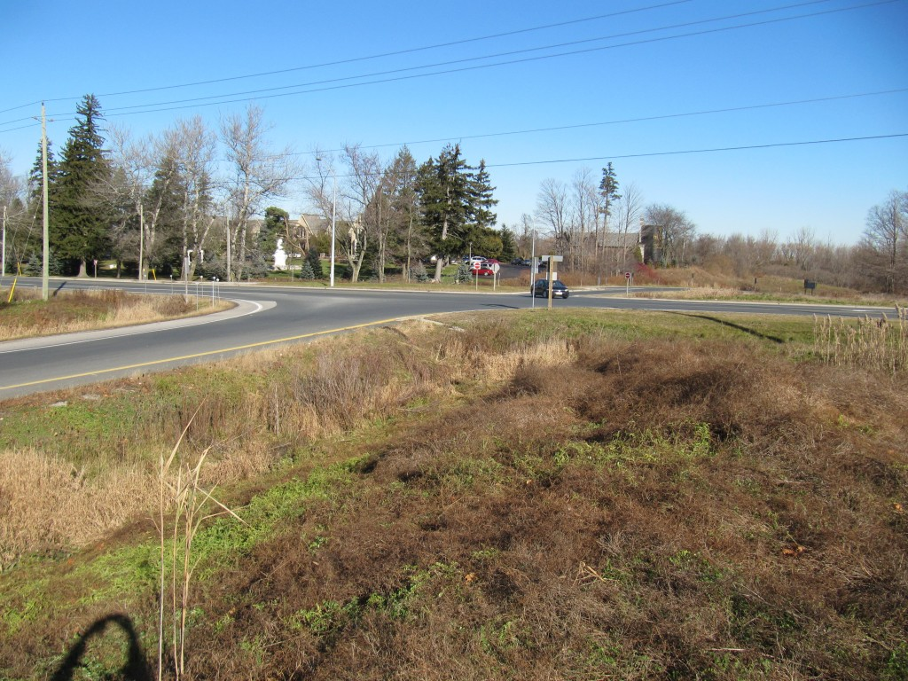
View looking east along the westbound ramp to Highway 401. Nissan rolled over into south ditch in the background
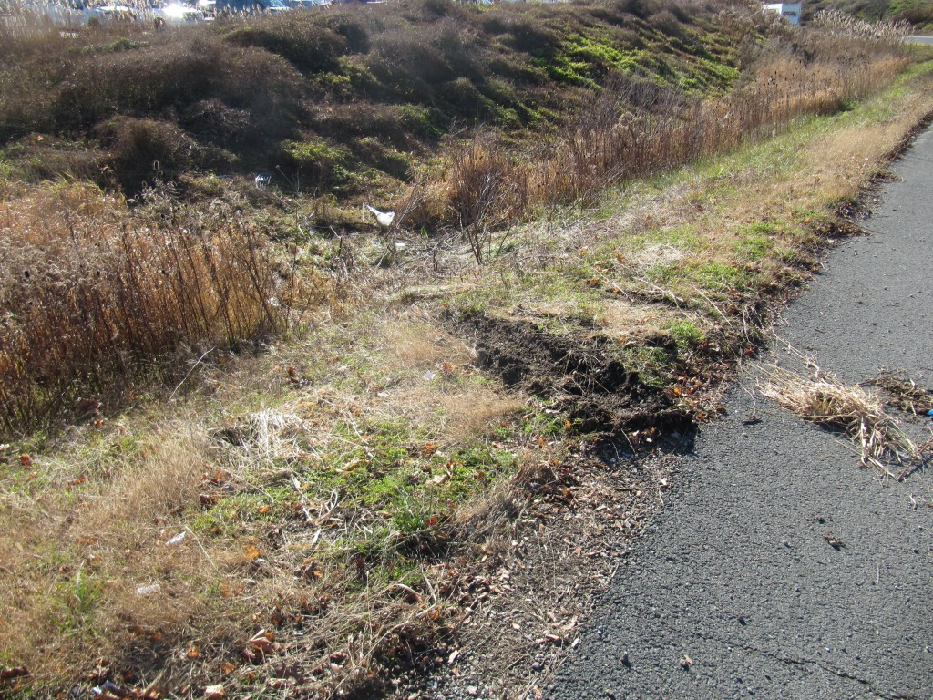
Earth gouging from towing where Nissan rolled into south side of WB ramp.
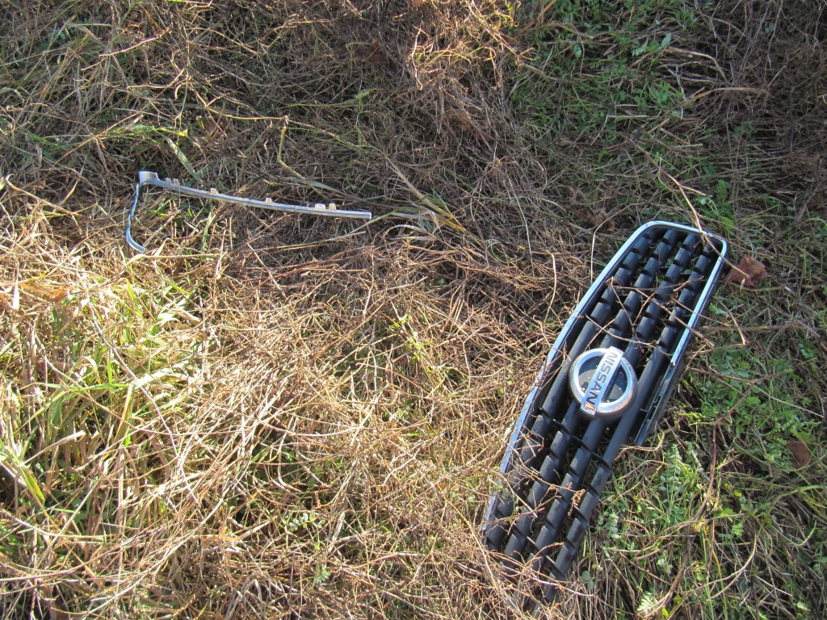
Parts from Nissan Altima lying in area of rollover in south ditch of westbound ramp of Hwy 401
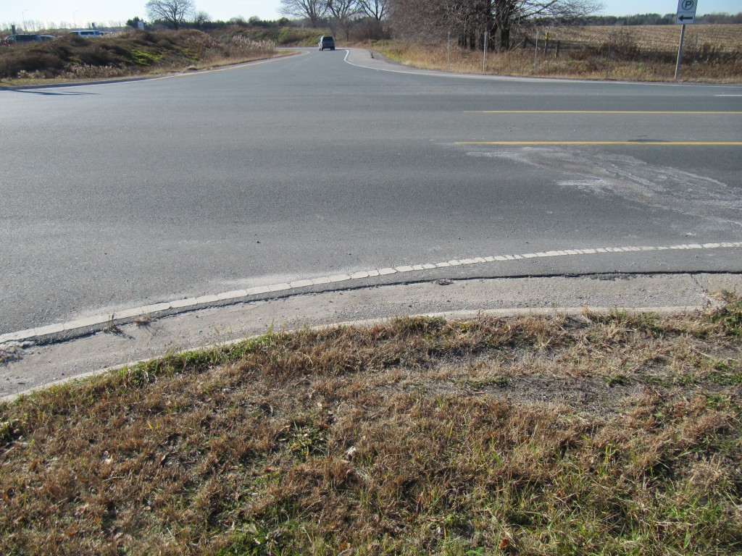
View looking west toward westbound ramp of Hwy 401. A fluid stain on the right edge fo the view indicates the final rest position of the second (unidentified) vehicle involved in the crash with the Nissan.
November 26, 2011
A fatal, single vehicle crash has claimed the life of a Norfolk County man, Gordon Alexander Oakes, 40. The 2005 GMC Sierra Pick-up truck that he was driving rolled over several times on Middleton NOrth Walsingham Townline Road, between Plank Road and Byerlay Side Road, south-east of Tillsonburg, Ontario at appoximately 1000 hours on Friday, November 25th, 2011. A passenger of the vehicle, Jonni Ionson, 22, sustained minor injuries.
UPDATE: November 28th, 2011
We examined the site of this collision on November 27th and have prepared an article on our findings that can be seen on our Articles page.
November 25, 2011
Recent Concentrated Maintenance Efforts at Clarke Road North of Fanshawe
Peculiar activity by City of London maintenance staff has concentrated on the problems mentioned several times in our posted articles. The edge drop-off issues have existed along the east edge of the Clarke Road in London, Ontario for a number of years and we have been monitoring the depth of the drop offs at 5 metre intervals over a required 20 metre distance.
In 2010 the edge drop-off was re-graded in August and November but then there was a long period of no maintenance between November, 2010 and October, 2011. During this time edge drop-off measurements were over 4 inches at several of the 5-metre measurement stations but predictably, a full 20 metres of edge drop-off above the 3.15 inch (8 centimetre) Provincial guideline (Minimum Maintenance Standards) was never reached because at least one of the five measurement stations always had an edge drop-off that was just shy of the 3.15 inch (8 centimetre) threshold. It has been our criticism that the biased Provincial MMS has created a threshold for maintenance that will rarely be met since edge drop-offs over 4 inches deep can exist for many months, as demonstrated at the Clarke Road site, without ever producing a full distance of 20 metres of those “excessive” values.
While we have been conducting our measurements and taking photos we have noticed that our actions have frequently been observed by City staff as they drive past the site. Interestingly, there has suddenly become a concentrated effort to re-grade the shoulder where this drop off problem exists. After the noted lack of action between November, 2010 and October, 2011, re-grading of the shoulder took place again on approximately November 3, 2011 or only about one month later. And now we observed that the shoulder was re-graded again on appoximately November 24, 2011 or just three weeks after the previous re-grading.
So something has finally caught the attention of City staff. This is good news for this one site and for this short time. But the issue of excessive edge drop-offs is a Province-wide problem that carrys across many municipal jurisdictions. While there may be periodic concentrations of effort for brief periods often that effort fades back to oblivion and long periods of neglect.
This can be expected when the responsibilities for maintenance are left to individual municipalities that do not have to answer to anyone. If inspections and maintenance are carried out it is done so in a secretive fashion. This is partly due to the pressures to maintain that secrecy from plaintiff lawyers who are quite eager to file a civil suite against what is referred to as a “deep pocket”, or an agency from which money is available for extraction by the courts. Municipalities have “circled the wagons” against this common threat of plaintiff lawyers and in so doing have made it impossible for the general public to confirm that their actions are what they should be.
Our work has involved evalution of accident reconstruction cases for both defense and plaintiff sides. When we raise the issue of hidden agendas by both groups it does not help the marketing of our business as it raises some irritation in both camps. However the safety of the public at large is at stake and that public is not particularly aware of the influences that are at work unless there is some violent awakening which will simply not happen. One fatal collision passes onto another and news media reports are a dry bit of reading unless it is your personal tragedy. Whether a roadway problem contributed to a collision or whether the problem has been trumped up by plaintiffs cannot be determined by the general public. Large monetary consequences lead largely to shifting of the facts like dirty laundry that has been left on the line.
November 18, 2011
Pavement Edge Drop-Off Problems
We continue to discuss the issue of pavement edge drop off. Over several years we have followed the development of this problem at several locations in Southwestern Ontario. It has come to light that, despite seemingly active maintenance of roadway crews these drop offs continue to exist. It would seem that a reasonable solution would involve regular inspections by inspectors and the sending of shoulder graders to re-level the gravel shoulders. But that is not happening. The only other solution is a permanant change to the width of the pavement where the problem persists. We have prepared a new article in the Articles page of this website that looks at a persistent pavement edge drop-off problem on Veterans Memorial Parkway in London, Ontario, Canada. The chronic problems at this location are not unique to the site nor is the City’s reaction any different that what we would expect from many other jurisdictions in our area. However there are reasons why problems like these are not being properly addressed and we provide our opinions in the article.
November 14, 2011
The Gorski Consulting website as been down for the last week as we dealt with some computing issues, which have now been resolved.
In this time a number issues have arisen both locally and internationally.
Locally, there continue to be a rash of fatal collisions in the area that give the appearance that our progressively reduced level of fatals in recent decades has turned back upward. Whether this is just an unscientific and media propogated appearance is unclear, but we seem to be attending a large number of fatal collisions in the area that did not seem to be as prevelant a year ago.
Continued Safety Issues with Farm Vehicle Collisions
Certainly, with the coming of the fall season we have witnessed a number of tragic collisions involving farm vehicles. Persons who rear-end such un-common devices or who are blinded by the unusual lighting, location or speed of these implements. Each year this is a common occurrence without much notice or focus applied by local agencies to inform the general public, and the farming community about what scenarios can pose a dangerous condition. Thankfully the harvesting season is near its end but there is always next year. I question when we will ever come together to form a collective response to these problems by highlighting what has been learned, even from this past season, about what to do and what not to do. Unfortunately it seems we will simply report the sad statistics in the general media as if it is a pre-ordained consequence with no apparent solution.
The Tragic Accident, or Homicide, Involving Justine Winter
Internationally, a particular accident scenario has caught the attention of the U.S. national broadcasters such as NBC in their Dateline program. The tragic scenario is one of a young teenager, Justine Winter, who has been convicted of homicide as a result of a head-on collision that occurred March 19, 2009 in Montana. Much of the trial was consumed over text messages made by Winter to her boyfriend just prior to the collision suggesting that she would commit suicide. Such messages became incriminating as Winter’s Pontiac Grand Am reportedly crossed the centre-line of a rural highway and collided head-on with a Subaru Forrester occupied by a 35-year-old female driver, Erin Thompson, and her 13-year-old son, Caden Odell. Both Thompson and Odell sustained fatal injuries while Winter survived. This event was even more tragic when the families of the victims were identified and the magnitude of the loss was appreciated.
Erin Thompson was obviously loved by her husband, Jason Thompson, who had endured several previous tragedies in his life but who had finally found his soul-mate in Erin. Jason was as decent of a man as anyone could imagine and his loss would have been deeply felt by anyone who became aware of his life. Unfortunately, the exceptional person that he was had the potential of playing into the emotions of the judge, jury and many who had a scant understanding of the evidence that was being brought forth at trial. It was more difficult for anyone to bear when it was also revealed that Erin Thompson was pregnant with Jason’s child.
The reported evidence was that Winter was travelling toward a construction site at a bridge and the speed of her vehicle “climbed to 85 miles per hour”. Road construction constricted the bridge from four lanes to two, yet Prosecutors said that she made no effort to brake as she entered the construction zone. A witness travelling behind the Thompson Subaru reported that the Subaru slowed and then there was an explosion as the two vehicles collided.
Police determined that Winter’s Pontiac crossed the centre-line and this is what caused the collision. It was reported that police “had a lot of questions” and that “we didn’t know why this happened, there had to be a reason”. The police then questioned Winter’s boyfriend and the text messages were revealed in which Winter threatened to commit suicide. Then “authorities believed they found the reason”. Patrol Sgt. Ernie Freebury was quoted as saying “She did just exactly what she said she was going to do”. And the County Attorney, Ed Corrigan added “She purposely went into that wrong way in traffic, ran into that car -and had to know, or should have known that by doing so, she was going to kill the occupants in that other vehicle”. Thompson’s Subaru was reported to be travelling at 31 mph at impact as determined by a state crash investigator.
Explanations of the evidence was revealing of the quality of the investigation. For example, Montana State Troopers “explained just how serious this crash really was”. Trooper Dustin Larette “discovered that the vehicles collided so violently that Winter’s car covered nearly 70% of Erin Thompson’s vehicle”. Although much of the objective evidence was never revealed for our evaluation, some photos of the vehicles were available through various news media and the police comments are enlightening.
Trooper Glen Barcus referred to a “hash mark” made by the speedometer needle at 85 mph at the point of impact. His remark was ” The vehicle stops and the needle continues to go for a second. In that split second it can impact the speedometer and leave a mark”. Barcus was also quoted as saying he believed that Justine Winter was not wearing her seat belt based on the evidence that “showed no stretch marks or cuts on the seat belt and that it was loced ina the up right position. It is unclear whether the media reporting is bad or the investigation was bad, or both were bad. But clearly this comments expressed a horribly, unprofessional ignorance of what evidence should be relied upon to make such conclusions.
We do not make conclusions about vehicle speed from speedometer needle imprints, we do it from things like pre and post crash directions of travel, amount of crush on the vehicles and other evidence. The Thompson vehicle was not “covered 70%” by the Winter vehicle. Frankly, I don’t even know what that comment means. How much crush was there, was it representative of a certain change-in-speed or Delta-V? That is what we should be talking about.
The conclusion about seat-belt usage from “stretch” marks really impresses me. Does not police investigator really understand what he is saying? This is a colllison with massive intrusion of the structure into the seating spaces of both drivers. Such intrusion often gets to the drivers before they have time to apply a load to their seat-belts. So, sometimes, in very severe crashes you may find little evidence of “loading” marks on a seat belt. But such theoretical mumbo jumbo is irrelevant. The question is: What evidence did the police investigator find on the seat belt and where was it located. Even if the seat belt was not worn it has nothing to do, and should have nothing to do with the finding of whether someone attempted to commit suicide.
Sgt. James Kitchin provided more useful information in terms of the data that was recoverd from the “black box” of Winter’s Grand Am. This indicated that “she was travelling 86 mph two seconds before her airbag deployed”. But clearly that is not all that the black box indicated. Surely if the speed was recorded then this was likely an SDM that would have five seconds of pre-crash data about braking, throttle application, engine speed and speed in mph. But all that evidence is not presented. One of the recordings on such an EDR is whether the driver’s seat-belt was latched during the crash. But anyone familar with such recordings knows that the default, place-holder for that coding is “Unlatched” meaning that it can be recorded as unlatched if the signal to switch it to latched is not properly received/achieved. No mention was made of that common possibility.
Peculiarly, Caden Odell, who had been seated in the right front seat of the Subaru died of a “broken neck” as determined by the coroner, who was reported to be Sgt. Ernie Freebury. This is an interesting revelation by the news media since in all other parts of the civilized world coroners are supposed to be medical doctors, not Seargents. So what is reported somtimes needs to be taken with a grain of salt.
What is apparent when I read all these news articles about this case is just how uninformed persons are, not just in the news media, but most importantly, the investigators who bring the evidence to a trial, the jurors who must make the ultimate decision of guilt or innocence and the judges and lawyers. What these people focus on are issues such as the meaning of a text message and whether that indicates a deliberate intention to cause a collision. They have absolutely no clue about what is important.
This collision occcurred as a head-0n collision with about a 50% overlap, or less of the front ends of the vehicle. People have no clue to the fact that this is typical of an accidental event. When head-on accidents happen they involve about 50% of the left front ends of the vehicles. Did the jury know this? Did the judge or lawyers understand this?
What about energy dissipation. Vehicles travelling at 31 and 86 mph create a total kinetic energy that has to be dissipated by crush and post-impact travel. What was the kinetic energy is this crash? Was it calculated? Did the police have the ability to calculate that total energy? Did it match what the EDR (black box) recorded?
At one point I read a small comment in the news articles about there being braking by the Winter just before the crash. Hmmm. Why would you be braking when you are attempting to commit suicide? But this is the type of reaction you would expect in a head-on collision in the very short time that a driver realizes their vehicle is crossing the centre-line or the other vehicle is coming into their lane.
And there was a comment, even from the witness about the Winter vehicle “veering” into the other lane just before impact. Hmmm. Why would someone wait until the last instant to veer into the opposing lane when attempting to commit suicide? Is that typical? Did anyone actually look at other collisions that were obvious suicides to see if this veering action was common or expected? What if I said that, in my experience, suicidal drivers line up their “victim”, whether it be a tree, wall or other vehicle, from a long distance so they can be sure that they can make contact? They do not “veer” suddenly into someones path even though lawyers, judges, and jurors would like to believe so.
But how easy would it be to line up a “victim” in the very last second or seconds before impact. Make this mind experiment: pretend you are travelling 86 mph and another vehicle is travelling 31 mph toward you, how good are you going to be at aiming your vehicle into a head-on collision that will assure your death? Do you turn your steering wheel 30 degrees at 2 seconds before impact or do you turn it 5 degrees at 5 seconds before impact? Did anyone in the courtroom know? Did anyone actually perform any kind of test to determine whether this would be such an easy task for a 16-year-old female?
Why did Ms. Winter decide to pick this complicated scenario to do herself in, in the middle of a construction zone where the narrowed confines might lead drivers to possible lose directional control of their vehicles. Google maps indicates that the highway was straight as an arrow. Why not aim for something that is more accessible, that is standing still and easier to hit such as a tree, wall or something very large like a transport truck? Was the court informed that many suicidal drivers were pick such “victims” because these suicidal drivers can be more certain of their success?
Ms. Winter was found guilty of homocide and was sentenced to 30 years in jail for an incident which she cannot remember because the her brain injury. But that is not the point. I have grave concerns about the manner in which our courts operate. We are very much controled by judges, lawyers and jurors who might as well be blindfolded and ear-plugged when it comes to understanding the evidence that is before them. Combined with “experts” from all sides who are either hired by the crown (state) or by the defence or plaintiff and these fine persons are able to make water flow uphill and ghost vehicles pass each other through some form of vaporization device developed on the starship Enterprise. No one in the whole troop is obligated to find the truth without twisting, sensationalizing or using some hypocritical logic to get at what they want to see happen.
In the end I see many victims, obviously Jason and Erin Thompson and Caden Odell, and their families. But I also so Justine Winter and her family. I see all these people caught up in a crazy scenario that fate has thrown at them and some are left behind to try to make sense of it, if they can. I also see a system of investigation and judgment that is twisted and broken. Investigators who do not understand the meaning of evidence. Lawyers who are interested in doing whatever it takes to win a case. Judges and juries who are not equipped to deal with the complications of modern evidence and have no impartial expert to steer them along a proper course.
This matter is now to be delivered to a Supreme Court, in Montana, I believe, where an appeal to the verdict will be heard. Whatever the result I hope that it is based on a clear understanding of the objective evidence. Let me repeat, objective evidence.
October 30, 2011
Young Driver’s Life Is Claimed in Highbury Avenue Rollover Collision
A fatal, loss-of-control, rollover collision occurred this early morning on Highbury Ave South, between Manning Drive and Glanworth Drive, just on the south border of London, Ontario. A Mercedes was travelling northbound on Highbury and approached an S-curve. Just as the Mercedes entered the curve it travelled onto the east shoulder and then into the grass roadside. There were no tire (yaw) marks to indicate that the vehicle was out of control prior to travelling off the road. However, once it came off the paved surface there was clear evidence of its counter-clockwise rotation. As it reached an approximate 45 degree angle it struck the earthen embankment of an access driveway leading to a farm field. This projected the vehicle into the air and caused it to commence tumbling for approximately 82 meters. The vehicle came to rest on the east gravel shoulder. Although the 16-year-old driver was reported to have been ejected from the vehicle there was no physical evidence to determine where the ejection occurred or where he actually came to rest.
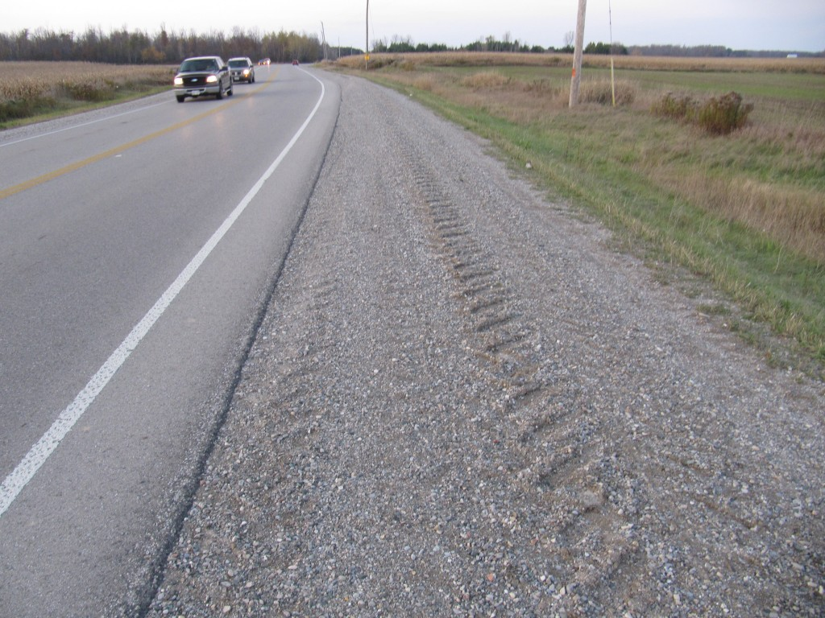
Looking north at tire marks travelling onto east shoulder of Highbury Ave
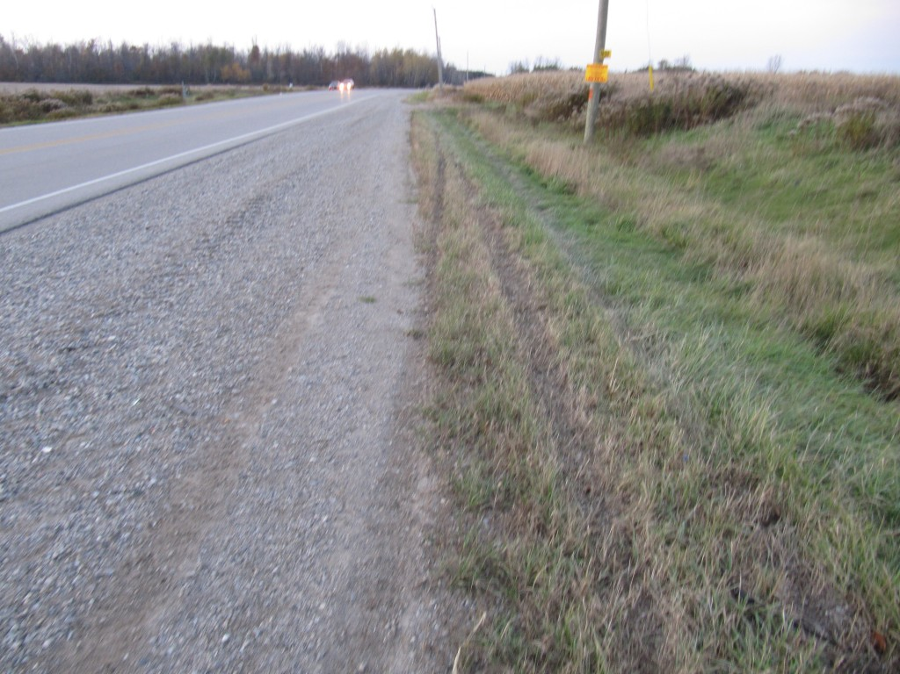
Looking north at counter-clockwise rotation tire marks on east shoulder
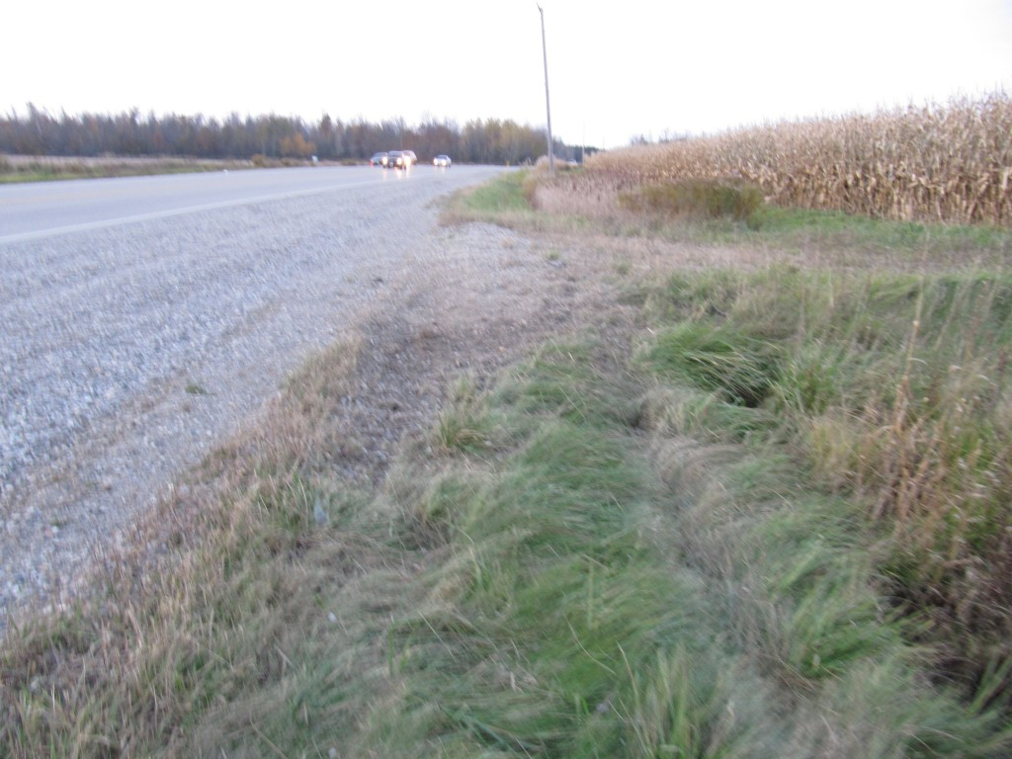
Looking north at point where Mercedes struck the driveway access leading to its rollover
The mystery at this time is in determining what caused the young driver to travel off the road surface. Undoubtably the police investigation will confirm that the young driver was travelling at high speed but that in itself is not what caused the vehicle to travel off the road surface because the vehicle left the roadway before the curve, not while attempting to negotiate the curve. Several possibilities exist including that the driver may have fallen asleep or was otherwise incapacitated. But other possibilities include the involvement of another vehicle or other vehicles. A skid mark from a dual wheel, typical of a heavy truck, existed in the straight portion just south of the curve and this evidence could be related. However this cannot be determined without knowing if the police have spoken to witnesses or other drivers who may have been in the vicinity when the incident occurred.
The lack of yaw marks on the paved road surface is uncommon and may indicate that the driver of the Mercedes did not lose control of the vehicle until after if left the road. However, if there was substantial dampness of the road surface, which is not uncommon on cold fall nights, then the opportunity to produce such visible yaw marks would be diminished. Hopefully further information will be revealed from the police investigation shortly.
October 26, 2011
October Typically Busy Time At Gorski Consulting
While it is apparent we have not been preparing many articles on our Articles webpage in the last couple of months this is only because this has been a very busy time as it usually is every year. There have been a number of important collision events occurring around us that deserve comment however we are firstly committed to handling the files of our clients. When time permits extra-curricular examinations of sites and testing is done, reported and summarized in articles.
So this note is meant as a brief apology and to indicate we will likely be freed up somewhat in a couple of weeks and will continue adding new articles at that time. In the meantime we can only make brief comments in this news section unless something quite critical becomes necessary to be discussed.
October 22, 2011
Drivers Dying of “Medical Conditions” at an Unusually High Rate
On October 19, 2011 an 81-year-old male driver was killed following a head-on collision on Longwoods Road just west of Dew Drop Line, just west of Thamesville, Ontario. It was reported that the man was driving a Dodge Intrepid and that his vehicle crossed the centre-line of the roadway when it collided with an eastbound Ford which was occupied by three women from the Thamesville area.
The roadway itself was in good condition and was straight and level. While commonly a driver may lose directional control of his vehicle while wandering off the right asphalt edge, this was particularly uncommon at this site because there was additional pavement of about 0.70 metres width between the white lane edge line and the edge of the pavement. There were also not pre-crash yaw marks that would indicate that the Intrepid was rotating before impact. It appears that the female driver of the Ford managed to steer away from the impact to a substantial degree as the gouges from the impact were located at the south edge of the pavement. Furthermore, the Ford travelled south-east about 10 metres into the south ditch. The deceased’s Intrepid also continued westward after the impact and gouges in the gravel shoulder and grass ditch suggest that the vehicle may have rolled over before coming to rest about 33 metres west of the impact. This would suggest a substantially greater speed on the part of the deceased although the female driver of the Ford likely reduced her speed significantly before the impact occurred.
There is not obvious explanation for why the elderly driver’s vehicle crossed the roadway centre-line just before the crash. Walnut trees located about 150 metres east of the impact had shed their nuts from their overhanging branches onto both sides of the road surface and this is an interesting though unknown if related factor.
Lately there have been a number of “medical condition” causes reported in fatal and serious personal injury collisions in the area. A similar result occurred just south of Brucefield, Ontario on October 1st, 2011. In that collision a relatively young male driver had his vehicle travel into the east ditch of Highway 4 (London Road) with little evidence of any pre-crash loss of control. The complicating factor in that crash however was that the local road works department has just re-paved the roadway and the gravel was piled up away from the asphalt edge resulting in a possible safety issue. Although matters like this are officially noted as caused by a medical condition we must always remain watchful of other factors that are not always revealed in the official news media.
Heavy-Laden Trucks Travel Long Distances After Impact & Make If Difficult to Assess Speed and Fault
The fatal collision of a heavily-laden transport truck that stuck and killed 66-year-old Keith Smith on October 19, 2011 is not exactly a clear-cut fault issue. It was reported that 32-year-old Jonathan Gordon of Warwick Township was driving the truck westbound on Ilderton Road and as he approached the intersection with Vanneck Road Smith accelerated southbound in his Volkswagen and was struck at his vehicle’s driver door. There should always be concern when, following such a crash, the transport truck travelled an additional 246 metres to its final rest position on the north shoulder of Ilderton Road. The final rest position of the Volkswagen was never clearly defined but the evidence suggested it might have been carried a long distance along the truck’s post-impact path.
While it is true that the transport truck would need a long distance to come to a stop that should not preclude the investigation’s termination without further evaluation. Certainly many modern trucks are equipped with “black boxes” in their engine control modules (ECMs) that can be down-loaded to determine speed and other factors. But one can also consider a time distance analysis.
For example if the truck was travelling 90 km/h (25 metres every second) and the Volkswagen took about 3 to 4 seconds of motion to reach the point of impact, this should suggest that the truck driver should have had an opportunity to commence braking before reaching the point of impact. But no pre-crash tire marks were found. That does not tell the whole story because fully-laden trucks often will not have the capability to lock their wheels simply because there is much greater force required to do so. But certainly we could expect braking at a level that was near its maximum. Even at a deceleration rate of 0.3g and a braking distance of 246 metres these facts would indicate a pre-crash speed of 137 km/h. Something to think about. Certainly not conclusive but something that should be confirmed before walking away and saying it was all the fault of the deceased.
October 10, 2011
Fatal Rollover Results in Death of Passenger of Sunfire
Last evening, October 9, 2011 a 1998 Pontiac Sunfire was involved in a single vehicle rollover collision that claimed the life of its, passenger, Johan Thiessen Penner, 24, of Leamington, Ontario. It was reported that the vehicle was travelling northbound when its driver attempted to pass another northbound vehicle. The Sunfire travelled onto the west roadside where it struck two mailboxes while rotating clockwise. While rolling over the vehicle then crossed the road and came to rest on the east edge of the asphalt. The distance from entering the west gravel shoulder to the area of final rest was about 105 metres. Using a drag factor over the total travel distance of about 0.4g would result in an initial speed of about 103 km/h. If we have the time an article will be placed on the articles page of this website showing the details of what was encountered at the accident site.
October 2, 2011
Mysterious OPP Cruiser Crash at Colonel Talbot & Littlewood
Other than a brief mention on London’s CTV News yesterday, there has been no mention of any details about a crash between an OPP cruiser and a passenger car that reportedly caused serious injuries to two police officers.
The evidence of a collision exists at the intersection of Colonel Talbot Road and Littlewood, just north of the Highway 4 interchange of Highway 401. It is apparent that a southbound vehicle collided with a westbound vehicle but the evidence indicating which direction the cruiser was travelling is not clear. The site was made clean of almost all debris so the only way to tell that a collision occurred was from the tire markings in the intersection and the subsequent gouging of the southwest roadside ditch. Even the evidence in the ditch was very much destroyed as the tow truck dragged at least one of the vehicles directly through the evidence that was caused by the crash, as shown in the site photo below.
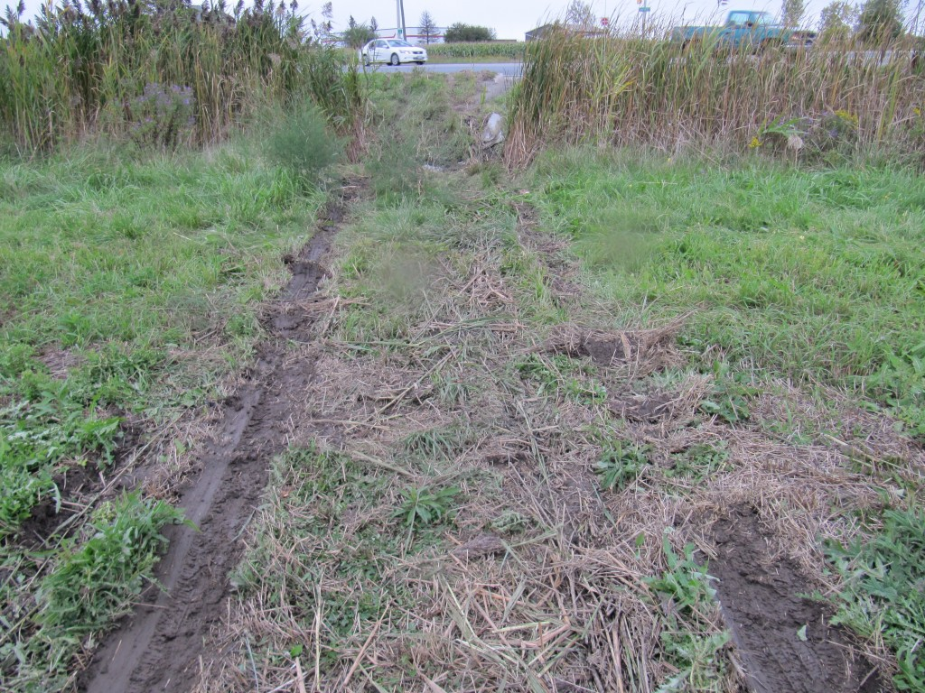
The intersection is controlled by a traffic signal.
There is evidence that police used a total station to map out the site and this is also unusual because this would not be done in a typical accident unless there were life-threatening injuries.
In all, the mystery behind this event will remain unless further details are released. But certainly the public should be informed of the details whenever police are involved in a serious crash.
UPDATE: OCTOBER 2, 2011, 2115 HOURS
The London Free Press has just filed a report indicating that the collision is being investigated by Ontario’s Special Investigations Unit (SIU). They confirmed that two police officers and two civilians were taken to hospital but none of the occupants’ injuries were considered life-threatening.
What will happen now is that all information about the event will be withheld and the SIU will eventually present a very sparely worded comment upon completion of their investigation that an officer(s) was or was not guilty of a criminal offense. But this is not what the public should accept.
There are many instances where the actions of police do not reach the “without reasonable doubt” threshold of a criminal act yet the public should be made aware of police behaviour that needs adjusting. Certainly an issue of concern that has been raised many times over is the incidence of police involvement in collisions when they are responding to a call, or sometimes not. When the public does not obtain clear information about the extent of the problem, or even if a problem exists, many complications develop that become harmful, not only to the public at large, but also harmful to the police when persons develop a misunderstanding of their actions.
UPDATE: OCTOBER 3, 2011, 1100 HOURS
A little further mystery has been peeled away from this incident. London’s CTV news displayed the collision site last night showing the rest position of the “public” vehicle in bottom of the grassy ditch and an OPP cruiser is shown in the field about in the location of the tire marks in the above photo. If the OPP cruiser shown in the field is the one that was involved in the crash then it would suggest that both vehicles seemed to be “glued” together as they moved away from impact along the wide intersection and that they f0llowed the same post-impact path. That is possible but it is not common. If such a sustained contact occurred then it is not clear why the OPP cruiser travelled so much further than the “public” vehicle since, if they are welded together, they should attain about the same post-impact velocity.
It is possible that the Cruiser was actually travelling much faster than the “public” vehicle and both vehicles just happened to follow the same post-impact path. But it is strange that the tow truck would run over the tire mark evidence produced by the cruiser as such evidence could be crucial in estimating the speed of the vehicle. Normally, cruisers are now equipped with event data recorders that should provide information about vehicle speeds but still, destruction of physical evidence like this is unusual. The tow truck could easily have followed a path back onto the road along a fairly flat portion of the field toward the north as shown in the photo below.
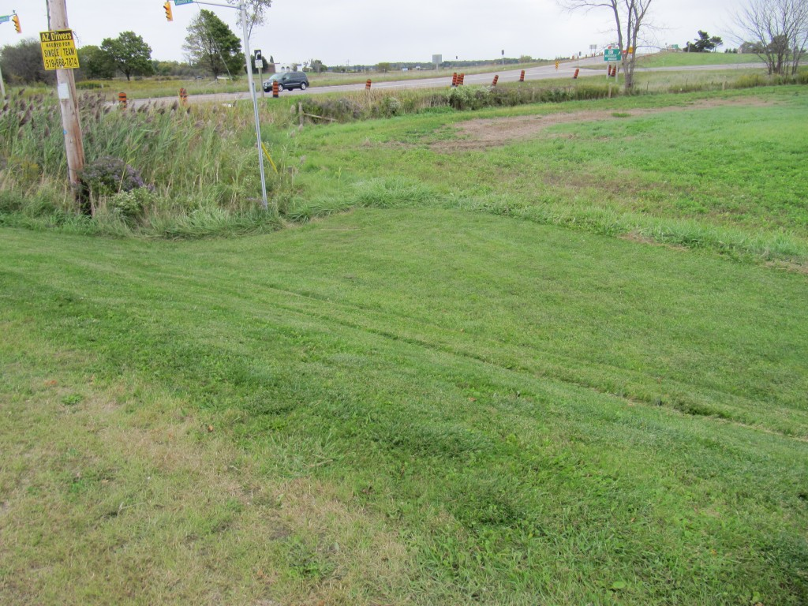
Again the video did not show very much damage to either vehicle but that may simply be the common practice of many news media of not showing the portions of the vehicles that sustained the damage.
UPDATE: OCTOBER 3, 2011, 2100 HOURS
The SIU is reportedly looking for witnesses to the crash that has sent two police officers to hospital. The site at Colonel Talbot and Littlewood is controlled by a traffic signal. It is not clear what the issue may be other than perhaps there could be uncertainty as to who had the right of way. At this time very basic information as to who the officers were or from which detachment has not been indicated nor has it been explained which direction each vehicle was travelling. The travel directions could be easily determined if CTV News had videotaped the damage to the vehicles but this has not been done.
September 28, 2011
Mount Salem Site of Fatal Collision Involving Alcohol Impaired Driver
It has been reported that 24-year-old Craig Duncan Chittenden of Malahide Township, has passed away as a result of injuries he suffered in a collision that occurred about 0550 hours on Sunday morning, September 25, 2011. The collision occurred at the intersection of Springfield Road and Calton Line in Mount Salem, south-east of London, Ontario. Chittenden had been travelling northbound on Springfield Road when his Pick-up truck was struck in the right side by the front end of another pick-up truck that was headed westbound on Calton Line.
The evidence at the site of the collision clearly indicated that the westbound vehicle had passed through a stop sign, likely at highway speed when it struck Chittenden’s vehicle. This violent event took place when the speed limit for both roads was only 50 km/h. The 1999 and 1998 GM pick-up trucks involved in the collision were equipped with event data recorders but it is questionable whether they were of the kind that would provide pre-crash data. Certainly the 1998 truck would not be so equipped but in 1999 there was a change-over in the recording capability such that the possibility of such data is still possible.
The westbound vehicle travelled about 41 metres from impact to rest while the northbound vehicle travelled about 32 metres. Such post-impact travel distance themselves speak of a highway speed impact.
The westbound driver has been charged with alcohol-related charges.
UPDATE: SEPTEMBER 29, 2011, 2030 HOURS
Peter Friesen, 23, of Mount Salem, Ontario has been identified as the driver of the 1998 GMC pick-up truck that struck a 1999 Chevrolet pick-up truck and killed Craig Chittenden on Sunday, morning, September 25th. As a result of the death additional charges have been laid against Friesen including criminal negligence causing death. Friesen was reportedly held in custody until a hearing, the date of which has not been consistently reported by the news media.
It is clear that the Chevrolet pick-up truck operated by Chittenden rolled over shortly before it came to rest on a lawn north east of the intersection. Such results cannot be predicted nor expected but are the consequence of a major collision where the post-impact vehicle trajectories are affected not only by the speed of the vehicles but by their rotations and the damage caused to the portions of the vehicles (wheels) that are in contact with the ground.
At close to 0600 hours on a Sunday morning it is not common for two vehicles to meet on a quiet, village intersection and collide when travelling at speeds that are likely higher than the speed limit (50 km/h). Yet the circumstances reveal how one cannot predict what events may unfold.
September 25, 2011
Loss of Control Rollover Results in Death of Driver
A King Township (north of Toronto, Ontario) man, reportedly found deceased in the middle of Concession Road 11 is an unusual occurrence when the 2001 Ford Escape in which he was reportedly travelling was found rolled over in a nearby ditch. This occurred last night, Saturday, September 24th, 2011.
Rollovers almost exclusively involve a progressively greater lateral fish-tailing or yawing before the vehicle reaches a sideways orientation and then rolls over. Also occupants of such a vehicle are almost exclusively ejected through side windows. When you combine these facts it becomes rare for a vehicle to tip over within the road surface and spill the occupant onto the road while then the vehicle progresses into a ditch. Instead, the ejection occurs predominantly after the vehicle exits the road surface and most often after the vehicle has been tripped up within the softer earth of the roadside.
In this case, police should be looking a little more closely than normal for signs of that this was not just a typical rollover.
September 20, 2011
North Adelaide Jogger Has Passed Away
Regrettably, it has been reported that the female jogger who was struck on the morning of September 11th, 2011 near the intersection of Adelaide Street and Ten Mile Road, has passed away.
Although this is an uncommon occurrence we need to remind readers that such a danger exists and is largely unknown to most. As an accident reconstructionist I have had to examine many collision sites where I have had to stand on a highway and take photographs and measurements. It took me too long to appreciate that, while standing there it was necessary to be cognizant of traffic coming from both directions even though I might have been standing in only one of the two lanes. Consider that when a vehicle makes a passing motion it uses the opposing lane for that purpose. In one instance I was standing partly in a lane and such a passing vehicle brushed past me at tremendous speed from behind my back. It was a lesson I quickly learned that I could not expect traffic to approach from only one direction in a lane just because that lane is so designated.
These are ideosyncracies that many pedestrians are not aware of until something unfortunate happens. With the present scenario of this jogger the situation was somewhat different and difficult to avoid as there was a major collision behind her and this caused one of the vehicles to be re-directed into her path. Even if she had been jogging on the shoulder or even on the roadside grass the same result could have occurred. For this reason it truly is an unfortunate circumstance.
Dangerous Georgetown Road Was Not Likely The Cause of Fatality – But Cause Still Not Clear
Much concern has been expressed by residents in the Georgetown area of a steep downgrade of Tenth Line as it contains a stop sign with its intersection with 22nd Side Road just north east of Georgetown. So much concern had been expressed that Halton Roadway authorities had placed a flashing beacon at the intersection along with additional signage. Unfortunately this is a cosmetic cure as the steep down-slope is still present and under conditions of snow or rain the ability of drivers to stop will continue to be challenged.
A 21-year-old Georgetown man was killed on Saturday at approximately 0200 hours as his Honda was travelling toward the steep downgrade and his vehicle went out of control and struck a small tree on the left roadside. Many residents have suggested that the down-slope was responsible, to the point of writing comments on the “Steep Down-Grade” warning sign as shown below:
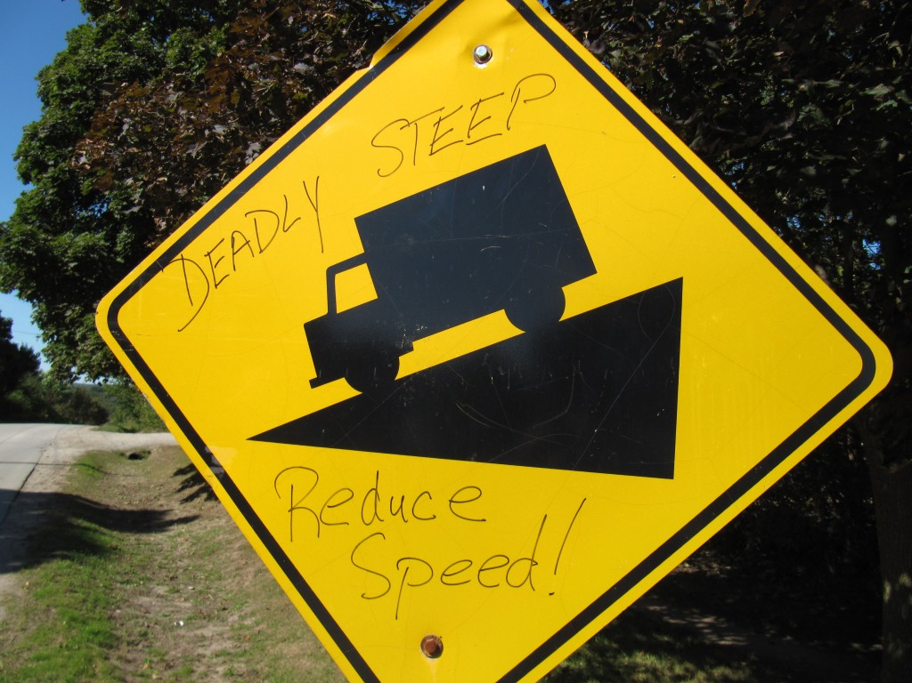
“Deadly” Steep Down-Grade
While I sympathize with the residents’ concerns, the present fatal collision occurred at the top of the down-grade and before the vehicle reached the noted problem. For example, the down-grade at the point where the vehicle’s loss of control marks first became visible was only about 5.3 %. At the point of impact with the tree the slope, another 41 metres down the hill, was still about 9.4%. The greatest down-slope occurred beyond the ares of impact where the slope was about 11.9 percent and this steep slope carried on for almost the full 230 metres past the tree impact to where the intersection with 22nd Side Road was located.
In fact, the loss of control events did not initiate where the tire marks first became visible because at that point the vehicle was already in an obvious yaw rotation. Something occurred near the top of the slope or at the point where the Honda first made it correction in travel direction as it began to move into the curve. A gravel driveway located just under 100 metres back from the tree impact is one possible cause for loss of control but there was no physical evidence there to tie that to the actual collision.
The circumstances that led to this tragedy are still unknown to me.
September 12, 2011
It has been an unusually busy few days with several fatal collisions occurring.
In Woodstock, a woman reportedly died of a medical condition as her westbound vehicle veered off the road and struck a chain link fence. Much like the London Transit bus from Friday, the upper pole of the fence was knocked out of it moorings but did not penetrate the vehicle’s windshield. At the same location a bicyclist was reportedly struck and sustained minor injuries.
In Lambton County two persons from Wallaceburg sustained fatal injuries after an eastbound motorcycle crashed into a northbound car at the intersection of Brigden Road and Lambton Line. This would appear to be another unfortunate circumstance since it is rare that collisions with motorcycles result in fatal injuries to car drivers. In this instance the motorcycle would most likely have struck the driver’s door in order to cause this result.
A couple of dirt bike collisions have resulted in severe injuries and fatalities. One person was fatally injured in the Mount Brydges area while two others are in critical condition following a collision near the Woodstock area when their dirt bikes collided while approaching from opposite directions.
Overall it has been a very unpleasant result. We need to keep vigilant.
September 11, 2011
Jogger Unfortunate To Have Been Struck By Unusual Circumstance
A jogger was struck and reportedly sustained life-threatening injuries at the intersection of Adelaide Street and Ten Mile Road, just north of London. The collision occurred at about 10:20 A.M. this morning when a Montana van, travelling eastbound on Ten Mile Road stopped at the stop sign with Adelaide Street. After letting the jogger pass by the intersection the Montana driver pulled into the intersection and was stuck by a southbound Chevrolet Pick-up travelling on Adelaide. In the process of attempting to avoid the collision the Pick-up driver steered toward the centre of the road but was unable to avoid the collision. Unfortunately this avoidance attempt might have made the truck travel into the path of the jogger who was struck and pushed into the east roadside of Adelaide. Our article photos of the evidence at the site are available in an article on the Articles page of this website.
September 9, 2011
London City Bus “Harpooned” Without Apparent Notice & Hopefully Without Major Consequence
A major collision, reportedly involving non-life-threatening injuries, has occurred at approximately 1705 hours today at the intersection of Commissioners Road and Wellington Road involving a northbound London City Transit Bus and a Black, Crown Victoria passenger car that was attempting to make a left turn from southbound on Wellington Road to eastbound on Commissioners. By chance I happened to have been stopped at the traffic signal on Commissioners, facing eastbound when the impact occurred.
While much of the attention will be focused on the left turn of the car and the subsequent rest position of the bus, it is unlikely that anyone will have realized that the occupants of the bus may have missed being seriously injured or killed, not by the impact itself, but by the horizontal, upper anchorage bar of the chain link fence through which the bus travelled en route to its rest position. This horizontal bar entered through the windshield of the bus and at final rest the end of the bar was pointing directly into the bus driver’s seat. Whether in fact the bus driver was struck by the bar we may soon discover. But regardless of the end result, we are simply left unaware of these dangers.
An article with on-site photos has been posted on the Articles page of this website.
September 8, 2011
High Speed Maximum Braking Tests – Photos of Resulting Evidence
Last month Gorski Consulting was involved in some high speed braking tests with a new vehicle equipped with a modern, anti-lock braking system. The results from that testing included some detailed photos of the skid marks. While investigators have expressed concern that skid marks would no longer be visible during their reconstructions of accidents our testing clearly demonstrates that skid marks can be very visible depending a the unique circumstances of each collision. An article about these results is available for viewing on the Articles page of this website.
Crash of London City Police Cruiser
Yesterday evening at approximately 2100 hours a London City Police cruiser was involved in a collision with an SUV at the intersection of Highbury Avenue and Hamilton Road in London, Ontario. The cruiser was reportedly westbound on Hamilton road and had its siren and emergency lights activated. The officer was attempting to reach the site of a robbery a short distance further to the west on Hamilton Road. Of photo of the cruiser showed extensive damage to its front end but no injuries were reported.
September 2, 2011
McEachern and Kaufman “Homicide”
Police have now released photos of the yellow Chevy pick-up truck that was allegedly involved in the death of Brett Kaufman in Kitchener, Ontario last weekend. The photos show no obvious evidence of damage on the front end of the vehicle and this is a clue to the manner in which events could have unfolded. As stated earlier, pedestrians who are struck and killed will usually involve a vehicle moving at relatively high speed and this will leave distinctive evidence on the front end of the impacting vehicle.
The lack of any obvious damage on the front end of this vehicle suggests various possibilities but the most common is that the wheels of the vehicle ran over the deceased. There are also instances where a pedestrian is moving toward the vehicle and therefore the pedestrian’s head becomes exposed to impact, resulting in very little evidence of damage but major head injuries to the pedestrian. In either case this would make it more difficult for police to prove intent than if there was obvious damage on the vehicle’s front end involving major deformation and therefore high speed.
QEW Fatality From Object Striking Windshield
A small amount of additional information has been released regarding the fatal collision on the QEW yesterday morning. The driver of the Toyota was identified as Miguel Pena. Police now confirm they have possession of the object that struck the vehicle and that the object actually contacted the driver. But they are still not releasing the identity of the object. As we indicated in our article on this subject, the failure to disclose the identity of the object can be a double-edged sword if police hope to get further witnesses to the event.
September 1, 2011
Object Strikes Windshield of Westbound Vehicle on the QEW in Mississauga Ontario Resulting in Fatal Injuries to Driver
A 43-year-old male driver was fatally injured in a single vehicle collision this morning on the westbound QEW near Hurontario Street in Mississauga. But investigating police are reporting that the event occurred after an object struck the windshield of the vehicle and caused a “30-centimetre-square” hole. While police are searching for witnesses they are also not indicating why they are not able to identify the object, as if they are unable to locate it. You can read my comments on this in an article on the Articles page of this website.
August 30, 2011
Fatal Injuries to Brett Kaufman in Kitchener Ontario Incident Being Treated by Police as a Homicide
An impact occurred over the weekend in Kitchener, Ontario, Canada, wherein the passenger of a pick-up truck, Brett Kaufman, exited the vehicle and was struck and killed by the vehicle which was driven by Norman McEachern. Police have charged McEachern with 2nd Degree Murder. The events reportedly occurred in the parking lot at Pioneer Park Plaza as well as on Homer Watson Boulevard near Hanson Avenue where the impact actually took place. Although an argument was reported between the two it should take more than that to prove beyond a reasonable doubt that McEachern’s intention was to kill his best friend. (An article on these events has been prepared in the Articles page of this website)
Regardless, this happening is a reminder that all motorized vehicles can become lethal weapons, not only by intent, but also through reckless neglect for the safety of oneself, and particularly the passengers of a vehicle.
Vehicles become lethal weapons in many instances but particularly in instances where young male drivers are involved who want to “show off” by speeding and involving themselves in dangerous acts. But this is not exclusive to this group as an immature driver, regardless of age, sex, or any other trait, can engage in similar behaviour. We can be reminded of two recent incidents, north of Toronto, Ontario where police officers lost their lives while attempting to stop young male drivers who accelerated in order to evade capture. The possibility of fatal results are no different than if these drivers were in possession of a knife or fire arm.
The horror caused to innocent passengers by drivers gone out of control is most easily demonstrated in the very famous fatal collision involving Princess Diana, Dodi Fayed, and Trevor Reese Jones. In that crash, the driver, Henri Paul, took it upon himself to take his passengers on a mere 40 second ride, at tremendous speed, and likely horrified his passengers who would have no control over his actions. These events repeat themselves in many situations across North America. It is a reminder that, before we become passengers of any vehicle we should carefully evaluate the mental stability of the driver. And this is why parents should particularly be aware of the friends that their children drive with.
August 29, 2011
The following is being reported today in London, local news media:
“Chris Zoidis of Strathroy was crushed to death after he was run over by a skid steer while working at a subdivision at 464 Commissioners Rd. W. last Tuesday.”
Besides the wishes of the family, which need to be taken into account, the public has a right to know of significant events like these in a timely fashion. It is notable that this event took place almost one week ago yet nothing was mentioned of its occurrence until today. For important reasons our democratic systems cannot function properly when news is intentionally withheld my mainstream news outlets. While this may appear to be a trivial matter in my opinion we should be vigilant of instances where important news events are held from public scrutiny.
August 25, 2011
Police Fail To Report That A Traffic Signal Malfunction May Have Been a Factor In A Serious Collision South of Sarnia, Ontario On August 22, 2011
We rely on our official agencies to properly investigate motor vehicle collisions and report to the public about any dangers that they should be aware. It is disturbing therefore when I read in today’s Sarnia Observer newspaper that a serious intersection collision occurred on Highway 40 and Moore Line, South of Sarnia, wherein a traffic signal had reportedly been malfunctioning for a week before the collision yet this fact was reportedly not mentioned in the police investigation. The Ontario Ministry of Transportation who reportedly repaired the signal the day after the collision claimed that the signal was not a factor because the offending driver travelled through the signal on a red. Yet, a nearby resident was reported to state that the traffic signal had stayed red for minutes at a time preventing drivers from passing through the intersection. Surely the fact that this driver was frustrated to the point of crossing on the red should be of concern to all of us, particularly when the official agencies who have exclusive legal right to document this fact have apparently not done so. I have prepared an article on this point in the Articles page of this website.
August 23, 2011
A double-fatal collision also occurred on Kent Bridge Road near Chatham, Ontario a few days ago. It was interesting that the location of that double-fatal collision was not revealed until today and that the family asked that the identity of the victims not be released. Requests from the family are understandable but the withholding of the location of the collision by news media is not. Discussion of collisions where persons have been seriously injured or killed is never pleasant. Sometimes we must reach a balance between such a discussion and having compassion for those family and friends that are pained by the results. I have tried where possible to refrain from making hurtful comments but at times that is simply not possible when we must address a problem that the public should be aware of. I hope that those reading these articles and viewing my videos will become more educated about the causes of these devastating events. Speed, alcohol, inattention, roadway conditions, all these factors are often discussed in a dry manner and fed to all of us without any significant impact on our behaviours. Psychologists have long discovered that freightening people is also not a solution to a long-lasting behaviour modification. However, education is. The more we learn about something the more attention we pay to it and the more likely that we will be willing participants in changing our own habits.
August 16, 2011
A Charge of “Failing To Yield” Is Not Clear When The Other Driver Is Speeding
I examined the site of an angle collision at the intersection of Nauvoo and Egremont Roads in Lambton County this afternoon. Although only minor injuries occurred the collision was interesting from the standpoint that a northbound driver who entered from a stop-sign was pushed about 50 metres in the direction of the westbound vehicle. That westbound vehicle itself also travelled about 50 metres after impact. Such evidence should normally raise an eyebrow but police have laid a charge against that northbound driver. I am preparing a YouTube video that will explain the evidence. I will also prepare a written article on the findings shortly.
The issue of “failing to yield the right of way” is a continual problem when it comes to achieving justice in that police do not have the capability of determining the speed of vehicles on a through road when an intersection collision occurs. Even now, with the advent of event data recorders (“Black Boxes”) police are reluctant to spend the time to download the data in many minor collisions to confirm that their charges are appropriate.
August 14, 2011
I examined the site of a fatal collision at the intersection of Embro Road and Perth Road 26, south west of Stratford, Ontario last evening. Information about that examination can be found in the Articles page of this site.
Also, there have been reports of a motorcyclist fatality in the Newbury area, on Friday, August 12th, 2011. Newbury is located south-west of London, Ontario. It was reported that Gary Rooyakkers, 56, was travelling south on Hagerty Road around 2230 hours on his Kawasaki motorcycle when he went off the road and struck a fence and tree. He was reportedly not wearing a helmet and alcohol was considered a factor in the collision. A Google Earth view from 2009 shows that the motorcyclist would have approached a left curve as he proceeded southbound past Dundas Street in Newbury. Normally one would want to review the roadway conditions as well as issues such as alcohol and helmet use before leaving the public with the impression that the mere presence of alcohol or not wearing a helmet were the only factors the public need to know about.
August 12, 2011
Much police interest has been centered in the last 24 hours with respect to the woman who was struck and killed on Highway 401 near the old Highway #2 interchange at Woodstock, Ontario.
It is reported that the collision events took place at approximately 0230 hours on Thursday morning, August 11th. The woman was driving her Mazda passenger car eastbound on Highway 401 and then exited at the exit ramp toward Highway #2. At this point the Mazda was said to have rolled over several times. The woman exited her vehicle, walked around the tall grass of the area, and then entered the eastbound lanes of Highway 401 where she was reportedly struck by several vehicles.
Tire marks on the pavement of the exit ramp clearly show that the Mazda was yawing, or rotating about its vertical axis, within the exit lane. It is notable for example that the Mazda simply did not plow straight off the ramp as if she had fallen asleep. Events unfolded on the ramp which involved her active participation, such as steering.
Views of the Mazda at its final rest position in the field do not show any major deformation in the roof area and that provides an indication of a relatively slow exit and rollover to rest. Damage at the right-rear corner of the vehicle looks suspect but the distance from which the photo of the vehicle was taken does not enable me an opportunity to see the details of that damage. Given the relatively deep down-slope that the Mazda traversed off the ramp it is not surprising that it would roll several times, even at low speed before coming to rest.
The disturbing fact is that this woman reportedly entered the eastbound lanes after being involved in the noted rollover. What would be the point? If she was looking to get some help a more obvious path would be to walk to Highway #2 where the traffic is slower and there are buildings nearby where she might have an opportunity to contact someone. So why the urgency to get onto the 401 Highway?
Additionally, we have three witnesses of interest to police:
• The driver of a dark-coloured Oldsmobile Alero who was parked along the eastbound centre median wall with its four-way flashers blinking at the time of the collision;
• A man of South Asian descent in his mid-20s or early 30s, who was wearing jeans and a dark top, and was observed on foot at the scene before leaving, and
• The driver of a loaded flatbed tractor-trailer who was immediately ahead of the first vehicle that struck the woman.
Initially, the dark-coloured Oldsmobile Alero is rather peculiar since it is a rarity for vehicles to stop against the centre, concrete median. The fact that police seem to believe they have identified a vehicle that initially struck the woman indicates that they are not discussing all the details of what they have. For example, there is no description of the striking vehicle or driver.
UPDATE: AUGUST 12, 2011, 2130 HOURS
Since my posting of this morning police have now released the identity of the woman killed in this event. She is noted as Maude Desgagne-Bedard, 29, of Gatineau, Quebec. I might assume from her residence that she may not have been familiar with this area, but none of such information in available to me. The question that puzzles me is, assuming she may be travelling to her residence, why does she turn off the 401 at such high speed that makes her vehicle travel off the exit ramp and rollover? And then why does she return to this busy highway where she is struck and killed? These questions are both puzzling and disturbing. I would like to believe that there is an innocent event here with no additional players…but. I am glad to note that the investigating police have sent a large contingent onto this site to look for clues. All of this may come out to be just nothing but I have this nagging suspicion.
UPDATE: AUGUST 14, 2011, 1425 HOURS
It is being reported that police have now located the driver of the Alero that was parked against the centre median of Highway 401 and this person was the same as the male witness who was on foot at the site. Police are now only interested in finding the flat-bed transport truck driver who was reportedly just ahead of the vehicle that initially struck the deceased.
I think it is owing to the public that news media acknowledge the obvious that nothing has been said about the vehicle or driver who reportedly struck the deceased. While it may be necessary for police to withhold certain information during their investigation the news media should not be participants in such a cover-up, particularly when a death is involved. There is an 800 pound gorilla in the room.
August 11, 2011
News reports indicate a woman was struck and killed this morning on Highway 401 at Woodstock, Ontario. Read my comments in the Article on the News Articles page of this site.
Not too far away, yesterday, at approximately 0300 hours, the trailer of an eastbound tractor trailer unit grazed the bridge support of the Highway 19 overpass on Highway 401 at Ingersoll, Ontario. Fortuneately the light contact did not result in a high severity impact for the driver and the vehicle combination travelled several hundred metres east of the overpass before coming to a halt. Another lucky break but things could have been a lot worse.
August 10, 2011
While I have been busy with my regular file work for my clients, events have been occurring leading to the posting of several new articles in the Articles page of this website. You will note the most recent concerns regarding the site on Clarke Road in London, Ontario and the development of an edge drop off that, in my opinion, needs correction as soon as possible. Unfortunely the Ontario government Regulations state that no maintenance is required to repair the drop off. This is a dangerous outcome and bad legislation. You will note my strong opposition in the article entitled “Ontario Regulation Allows Existence of Dangerous Drop Offs at Edge of Asphalt Rural Roads”.
I am still experimenting with the creation of videos that will accompany some of the articles that I post. You can see these early trials on the Videos page of this website. I am not pleased with the video quality and am working to improve that, so standby.
I have also been noting a number of major collisions in our area resulting in post-impact fires. A recent inter-city bus collision involving residents from the London area occurred in New York state and it was lucky that the occupants escaped before the bus was engolfed in flames. But there have been several other incidents as well that I do not have time to go into. But the bottom line is these results should not be taken as matter-of-factly as they are. Vehicles should not be expected to catch fire just because they are involved in a collision. Federal Safety regulations in Canada and the U.S. require that vehicles pass fuel spillage tests before they can be sold. Where fires occur federal agencies such as Transport Canada or NHTSA should be notified and a proper investigation and documentation should be carried out.
July 22, 2011
We have only 13 old news articles to add to the Articles page and then we will be done. This has been a long process.
July 21, 2011
We are about halfway through loading our older News Articles on the “Articles” page of this site. But it takes time. Meanwhile we can begin mentioning so newer issues.
July 21, 2011
The Kitchener Record newspaper has been running several articles regarding the paving of Wilmot Line which had been a gravel road. In a rare spat the Township of Wilmot and the City of Waterloo are slinging mud at each other over the reasoning for paving the road. One suggestion was that it was for personal benefit of a local politician whose home is only a short distance from the project. This is an unfortunate and disguided contraversy and all involved fail to understand the real issue.
The real issue was noted in another Kitchener Record article entitled “Grieving Mother Wants Whole Country Road Paved”. This article dealt with Jennifer Price, a mother who lost her teenage daughter, Hayley Price-Geddes, 17, in a motor vehicle collision on the road when it was still gravel. I wrote an article about this accident a while back and it has been re-loaded in the Articles section of this website.
Jennifer Price is quoted as saying “I don’t think it’s very safe. Finish it. Don’t pave half. Get the job done”. My sentiments exactly. But I think the reason why there are polictical overtones to this issue is because no one really understands or is aware of the condition of the road on at the time of the accident because that information was never revealed in the investigation. Certainly the young driver may have been at fault but I do not have any information about the official investigation. What information I have relates to my examination of the collision site and what I reported on this website at the time. I am glad to see Jennifer Price speak up since no one else has. I may discuss this further and provide new evidence shortly.
July 20, 2011
We are continuing to load the old news articles from our previous website into the Articles page of this website. There are over 60 articles to add so this will take some time. Once that is completed we should be able to add news on this page of our latest collision reviews.
Just as as short note, we examined the site of a car crash on Marconi Boulevard in east London, last week where a stolen vehicle was travelling around a curve of the road at high speed. This vehicle slid off the outside of the curve and struck a house. The right front passenger remained in the vehicle due to his injuries while the driver fled and was caught by police. My examination of the site revealed tire marks at a distance of over 130 metres before the impact with the house. Even using a conservative deceleration rate of 0.3g would result in a speed loss of about 100 km/h, even without the damage caused from the house impact. But the vehicle also knocked down a small tree and a lamp post – all in a residential area where the speed limit is 50 km/h. The photos from this event would be interesting to show but I am still tied up with developing a procedure to organize the news in a proper fashion. So Stay tuned.

