Gorski Consulting Website

Archived News - 2012 - July
July 31, 2012
Speed Calculation From Sarnia Motorcyclist Fatality Should Be Taken “With A Grain Of Salt”
It has been reported that the Ontario Special Investigations Unit (SIU) has decided that no criminal charges will be laid against a Sarnia police officer with respect to a chase and subsequent fatal crash of a motorcyclist at the intersection of Michigan Avenue and Indian Road in Sarnia, Ontario, Canada. The motorcycle struck the right side of an SUV in the intersection causing substantial crush as well as a rollover of the car.
While the reported scenario suggests a high speed of the motorcycle the news media reported that “A forensic reconstructionist calculated the biker was travelling 175 to 182 km/h before hitting the brake”. Given the likely uncertainty of the evidence that this reconstructionist had to work with, we find this narrow range of speed suspicious and we would advise taking that information “with a little salt”.
The “hitting the brake” part of the news report suggests that the motorcyclist was braking before impact. That would have to be the case because the photograph showing the SUV on its side does not support such a high speed loss on its own.
Brake skid-marks from a motorcycle are more difficult to interpret because of the unique manner that the brakes can be used whereby a variety of front and rear braking forces can be present. Even if detailed testing was used to find the co-efficient of friction of the road surface on which any skid marks were deposited, there should normally be a wide range of possible deceleration rates that should be used to encompass the full range of possibilities.
Secondly, the actual severity of the impact needs to be evaluated. A momentum analysis might be used but the small mass of the motorcycle versus the larger size of the SUV could complicate the accurate replication of the speed particularly if there was some turning motion of the SUV whose angle would have to be accurately determined if the momentum analysis was to be accurate. An additional approach evaluating the crush and extent of kinetic energy dissipation could also be considered but again, the stiffness values of the side of any vehicle are difficult to determine and the stiffness of a motorcycle is equally so.
Finally, any post impact travel of the vehicles would have to be included in the calculations. Again, the rollover of the SUV would complicate the calculations as a specific rate of deceleration would not be available and a range would have to be used. Similarly a range of deceleration rates for the sliding motorcycle would further dilute the accuracy of the calculations.
So, in totality, the very narrow range of calculated speed reported from the “forensic reconstrutionist” should be viewed with suspicion. Unfortunately, very often the process of such calculation turns into an art where certain persons like cubism or impressionism rather than the realism of Rembrandt.
July 26, 2012
Another Fatal Loss-Of-Control Collision on Highway 401 in Chatham-Kent
A second fatal loss of control collision on Highway 401 in the Chatham-Kent region has claimed the life of a driver of a 1994 Caravan who was ejected from his vehicle. The present collision reportedly occurred on Wednesday, July 25th, 2012. A couple of days earlier another collision involving a median cross-over of a Toyota mini-van resulted in two fatalities and two others with critical injuries. In neither of these instances was there any information as to what caused the vehicles to enter into a state of loss-of-control.

July 25, 2012
Collision of Two Pick-up Trucks Near Sweasburg Ontario Leads To Peculiar News Media Reporting
Although it is not often the fault of news media outlets in reporting various facts about motor vehicle accidents provided to them by police, their descriptions of a collision that occurred this afternoon, July 25th, 2012 near Sweaburg would cause anyone who studies motor vehicle accidents to be puzzled by the reported facts.
Apparently police have reported that someone stole a pick-up truck, crashed it into another pick-up truck at the intersection of Sweaburg Road and Trillium line and then fled the scene. The problem occurs when a photograph is shown of the remains of the stolen pick-up truck which has its total frame detached from the body. Evidence visible on the frame indicates substantial deformation. The report also confirms that the other pick-up truck was also badly damaged. The London Free Press’s caption under the photo states “no one was hurt in the collision”. If the driver who stole the pick-up truck fled the scene and it is reported that the police are presently involved in a “man hunt” to capture the person, how do the police and the London Free Press know that the fleeing driver was uninjured? At face value, unless the stolen truck was in extremely rusted condition and ready to fall apart then the extent of damage would suggest a substantially severe collision and this would suggest substantial injuries to the persons in the two vehicles. So it leaves one puzzled about the accuracy of the reporting and what the actual facts might be.
Man Sustains Fatal Injuries As Result of Collision With Truck In Brigden, Ontario
An 80-year-old man reportedly sustained fatal injuries after his eastbound car travelled into the path of a westbound truck in the Village of Brigden, Ontario. The accident site was located on Courtright Line (east/west) and near the intersection of Brigden Road (north/south).
This location reportedly had a maximum speed limit of 50 km/h. Police were quoted as saying that “speed was not a factor” in this collision. Meanwhile the car was reportedly pushed some 30 metres back from the direction that it came. The extent of crush at the right front of the car would suggest that a change-in-speed (Delta-V) of 50 km/h would not be unreasonable. Also, the 30 metres of post-impact travel could also lead to a similar 50 km/h speed loss. Thus, depending on the approach speed of the car into impact, the truck’s impact speed could potentially be much higher than the maximum posted speed of 50 km/h. The truck’s maximum braking over a distance greater than 30 metres could also place it above the maximum posted speed. Thus it is curious that police would make the comment that they did about speed not being a factor so early in their investigation when it is doubtful that all the facts would have been fully assessed.
July 24, 2012
Double Fatality on Highway 401 West of Chatham Was A Median-Cross-over
It has been many years since the term “median cross-over fatality” has been used to describe an accident on the Highway 401. Since most of the highway has been equipped with New Jersey barriers this has prevented such tragedies. However it is reported that yesterday evening, July 23, 2012 an eastbound van crossed the median of Highway 401 in an area where the New Jersey barrier still does not exist, resulting in at least two fatalities. After the van crossed the median it reportedly struck the rear wheels of a trailer being hauled by a road tractor. Beyond the two fatalities two other occupants of the van are in critical condition.
It was during the 1980s that much publicity was given by local news media to the phemomenon where fatalities were occurring and a coroner’s inquest was called in 1989. The inquest recommended that the time line for New Jersey barrier installations be sped up. Certainly by the early 1990′s a stretch of Highway 401 between London and Woodstock received those barriers and further work was done between Woodstock and Kitchener. Similarly work has been ongoing to install barriers eastward from Windsor.
Unfortunately much of the important information about how and why collisions are occurring on Highway 401 in recent years is not being made available for public scrutiny. This is so because when such a collision occurs the highway is closed from one interchange to the other and there in no independent way of confirming what evidence might have been present. Many construction and maintenance activities are present when collisions occur on Highway 401 but these influences are never reported in official news media. It is only by visiting the area several days afterword that you appeciate that additional factors existed that were not reported but their specific influence or possible causation of the collision events are never revealed to the public.
No Further Information Regarding Fatality at Sunningdale Road and Adelaide Street
There has still been no further details regarding how the fatal collision took place at the intersection of Sunningdale and Adelaide Street on July 21st. It has been confirmed that a passenger in a westbound mini-van was the fatally injured party but there was relatively little structural intrusion into the seating space of the vehicle therefore, if the person was properly restrained in a typical manner, and was seated in the right front seat, the possibility of fatal injuries should have been low since the impact appeared to be to the rear of the van’s right side.
It was also evident from our site examination that the southbound SUV was in an unusual location, in the northbound lane when the impact occurred. This might be explainable if the SUV was making a left turn to travel eastbound on Sunningdale. However since evaluating this scenario further, it appears to us that the SUV’s speed would be too high to be consistent with a left turn. It would appear that the SUV was on the wrong side of the road when it entered the intersection and struck the right side of the mini-van so the lack of a proper explanation by police and the local news media speaks again to the lack of proper revelation of important events like these that the public ought to be informed about.
Fatality at Sunningdale & Adelaide Street in London – Preliminary Review of Evidence at the Site.
Update: July 23, 2012; 1910 Hours
When we reported the results of our site examination that was carried on the morning of July 22, 2012, we did not have good information about the identify of the two involved vehicles and we reported them incorrectly. Generally we do not like to change the content of our News and Articles posts after they have been written however we notice that a large number of visitors made inquiries on our website and our continued reference to the wrong vehicle descriptions may appear to be confusing. Therefore we have opted to change our original posting – but only by replacing the erred descriptions of the vehicles. Otherwise the wording of our information remains the same as we initially wrote it.
We also note that the picture captions “ran over” into oblivion so that you could not read the right portion of the text. We apologize. We use the finest setting on our camera when we take our photos and we have been posting them in that condition because we have been frustrated with other websites where details are difficult to be seen, or it is not possible to download a good detailed view. However, in this last posting we decided to reduce the size and resolution of the photos so we could post them faster onto our web News. In the process we discovered that, during shrinking of the photos, the captions did not seem to shrink and ran beyond the edge of what you are able to see. So this is our explanation. We believe we have now corrected the problem. In the meantime, below is the original news article as we posted it on the morning of July 22nd, with corrections to the vehicle descriptions…
July 22, 2012
Fatality at Sunningdale & Adelaide Street in London – Preliminary Review of Evidence at the Site.
We were able to examine the site of the fatality this morning at the intersection of Sunningdale Road and Adelaide Street. The photo below shows a view looking southbound on Adelaide toward the intersection with Sunningdale. The area of impact is identified by a black stain along with a scrape that are located in the middle of the intersection to the left of the centre-line of Adelaide. Presently it is believed that a southbound SUV struck the rear of the right side of a westbound SMini-van. Thus the location of the area of impact would appear to be on the wrong side of the centre line for the southbound SUV’s travel direction.
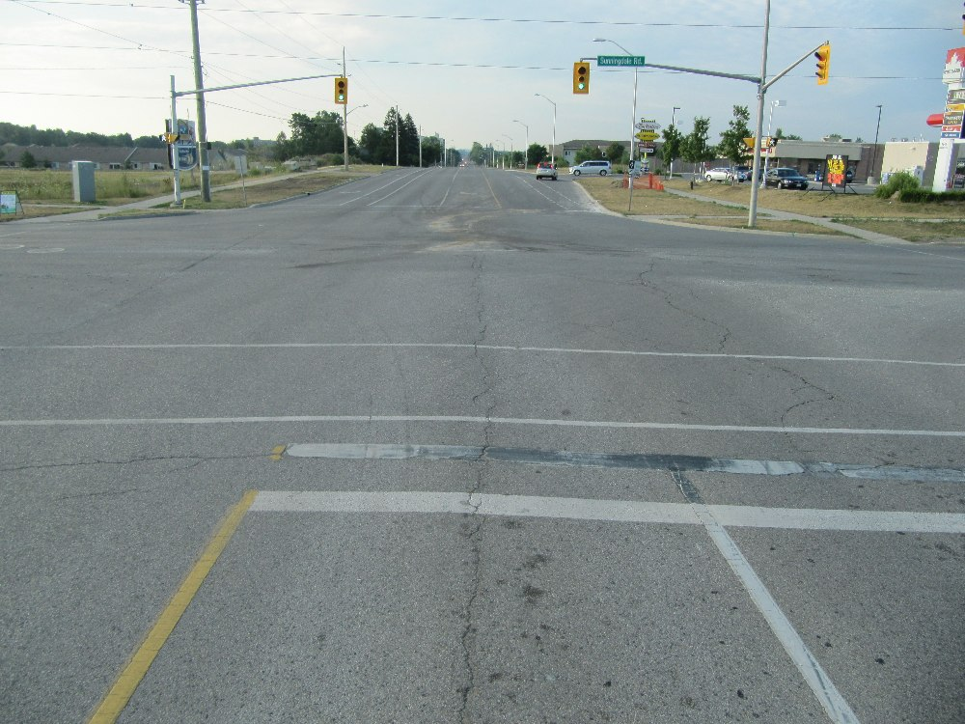
View, looking south along Adelaide Street from the north edge of the intersection with Sunningdale Road. This view is taken from the southbound left turn lane of Adelaide Strreet. The area of impact was located just to the left (east) of the centre-line of Adelaide yet one of the vehicles (likely the SUV) was southbound. This would either suggest that the SUV was making a left turn at the time of impact or was on the wrong side of the centre-line.
Below is another southbound view looking closer toward the dark stain and scrape located in the centre of the intersection.
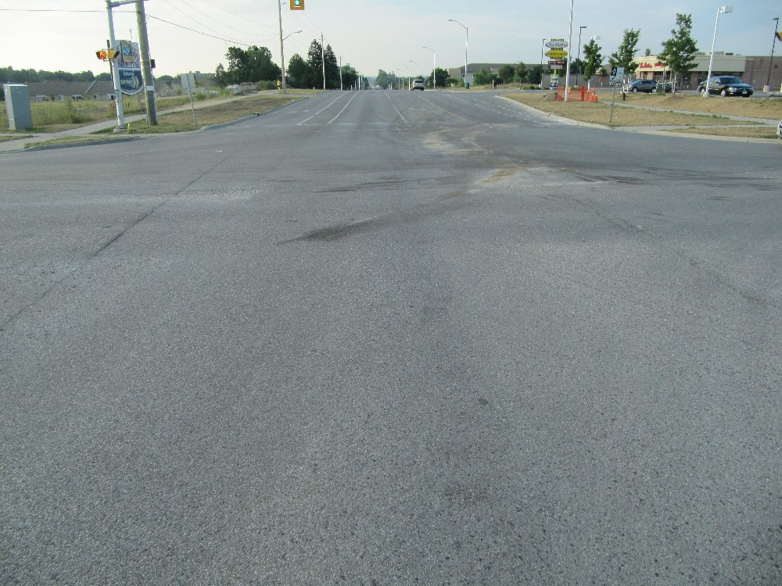
Closer view of dark stain and scrape located in the centre of the intersection, still looking southbound on Adelaide.
And below is another view taking you even closer to the dark stain and scrape that were created at the area of impact.
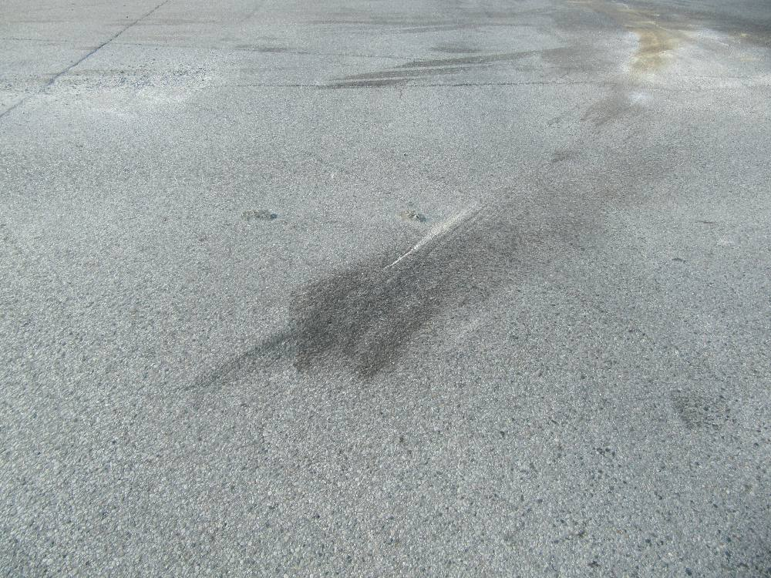
Closer view, still looking southbound, toward the black stain and scrape caused by the vehicles at impact. The stain and gouging travels in a southwest direction which is consistent with a vehicle travelling southbound and a second one travelling westbound.
The staining that you see is most frequently associated with a vehicle that has sustained front end damage and the fluids from the vehicle’s front end spill onto the road. Since the southbound SUV was the one that sustained the front end damage it would be our preliminary opinion that you can follow the trail of this staining to the final rest position of that southbound car. Below is a photo showing additional evidence of the stain as its trail takes a curved path toward the west curb of Adelaide, just south of the intersection.
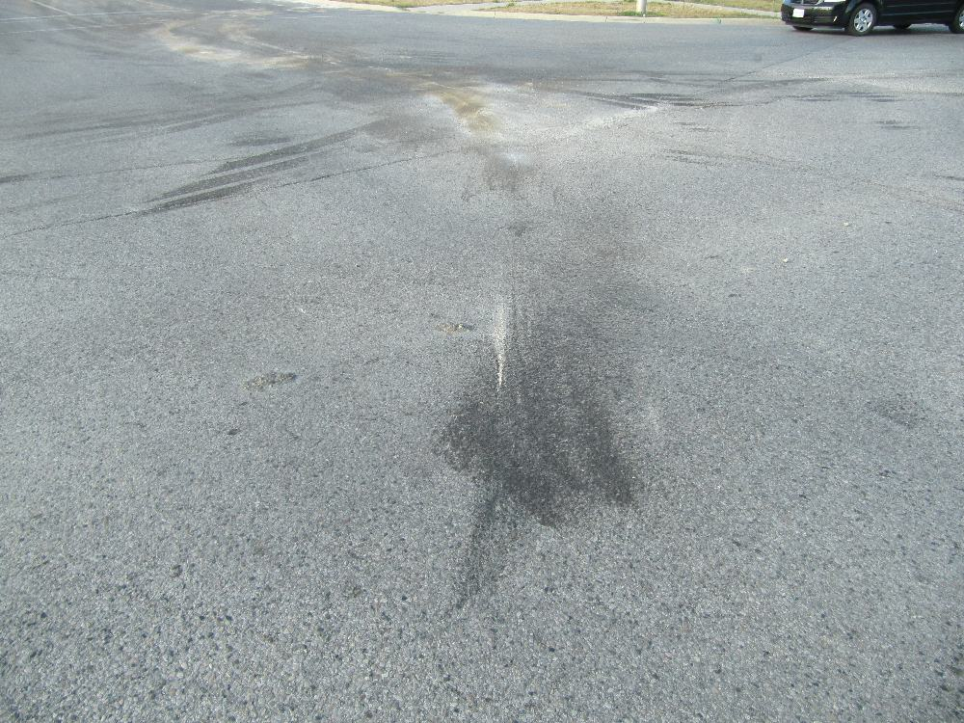
View, looking southwest from the dark stain at the area of impact. You can follow the trail of the stain in the background to the west curb of Adelaide Street just south of the intersection It is believed that the southbound SUV likely came to rest near that west curb.
Below is a view, looking northbound toward the suspected final rest position of the southbound SUV against, or near the west curb of Adelaide Street, south of the intersection.
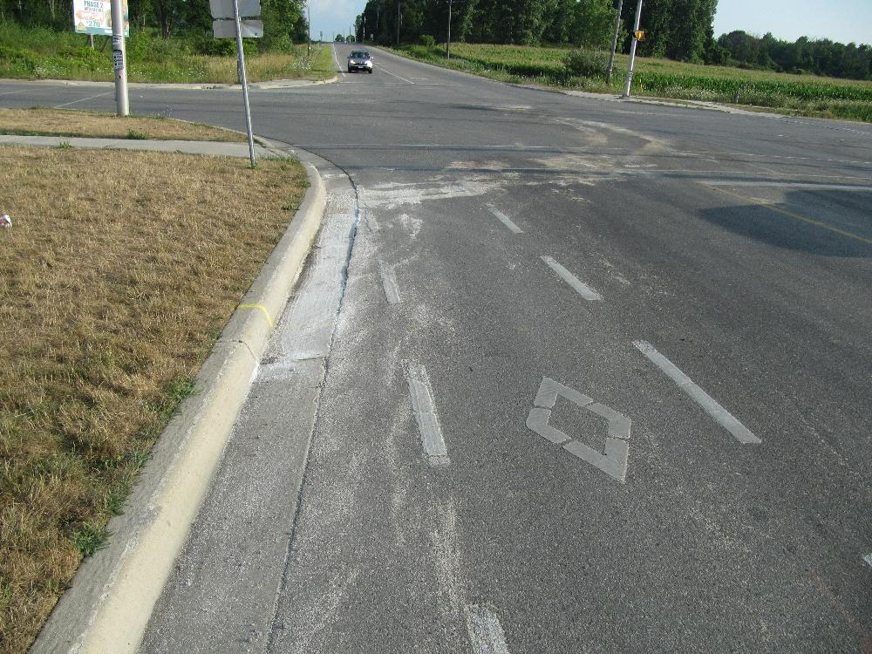
View, looking north from the west curb of Adelaide Street south of the intersection with Sunningdale. The final rest position of the southbound SUV is evidenced by the white staining against the curb. The whiteness of this stain is likely due to the absorbant that was placed on the oil/gasoline stain by emergency/towing personnel.
Below is a view, looking northeast from the suspected final rest position of the SUV and this takes us back toward the area of impact in the middle of the intersection.
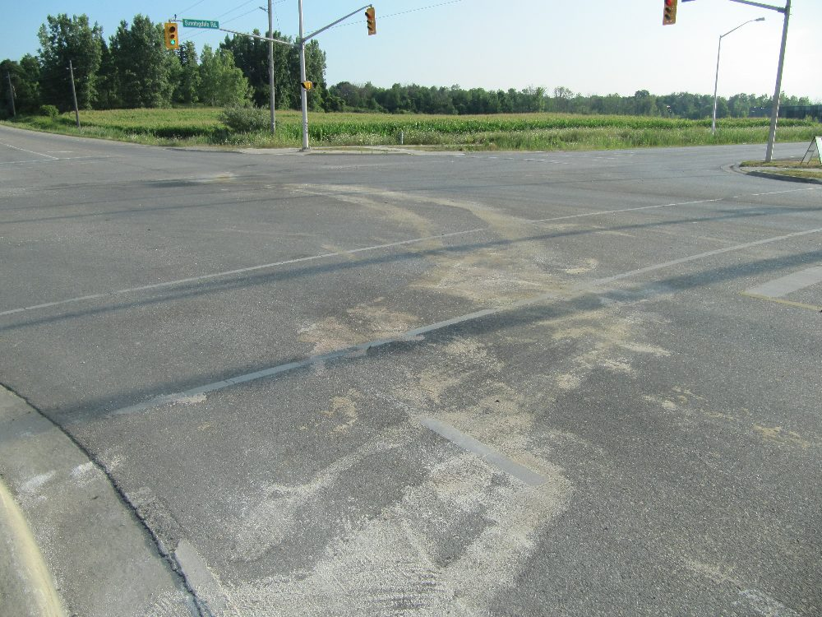
We can follow the stain from the west curb of Adelaide back northward toward the middle of the intersection as shown in this photo which is looking north east fromt the southwest (i.e. from where the SUV came to rest).
The curved manner of deposit of the fluid indicates that the SUV was rotating after impact.
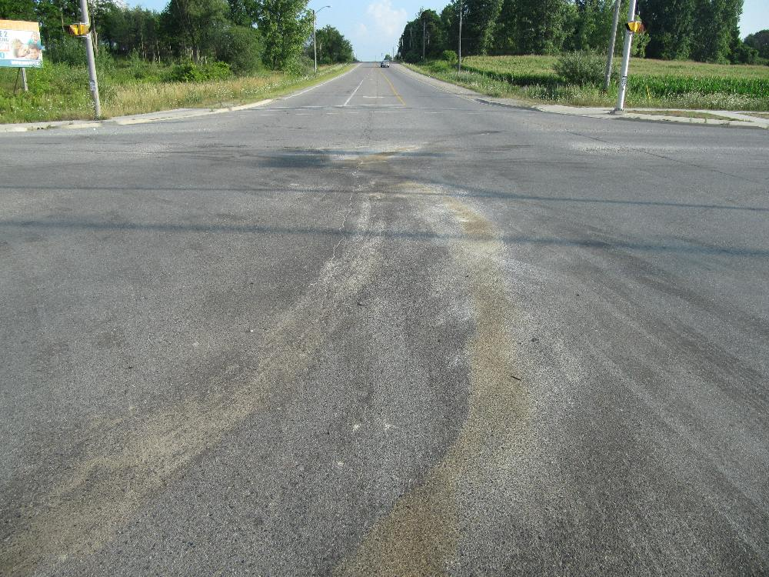
Closer view returning to the area of impact, looking along the stain caused by the southbound SUV, This view is now looking northbound from south of the area of impact.
We can get a further appreciation of the location of the area of impact by examining views looking westbound from the westbound through lane of Sunningdale. It is our preliminary belief that the Mini-van was likely travelling westbound in that through lane as it entered the intersection. Below is the approximate view that the westbound driver of the Mini-van would have had as he/she approached the intersection.
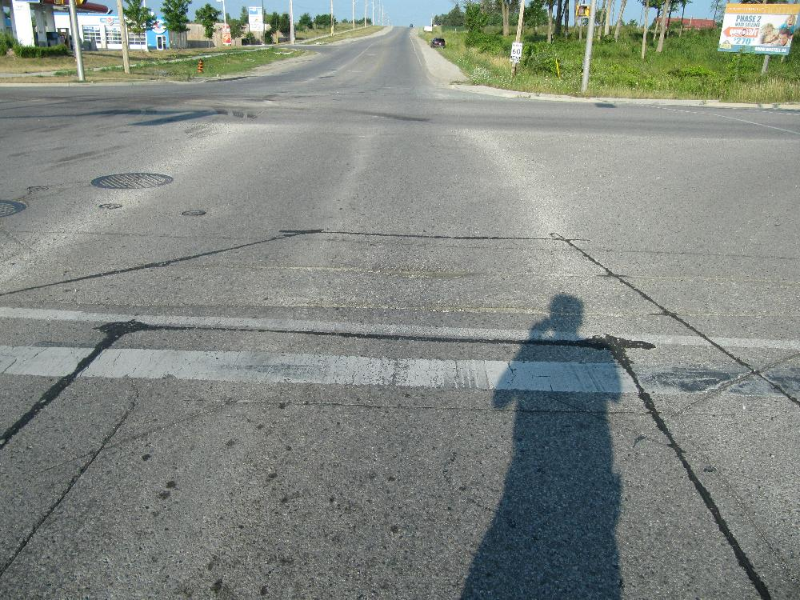
View, looking westbound from the westbound through lane of Sunningdale, from east of the intersection.
It should be possible to locate the dark stain (area of impact) in the above photo as it is located just to the right (north) portion of the westbound through lane. The photo below is a closer view of the dark stain and scrape at the area of impact.
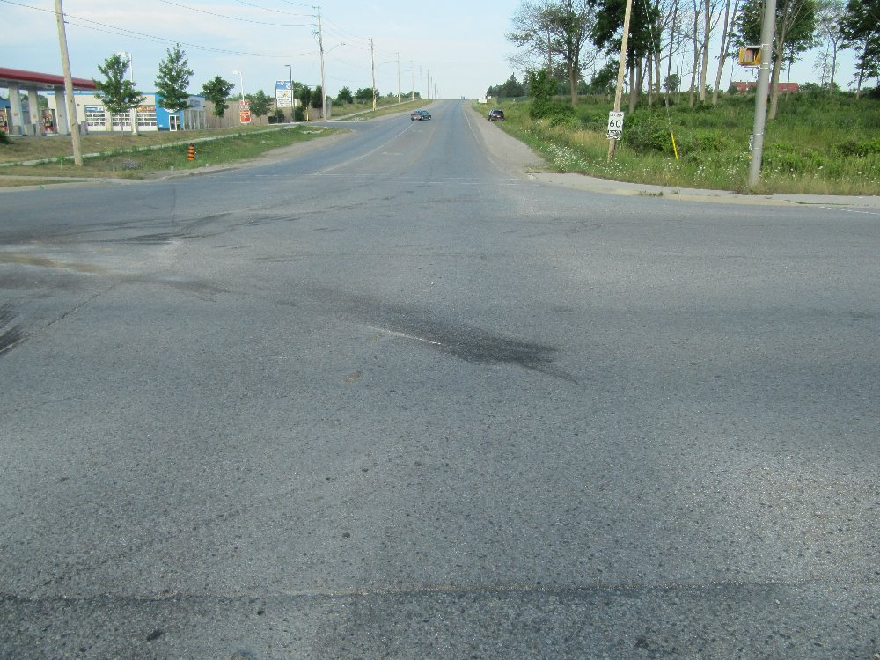
Closer view, looking westbound along the through lane of Sunningdale Road. The dark stain in the middle of the view is where the vehicles first made contact. It would appear that the Mini-van was lilely pushed to the southwest from this location and travelled to the southwest curb.
The final rest position of the Mini-van is located at the upper left of this view. Evidence would suggest that the Mini-van slid over the curb and came to rest in a ditch filled with rocks.
As shown in the photo below the Mini-van slid toward the southwest curb and crossed over it, entering a rock-filled ditch.
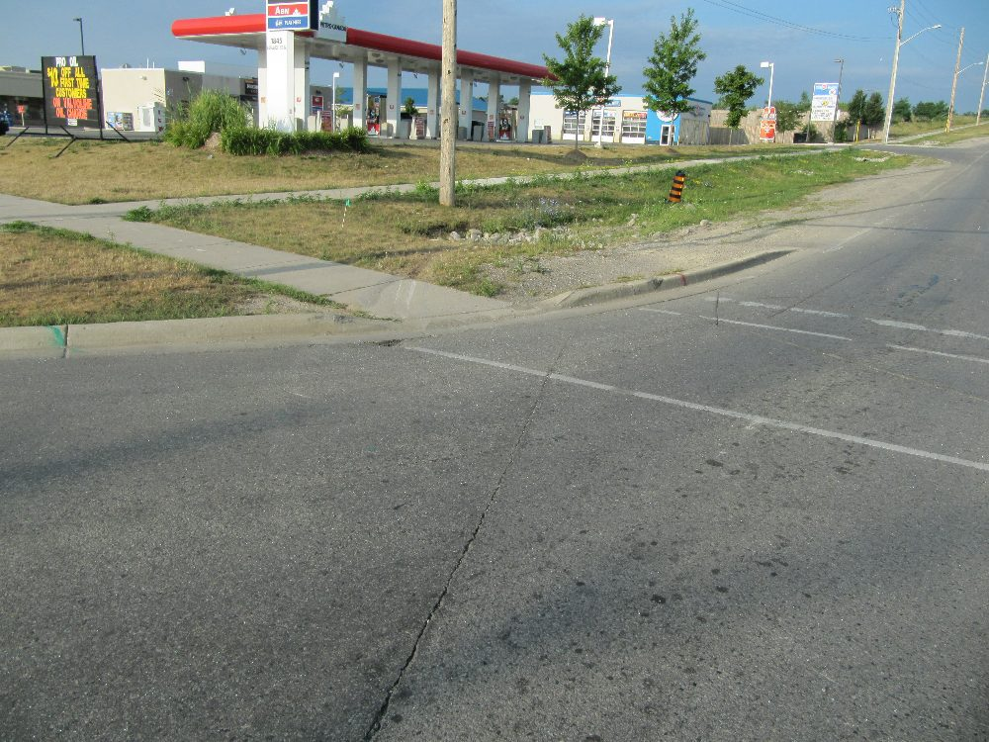
View, looking southwest toward the suspected final rest position of the Mini-van. The Mini-Van travelledd toward the curb shown in the background and then crossed over entering the ditch.
In the photo below we can see the evidence caused by the Mini-van as it slid over the curb and into the ditch.
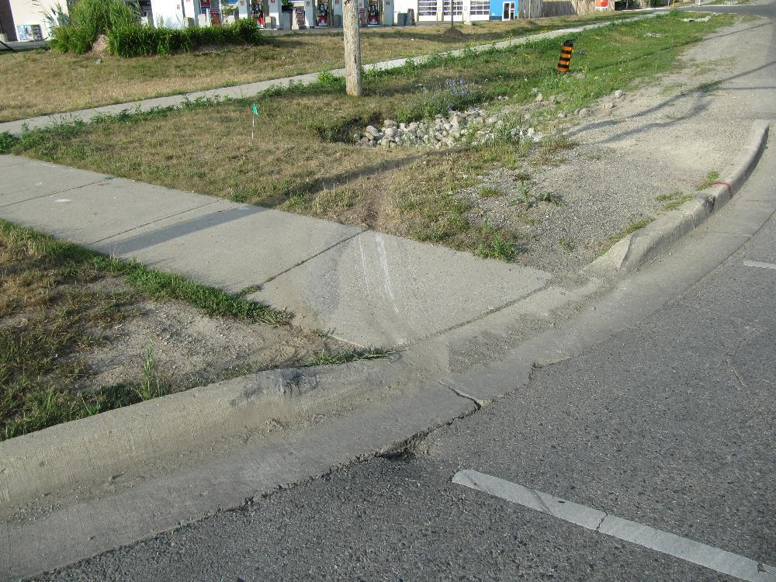
View of evidence indicating the Mini-van's travel against the south-west curb and into a rock-filled ditch.
July 21, 2012
A fatal collision has reportedly occurred at the intersection of Sunningdale Road and Adelaide Street in north London, Ontario. The collision reportedly occurred at approximately 2000 hours this evening. Details are still sketchy but it appears an SUV has been struck in the rear of its right side by the front end of a passenger car.
The impact has not been severe enough to cause structural intrusion into the occupant compartment of the SUV and air bags have been deployed on the car. Thus the reason for the fatality initially appears to be puzzling.
Police have closed the intersection and further details may be forthcoming.
Below are two views of the accident site taken in January, 2012.
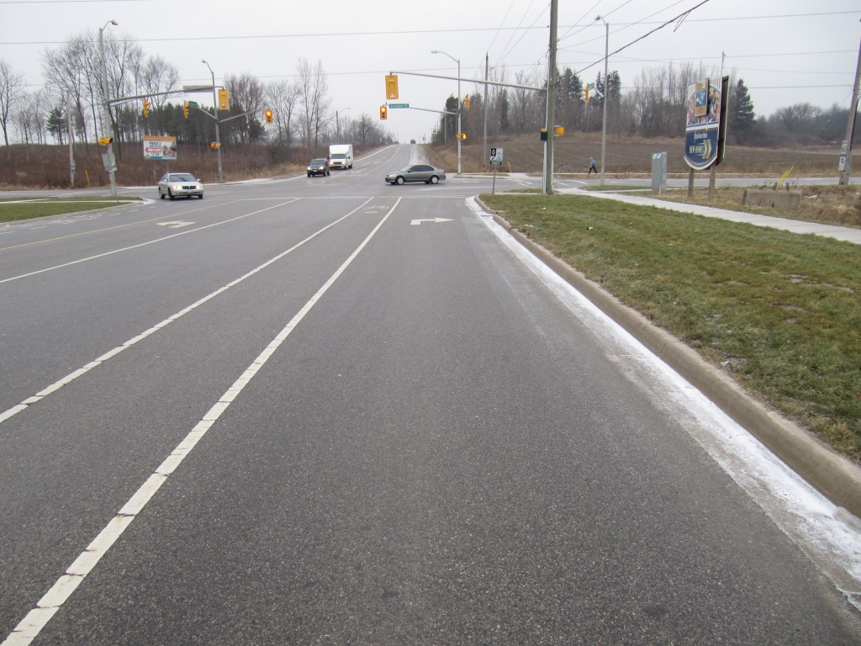
View, looking north on Adelaide Street toward the intersection of Sunningdale Road. This view was taken in January, 2012 and shows the general layout of the intersection.
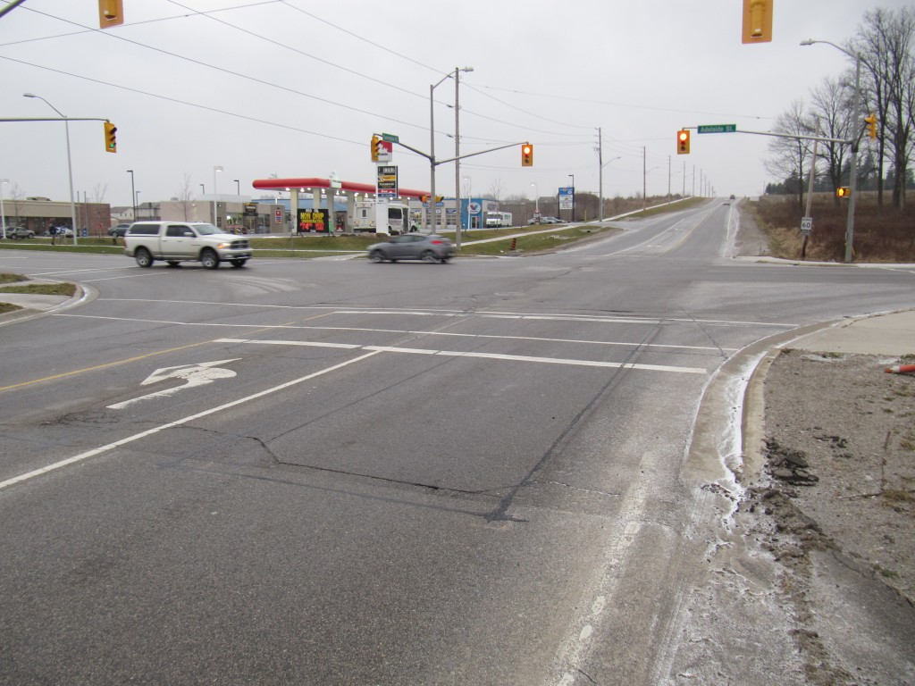
View, looking west along Sunningdale Road, toward its intersection with Adelaide Street.
These photos were taken to show a double stop bar for westbound traffic on Sunningdale which we indicated at the time might confuse drivers. When we consider that Adelaide Street is wider than a typical 4-lane road due to the presence of a designated bicycle lane and left turn lanes, then westbound drivers on Sunningdale could need more time to cross the road. There is no information presently to indicate if any of these factors might have anything to do with the present fatal collision at this location.
July 20, 2012
Seeing What’s Ahead Is Vitally Important For Your Safety
While we often take it for granted that the roadway we have always travelled will be in the same condition it has always been, this is a particularly dangerous assumption that we make when we cannot properly see the roadway ahead.
Roadways are designed with a certain amount of safety built in. For rural roadways in Ontario with a maximum posted speed of 80 km/h per hour drivers can usually be assured that they will be able to see an object about 135 metres ahead of them and therefore be in a position to stop or avoid the obstacle…but not always. The standard assumes that most obstacles will have a certain height to them. In Ontario we assume the object to be avoided will be at least 38 centimetres tall. Why? Well it is just a simplification; a decision that relates more to seeing taillights of vehicles more than anything. But there are many real-life instances where the danger to be avoided is not at least 38 centimetres tall.
For example, imagine you are approaching a right curve on a rural road such as the one shown in the photo below. A warning sign on the right roadside indicates the layout of the curve and also advises that you should reduce your speed to 60 km/h.
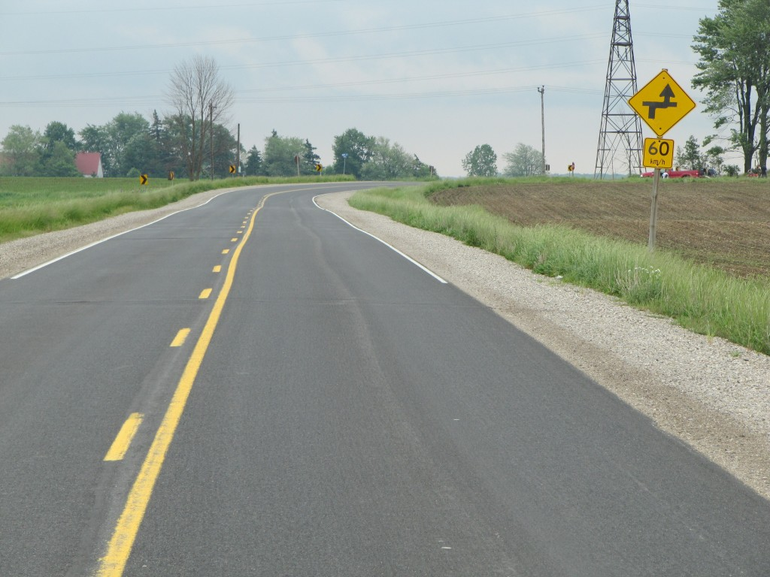
View of right curve on a typical rural road.
Having passed through the curve on many previous occasions you decide that you can travel through it at a much higher speed. But something in the curve has changed. In this case, some off-road bikers have been using the road to enter and exit from a dirty field as shown in the photo below.
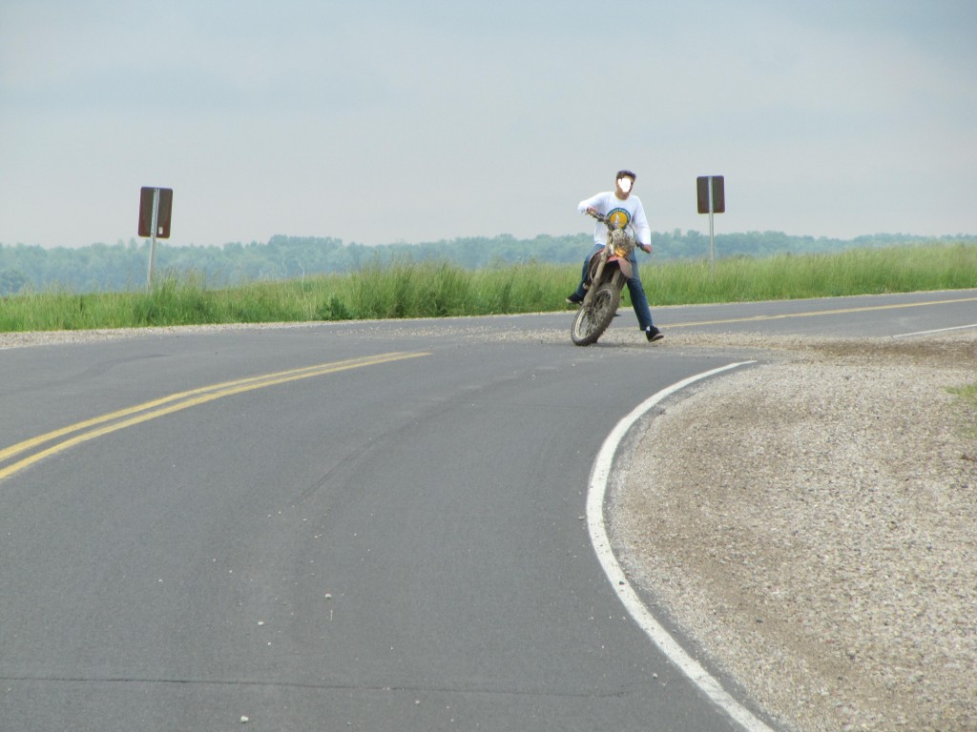
Dirt-bikers enter and exit on curve of roadway depositing dirt on the surface.
Now the roadway that you assumed was going to be similar to what you have previously encountered is covered by dirt and gravel, as shown in the photo below.
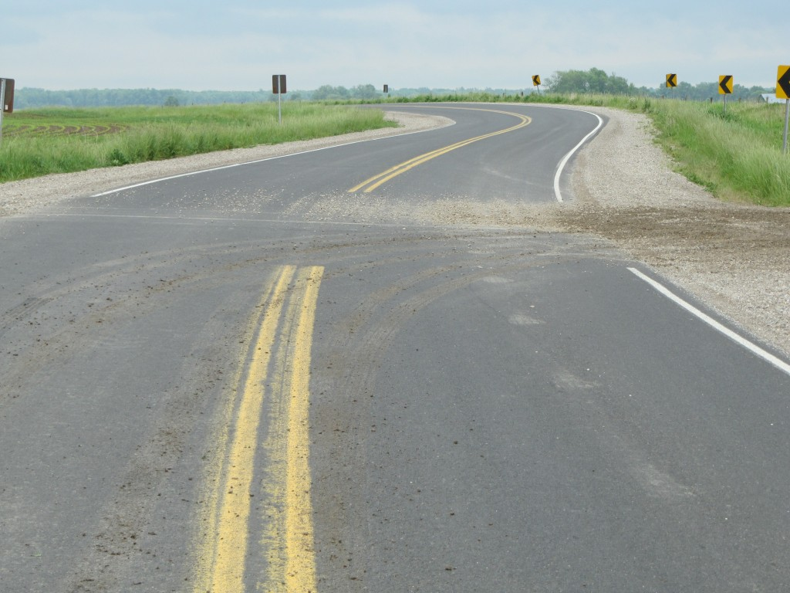
Dirt and gravel on road surface cannot be seen from the assumed distance of 135 metres ahead.
But you assumed that the roadway design would protect you by allowing you to see obstacles at least 135 metres ahead of you. But dirt and gravel have no height. Unless the dirt and gravel is piled 38 centimetres (over a foot) high on the road, your assumed “stopping sight distance” of 135 metres is no longer there.
One of the worst road characteristics where drivers lose directional control of their vehicles is just after entering a curve on a rural roadway. Drivers habitually over speed the advised speed of a warning sign at a curve. But a change in the aggressiveness of the road surface (such as a deposit of dirt and gravel) that keeps your vehicle stably passing through the curve can cause your vehicle to rotate out of control. So the above scenario is particularly important to comprehend.
Your vision ahead of you and your focus on distant objects ahead is vitally important to your safety on the road. If you cannot see the road surface for a sufficient distance ahead you cannot assume that it will be of the same character as the surface on which you are travelling. This is vitally important at curves on rural roadways.
July 18, 2012
Boy Killed in Hit & Run Collision on QEW Near Grimsby, Ontario
A van, transporting nine persons, was eastbound on the Queen Elizabeth Way, at approximately 0300 hours on July 17, 2012. A white Volvo road tractor struck the van from behind whereupon the van passed through a guard rail and rolled over. An 11-year-old boy in the van sustained fatal injuries. It is reported that some of the occupants of the van were ejected from the vehicle.
The Volvo truck left the accident scene and police are now tried to track it down. It is reported to have damage to the right side of its front end with a large piece of its right front fender missing.
While questions will remain regarding how the events unfolded it is also an important question to ask how the van interacted with the guardrail and whether the rail was placed at an appropriate height to lessen the likelihood that the van might pass over the rail and enter into a rollover. It must be remembered that barriers of this type are made to lessen the severity of a collision by re-directing a vehicle while keeping it on its wheels. When a rollover occurs it can be in indication that the barrier did not perform as it should have. Whether or not that is the case should be properly evaluated along with the other important issues in the case.
Jarrod Hinz Killed In Two-Vehicle Collision in Malahide Township East of St. Thomas, Ontario
It is reported that 21-year-old Jarrod Hinz of St. Thomas, Ontario was killed when his westbound Saturn when through a stop sign on Elgin County Road 45 (John Wise Line) and was struck by a northbound pick-up truck on Springfield Road. The collision occurred in the afternoon of July 18th, 2012.
UPDATE: July 20, 2012; 1330 Hours
We examined the site of this collision on July 19th near rush hour (1600-1700 hours). As at other intersections in the area we noticed a surprisingly heavy volume of traffic at the intersection of both roadways but particularly on Ron Wise Line which the roadway containing the stop sign on which Jarrod Hinz was driving when he was killed.
As an example, below is a view, looking north towards the intersection while standing on the west shoulder of Springfeild Road. The view shows at least four westbound vehicles waiting to pass through the intersection. This is the same direction that Jarrod Hinz was travelling just before the collision.
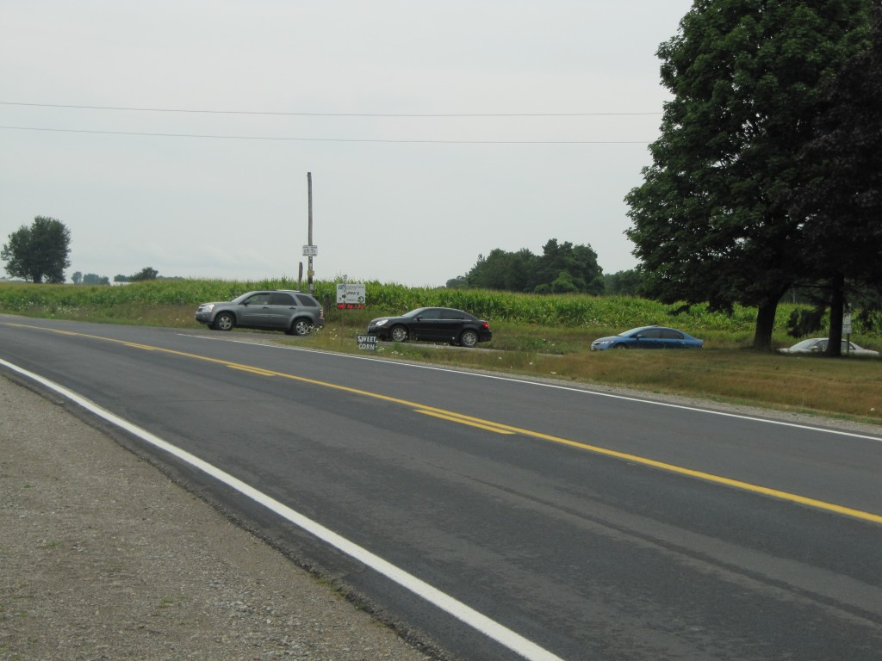
View, looking north from the south side of the intersection of Ron Wise Line and Springfield Road. There is a line up of four westbound vehicles visible at the westbound stop sign of Ron Wise Line.
We also noted a number of large trucks and farm vehicles using the intersection such as the large eastbound truck shown in the photo below. This view is from the opposite direction of the previous photo.
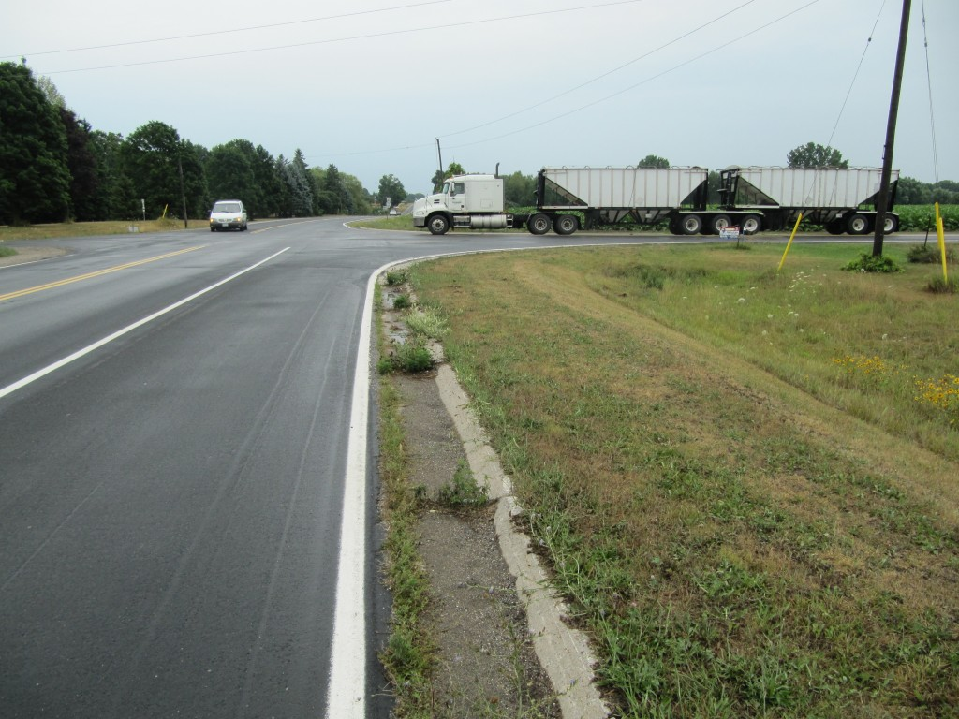
View, looking south, along Springfield Road toward the intersection with Ron Wise Line. An eastbound road tractor hauling two large trailers is seen preparing to cross the intersection from its stopped position at the eastbound stop sign. While watching its travel we noted how slowly it moved and that it took a long time to clear the intersection.
With these larger traffic volumes it is not surprising that eventually a collision will occur.
July 17, 2012
Fleeing Police – How Do We Know?
There are times when we present information on this website without having the opportunity to explain in detail how we arrived at the conclusions we have provided. The reality is that it takes considerable time to gather material and present it in a comprehensible article. Yet, we believe we do a reasonable job compared to the information that is regularly displayed in the official news media which is mostly based on what a reporter has been told, let’s say, from a police media representative.
The discussion of a few days ago involving the police chase through London, Ontario did not elaborate how we determined that a fleeing vehicle made the actions that it did while the theives were attempting to avoid capture. In fact we took hundreds of photos as we followed the physical evidence through the various streets. As an example, we have included several photographs below to demonstrate the type of physical evidence that we gathered which resulted in the comments that we made.
Below is a view, looking northbound on Wellington Road , at the S-curve located north of Emery Street and south of Grand Avenue. In this view we are pointing to a scrape mark that was caused by one of the left side rims of the fleeing northbound vehicle as it travelled through the curve.
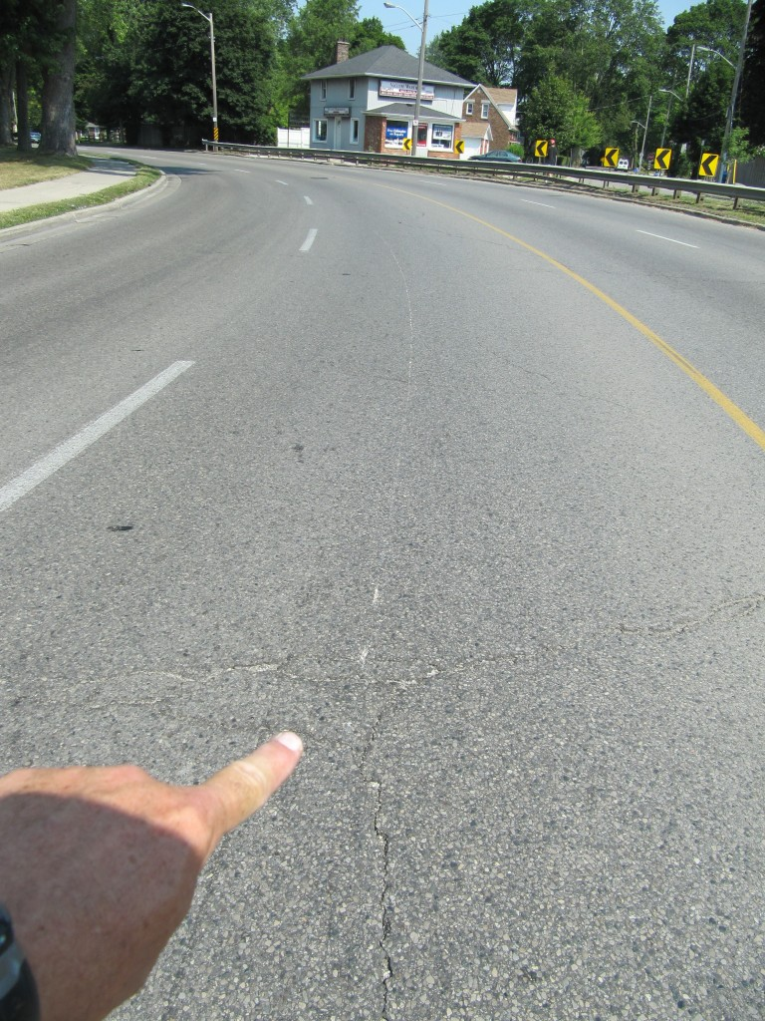
Scrape from left front tire rim of fleeing vehicle on wrong side of the road.
If it is not obvious, this scrape is on the wrong side of the centre-line of the road. This means that the vehicle is travelling through the curve on the wrong side of the road.
Once again, below is a northward view on Wellington Road in the southbound lanes and we can see the obvious scrape from the same rim caused by the fleeing vehicle. The vehicle is heading northbound into downtown London and this location is several kilometres north of the previous photo. Again, if it is not obvious, the vehicle is on the wrong side of the road when it is making this mark. Note the conrete planters on the right side of the view are located in the median of the road.
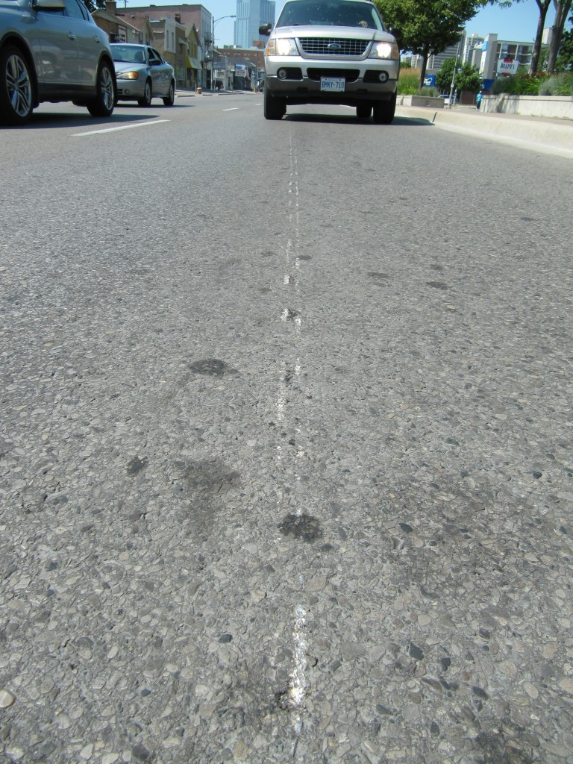
View, looking south on Wellington Road showing the scraping from one on the rims on the left side of the fleeing vehicle.
As another example, below is a photo taken of the scrape mark, another several kilometres to the north as the vehicle made a left turn from Wellington Road onto Pall Mall Street in the north end of London’s downtown.
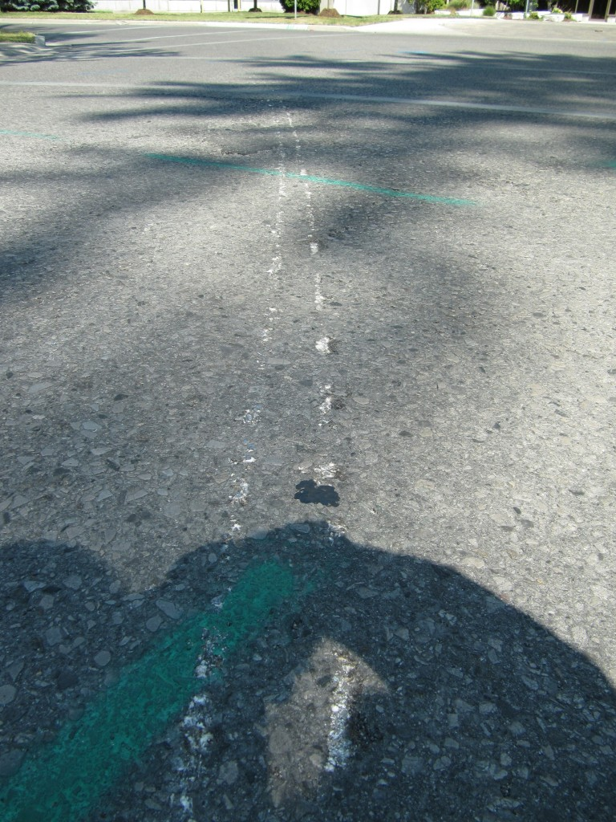
View, looking north at the scrape caused as the fleeing vehicle made a left turn from Wellington Road onto Pall Mall Street at the north end of London's downtown.
We also relied upon the evidence of pieces of tire that was strewn onto the roadside of Wellington Road, as shown in the photo below.
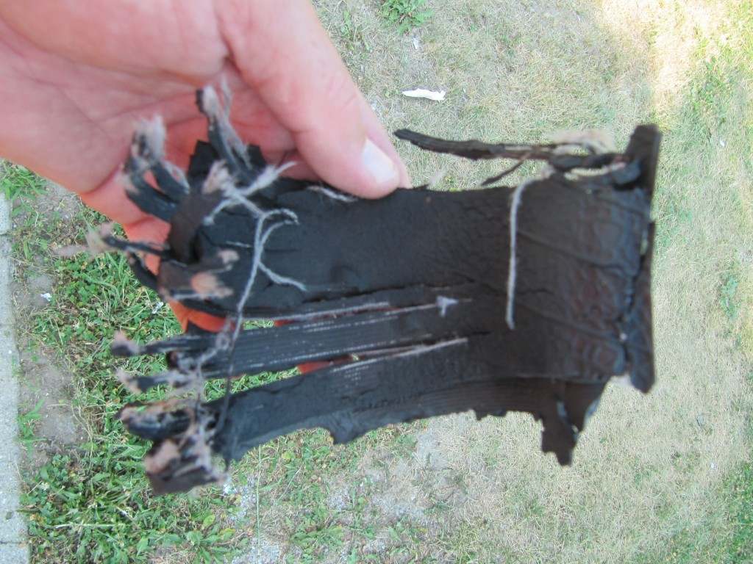
View of torn sidewall of tire found on the roadside of Wellington Road south of Grand Avenue.
We also relied upon other evidence such as a broken piece of wheel rim that was also found lying on the side of Wellington Road south of Grand Avenue and is depicted in the photo below.
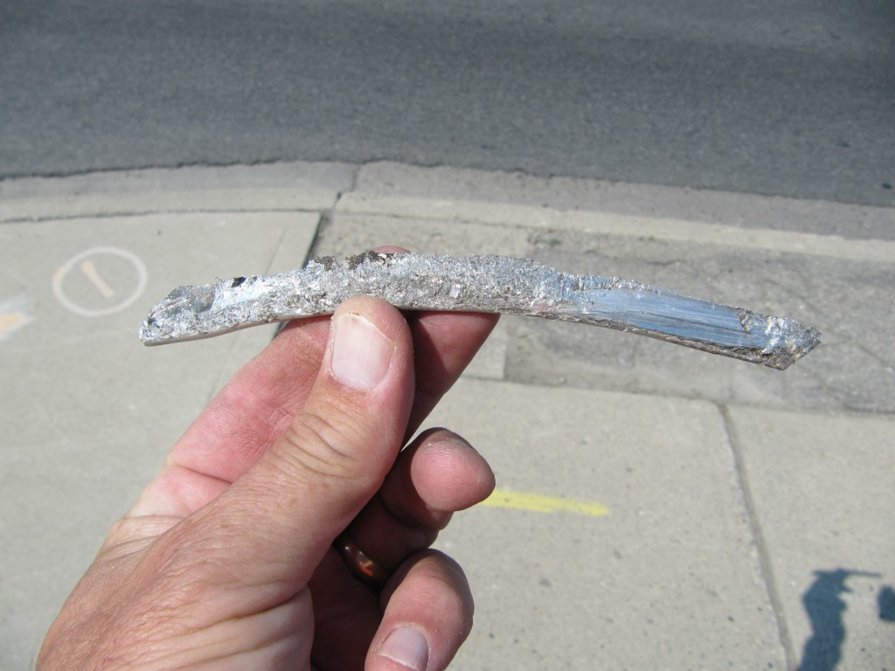
View of fractured piece of wheel rim showing evidence of being driven on the pavement road surface for an extended time.
All the noted evidence was followed through a continuous trail up to the point where the fleeing vehicle finally came to a stop at the CPR railway tracks near the intersection of Piccadilly and Saint George Streets and the suspects were apprehended.
The physical evidence laid down at an accident site does not tell the whole story about how a collision occurred however, in many instances such physical evidence lies around for a considerable time, undetected by persons who are unable to identify it or its relationship to the event.
We began independently examining accident sites and posting our finding on this website about three years ago. In that time we have sharpened our skills in this area. Oftentimes, in a “real” investigation investigators, including ourselves, have been deluged with a large quantity of evidence from the vehicle, site, expert examination reports, statements of witnesses/drivers, etc. such that the most obvious evidence grabs the investigator’s attention. We notice that when there is a scarcity of information sources and the only source is from the accident site, we become more attuned to that site evidence. Small pieces of debris or markings that would not normally attract our attention become more important as we evaluate its possible connection to an incident. It makes us better at being investigators and analysts. More than ever we recognize the educational value of such an exercise for any novice student of forensic analysis.
July 16, 2012
Richard Davison Identified As Motorcyclist Fatally Injured Near Sarnia, Ontario on Friday, July 13th
A collision between a 2009 Suzuki motorcycle and 2009 Honda Civic at the intersection of London Line and Camlachie Road has claimed the life of Richard Davison, 63, of Sarnia, Ontario. The 19-year-old driver of the Honda has not been identified.
Fatal Rollover Collisions A Sign of the Season and the Times
Periodically, the official news media raise concerns of the number of loss-of-control and rollover collisions occurring in our region. Although this epidemic has existed for decades, as vehicles become more capable of protecting occupants in other types of collisions, loss-of-control and rollover events appear to stand out.
In the Brantford area the Six Nations Territory has experienced its third major rollover collision in as many weeks as a single vehicle rollover occurred on Saturday, July 14th at approximately 0645 hours on Tuscorora Road.
Similarly, on the Oneida First Nation Reserve an 18-year-old man, Kevin Dawson-Olafsson lost his life after he attempted to avoid striking a dog on Ballpark Road and rolled his Neon into a ditch.
Rarely do investigators and reconstructionists get a firm hold on what precipitated the deadly events. Even descriptions such as the attempt to avoid an animal are based on information from witness and there is no way of independently confirming whether what someone says is in fact what actually happened. It is very rare that these loss-of-control events actually produce physical evidence at the point where the emergency occurred. Usually a driver will encounter a difficulty and will respond for several seconds before the point of no return is reached. During those several seconds there is little evidence produced to lead investigators back to that specific location which could be several hundred metres back (in highway speed rural scenarios) from where the vehicle comes to rest.
July 15, 2012
Triple Fatality in Pelham Head-On Crash Leads to Questions Why One on the Vehicles Caught Fire
The general public does not think to question why a vehicle would catch fire in a crash leading to the death of three people. Yet there are government safety standards in place specifically to prevent such an outcome. While official investigators what to withhold information when it may be disturbing to the families involved there is an equally important consideration that the cause of such fires be investigated with proper public attention so that a problem is not swept under the carpet leading to future similar incidents.
Many decades ago Ford Pintos reached the headlines when a number of them caught fire in rear-end impacts. More recently Ford Crown Victorias were blamed because many police vehicles stopped at a traffic stop would catch fire when rear-ended by approaching vehicles.
Often it takes a long time for the mass media to focus onto an issue when they sometimes appear to be busy trying to create a public panic about something else that does not exist.
Police investigators in the Pelhem crash have been quoted as providing the standard reply that it will take some time to determine the cause of the crash. But nothing was mentioned about determining the cause of the fire which may have been the reason why there were three fatalities. Such important factors are simply glanced over and the general public has no reason to question why it should be otherwise. We need to be more vigilant of such hidden issues and expect the authorities to report on them.
July 12, 2012
Canadian Pacific Railway “Spike Belt” Finalizes The Stop In A Prolonged Chase the London Police Spike Belt Did Not Finalize
The story line sounds peculiar but early this morning, July 12th, 2012, various local police forces were engaged in trying to stop a vehicle with three robbers. A spike belt was used but the vehicle continued travelling through various streets in downtown London without any apparent end in sight. A line of aluminum transfers and gouges were left in the roadways that could be followed like a deer trail. Finally, as the vehicle travelled westbound on Piccadilly Street toward Saint George it rode parallel to the Canadian Pacific Railway line and got its wheels stuck in the deep rock/coal along the rail bed. The chase came to an un-dramatic end as the vehicle’s wheels became buried in the rock/coal deposit. It is an interesting way to use raw materials to end a chase where a real spike belt only partially disables a vehicle.
For the purposes of accident reconstruction, the many kilometres of trail of gouging and rim deposits make for a useful study of what evidence looks like when a vehicle is travelling on wheel rim for an extended distance.
UPDATE: July 12, 2012; 1650 Hours
The official news media do not have the full story regarding this “incident”. Although we also do not have the full story we at least have a greater part of it and it is based on the physical evidence.
So far we have tracked the tire marks from the fleeing vehicle as far back as the intersection of Grand Avenue and Wellington Road. At this point the northbound vehicle lost a large chunk of its deflated tire and, rather then moving northbound in the northbound lane it moved into the southbound lane. Imagine this: The driver of the stolen vehicle travelled northbound in the southbound lane of Wellington Road from about Grand Ave all the way past some of London’s busiest crossroads like Horton Street, York Street, Dundas Street and Queens Ave. – it even travelled in the southbound lanes through the narrow CNR underpass on Wellington Road between Norton Street and York Street. Yet there was not a single collision.
After passing Queens Ave it moved back into the northbound lanes of Wellington and then made a left turn at Pallmall to head toward Richmond Street. It then made a right turn to travel northbound on Richmond. It was on the proper side of the road as it approached Oxford Street but the driver suddenly turned left onto Piccadilly. As the vehicle approached Saint George Street there was an obvious disturbance in the continuous gouging and scraping of the pavement as, for about one or two metres, there was a patch of tire rubber deposited on the pavement. This is probably what the official news media have been told by police that three of the vehicle’s tires became blown out. That may be so but the physical evidence does not exactly show it that way. The vehicle continued to deposit only one marking from the same tire it had all along the “race”. But as it crossed Saint George it travelled parallel to the railway track where, as we stated earlier, it became wedged in the broken rock/coal debris. Whether there were three tire deflations at that point is not shown by the physical evidence but it appears to be a minor point.
So far this breaks our record for the longest escape on a wheel with no tire, and riding through the City streets on just the rim, while gouging every roadway that it travelled. The evidence is fairly easy to follow once a person knows what to look for. Whatever happened prior to Grand Ave is still unknown but we have still not seen any tire marks which would have to be made before the vehicle actually broke the tire apart and began riding on its wheel rim. Obviously the police who were involved in the chase know very well what took place and when, but that information will likely never reach the official news media.
This was a dangerous event that could have had tragic consequences if it did not occur at about 0200 hours. There was some luck involved that no one else got hurt. While we may weigh the consequences from time to time and blame the police for creating the dangerous situation, one must ponder the fact that these robbers were intent on causing the dangerous situation. Imagine for a moment, if you are familiar with the busiest road in London, Ontario, that these persons were driving on the wrong side of this busy road for several kilometres. They had no concern for what they were doing. What if there was another vehicle travelling that road?
What are police to do? Use common sense and discretion. We do not fault them for that. But sometimes police fail to admit it when they have made a mistake and the cover up is just bad for everyone including the police. We do not expect police to be perfect. We just expect the community to root out those instances when mistakes were made and then be accepting of those mistakes.
July 11, 2012
Time Constaints Lead To Decision Not To Produce Website Article
As may be appreciated by many, time when it is given volunarily can be a difficult item to offer. Unfortunately we have a business to run such that, we do our best to volunarily examine collision sites and post our comments. But sometimes time commitments force us to concentrate on matters related to why clients retain our services. So we are simply too busy (temporarily) to prepare an article discussing the crash that occurred on Oxford Road 8 on July 7th. Unless we receive a specific request that we deem worthwhile we will not post any further details in a separate article.
We can comment however that the crash was particularly tragic in that the vehicle was travelling at relatively slow speed when the driver was ejected, or partially ejected, from his vehicle. This is a difficult issue as it brings no solice to the family and friends who knew him.
But for those of you who may consider driving while not wearing a seat-belt, stop and evaluate your decision. You are not only putting yourself at risk but you will burden those who will miss you greatly or have to look after you if you should sustain permanent injury. Clicking a seat belt is such an easy thing to do. Do that one little thing and help prevent a possible tragedy.
July 9, 2012
Single Vehicle Rollover on Oxford County Road 8, north of Drumbo, Ontario, Claims the Life of James White
On Saturday, July 7th, 2012, at approximately 2245 hours, James White was travelling eastbound in his pick-up truck on Oxford County Road 8, just east of County Road 3 when he approached a left curve accompanied by a steep downgrade. The vehicle travelled on the south (right) road edge and then rolled over resulting in his death. We examined the accident site on the morning of July 9th and will be posting details of our findings in a separate article on the Articles page of this website.
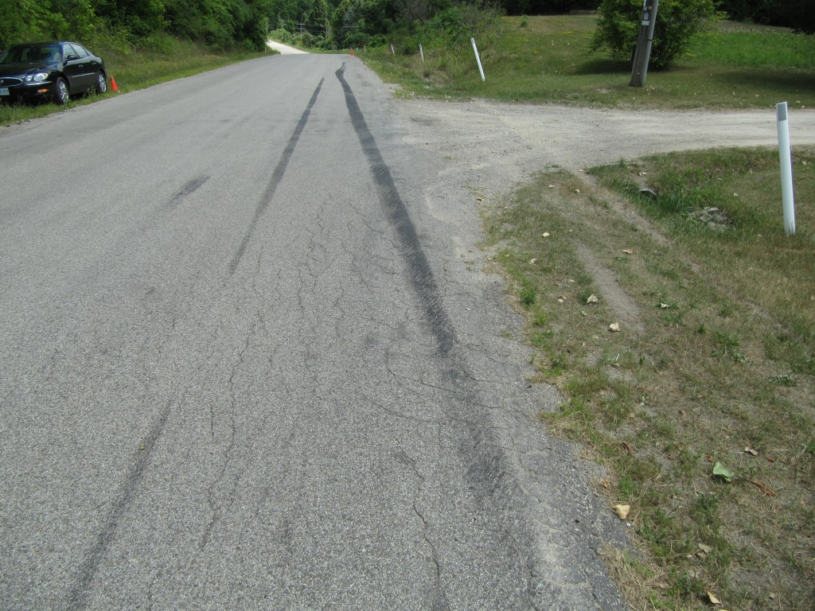
View of tire marks left by the eastbound pick-up truck just prior to its rollover over on the south side of Oxford Road 8
The photo above shows the tire marks left by the vehicle just before it rolled over. The orange cone on the right (south) roadside if the distant background is where the vehicle came to rest.
July 5, 2012
Serious Injuries To 4-Year-Old Child Need Revelation To Prevent Similar Occurrences
It has been reported that shortly before 0900 hours today, July 5th, 2012, a 2004 Dodge van was southbound on Bloomfield Road, south of Chatham, Ontario, Canada. The Van approached a T-intersection with Eighth Line. The vehicle passed through the intersection, struck a guard rail and passed through that barrier and struck several trees. A 4-year-old girl in the van sustained major injuries but the details of what occurred have not been released.
While we sympathize with the family and friends at this difficult time there are other issues at stake that are often glanced over. We suspect there is reason to make it known how those injuries occurred because we have examined a large number of accident cases and are aware of what injuries could potentially have occurred in such a crash. This may not be the appropriate time and we agree that time needs to pass. But very often these incidents make initial headlines or lead stories but then the follow-up fails to occur. The public must be made aware of the dangers that exist so they can have the opportunity to evaluate their own actions and decisions. We have stated numerous times that the lack of disclosure means that these tragedies will re-occur and nothing will be learned from this tragedy.
UPDATE: July 7th, 2012, 1150 Hours
We examined the site of this collision shortly before 0900 hours on July 6th, or about 24 hours after its occurrence. We have several concerns about the placement and performance of the guardrail at the T-intersection. Also, it was apparent that two stop signs were placed, one on top of the other, in an unusual arrangement that should not have been allowed. We have uploaded an article on the Articles page of this website which provides further details of our findings.
July 2, 2012
Purtill Trial Verdict – How Will We Prevent Another Similar Tragedy?
An innocent baby was killed almost four years ago when Bonita Purtill chose to drive while impaired by her alcohol consumption. That is the conclusion of a jury that found her guilty of all six charges laid as a result of the accident that occurred on a Thanksgiving day weekend in 2008. The accident occurred in Devonshire Avenue in Woodstock, Ontario, Canada. The death of baby Alex Rodrigues will not be changed by that finding nor will the difficulties that lie ahead for the Rodrigues family.
We have an opportunity, every day, from this point forward, to reduce the possibility that such a tragedy will recur. While there are many flavours of attitude and opinion as to how this could be done, recent discussions have polarized into two distinct camps. On one side is a group claiming that a tough line on crime is required, no benefits to criminals, and simply throw them in jail for a very long time. On the other side is a group that claims we need social programs, help and rehabilitation to change the actions of those whose behaviors could be changed. Whereever the correct action may lie it is more important that citizens become engaged and educated in the details behind the discussion. The loudest voice should never be the one we should listen to but the quietest voice is sometimes impossible to hear. A diversity of thought and opinion with input from the widest spectrum of our society will likely achieve the best result.
In our experience drunk driving only reflects a small part of a much larger problem about the actions of many us, not only behind the wheel of a motor vehicle, but in the way we act inappropriately and in a distructive fashion in many aspects of our lives. What things can parents teach their children when the parents themselves come from a background where they are incapable of teaching their children to be productive and successful human beings? How can we act in an ethical manner when so many things broadcast to us in popular media glorifies negative behaviours such as greed, lies, hypocricy, self-indulgent behaviour and so on?
It is a discussion that needs to be carried out beyond the narrow bounds of traffic accidents.

