Gorski Consulting Website

Archived News - 2012 - March

March 27, 2012
OPP Constable Charged In Dunnville Ontario Crash May Not Be Guilty
Due to several questionable incidents in recent years we have come to criticize the OPP for failing to objectively investigate collisions involving their own officers. The questionable investigations have generally be used to hide police responsibility for a crash. However, in a recent OPP crash in Dunnville, Ontario, we believe there is reason to reverse that criticism and say that investigating police may have been unfair to their own in charging an OPP officer with making a left turn not in safety.
The incident occurred on Friday, March 23, 2012 in Dunneville, Ontario, a town located near the north short of Lake Erie, west of Niagara Falls. Constable Lisa Randall, a 17-year veteran of the force was on duty and travelling in an unmarked Chevrolet SUV and was attempting to make a left turn from Broad Street onto Tamarac Street. A Pontiac Vibe, travelling in the opposing direction struck the OPP SUV in the right front wheel area causing the OPP SUV to be pushed into a Ford F150 Pick-up truck that was stopped at the intersection.
The physical evidence can be misunderstood when looking at the damage to the right front wheel area of the OPP SUV in that there appears to be only moderate crush. Investigators can fail to understand that this stiff portion of the vehicle can sustain a large force without revealing itself. The Constable’s guilt comes into question when we look at the extensive crush to the front end of the Vibe. The amount of crush suggests that this was a substantial impact. The Vibe’s speed is also reflected in the fact that it pushed the OPP SUV into the stopped Ford where more damage was caused.
The bottom line is that there is evidence of substantial kinetic energy that must come from the pre-impact speed of the Vibe. Unfortunately the Vibe’s event data recorder (“Black Box”) cannot be read by police investigators unless they ship it to Korea, which is not going to happen in a collision involving these minor consequences.
Secondly, with no ability to download an EDR, police investigators are trained primarily to use a momentum analysis to calculate speed. Such an analysis must determine facts such as the post impact travel angles and distances of both vehicles along with the rate of deceleration during that travel. The calculation of these facts becomes difficult when there is a secondary impact. Crush to the vehicles involved in the secondary impact must be evaluated in order to estimate the post-impact deceleration of the OPP SUV. This is not an easy task using hand calculations even if one knows what those calculations should be. Practically speaking, the only way to resolve this is with computerized programs (SMAC, CRASH, PC-Crash, etc.). But police have never purchased such products and are untrained in these methods. Therefore a proper, objective analysis of the speed of the Vibe was likely never conducted by police investigators in this crash.
We have come across this bridge many times, in that a driver of a left-turning vehicle is charged or held at fault seemingly regardless of the facts. A landmark case in a Montreal intersection a number of years ago had investigating police determine that a left-turning driver was at fault for his own demise until the EDR on the through vehicle determined that it was travelling at incredible speed. This is not an anomoly, it is a common occurrence.
Therefore we should not convict Constable Lisa Randall in the court of public media until we analyse all the facts.
March 25, 2012
Springbank Drive Fatal Tree Impact Still Too Early To Determine Cause
(See Related Article in Articles Page of This Website)
A 21-year-old male lost his life this morning as a result of a reported, single vehicle collision that occurred on Springbank Drive in London, Ontario, Canada. Although police have released little details, we were able to examine the site this afternoon, less than 12 hours after the occurrence time of shortly after 0500 hours.
Preliminarily, it would appear that the vehicle was headed westbound and approached a left curve just a few hundred metres east of the intersection with Commissioners Road. The rather than following the curve the vehicle travelled straight onto the north roadside where it commenced a counter-clockwise rotation and a lateral roll, leading with its right side.
The facts at the tree impact become somewhat peculiar as it would appear that two trees, at least 4.7 metres apart sustained contact damage. This is unusual since a photo of the vehicle in a London Free Press article showed that the vehicle sustained a tree contact to the rear portion of its roof. Since a typical vehicle might be 4.7 to 5.0 metres long it becomes obviously suspicious that two trees could be struck by the same vehicle given the noted distances. The two trees were positioned laterally side-by-side along the vehicle’s path so it is difficult to suggest that the vehicle struck one tree and then was deflected to strike the other. Obviously there are complications here that we are not aware of but we are simly reporting the problems that appear to exist.
Tire marks on the north roadside were visible for about 75 metres before the tree impact. Using a typical range of deceleration of 0.2 to 0.4 g for that distance of travel would result in a speed loss of about 62 to 87 km/h. This is not extremely high but it is quite a bit higher than the posted speed of 50 km/h for this road. Note that after losing that amount of speed there was sufficient deformation to the vehicle to cause the fatal injuries. So the speed of the vehicle is one of the factors that led to the crash. Witnesses also reported that there was fog in the area and that the road surface had a “glistening” shiny look to it suggesting that it was damp. This is a sign of a slippery road surface and and therefore this could be another factor leading to the crash. A friend of the victim also reported that the deceased was hearing a noise in his steering system just a day or two before the crash. Hopefully police will pay attention to this issue and examine the vehicle properly.
So there are many issues still to be resolved and this is still very early in the investigation.
UPDATE: March 26, 2012; 1310 Hours
We have now uploaded an article in the Articles page of this website which provides details of the collision evidence at the site.
UPDATE: March 26, 2012; 1610 Hours
The deceased driver has now been identified as Omran Khadar.
Lack of Proper Investigation Becoming More Prevelant
We gave testimony this week in Montreal, Quebec with respect to a injury claim dispute between a female driver and the government-run Quebec insurance system. The claimant had just finished therapy about two months earlier with respect to a previous collision when her vehicle was struck again in a seemingly minor collision in which she claimed her further injuries. The full extent of the objective evidence to deny her claim was several photographs of the driver’s door of her vehicle which, at face value, appeared to show very limited crush in the order of several inches. Neither of the vehicles nor the collision site was actually inspected. There was no information about where the impact occurred and where the vehicles came to rest. The “sliding” type of damage shown in the photos also could not provide any indication of which part of the other vehicle made contact with the driver’s door of the women’s vehicle.
The damage appeared to terminate abruptly at the edge of the left front wheelwell such that the crush was inboard of the left front wheel, yet no one, including the expert hired by the government-run insurance system, would admit to the possibility that the tire and wheel might have been struck and therefore the collision severity was quite different than what was being assumed. Even when the insurer set out to deny the claim they failed to arrange an inspection of the other vehicle, which was reported by the other driver to sustain no damage, to confirm that indeed there was no damage. This is an important point in “low speed” impacts because damage that appears to be non-existent to the lay person may actually exist and explain how additional kinetic energy in the collision was dissipated. The front facia of a bumper system frequently “bounces back” to its original form while masking the possibility that there could be hidden damage to the energy-aborbing material behind that facia. If a vehicle is not properly inspected to assess this possibility, as well as others, then the vehicle may appear to a judge or jury as having been undamaged.
The bottom line is that this incident demonstrated the degree to which official agencies have changed their actions in recent years by failing to conduct proper investigations to gather objective facts. As the cost for such investigations are recognized, those officials who are not held accountable for their actions, are forcing investigators under their control to complete more and more work with less resources and thereby causing investigations to be incomplete or essentially not done at all. This is an unrecognized problem in many facets of our modern society as goverment debt is being used as an excuse to terminate public services to the point of reaching a crisis. Lack of proper functioning of our public investigative agencies is only going to become more prevalent as further cuts are anticepated by Canada’s Federal and Provincial governments.
March 13, 2012
What Actually Happened When A Middlesex OPP Cruiser Crashed While Reportedly Avoiding A Deer On The Road?
We agree that every driver deserves a fair evaluation of their case when they are involved in a motor vehicle collision. However the official news media explanation of how a Middlesex County OPP cruiser crashed while the officer was attempting to avoid a deer should be clarified since the evidence at the site is peculiar at the least.
The news media made very little mention of the fact that, shortly before midnight on Sunday, March 11, 2012, a Middlesex County OPP Constable was responding to a call and was travelling southbound on Hyde Park Road just south of Fourteen Mile Road, just northwest of London, Ontario, Canada. It was stated that a deer ran out on the road and this caused the officer to attempt to avoid it. In doing so the cruiser entered a ditch and rolled over. The officer had to be freed from his vehicle and was treated at hospital for non-life threatening injuries.
The evidence at the site shows fresh evidence of two separate vehicles being involved in a crash. Both vehicles went off the road at the same curve. One vehicle, an older model (99-02) Ford travelled off to the west side of the road where it side-swiped a number of trees and tore off some of its suspension parts. The second vehicle, likely the officially named police cruiser, travelled to the east side of the road where, indeed, it exited onto a farmer’s field and rolled over.
We are willing to accept that strange coincidence sometimes occurs such that two separate collisions, involving two different vehicles, can occur at the same location of a road within a day or two of each other. But the evidence is also peculiar in that the characteristics of the accident site, along with the physical evidence of the collision has the characteristics of being caused by travelling around a curve in a road at too high of a speed. Again, it can be a coincidence that a deer might happen to enter the road at this curve and cause the officer to react in a manner similar to someone losing control of a vehicle while travelling too quickly. But we think an explanation from the OPP as to how this evidence occurred would help.
March 12, 2012
Fatality on Highway 4 Near Mount Carmel Road Is A Possible Loss-of-Control Event With a Severe Impact
While details are obviously still very sketchy, a fatal collision on Highway 4 near Mount Carmel Road around 0700 hours this morning shows evidence that the driver of a silver-coloured passenger car may have lost directional control of his/her vehicle resulting in a counter-clockwise rotation into the opposing lane where the Silver vehicle was then struck by the red vehicle in the red vehicle’s lane. This interpretation is based on a photograph displayed in the London Free Press article on the collision, which shows the two vehicles at their final rest positions.
Although many factors could be at play and each collision is unique, our interpretation is based on seeing the location of the final rest positions, the pointing angles of the vehicles, areas of damage on the vehicles and the extent of crush. This pattern of evidence can be seen in many loss-of-control collisions in the past and therefore this why we make these comments.
Viewing the London Free Press photo of the site it initially appeared that the site might have been near a curve. However having examined the London Free Press video of the accident site the illusion of a curve may have been an artifact of the telephoto lens used to take the photo. It is now more likely that the collision occurred just south of the intersection with Mount Carmel Road and close to Tasko Drive. The vehicles would appear to be on the west roadside at their final rest positions therefore the Silver vehicle was northbound and the red vehicle southbound.
We conducted testing at this location just two days ago, on March 10th, 2012 wherein we mounted five video cameras to our test vehicle and, travelling between 75 and 80 km/h, we documented how drivers made their passing motions around our vehicle. Our drive through the site was both northbound and southbound. We documented several vehicles making passing motions of our test vehicle. It is not clear whether the loss-of-control of the silver vehicle in the present case was related to any passing motion.
We will post further comments and corrections to these interpretations if the facts turn out to be different than what has been stated.
UPDATE: March 12, 2012 1925 Hours
The deceased has been identified as Andrea Chappell, 35, of London. She was driving the silver, Pontiac G5 northbound and lost directional control of her vehicle, crossed the roadway centre-line and her vehicle was struck in the right side by a southbound Oldsmobile Alero, driven by Michael Thomas, 55, of North Huron.
Hopefully, investigating police will have looked closely for any evidence that the Chappell Pontiac may have strayed onto the right (east) shoulder just before the crash as this is a very common scenario. During our testing on March 10th we did not observe any excessive edge drop off in that area although we would have been pre-occupied and did not made a detailed assessment at that time. It is not uncommon to fail to see a significant edge drop off when you are travelling at highway speed and the angle of your view toward the asphalt edge is not ideal to make that observation.
UPDATE: March 13, 2012; 1640 Hours
We examined the accident site this afternoon and confirmed that there were tire marks on the east shoulder of Highway 4 which were caused by the Pontiac G5 just before it crossed the roadway centre-line and was struck in the right side. This is a fairly typical finding. However, the extent of divergence of the tire marks on the shoulder suggest that the Pontiac G5 was already in a state of loss-of-control, or the driver was already steering sharply to the right, before the vehicle entered the east shoulder.
Causes for this collision could be many. One, important fact is that another vehicle had loss directional control at this very same location just 3 to 4 weeks previous, as explained to us by a resident living at the site. This information was confirmed in that we documented the tire marks of this other northbound vehicle as it rotated clockwise and slid into a farmer’s field on the east side of the road, as shown in the photo below.
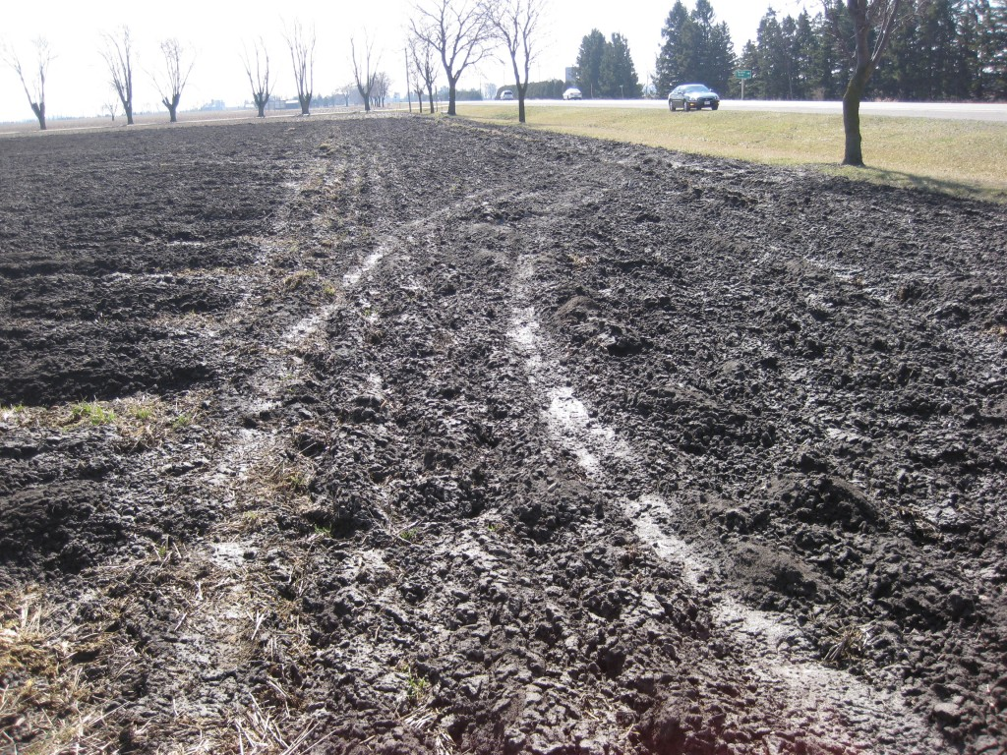
View, looking south, from a farmer's field located on the east side of the accident site and showing the tire marks in the field from another vehicle that left the roadway.
Luckily the driver was able to maintain control and then exited the field without rolling over. This evidence is located just north of the location where the two vehicles collided in the fatal collision. We must not ignore facts such as these as they could help to explain why the Pontiac G5 went out of control.
March 11, 2012
Teen Fatality On Belmont Road South of Belmont, Ontario, March 10, 2012, Not Typical Loss-of-Control Scenario
It has been reported that a southbound Sunfire “travelled onto the shoulder, then the vehicle crossed the centre-line” (London Free Press) where it collided with a northbound Firebird. Four teenagers were in the Sunfire and the right front occupant, Nick Taylor, of Belmont, Ontario sustained fatal injuries.
Given that this collision occurred at approximately 1815 hours on a Saturday evening one would automatically assume some high speed on the part of the Sunfire. Well, that may or may not be so, but the physical evidence at the site does not suggest that the Sunfire was travelling quickly at the time of impact. The so called “travel onto the shoulder” was also not typical of a high speed motion.
In the photo below you can see the tire mark that was produced on the west shoulder of Belmont Road (Highway 74) as the southbound Sunfire rotated counter-clockwise just before crossing the centre-line of the road.
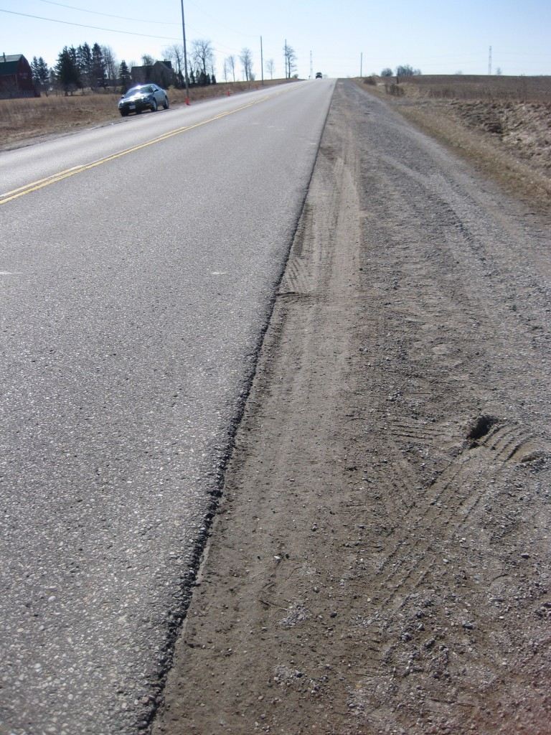
View, looking south, along the west shoulder of Belmont Road, showing the tire mark produced by the Sunfire as it approached the area of impact.
The area of impact was located at the east edge of the northbound lane just in front of our parked car in the background. The Sunfire’s tire mark is more clearly visible in the photo below where we have marked its path with a line of “X”s.
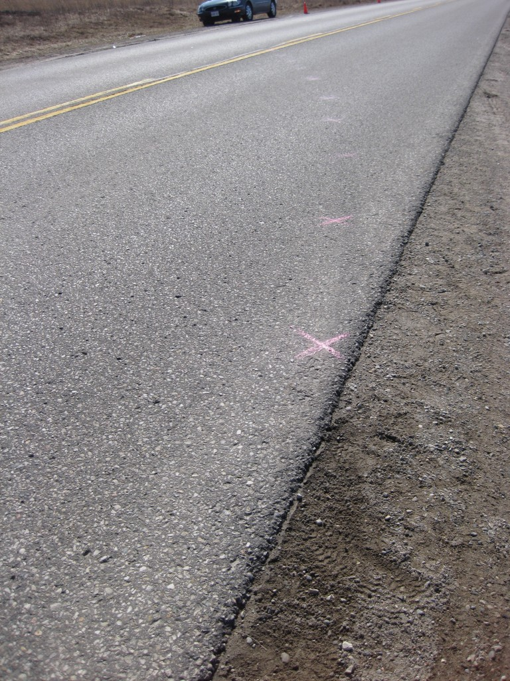
View, looking south, showing the point where the tire mark on the Sunfire exits the west shoulder and enters the southbound lane enroute to the area of impact.
The amount of curvature in this tire mark is an indicator of the lower speed of the vehicle. Also the Sunfire only travelled about 12 t0 13 metres southward while moving across the road from the west shoulder to the east edge of the road – this is another indicator of its relatively slow speed.
In the photo below you can see the tire mark on the right of the view but you may also see a second tire mark to its left which has also been marked with “X”s. These tire marks were caused by the right front (left mark) and right rear (right mark) of the Sunfire. This explains how the front end of the Firebird struck the right side of the Sunfire.
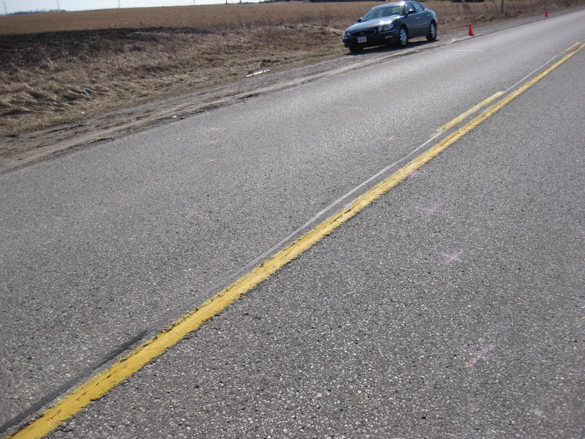
View, looking southeast, along the tire marks of the Sunfire as it rotates counter-clockwise across the roadway centre-line and into impact on the east edge of the northbound lane of Belmont Road (Highway 74).
Although the physical evidence near the area of impact confirms that the Sunfire was travelling at a relatively slow speed, that does not eliminate the possibility that the driver of the Sunfire may have been travelling much faster further away from this location and that, through various loss-of-control, yawing motions (“swerving” or “fishtailing”) , reduced the speed of the Sunfire before the visible tire marks were produced. However we looked at the road further to the north and did not find any additional tire marks that would confirm that his occurred.
March 10, 2012
Testing To Document Typical Rural Passing Motions
We have been conducting testing in the last fews days to document passing motions that occur on rural highways. It is important to study how a vehicle passes another vehicle on a rural highway because this is one of the actions that leads to head-on collisions and loss-0f-control events.
Our testing collaborates past research. The typical scenario involves a vehicle travelling 80 km/h. A driver who attempts to pass such a vehicle often requires about 8 seconds of travel in the opposing lane to complete the passing motion. In that time the vehicle being passed might travel about 180 metres while the passing vehicle might travel about 22o metres. A typical average passing speed might be in the range of 98 km/h.
We have been able to collect such data using just one vehicle that is instrumented with a number of video cameras. We are in the process of optimizing the camera locations to produce the best data. If we have time we may post some of our results, as well as photos of our camera positions in an upcoming article in the Articles webpage of this website. Stay tuned.
March 5, 2012
Tim Wood and his son Ryan were involved in a tragic collision on February 25, 2012 on Oxford County Road 6 just north of Embro, Ontario in which they both lost their lives. One of the issues in the crash was the condition of the road surface and how it might have led to the vehicles’s pre-impact loss-of-control. Coincidentally we have been involved in maximum braking tests during February to assess the condition of snow-covered roads and how they might affect a vehicle’s loss-of-control. We started our testing on the morning of the crash and happened to drive southward toward the accident site just an hour or two after its occurrence. The data that we complied from our testing demonstrates what condition area roads were in at the time of the noted crash. This testing is discussed in an article that has been uploaded to the Articles page of our website. Due to the close timing our testing to the time of the crash of the Wood vehicle we also provide some possible explanations the vehicle’s loss of control could have occurred.
March 4, 2012
Safe Driving – An Example of a Complicated Issue
We highly recommend that drivers, in general, reduce their speeds as excessive speed is one of the major causes of collisions on our roads. However, the opposite is also sometimes true. Excessively slow driving can also have its deadly consequences. We have prepared an article on this issue and uploaded it to our Articles page of this website.
March 3, 2012
Pedestrian Fatality on Wellington Road South of Southdale On Friday Evening, March 2nd, 2012
Mr. Norman Stasyno, 81, is identified as the male pedestrian who was struck and killed on the southobund lanes of Wellington Road south of Southdale Road last evening at approximately 1844 hours. It is reported that Mr. Stasyno was a resident of the Dearness Home, which is a senior’s residence providing nursing care and is located at the north-east quadrant of the Wellington/Southdale intersection.
While the specifics of the incident are not known, there were many factors present that commonly contribute to such occurrences. Generally, Friday and Saturday evening/night are the most common times for the occurrence of major or fatal collisions as a whole. The presence of rainy conditions is a factor that commonly crops up as any precipitation generally degrades both the driver’s and the pedestrian’s abililty to see clearly. A factor that commonly crops up is that such precipitation, when its exists in commerical areas results in the reflection of light from various business establishements thus making the task of detecting vehicles and pedestrians within that complex environment more difficult.
If the collision occurred south of the interection as reported then it should be realized that the section of Wellington Road in that area contains four through lanes and thus a wide stretch of road that cannot be easily crossed by a pedestrian without exposing oneself to the presence of higher speed speed (60 to 80 km/h) traffic, which travels higher than the posted maximum. The higher expected speed of vehicles is due to the wide expanse of the road, the fact that it would be carrying less vehicles than at rush hour and the simple fact that a Friday evening generally contains a riskier population of drivers due to the recreational character of the trips likely to be made.
The elderly age of the pedestrian would also be a factor in the speed at which he could cross the road and therefore would increase his risk of being struck.
While many patterns of injury are common, and these will include injuries to the lower extremities, pelvis and chest, it is often the status of any head injuries that determine whether those injuries result in a fatality.
In a substantial frontal impact of a pedestrian the upper torso generally pivots over the front hood edge and the pedestrian’s head will strike the area of the hood surface. Longitudinal scrapes and scratches may exist on the hood as the pedestrian’s body slides over it, culminating in a small circuular impression that would identify the head contact. Sometimes knowledge of the hood height, pedestrian height and the location of the circular impression on the hood can provide a general estimate of the impact speed of the vehicle. However a more common method for calculating speed is to determine the “throw distance” of the pedestrian from impact to rest.
In more recent times, significant pedestrian impacts have caused events to be written in event data recorders (“Black Boxes”) and the speed of the striking vehicle is more easily obtained. These events would not be severe enough to deploy a safety device such as an air bag or belt pre-tensioner and some EDRs simply do not the capability of documenting such lower impact severities. Also the generally higher “wake up” thresholds for stiffer vehicles such as SUVs would also mean that a pedestrian impact may not be registered in the EDR of such a vehicle.
In sideswiping types of pedestrian impacts a common determiner of head injury severity is a simple case of luck, or bad luck, with respect to whether the pedestrian’s head strikes the windshield glass or the frame surrounding the glass. Many severe collisions can be survivable if the pedestrian’s head makes contact with the windshield glass and therefore the relative softness of the surface results in lower head accelerations. In contrast, a head impact to a stiff A-pillar (front pillar that holds up the roof) can result in much higher accelerations and consequent major head injuries often resulting in death.

