Gorski Consulting Website

Archived News - 2012 - May
May 31, 2012
Man Whose Pick-up Truck Struck Cyclist On Glendon Drive Charged With “Distracted Driving”
An unidentified male driver of a pick-up truck has reportedly been charged by police with “distracted driving” following a collision between his truck and an elderly cyclist on Glendon Drive near Mt Brydges, west of London, Ontario, Canada.
The deceased cyclist was identified as 87-year-old Gerrit Van Laar. The pick-up truck driver was reported to be using a “handheld device” the time of crash (0900 hours, May 30th, 2012). It has not been reported how police determined that the handheld device was being used. Normally such a determination is made if it is found that a cell phone is activiated at the time of a crash but that may have little bearing on whether the actual holding or talking on a cell phone was actually involved.
Regardless, distraction while driving has been a primary cause of motor vehicle collisions ever since the first vehicles were built at the beginning of the 20th Century. It is only now, primarily because of devices such as smart phones and other in-vehicle distractions that “distracted” driving has become a favourite catch phrase that brings readership and viewers to newspapers and television viewers. But the problem has always been there. It is an important issue and one that needs to be addressed, but not only from the standpoint of modern devices.
Radios have been used in vehicles for decades. People talk amongst themselves in a vehicle and a driver is naturally drawn into that conversation. There are a variety of personal grooming and eating activities that drivers have always engaged in. How will we deal with the driver who enters into a trance of recalling some notable activities of the day while driving? Is that not distracted driving” What about the driver who had had too little sleep? What about the driver who has just had a dispute with a family member and is now distracted by the thoughts of that event? Is that not distracted driving? We frequently hear the complaints of persons who say distracted drivers should be locked up or charged with manslaugher or even murder. For those who have lost a loved one due to an apparent distracted driver that is an understandable reaction.
However what we see is that the distracted driver is easy to detect. We should all go to the nearest mirror and look into it. That evil distracted driver will certainly be portrayed in that mirror because we are all guilty of that offence at one time or another. Granted, some of us or more attentive than others but we all fail sooner or later. We must be aware of that fact. We must deal with the problem drivers and work to get them off the street but we must also understand that even the most attentive driver sometimes fails to be attentive.
May 28, 2012
Loss of Control on Gravel of Cherry Hill Road Results in Fatality to Ejected Male Driver
It is reported that about 2120 hours of May 27, 2012, a lone male driver was driving southbound on Cherry Hill Road, north-east of London, Ontario, Canada. As the vehicle passed the intersection of Wyton Road it countered a downslope in the gravel roadway. Evidence would suggest that the vehicle moved into the northbound lane just before reaching a small bridge. It then turned back to its own side of the road as it passed over the bridge and then moved back onto the northbound side of the road and finally back toward the west roadside where it rolled over. The lone male driver was ejected from the vehicle and sustained fatal injuries.
The photo below is a view looking south from north of the accident site. Our car is parked on the east roadside approximately across from the final rest position of the Pick-up truck which came to rest in the field on the right (west) roadside.
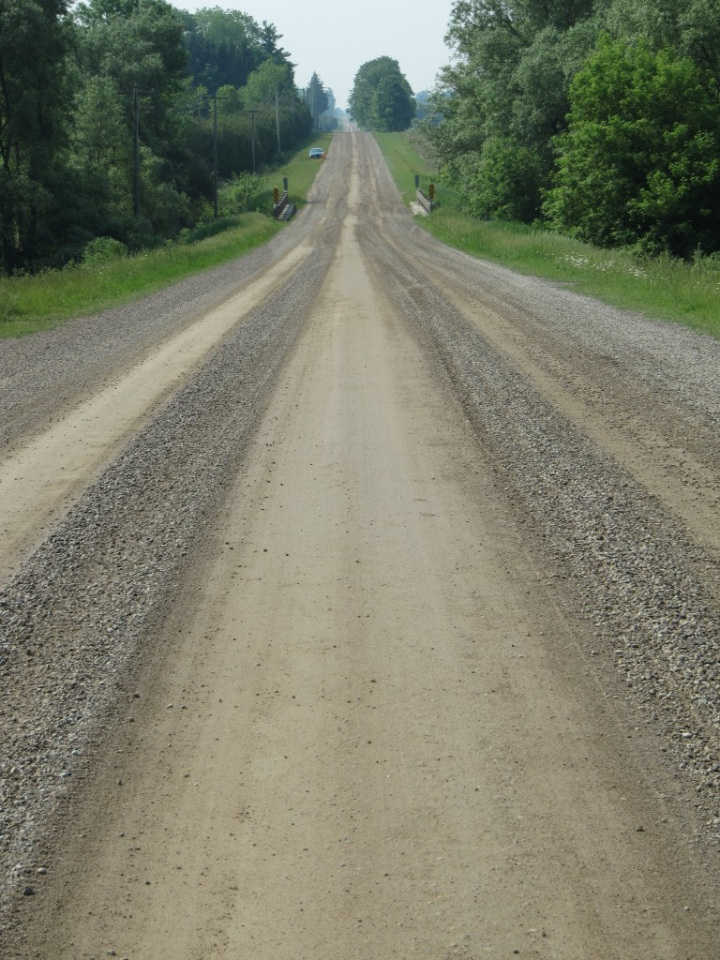
Although there are numerous tire marks visible on the freshly graded gravel road surface, the tire marks caused by the Pick-up truck as it swung back and forth on the roadway were well defined.
To help visualize the relevant tire marks the photo below shows some small cones placed on the road along the tire marks. The cone in the foreground and just past the bridge delineate the mark caused by the right rear tire. Four large cones surrounding our vehicle are not relevant.
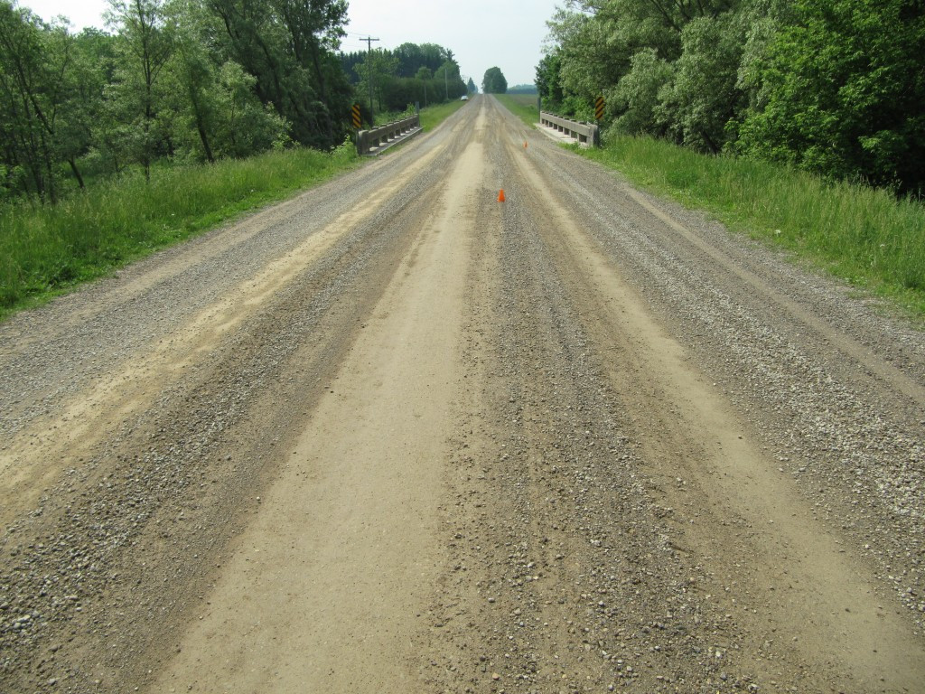
View, looking south with small cones placed along the tire marks caused by the Pick-up as it swung side-to-side prior to exiting the road and rolling over
The photo below shows a view of the tire marks just past (south of) the bridge.
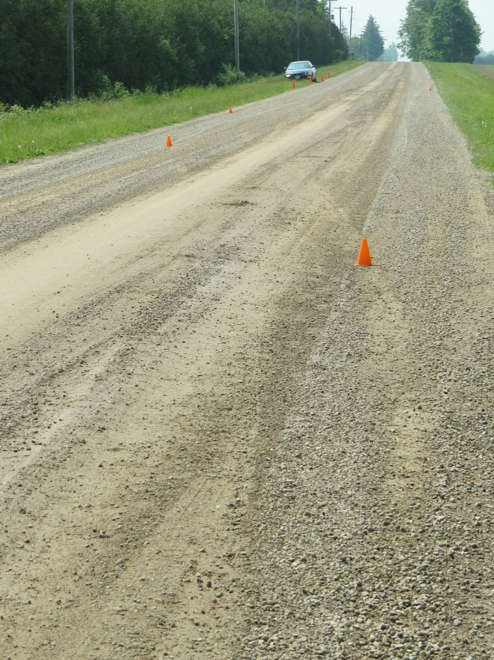
View, looking south, from south of the bridge showing the tire marks moving from the rigth side of the road to the left. The cones on the left side of the road delineate the marks caused by the left rear tire.
The cone on the right background indicates where the vehicle left the roadway and rolled over. The cone in the foreground identifies the mark caused by the right rear tire while the two small cones on the left (northbound side) of the road identify the mark caused by the left rear tire. Again the four larger cones surrounding our vehicle are irrelevant.
Looking back northbound from the bridge it is possible to see the tire marks as the driver first lost control of his vehicle in the photo below. The two small cones identify the right rear tire mark and the marks caused by the left side tires are also visible. You can follow the tire marks past the two cones to notice where they first exit from the southbound side of the road.
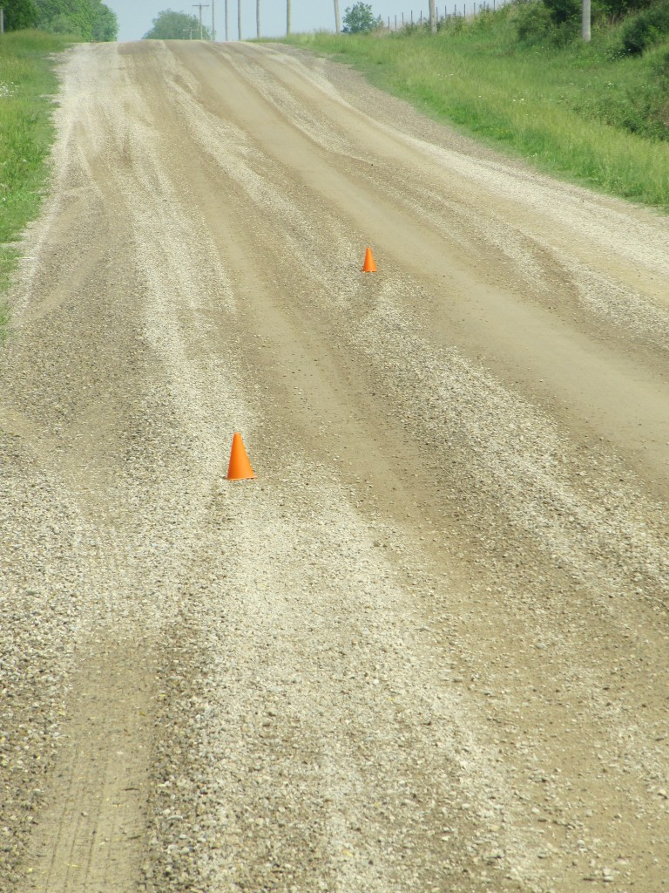
View, looking north, along the upslope of the road just north of the bridge with two small cones identifying the right rear tire mark.
A combination of factors could have led to this loss-of-control event. Another factor to consider is that, at the point where the tire marks first became visible there was a significant cross-slope in the road as demonstrated by the southbound view of the carpenters level in the photo below.
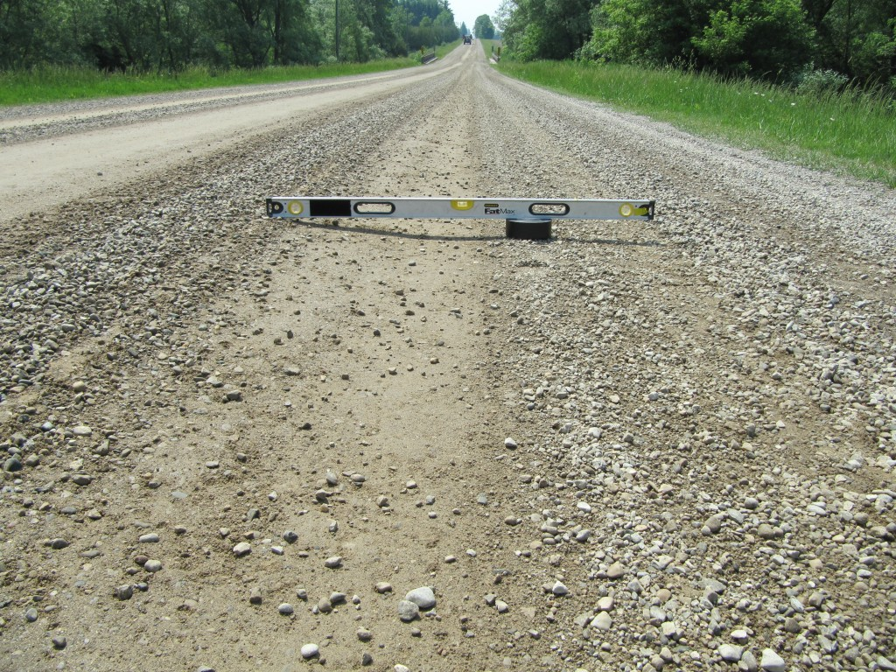
View of ccross-slope at the normal riding position of the right side wheels of southbound vehicles.
There is no doubt that such a obvious slope could play a role in the instability of a vehicle. However if a vehicle travels at reasonable speed such loss-of-control could be minimal or of no consequence. It depends on the specific circumstances of each collision event.
It is uncommon that we should be able to see tire marks for such a long time and distance prior to a rollover. But the loose gravel and the wet road conditions on the night of the crash likely help to reveal those marks. It indicates how often the cause of a loss of control collision is often several hundred metres away from where a vehicle eventually rolls over or strikes another object. It is important to keep that in mind when examining a collision site where the physical evidence might be minimal.
May 27, 2012
Double Fatality Following Impact With Utility Pole on Fingal Line North-West of St Thomas Ontario
Official reports indicate that at approximately 0110 hours on Sunday, May 27th, 2012, a GMC Jimmy was travelling eastbound on Fingal Line, just west of Sunset Drive, north-west of St Thomas, Ontario, Canada. The vehicle was occupied by three young males. The vehicle struck a utility pole on the south side of the road and then rolled over. The two passengers of the vehicle, 28 and 25-years-old, both sustained fatal injuries. The 22-year-old driver was taken to hospital but reportedly did not sustain life-threatening injuries. The driver has been charged with two counts of impaired driving causing death, failing to stop at the scene of an accident and possession of marijuana.
The 25-year-old passenger was identified as Kyle Payne of St. Thomas. The other two males have not yet been identified.
The photo below shows a general view of the accident site taken in the early evening shortly after the police opened the road. The photo contains a “zoomed in” view such that the length of the road is shortened giving an exaggerated appearance to the curvature of the road but this is necessary to give a full view of the area.
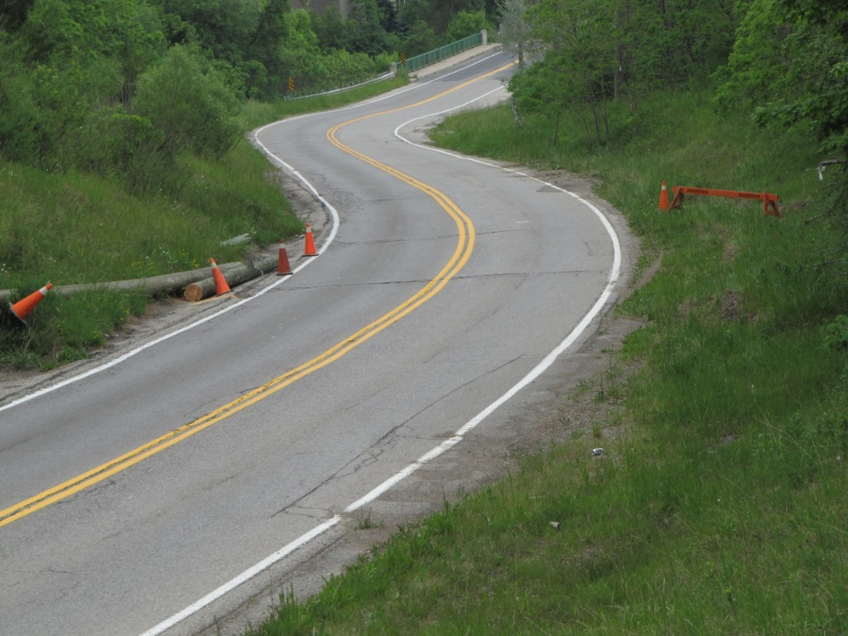
View, looking east, along Fingal Line at the accidnet site (Zoomed In View)
If you look closely toward the south (right) shoulder you should be able to see some tire marks in the grass just before the orange barricade. The tire marks were caused by the GMC Jimmy as it rotated counter-clockwise and struck down a utility pole that was located just beyond that barricade. On the left (north) side of the road you should be able to see peices of the utility pole as well as a replacement pole that will likely be erected shortly to replace the damaged one.
While alcohol and marijuana were mentioned in the official news media the specific details of my the vehicle left the roadway at this specific location has not been revealed.
We have further details including detailed photos of the accident site but we are not sure if we will have time to post some of this information in a detailed article. But we will be monitoring developments in the future.
May 25, 2012
Fatal Crash On Vanneck Road South of Elginfield Road
The scenario that unfolded this morning as a northbound vehicle left a curve in a road was fairly common, but the results were rather unusual.
It was reported that a single vehicle collision occurred on Vanneck Road near Elginfield Road at approximately 0720 hours today, May 25, 2012. A northbound vehicle “left the road and crashed into the backyard of a rural property”(London Free Press). That is approximately what happened but the details are more revealing. We examined the site this evening and hope to provide further details of our findings in the next day or so.
In the meantime we can indicate the following. The northbound vehicle approached a very sharp curve (very small radius of curve) to the right. The vehicle travelled essentially straight producing some very straight yaw marks that became visible as the vehicle exited the paved surface. The vehicle travelled over a small enbankment, through a rock garden and then into a very large pond. One would think that the vehicle would have sunk in the pond but not so. On the opposite side of the pond there was evidence that the front end of the vehicle drove into the steep embankment. This is a substantial distance for a vehicle to travel over that length of open water. Thus it is not surprizing that police have been quoted as stating that speed was a factor in the crash.
Even with the very substantial speed there were also roadway issues. The roadway was not signed properly. When drivers approach a curve like this at highway speed they must reduce their speed substantially in order to travel around the curve. In such a case a curve warning sign is required along with an advisory speed tab which indicates the recommended speed at which it is safe to pass through the curve. No such warning sign and advisory speed were posted.
Secondly, placement of a pond at the end of this “runway” is simply a bad idea without the placement of some form of barrier to help those drivers who might misjudge the curve.
These two roadway issues are not only common sense but their requirement is posted in various standards and guidelines such as the Manual of Uniform Traffic Control Devices (MUTCD) or similar manuals created by local jurisdictions.
UPDATE: May 26, 2012; 1430 Hours
We have uploaded an article in the Articles page of this website that provides a detailed assessment of the physical evidence that was found at the accident site.
UPDATE: May 26, 2012; 1510 Hours
Police have now released the identity of the man fatally injured in this crash as Ryan Whitty, 33, of London. There is still no mention of the details of how Whitty succombed to his injuries or the fact that his vehicle was involved in the pond and did not just “crash into a backyard”. The presence of a pond would lead to people questioning why the driver was not protected from entering the pond if in fact the cause of death was drowning. Thus the failure to mention this issue is significant.
May 18, 2012
A Wish For A Safe Long Weekend
As today is the beginning of our Canadian long-weekend, we want to wish all a happy time on the beaches, parks or just at home enjoying the yard.
At the same time remember to stay safe, take your time and pay attention when you are driving. Even if you are a passenger you can create conditions in your vehicle to allow your driver to focus on driving.
We are also taking a fews days holiday from posting material on this website.
May 16, 2012
Was Speed The Primary Factor That Led To The Fatal Injuries Of Matthew Hartle?
Matthew Hartle, 25, of Roseville, Ontario (west of Cambridge) died as a result of a collision that reportedly occurred shortly after midnight on Tuesday, May 15, 2012. He was driving his 2012 Mitsubishi eastbound on Alps Road on the southern outskirts of Cambridge, Ontario, Canada, when his vehicle went out of control and struck a tree. Police have reportedly concluded that speed was a factor in this collision but nothing more has been stated. In fact, our examination of the accident site indicates that the issue of speed is not quite what the report suggests, and that roadway factors also likely contributed to the cause of the crash and this factor has not been reported.
UPDATE: May 16, 2012; 1650 hours
We have completed uploading an article in the Articles page of this website which discusses the details of our findings and a discussion of the relevant issues.
May 15, 2012
Did Missing Warning Sign Lead To A Serious Crash?
On Sunday morning, May 13th, 2012, an eastbound Pontiac Grand Prix crashed into some trees at a curve on Old Stage Road on the southern outskirts of Woodstock, Ontario, Canada. Through a combination of fortunate outcomes the young male driver survived. News media indicate that police are still investigating yet nothing was mentioned regarding the obvious fact that a curve-warning sign was missing at the site. Such a yellow-coloured sign is standard signage and required to warn drivers of an upcoming curve for roadways in Ontario, and essentially across North America. Why was no mention made of this very important fact?
Below are several views leading up to the curve. Without the warning sign, is it obvious that the driver is approaching a curve? The first photo is taken from several hundred metres west of the curve which begins at the top of the upslope in the distant background.
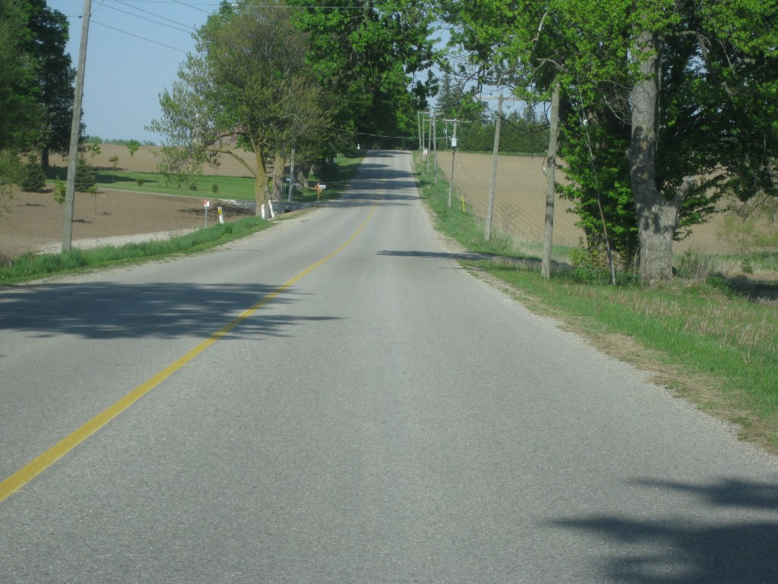
Where is the required "Curve Warning" sign in this eastbound view approaching the curve at the accident site?
As we get closer to the accident site you will notice that there is a sign on the right road edge but this has nothing to do with the upcoming curve.
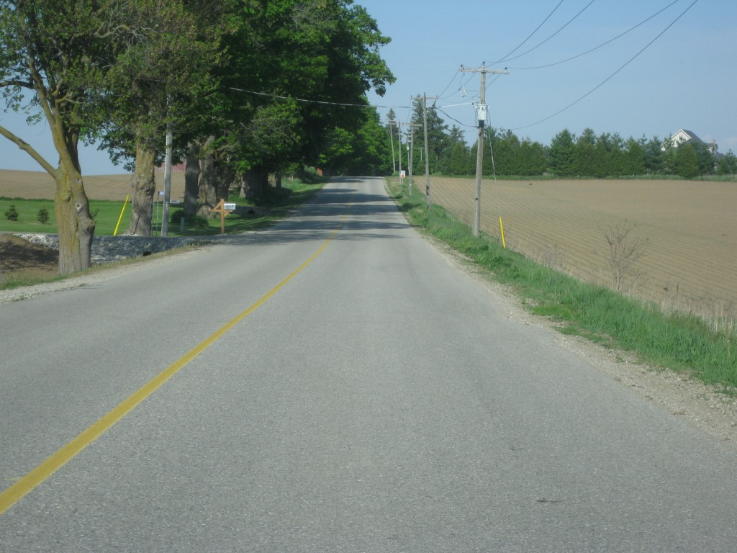
Eastbound view approaching the curve. Is the presence of the curve obvious? What is the content of the sign on the right edge of the road?
In fact the sign just before the curve warns drivers of slow-moving traffic. It says nothing about the presence of a curve. The view below shows a closer view of the sign.
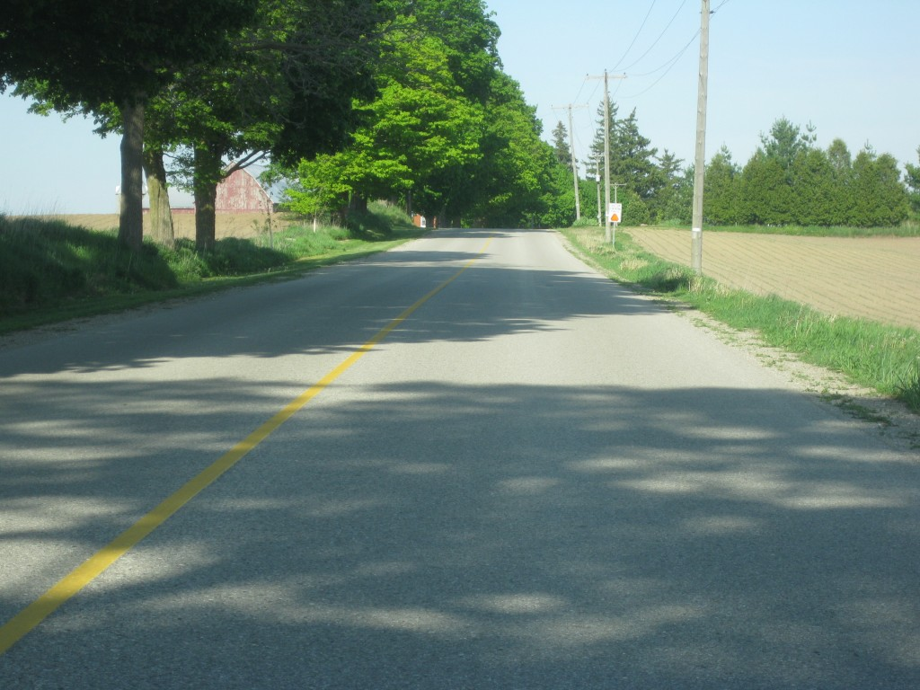
Closer view of sign on the eastbound approach to the curve.
Below you will now be able to read the content of the sign.
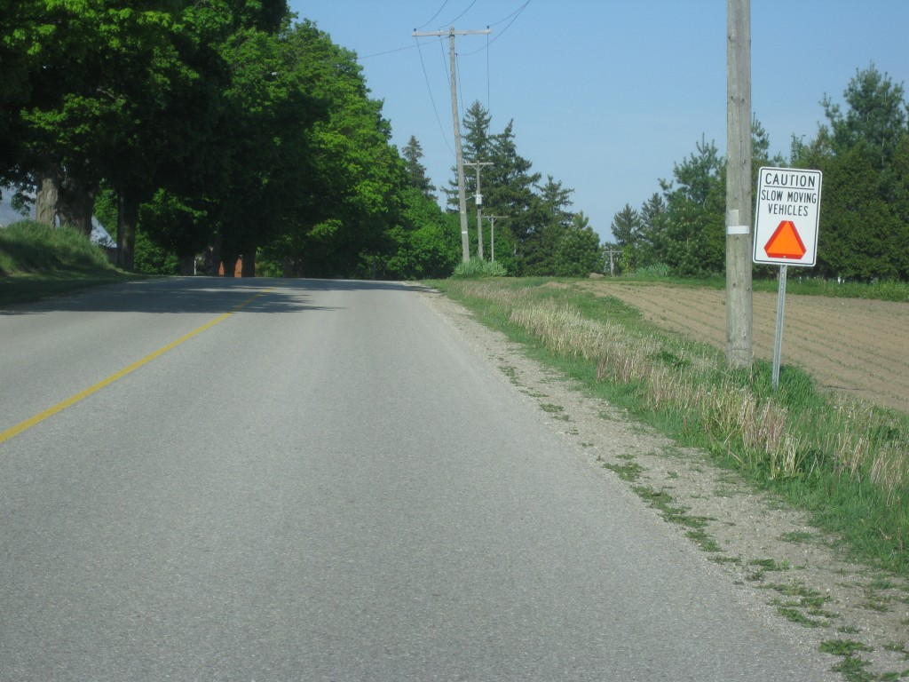
Note the warning sign is non-standard, as it does not contain the typical yellow and black markings and it says nothing about the presence of the upcoming curve. In fact, even from the location shown in this photo the presence of the curve is not obvious.
The presence of the curve is hidden by the slight crest of the hill as the curve is just beyond that crest. The young driver in this crash nearly lost his life as it was pure luck that his vehicle glanced off of two trees and a utility pole. His vehicle eventually caught fire, yet even so, he was rescued from the fire by a nearby resident. All this facts could easily have resulted in a fatality. But the question remains: Why was a warning sign not posted and will police reveal that fact to the public?
May 10, 2012
Two Serious Single-Vehicle Collisions Overnight
News media are reporting that a 49-year-old London man has been killed in a single vehicle rollover on Highway 403 near Ancaster, Ontario. They report the man was not wearing a seat-belt and was ejected from the vehicle. Seat belt use in rollover collisions is often difficult to detect from physical evidence and the download of an event data recorder can sometimes erroneously indicate the latch plate (tongue) was not buckled when there is only a partial or corrupted download.
On Highway 401 near Bloomfield Road in the Chatham area there was a reported police pursuit just after midnight resulting the in rollover of a vehicle. The driver was taken to hospital with undisclosed injuries and the Ontario SIU has been called in to investigate.
May 6, 2012
Tim Hortons Outlets And Traffic Problems Relate To Increased Likelihood Of Collisions
The large number of vehicles entering and exiting various Tim Hortons outlets in Canada is not an unknown fact. In many instances city representatiaves and staff fail to ensure that the extra traffic can be handled in a safe manner. This is apparent when looking at some of the Tim Hortons locations in London, Ontario and the traffic problems that keep recurring around them.
Many problems occur when there is insufficient parking available for large trucks. It is common for truck drivers to park in “No-Parking” zones next to a Tim Horton’s outlet.
As an example, Veterans Memorial Parkway is a high-speed expressway on the east side of London. There is a Tim Horton’s outlet at its intersection with Admiral Drive. Truckers continually park on the west sidewalk in order to access the Tim Horton’s located there. The photo below is an example of trucks that park there.
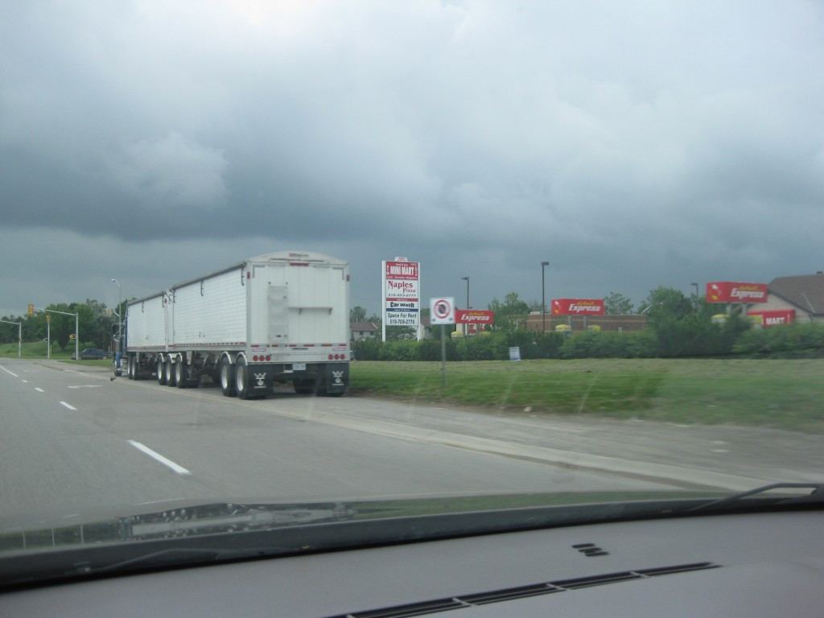
View of typical Tractor Trailer parked illegally on the west sidewalk of Veterans Memorial Parkway at Admiral Drive
Drivers can hardly be blamed for performing this illegal action when facilities are not provided to handle these large vehicles yet the Tim Hortons location is such that it entices truck drivers to stop where they do.
At the intersection of Clarke Road and Huron Street there is another common location where truckers park their vehicles to enter a Tim Hortons outlet. The important issue there is that many of the parked vehicles are tanker trucks because this is their common route from filling up with petroleum at the storage depots at Clarke and Oxford Street. Below are two views of one of the tanker trucks that has parked on the east side of Clarke Road.
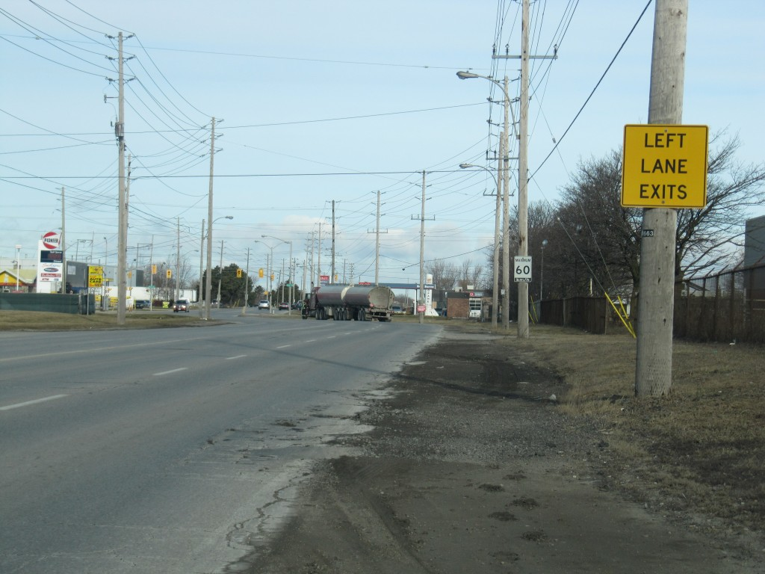
Tanker truck parked on a sharp right curve of Clarke Road - a precarious situation.
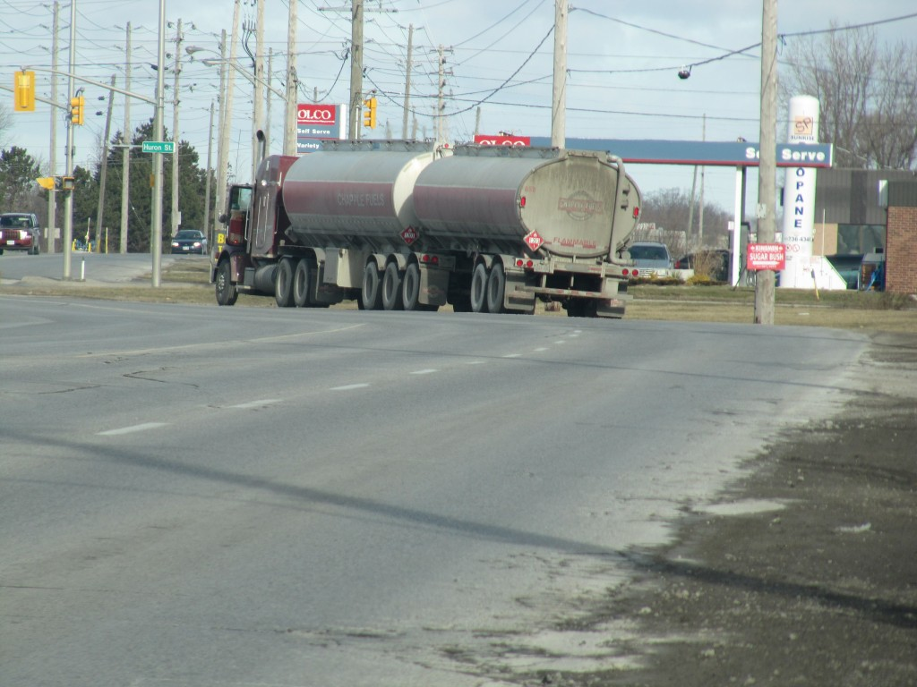
Drivers approaching the parked tanker truck can be confused because they cannot see the layout of the lanes ahead and may perform motions that could lead to a crash.
The above scenario is a little more precarious because, upon approach to the curve you can see in the upper photo that a warning sign tells drivers that the left lane becomes exclusive to left turns only. Thus drivers in the left lane who want to travel through the intersection must change lanes into the right lane. But the view of the lanes ahead does not allow the driver to know how the lanes proceed through the curve and they would be confused whether the parked tanker truck is parked on the roadside or within one of the lanes. This type of confusion can lead drivers to make unusual motions. If this confusion causes anther truck driver to take evasive action there could be a collision between the truck and the parked tanker truck. Such a consequence could be significant. The position of the Tim Hortons outlet would appear to be of no consequence to such a collision but that is not so. There are many instances where traffic patterns around Tim Hortons outlets needs closer evaluation.
May 5, 2012
Evidence From Double-Fatal, Head-On Collision On Highway 40 North of Chatham Ontario Is Rare And Unusual
It was reported earlier in the week that at approximately 1550 hours on Thursday, May 3, 2012 a double-fatal, head-on collision occurred on Highway 40 in Dover Centre, north of Chatham, Ontario. A northbound pick-up truck operated by Aaron Rubik, 37, of Wallaceburg collided with a southbound car driven by Mona Olsen, 77, of Sarnia. A Chatham Daily News article quoted police as stating that the pick-up truck struck the car “in the centre of the roadway”. It was also stated that witnesses saw the crash but police were still looking for other witnesses to come forward.
Although we have not examined the collision site, nor have we had a chance to examine the vehicles, the Chatham newspaper article provided a single photograph of the two vehicles positioned on the roadway. Few investigators would have the experience and capability of looking at the damage and rest positions of the vehicles and to understand that they have a rare and unusual case on their hands. A vast majority of serious head-on collisions involve direct contact to 50 percent of the front ends and that direct contact is typically located on the left portion of the front end. The vehicle damage patterns are like book-ends in that the pattern of damage is alike on both vehicles. The striking vehicles also pass each other and end up past the point of impact and generally toward, or on, the gravel shoulders.
Another type of head-on collision involves a loss-of-control of one of the vehicles and the patterns of damage are different between the vehicles. In this scenario both vehicles are pushed onto one side of the road and do not remain on the paved surface. There are many examples of this discussion in articles that we have uploaded on this website.
But in contrast the photograph in the present collision shows very different evidence than what we described above. Both vehicles have sustained direct damage to the right portions of their front ends and the maximum crush appears to be located at the right corners of each vehicle. That is very unusual. The crush on both vehicles is quite severe. And there do not appear to be any tire marks to suggest that either driver took some action before the crash. This means that likely both drivers have failed greatly in preventing this crash. That is not normal. This is one of those cases where police investigators need to recognize that they are dealing with an unusual circumstance that is not typical of what would normally take place. Police may have statements from witnesses but those statements will generally be imprecise and could even provide misleading information that could side track the investigation. Event data recorders may be downloaded but the data from these will be less helpful because issues such as speed, and timing of braking/acceleration will not lead the police directly to the answer they need to have. Police should have the opportunity to run a computerized simulation analysis to confirm whether the witness information and the police conclusions are correct but we have never encountered a police agency in Ontario that uses such a tool and has sufficient experience with its use.
Unfortunately, we cannot say anything further because we have not had a chance to examine the evidence.
May 2, 2012
“Eratic” Driving Complaint Of Rural Postal Delivery Reflects A Greater Issue of Witness Reliability
There was a small item in the May 2, 2012 Hamilton Spectator Newspaper regarding a complaint that had been received by police about an erratic driver who “was driving at high speed into oncoming traffic between 5 and 7 a.m.” Turns out that the erratic driver reported himself to police. He was a rural postal delivery person.
Now, we do not know the specific circumstances of this case but it reflects the greater problem of one person’s perception being different from another’s and both persons’ perceptions being different from reality. Far too often we see police wearing horse blinders and using tunnel vision whenever they are provided with a witness statement. It is as if police already know what they want to do and are more than happy to use the assistance of a witness statement without taking proper care to get to the true facts, not the easy facts. Time and again we have seen this occur in various accident scenarios, but this also applies to all criminal acts and to life in general.
The bottom line is that human beings make poor witnesses. They have always made poor witnesses. Why we say things is as complicated as our brains, which process the sensory material and create a fantasy, based on partial knowledge, partial memory and a mix of bias and prejudice. It is why the judgment of guilt or innocence must not be determined by what someone says alone. There are many scientific methods, instruments and reserach findings that are available to assist in any analysis of guilt or innocence. DNA analysis, laser scanners, use of the principles of phyiscs, use of research into human behavior and so on. All these can be used to debunk the mis-information of a witness if police and the courts were to use them correctly. But sadly, far too frequently, that assistance is not used.
The rural mail delivery person may travel the wrong way at times, and not follow the painted lines of a lane, and he may appear to accelerate and stop in seemingly unusual ways. If a person were unable to see the portion of his travel where he actually deposits something in a mailbox then what would you expect that witness to say about those driving habits? And in the general case very often a witness is capable of only seeing a portion of any event, very much like the partially viewed actions of this postal driver. What is not seen is filled in with fantasy, ignored or filled in to be consistent with some preconceived bias. Scientific analysis and results rarely have that problem, except when they are tampered with by the human element.
May 1, 2012
Further Details of Chrysler 300 Collision With Trees on Perth Road 139 (Prospect Road) on April 30th, 2012
We have had a chance to examine the accident site where a Chrysler 300 reportedly struck two trees just south of Line 2 on Prospect Hill Road (Perth Road 139). I will not provide too many details but it may be important that it was likely raining at the time of the crash and that the Chrysler entered into a valley and was travelling down a steep downslope when the collision events unfolded. Below, is a view looking south on Prospect Hill Road as the Chrysler approached the deep valley.
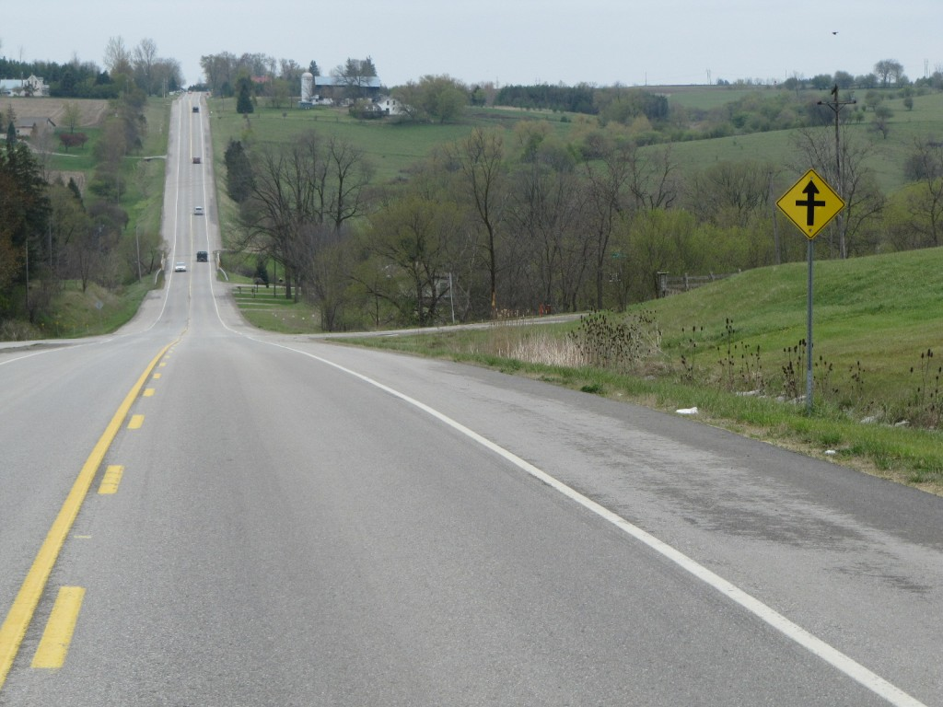
View, looking south, from just north of South Perth Line 2, as the Chrysler driver lost control and travelled to the right (west) side of the road.
The Chrysler exited the road just before it reached Line 2 as evidenced by the yaw marks on the west roadside as shown in the photo below.
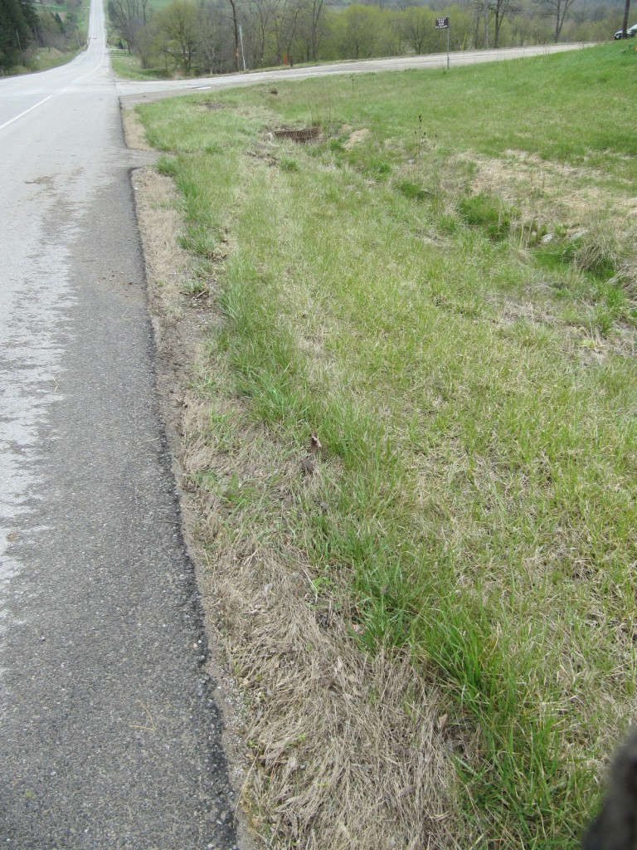
View of tire marks on west roadside on approach to Line 2 as the Chrysler left the road.
The Chrysler produced 17 metres of tire marks before its undercarriage struck a concrete gutter thus fracturing its oil pan. The Chrysler then travelled another 33 metres before striking the stop sign on Line 2. It then travelled a further distance where it glanced off two trees and came to rest at the second tree, about 50 metres past the point where it struck the stop sign. Below is a view of me standing next to the first struck tree to demonstrate how high the contact was on the tree.
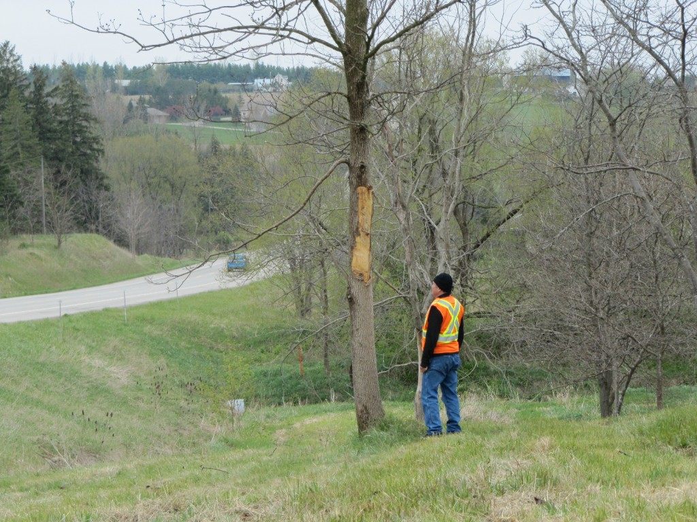
View of Zyg Gorski standing next to the first of two trees that was struck by the Chrysler.
We cannot say for certain why the Chrysler entered into a state of loss of control. Certainly the centre-line markings commenced a hatched “Passing Allowed” condition at the top of the slope and the driver could have commenced a passing motion and then lost control on the wet surface. If so then police would likely have some witnesses to confirm this. But there is not information to indicate that this actually occurred.
Further Details on Fatal Tanker Truck Collision of April 27, 2012 on Edgeware Road, Malahide Township
It is surprising how fatal collisions can occur in our midst without the public’s awareness. Abram Berg, 23, was killed on Friday April 27th, 2012 when his tanker truck exited the south side of Edgeware Road and struck a tree. No details of how this could have occurred have been provided in any official news media. It is particularly puzzling when the evidence at the accident site is examined. We conducted an examination of the site this afternoon. Below is a view, looking westbound on Edgeware Road, from just west of Goudy Road.
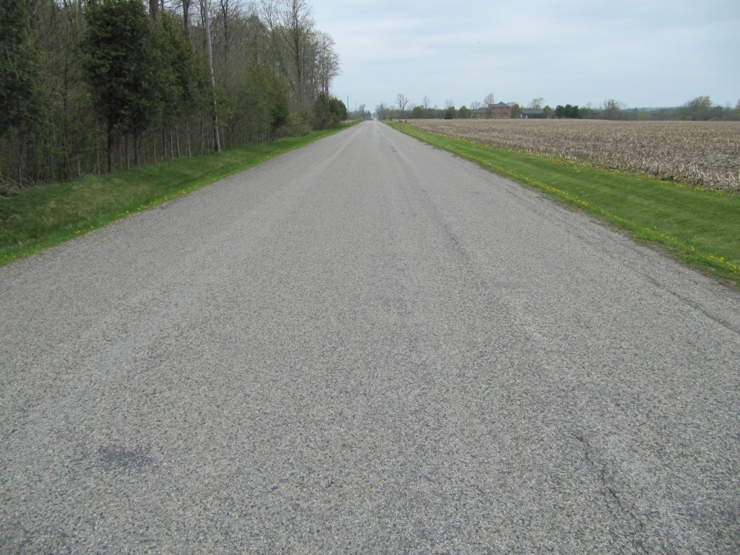
View, looking west on Edgeware Road from just west of Goudy Road. The fatal collision occurred several hundred metres away in the background.
You should appreciate how straight and level the roadway is. What would make a large truck exit such a road? Below is another view, still looking west, from just a couple of hundred metres from where the truck struck the tree on the south roadside.
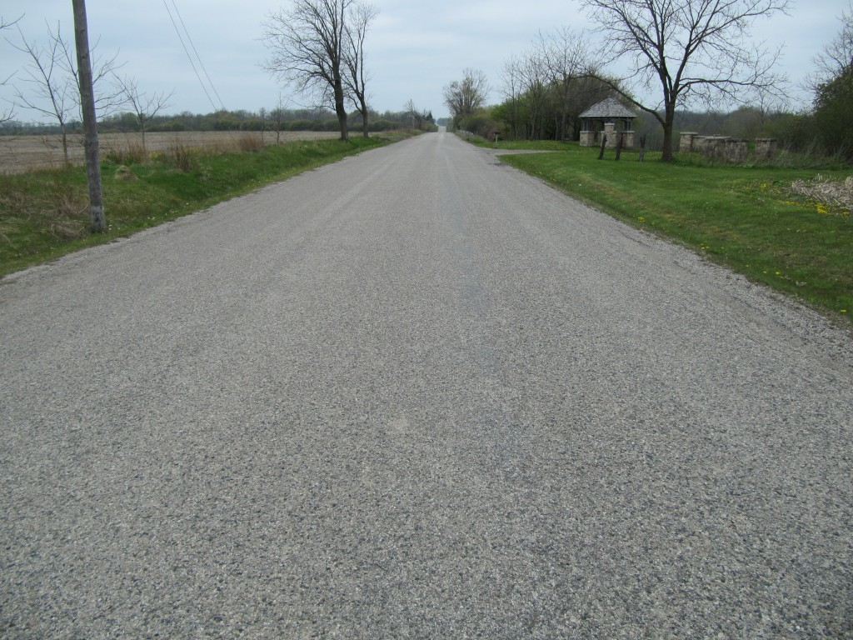
View, looking west, from about 200 metres east of the tree impact.
For some unexplainable reason the truck travelled onto the north, grass roadside in about this location as shown in the photo below.
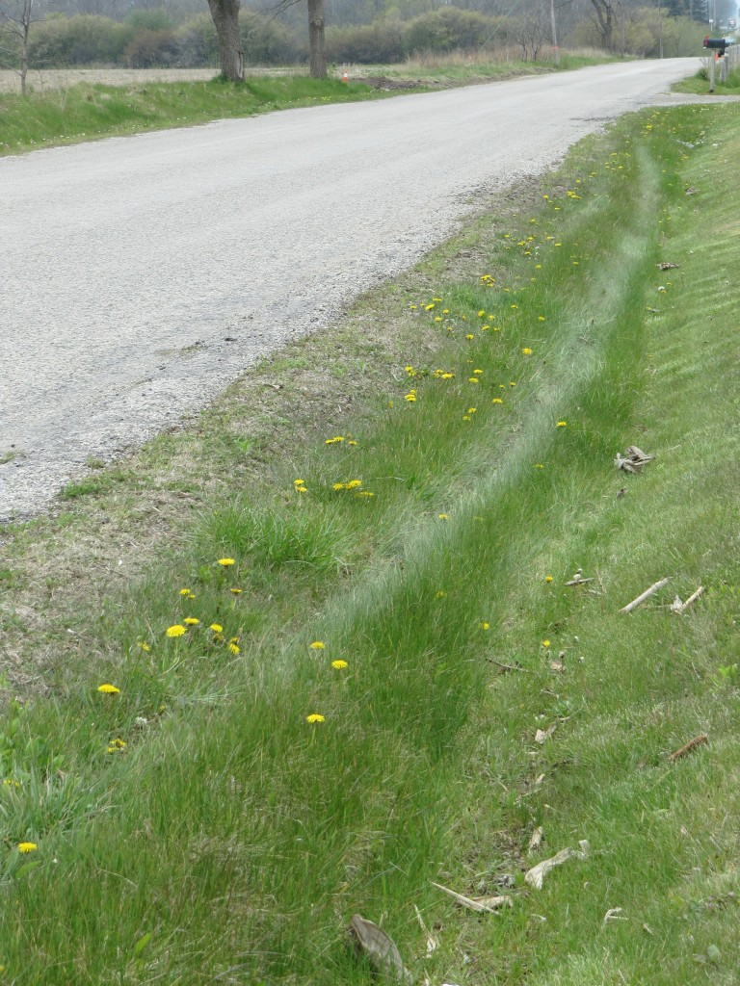
Zoomed in view, looking along north edge of Edgeware Road showing tire mark in grass likely caused by right side wheels of tanker truck
Obviously, we are examining this site almost five days after its occurrence therefore our suggestion that this tire mark was caused by the tanker truck might be viewed with some skepticism. However the curvature and location of the mark matches further tire marks on the road. We cannot imagine what other vehicle could have produced this tire mark.
Below is a view showing the faint tire marks that still exist on the roadway showing the truck’s counter-clockwise rotation as it travels toward the south ditch in the background.
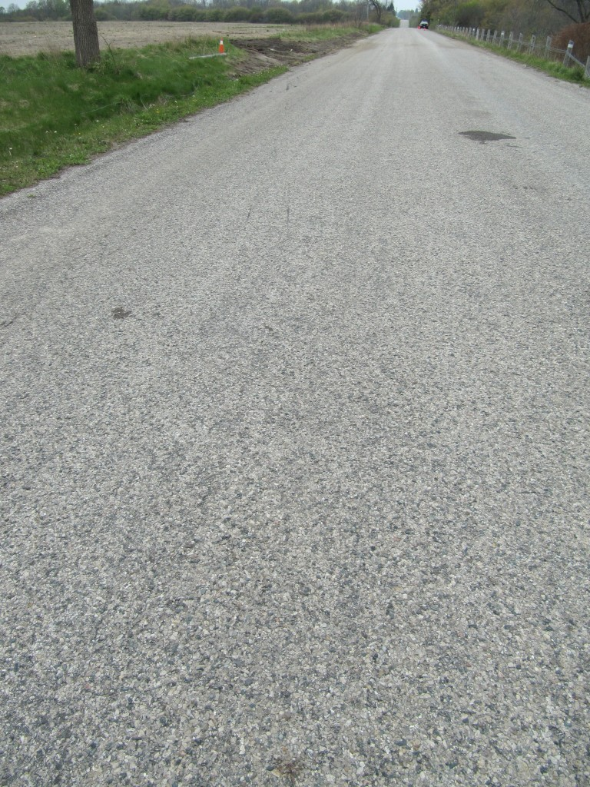
View, looking west, showing faint tire marks as the truck travels toward the south roadside and eventual tree imapct.
I admit that the tire marks are difficult to see in the above photo. However, at the location of the oil stain on the right side of the photo there is a typical yaw-type of tire mark with typical striations within it which was caused by one of the right side tires.
In contrast, a tire mark exists to the left side of the photo which does not contain the typical yaw-type markings. This tire mark shows intermittent, scallop-type markings which are more common with a tire that has been damaged and deflated. This should lead us to concern. Below is another attempt to show you the characteristics of that tire left tire mark.
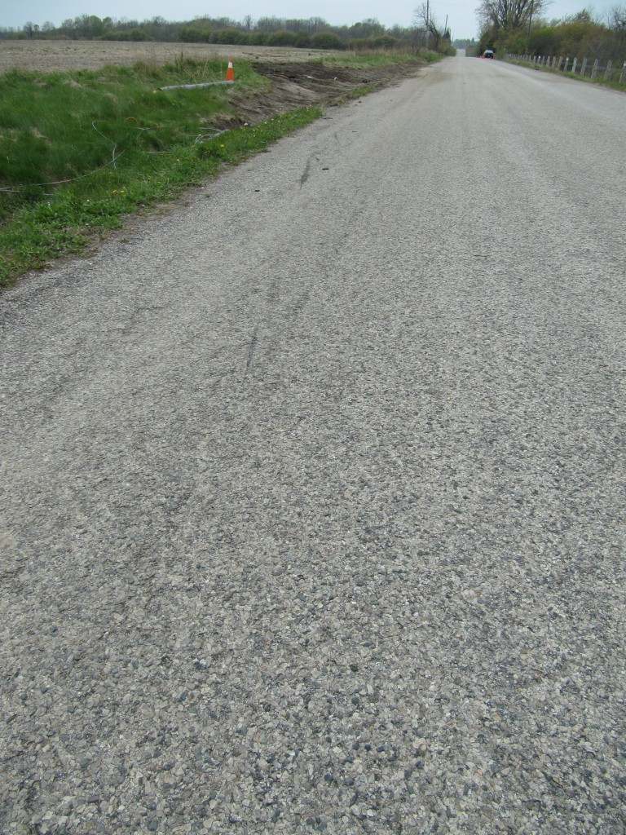
View, looking west, showing possible deflation characteristics in left tire mark of truck as it exits the road.
The above view takes us very close to the point where the left tire mark exits the road but you should still be able to see several, intermittent, black markings caused by that left side tire.
This is somewhat of a mystery and without further information from the police investigation I cannot say why this characteristic exists. Certainly, without any further information, it would appear as if the truck experienced a deflation of the one of the left side tires prior to exiting the road. This might also explain why it travelled onto the north roadside before exiting the south side.
But many other explanations could exist. The driver could have been affected by opposing traffic for example. But certainly the character of the road would not commonly lead to a loss of control situation because the road is straight and level.
UPDATE: May 4, 2012, 1315 Hours
We need to correct an erroneous assumption made in the previous text. The “left side” tire mark is likely not from one of the left sided tires of the truck. It is likely that the truck rotated counter-clockwise and as it was approaching the south roadside it would be the two right tires that would be expected to produce the visible tires. So any deflation would likely have occurrred at the right front tire, not the left.
Collisions in South Perth and Malahide Townships In Recent Days
Two, serious, single vehicle collisions have been reported in the last few days in the outskirts of London, Ontario.
In South Perth Township, Highway 7 was closed on April 30, 2012 due to construction causing vehicles to be diverted on to a detour route that passed through Perth County Road 139. It was reported that at approximately 1030 hours a driver of a Chrysler 300 left the roadway and his vehicle struck two trees. The man was air lifted to London Health Sciences Centre with undetermined injuries.
The collision in Malahide Township is peculiar because no official news agency reported it except the local newspaper, the Aylmer Express. This despite that there was a fatality involved. The Aylmer Express reported that on April 27th, 2012, a tanker truck driven by Abram Berg, 23, of Malahide Township was involved in a loss-of-control collision at approximately 1100 hours. The collision reportedly occurred on Edgeware Line just west of Goudy Road in northeast Central Elgin. The truck entered the south ditch, struck a hydro pole and then a large tree, causing the truck to fall onto its side. Mr. Berg was reportedly trapped in the truck and pronounced deat at the scene. Liquid fertilizer was spilt.
It is not clear why news media failed to report the Malahide incident. It demonstrates the spotty manner in which important news is reported or not reported. Even when these events are reported they often indicate that an investigation is ongoing but no results of that investigation are provided.

